INITIAL STUDY
CALIFORNIA ENVIRONMENTAL QUALITY ACT (CEQA)
ENVIRONMENTAL CHECKLIST FORM

- Project Title: Commission Determination No. 64

- Lead Agency Name and Address: Mailing Address:
City of Redlands City of Redlands
Development Services Department Development Services Dept. – Planning
35 Cajon Street, Suite 20 P.O. Box 3005
Redlands, CA 92373 Redlands, CA 92373

- Contact Person & Telephone: Catherine Lin, AICP, Principal Planner (909) 307-7308

- Project Location: South side of Sessums Drive, approximately 1,560 feet west of Wabash Avenue and 1,150 feet east of Aviation Drive (APNs: 0168-041-50-0000 and 0168-041-13-0000), in the City of Redlands (see Figure 1, Location Map).

- Project Sponsor's Name and Address: Mark Stanson, 1000 New York Street, Redlands, CA 92372. Telephone: (909)

- General Plan Designation: Light Industrial (see Figure 2, General Plan Land Use Map)

- Zoning Designation: Industrial (I-P) District (see Figure 3, Zoning Map)

- Description of Project: Commission Determination No. 64 is a request for the Planning Commission to make a determination of similar use to allow “Landscape Maintenance Facility” to locate within the Light Industrial (I-P) zone in the City, in order for a commercial landscape maintenance company to locate its operation yard at an approximately 5-acre parcel along the south side of Sessums Drive, approximately 1,560 feet west of Wabash Avenue and 1,150 feet east of Aviation Drive (APNs: 0168-041-50-0000 and 0168-041-13-0000). The operation yard will operate from Monday through Friday, between the hours of 8:00am to 4:00pm. It will be staffed by maximum of 3 employees. The operation will consist of the following:

- Staging of approximately 12 landscaped maintenance vehicles including a fork-lift.
- Service of vehicles and equipment
- Storage of PVC pipe and fittings
- Storage of trees and shrubs
- Storage of bulk materials such as bark, gravel, and DG.
- Use of storage containers for the keeping of small materials and/or small hand tools (picks, shovels, brooms, rakes)

The operation yard is for the use of the company’s employees only. No customers will need to visit this location.

The project site is presently vacant and will be improved with landscaping along the street frontage, six feet high chain link fence around the site boundary, a parking area for the use of employees, an area for storage containers, and an area for nursery stock storage. The parking area will be paved with permeable AC pavement, while the remainder of the site will be paved with crushed aggregate base. No permanent structure is proposed, and the only construction activity will be the paving of the site with permeable AC pavement and crushed aggregate base. No more than 3-inches of top soil disturbance is expected.

Trip generation for this project is expected to be 27 round trips maximums on per day on each operating day.

- Existing On-site Land Use and Setting: The site is currently vacant. (See Figure 4, Aerial Photo)

- Surrounding Land Uses and Setting: The project site was formerly an orange grove. According to available aerial photographs, the orange grove was removed between1980 to 1995. The project site is relatively level, sloping towards the southwest at an average gradient of approximately one percent. The elevation within the Project Site ranges between 1,536 to 1,548 feet above the mean sea level.

The Project Site is bordered by Sessums Drive to the Redlands Airport to the north. The project site and surrounding parcels are located within the Industrial (I-P) District. A two-story professional office building is located on the parcel to the east, otherwise, the surrounding properties to the east, west, and southeast are all vacant. The Redlands Sports Complex is located south of the project site.

- Other Public Agencies Whose Approval Is Required (e.g., permits, financing approval, or participation agreement): None.

- Related Technical Reports (incorporated herein by reference): The following technical studies/reports have been prepared to analyze this specific project.

- ECORP Consulting, Inc. (February 21, 2019). Results of a San Bernardino Kangaroo Rat Habitat Assessment Conducted at the Approximately 5-acre Property (APN 0168-041-50 and 0168-041-13), in the City of Redlands, California.

- ECORP Consulting, Inc. (March 29, 2019). Results of a Focused San Bernardino Kangaroo Rat Trapping Survey Conducted at the Approximately 5-acre Property (APN 0168-041-50 and 0168-041-13), in the City of Redlands, California.

- ELMT Consulting. (May 21, 2019). Peer Review of ECORP Consulting’s San Bernardino Kangaroo Rat (Dipodomys merriami parvus; SBKR) Habitat Assessment and a SBKR Trapping Study Prepared for the 5-Acre Sessums Drive Property (APN 0168-041-13) Located in the City of Redlands, San Bernardino County, California.

ENVIRONMENTAL FACTORS POTENTIALLY AFFECTED:

The environmental factors checked below would be potentially affected by this project, involving at least one impact that is a “Potentially Significant Impact” as indicated by the checklist on the following pages.

Aesthetics | Greenhouse Gas Emissions | Public Services
Agriculture & Forestry Resources | Hazards & Hazardous Materials | Recreation
Air Quality | Hydrology/Water Quality | Transportation & Traffic
Biological Resources | Land Use & Planning | Tribal Cultural Resources
Cultural Resources | Mineral Resources | Utilities & Service Systems
Energy | Noise | Wildfire
Geology and Soils | Population & Housing | Mandatory Findings of  Significance
ENVIRONMENTAL DETERMINATION:

On the basis of this initial evaluation:
I find that the Project COULD NOT have a significant effect on the environment, and a NEGATIVE DECLARATION will be prepared.
I find that although the Project could have a significant effect on the environment, there will not be a significant effect in this case because revisions in the project have been made by or agreed to by the project proponent. A MITIGATED NEGATIVE DECLARATION will be prepared.
I find that the Project MAY have a significant effect on the environment, and an ENVIRONMENTAL IMPACT REPORT is required.
I find that the Project MAY have a “potentially significant impact” or “potentially significant unless mitigated” impact on the environment but at least one effect 1) has been adequately analyzed in an earlier document pursuant to applicable legal standards, and 2) has been addressed by mitigation measures based on the earlier analysis as described on attached sheets. An ENVIRONMENTAL IMPACT REPORT is required, but it must analyze only the effects that remain to be addressed.
I find that although the Project could have a significant effect on the environment, because all potentially significant effects (a) have been analyzed adequately in an earlier EIR or NEGATIVE DECLARATION pursuant to applicable standards, and (b) have been avoided or mitigated pursuant to that earlier EIR or NEGATIVE DECLARATION, including revisions or mitigation measures that are imposed upon the Project, nothing further is required.

_______________________________
Catherine Lin, AICP, Principal Planner
City of Redlands
June 6, 2019

EVALUATION OF ENVIRONMENTAL IMPACTS:

A brief explanation is required for all determinations, except "No Impact" determinations that are adequately supported by the information sources a lead agency cites in the parentheses following each question. A "No Impact" determination is adequately supported if the referenced information sources show that the impact simply does not apply to projects like the one involved (e.g. the project falls outside a fault rupture zone). A "No Impact" determination should be explained where it is based on project-specific factors as well as general standards (e.g., the project will not expose sensitive receptors to pollutants, based on a project-specific screening analysis).

All determinations and discussion must take account of the whole action involved, including off-site as well as on-site, cumulative as well as project-level, indirect as well as direct, and construction as well as operational impacts.

Once the lead agency has determined that a particular physical impact may occur, then the checklist answers must indicate whether the impact is potentially significant, less than significant with mitigation, or less than significant. "Potentially Significant Impact" is appropriate if there is substantial evidence that an effect may be potentially significant. If there are one or more "Potentially Significant Impact" entries in any section of this Initial Study, then an Environmental Impact Report (EIR) must be prepared to fully analyze the identified issue(s).

“Negative Declaration: Less Than Significant With Mitigation Incorporated" applies where the incorporation of mitigation measures has reduced an effect from "Potentially Significant Impact" to a "Less than Significant Impact." The lead agency must describe the mitigation measures, and briefly explain how they reduce the effect to a less than significant level (mitigation measures from Section XVII, "Earlier Analyses," may be cross-referenced).

Earlier analyses may be used where, pursuant to the tiering, program EIR, or other CEQA process, an effect has been adequately analyzed in an earlier EIR or negative declaration (CEQA Guidelines Section 15063(c)(3)(D)). In such cases, a brief discussion should identify the following:

a) Earlier Analyses Used. Identify and state where they are available for review.
b) Impacts Adequately Addressed. Identify which effects from the above checklist were within the scope of and adequately analyzed in an earlier document pursuant to applicable legal standards, and state whether such effects were addressed by mitigation measures based on the earlier analysis.
c) Mitigation Measures. For any effects that are determined to be “Less than Significant with Mitigation Measures Incorporated,” describe the mitigation measures which were incorporated or refined from the earlier document and the extent to which they address site-specific conditions for the project.

Lead agencies are encouraged to incorporate into the checklist any and all references to information sources for potential impacts (e.g., General Plan maps or exhibits, zoning ordinances, specific plans, etc.). Reference to a previously-prepared or outside document should, where appropriate, include a reference to the page or pages where the statement is substantiated.

7) Supporting Information Sources. A source list should be attached and other sources used or individuals contacted should be cited in the discussion. In this Initial Study, a References section is provided at the end of the document.

8) This is only a suggested form, and lead agencies are free to use different formats. However, lead agencies should normally address the questions from this checklist that are relevant to a project’s environmental effects in whatever format is selected.

9) The explanation of each issue should identify:

a) The significance criteria or threshold, if any, used to evaluate each question; and,
b) The mitigation measure identified, if any, to reduce the impact to less than significance.

FIGURE 1
LOCATION MAP

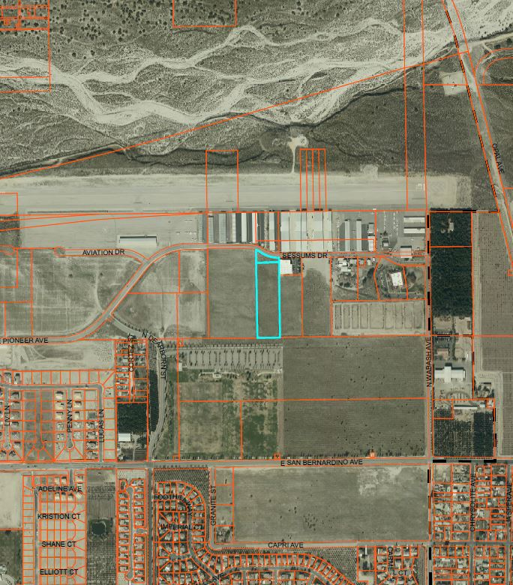

FIGURE 2
GENERAL PLAN LAND USE MAP

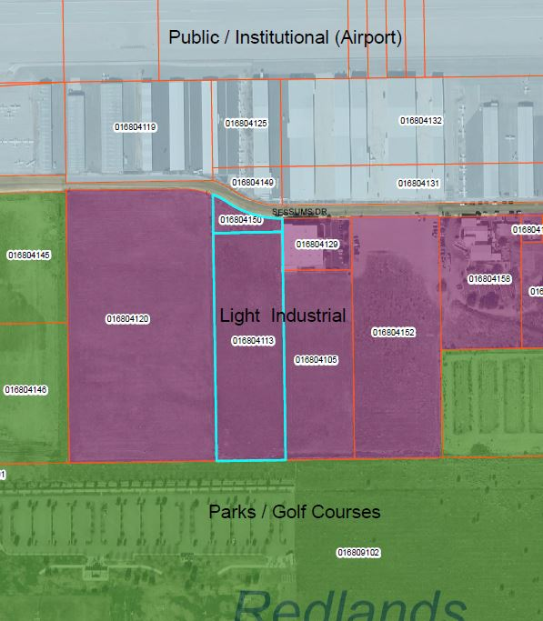

FIGURE 3
ZONING MAP

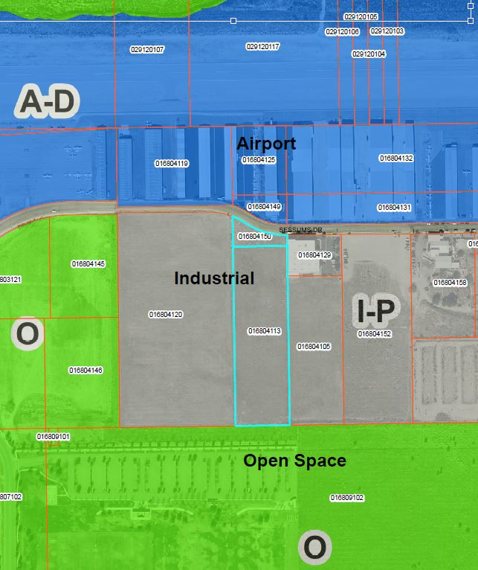

FIGURE 4
CURRENT AERIAL PHOTO

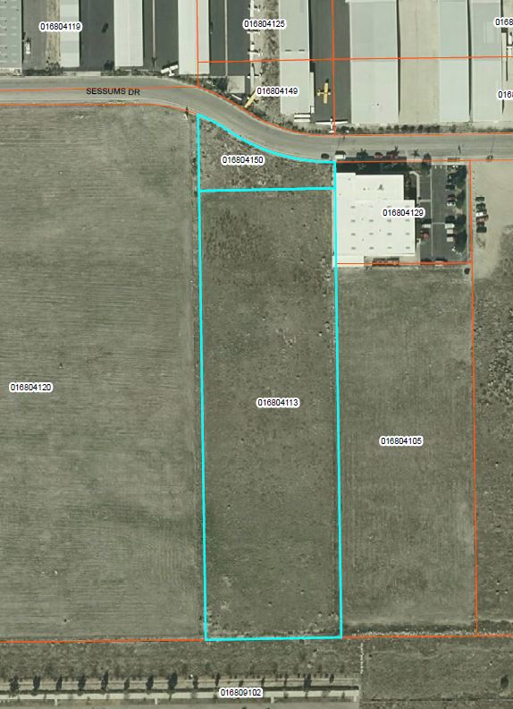

FIGURE 5
PROPOSED SITE PLAN

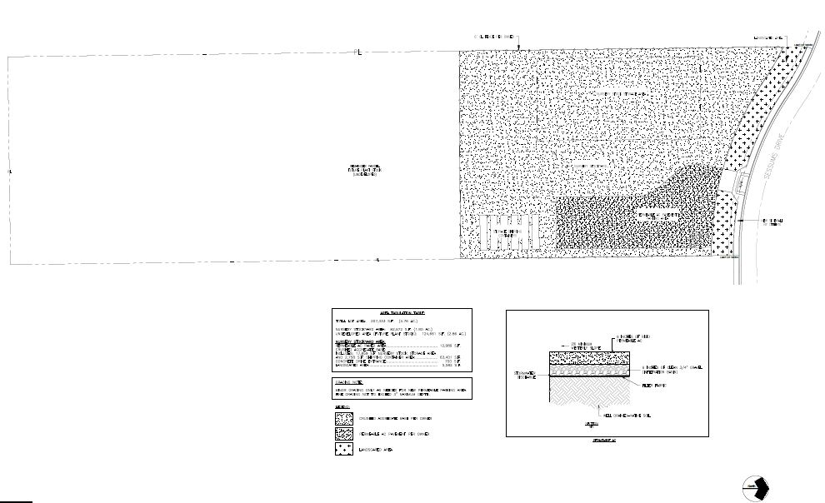

Issues: | Potentially Significant Impact | Less Than Significant With Mitigation Incorporated | Less Than Significant Impact | No Impact
- AESTHETICS.

Would the project:
- Have a substantial adverse effect on a scenic vista? | ___ | ___ | ___ | __
- Substantially damage scenic resources, including, but not limited to, trees, rock outcroppings, and historic buildings within a state scenic highway? | ___ | ___ | ___ | __
- Substantially degrade the existing visual character or quality of the site and its surroundings? | ___ | ___ | __ | ___
- Create a new source of substantial light or glare which would adversely affect day or nighttime views in the area? | ___ | ___ | __ | ___

Aesthetics – Discussion

a) No Impact. Caltrans identifies two eligible scenic highways within five miles of the proposed project site: the segment of State Route 210 (SR 210), between Interstate 10 Freeway and State Route 330 (SR 330); and SR 330 through the San Bernardino Mountains. These highways are identified as “Eligible, not officially designated.” The segment of SR 210 is located approximately 3.2 miles to the west of the project site. Interstate 10 is located approximately 2.1 miles to the southwest of the project site. The proposed development will not have an impact on any scenic vistas. In addition, the project will not obstruct the view of the mountains from adjacent view sheds. Therefore, there is no impact, and no mitigation is required.

b) No Impact. The project site is located within an area of the City of Redlands that is directly adjacent to Redlands Municipal Airport, commercial and light industrial businesses, and vacant (undeveloped) land. The project site does not currently contain any scenic resources that could be impacted by the proposed project. The project is not proposed to be located along a State scenic highway and will not substantially damage scenic resources. The location of the proposed project is not in a historic district nor have the existing structures been designated as a historic. The site and its environs do not contain any significant rock outcroppings. Therefore, there will be no impact, and no mitigation is required.

c) Less Than Significant Impact. The proposed project would change the existing visual character of the property from vacant/unimproved and convert it to a landscape business and related outdoor nursery. The proposed change would constitute a modest, albeit permanent, change to the visual character of the site. Therefore, visual impacts from the proposed development would be less than significant, and is consistent with the General Plan land use designation of the site.

d) Less Than Significant Impact. New sources of light associated with the project include security and street lighting similar to the existing commercial/industrial developments to the east and north of the project site. These new lights will have a less than significant impact on twilight or nighttime views, as they will be of a similar commercial intensity as existing lights in the area and will be required to comply with the standards of the Redlands Municipal Code. Therefore, any impacts will be less than significant, and no mitigation measures are required.

Issues: | Potentially Significant Impact | Less Than Significant With Mitigation Incorporated | Less Than Significant Impact | No Impact
- AGRICULTURE & FOREST RESOURCES. In determining whether impacts to agricultural resources are significant environmental effects, lead agencies may refer to the California Agricultural Land Evaluation and Site Assessment Model (1997) prepared by the California Dept. of Conservation as an optional model to use in assessing impacts on agriculture and farmland. In determining whether impacts to forest resources, including timberland, are significant environmental effects, lead agencies may refer to information compiled by the California Department of Forestry & Fire Protection regarding the state’s inventory of forest land, including the Forest and Range Assessment Project and the Forest Legacy Assessment project; and forest carbon measurement methodology provided in Forest Protocols adopted by the California Air Resources Board. Would the project:
- Convert Prime Farmland, Unique Farmland, or Farmland of Statewide Importance (Farmland), as shown on the maps prepared pursuant to the Farmland Mapping and Monitoring Program of the California Resources Agency, to non-agricultural use? | ___ | ___ | ___ | __
b) Conflict with existing zoning for agricultural use, or a Williamson Act contract. | ___ | ___ | ___ | __
- Conflict with existing zoning for, or cause rezoning of, forest land (as defined in Public Resources Code section 12220(g), timberland (as defined by Public Resources Code section 4526), or timberland zoned Timberland Production (as defined by Government Code section 51104(g)? | ___ | ___ | ___ | __
- Result in the loss of forest land or conversion of forest land to non-forest use? | ___ | ___ | ___ | __
- Involve other changes in the existing environment which, due to their location or nature, could result in conversion of Farmland, to non-agricultural use or conversion of forest land to non-forest use? | ___ | ___ | ___ | __

Agriculture & Forest Resources – Discussion

a) No Impact. According to the State Department of Conservation (Important Farmland Data Availability website), the project site consists of an area designated entirely as “Grazing Land,” which is defined as, “Land on which the existing vegetation is suited to the grazing of livestock.” No portion of the project site is designated as “Farmland of Statewide Importance,” “Prime Farmland,” “Unique Farmland,” or “Farmland of Local Importance.” The property today is a vacant infill parcel within an area that is developed with light industrial uses, municipal airport uses, and large vacant parcels. Based on reviewing past aerial imagery on ArcMap and Historic Aerials, it was identified that the project area has been vacant and unimproved since at least 1995. Therefore, no impacts are anticipated, and no mitigation measures are required.

b) No Impact. The subject property will not conflict with any zoning for agricultural use nor conflict with the Williamson Act, as the property is not involved in an active contract. Therefore, there will be no impact, and no mitigation is required.

c, d) No Impact. The proposed project site is not located in an area considered forest land. Forest land is defined by the California Public Resources Code (PRC) Section 12220(g) as land that can support ten percent native tree cover of any species, including hardwoods, under natural conditions, and that allows for management of one or more forest resources, including timber, aesthetics, fish and wildlife, biodiversity, water quality, recreation, and other public benefits. The project site abuts existing commercial/industrial development on the east, and Redlands Municipal Airport to the north. The site does not contain any forest land or timberland for timber production. Moreover, the site is not designated as forest or woodland by the California Department of Forestry & Fire Protection, and there are no such areas within the immediate vicinity of the site. Therefore, there will be no impact, and no mitigation is required.

e) No Impact. The project will not induce or involve other changes in the existing environment which could result in conversion of Farmland to non-agricultural use. The property is not currently part of a larger farmland, orchard, or other agricultural purpose. The project will not involve the conversion of forest land to non-forest use; see responses (a-d) above. Therefore, there will be no impact, and no mitigation is required.

Issues: | Potentially Significant Impact | Less Than Significant With Mitigation Incorporated | Less Than Significant Impact | No Impact
- AIR QUALITY.

Where available, the significance criteria established by the applicable air quality management or air pollution control district may be relied upon to make the following determinations. Would the project:
- Conflict with or obstruct implementation of the applicable air quality plan? | ___ | ___ | ___ | __
b) Violate any air quality standard or contribute substantially to an existing or projected air quality violation? | ___ | ___ | ___ | __
- Result in a cumulatively considerable net increase of any criteria pollutant for which the project region is nonattainment under an applicable federal or state ambient air quality standard (including releasing emissions which exceed quantitative thresholds for ozone precursors)? | ___ | ___ | ___ | __
- Expose sensitive receptors to substantial pollutant concentrations? | ___ | ___ | ___ | __
- Create objectionable odors affecting a substantial number of people? | ___ | ___ | ___ | __

Air Quality – Discussion

a, b,c,d) No Impact. The proposed project is a request for the Planning Commission to make a determination that a Commercial Landscaped Maintenance Facility is a similar use to a Lumberyard, and therefore it is allowed to operate within the Industrial (I-P) District. The approval of the Commission Determination would result in a commercial landscaped maintenance facility to locate on the approximately 5-acre project site. The proposed project does not require construction of any permanent structure, and the daily operation of the business will primarily be primarily storage of plant materials, landscape materials such as mulch, and landscape service vehicles, as no customers will be visiting this site, and that the majority of the employees work off-site. Furthermore, proposed use will not generate substantial air pollutants. Therefore, the proposed project will not conflict or obstruct the implementation of applicable air quality plan, violate any air quality standard, result in a cumulatively considerable net increase of criterial pollutant, or expose sensitive receptors to substantial pollutant concentrations.

e) No Impact. The operation of the proposed commercial landscape maintenance facility will primarily storage of plant materials, landscape materials such as mulch, as well as landscape service vehicles. Although minor service work for the landscape service vehicles is expected to be performed on site when needed, the proposed use will not generate objectionable odors.

Issues: | Potentially Significant Impact | Less Than Significant With Mitigation Incorporated | Less Than Significant Impact | No Impact
- BIOLOGICAL RESOURCES.

Would the project:
a) Have a substantial adverse effect, either directly or through habitat modifications, on any species identified as a candidate, sensitive, or special status species in local or regional plans, policies, or regulations, or by the California Department of Fish & Wildlife or U.S. Fish & Wildlife Service? | ___ | __ | ___ | ___
- Have a substantial adverse effect on any riparian habitat or other sensitive natural community identified in local or regional plans, policies, regulations, or by the California Department of Fish & Wildlife or U.S. Fish and Wildlife Service? | ___ | __ | ___ | ___
c) Have a substantial adverse effect on federally protected wetlands as defined by Section 404 of the Clean Water Act (including, but not limited to, marsh, vernal pool, coastal, etc.) through direct removal, filling, hydrological interruption, or other means? | ___ | ___ | ___ | __
d) Interfere substantially with the movement of any native resident or migratory fish or wildlife species or with established native resident or migratory wildlife corridors, or impede the use of native wildlife nursery sites? | ___ | ___ | ___ | __
e) Conflict with any local policies or ordinances protecting biological resources, such as a tree preservation policy or ordinance? | ___ | ___ | ___ | __
f) Conflict with the provisions of an adopted Habitat Conservation Plan, Natural Community Conservation Plan, or other approved local, regional, or state habitat conservation plan? | ___ | ___ | ___ | __

Biological Resources – Discussion

Two technical reports are incorporated herein by reference: “Results of a San Bernardino Kangaroo Rat Habitat Assessment conducted at the Approximately 5-acre Property (APN 0168-041-50 and 0168-041-13), in the City of Redlands, California”, and “Results of a San Bernardino Kangaroo Rat Trapping Survey Conducted at an Approximately 5-acre Property (APN 0168-041-50 and 0168-041-13), in the City of Redlands, California” by ECORP Consultants.

In addition, one peer review report is incorporated herein by reference: “Peer Review of ECORP Consulting’s San Bernardino Kangaroo Rat (Dipodomys merriami parvus; SBKR) Habitat Assessment and a SBKR Trapping Study Prepared for the 5-Acre Sessums Drive Property (APN 0168-041-50 and 0168-041-13) Located in the City of Redlands, San Bernardino County, California” by ELMT Consulting.

a,b) Less Than Significant with Mitigation Incorporated. The San Bernardino Kangaroo Rat (SBKR) is a federally listed endangered species that is known to be active in the area of the project site. SBKR occur primarily in the pioneer and intermediate phases of Riversidean alluvial sage scrub, a plant community with coastal sage scrub and chaparral elements on alluvial terraces and braided river channels in abandoned agricultural fields, and orchards, but usually only when such habitat are near suitable natural habitats. According to Figure 3.4-2 of the City’s General Plan EIR which identifies critical habitat areas within the City, the project site is within properties known to contain suitable habitat areas for the SBKR or are known to have SBKR presence. SBKR is known to be abundant within the Santa Ana River wash system to the north of the project site, and occurred more broadly in the general area of the project site historically. Overtime, various types of development to the north and south of the property have restricted the populations of this species to small, isolated and less disturbed parcels of land. Most of these parcels are located away from the SAR Santa Ana River wash system.

However, SBKR have been trapped on parcels located approximately 300 feet directly to the east, approximately 600 feet to the southeast, and in large numbers 1,250 feet to the west within the Judson Ranch residential tract. Thus, there was a clear potential for SBKR to occur on the project site. Therefore, the applicant contracted with ECORP Consulting, Inc. to conduct a San Bernardino Kangaroo Rat Habitat Assessment Study in February, 2019, followed by a 5-night trapping study in March, 2019, to determine the presence or absence of SBKR on the subject property.

The SBKR Habitat Assessment Study conducted by ECORP Consulting prepared in February, 2019, indicated that the property consisted of recently graded/grubbed land and was almost completely devoid of vegetation. The remaining vegetation on the project site was typical of disturbed/graded condition and consisted mostly or remnant non-native forbs, including Russian thistle (Salsola tragus), black mustard (Brassica nigra), fiddleneck (Amsincka menziesii), summer mustard (Hirschfeldia incana), and common dandelion (Taraxacum officinale ssp. Officinale). Soil on the site consists of Soboba gravelly loamy (NRCS 2019). No sign of small mammal activity was observed on the project site and no kangaroo rate sign (active burrows, scat, tail drag marks) were observed on the project site at the time of the survey.

Following a review of ECORP’s the SBKR Habitat Assessment report, the United States Fish and wildlife Service (USFWS) requested a focused small mammal trapping study to verify the findings of the SBKR Habitat Assessment. Therefore, the applicant contracted ECORP Consulting to prepare a 5-night SBKR Trapping Survey in March, 2019, to future determine the presence or absence of SBKR. The SBKR trapping survey was conducted according to established protocols described within the permitted biologist’s federal 10(a)(1)(A) endangered species recovery permit for SBKR. The recently graded project site is represented as one contiguous habitat type. To achieve ample coverage of the entire project site, traps spaced approximately 10 meters apart and placed in four north-south oriented lines (see Figure 2 of the “Results of a San Bernardino Kangaroo Rat Habitat Assessment Conducted at the Approximately 5-acre Property (APN 0168-041-50 and 0168-041-13), in the City of Redlands, California” by ECORP Consultants.)

The trapping survey commenced with the setting and baiting of traps on the evening of March 24, 2019. Trapping continued through the morning of March 29, 2019. Nighttime weather conditions during the five-night trapping session were generally suitable for small mammal trapping. At the conclusion of the trapping survey, no SBKR were or other small mammals were captured during the five-night trapping period. The table below presents the trapping survey result.

Table 1: SBKR Trapping Survey Results
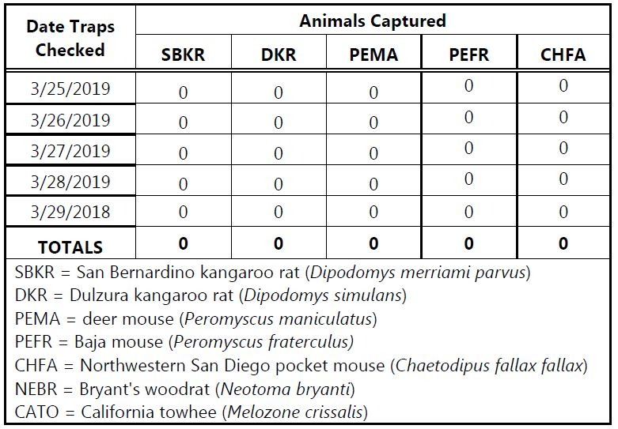
Source: “Results of a San Bernardino Kangaroo Rat Habitat Assessment Conducted at the Approximately 5-acre Property (APN 0168-041-50 and 0168-041-13), in the City of Redlands, California” by ECORP Consultants.

The SBKR Trapping Study conducted by ECORP Consultants concluded that the lack of kangaroo rat sign (e.g., burrows, tracks, scat) and the lack of any SBKR captures on the project site strongly indicates that this species is absent on the project site at this time. As a result, no impacts to this species are expected to result from development of the project within the next year. The report also indicated that endangered/sensitive small mammal species surveys are formally valid for a period of one year for the date of the trapping. For this reason, the trapping may need to be updated if development of the property is delayed past one year from the date of the current trapping survey, or if noteworthy changes occur to the project’s impact area.

The two studies prepared by ECORP Consulting were peer reviewed by ELMT Consulting. As part of the peer review of the technical studies, ELMT conducted site inspection of the project site, and assessed the potential presence of SBKR on the surrounding properties. In general, the ELMT Consulting concurred with ECORP Consulting’s assessment that the project site does not currently provide suitable habitat for SBKR. The property owner has been disking the property regularly, and a new chain link fence enhanced by a small mammal exclusion fence was installed in February, 2019. ELMT Consulting concluded that the recent grading has removed all native vegetation and has compacted the soils, eliminating any areas that could provide suitable habitat for SBKR or other small mammals at this time. The trapping study conducted in March found that not only are SBKR absent from the project site but that all small mammal species normally found in the area were absent. The exclusionary fence, combined with the removal of vegetation and compaction of soils, would be expected to keep the site free of SBKR for a period of time. However, ELMT Consulting notes that SBKR is a prolific breeder and has potential to recolonize the site, and documents that evidence of potential SBKR presence have been observed in areas just outside the property line of the project site to the south, southeast, and east.

Therefore, mitigation measures are required to mitigate the impact to SBKR to a less than significant level. The required mitigation measures are the following:

Mitigation Measure Bio-1: High level of diligence is required to ensure the effectiveness of the SBKR proof fencing. On an on-going basis, for as long as the commercial landscape maintenance facility is operating on the site, the integrity of the entire fence line shall be checked quarterly to ensure that no breaches of the chain link fence or buried SBKR-proof fencing has occurred. Even a small opening or sagging wire can be climbed by SBKR. Written documentation shall be provided to the City of Redlands Planning Division each quarter verifying that no breaches have occurred and the both fences are intact. Accompanying photographs shall be submitted with each quarterly report (email reports are acceptable if detail and visual documentation is adequate). The City may require monthly reports in its sole discretion. If a breach is discovered, it shall be repaired within 48 hours. The City shall be notified within 24 hours of both the discovery of the breach and repair of the fence. Photographs shall be taken that document the extent of the breach and the subsequent repair. The written report shall be submitted to the City’s Planning Division within 48 hours of the repair. Failure to comply with Mitigation Measures Bio-1, as determined by the City’s Planning staff, shall require that a certified SBKR biologist conduct a habitat assessment of the site to determine if the failure has resulted in access to and recolonization of the site SBKR. Once the biologist can verify that there are not visually signs (e.g., burrows, tail drags, dusting baths) of kangaroo rat, monthly monitoring shall resume as defined in Mitigation Measures Bio-1. Quarterly monitoring shall continue until the start of site construction including or the use of the site, but not limited to, clearing, grading, grubbing, or excavation, or any other activity that results in land disturbance.

Mitigation Measure Bio-2: Current site conditions shall be maintained at all times in order to ensure that site will not become suitable for SBKR. The site shall be maintained free of vegetation, non-native and native, and the soils shall be re-compacted following each grading event or clearing of vegetation. This is needed to ensure soil characteristic remain unsuitable for SBKR burrowing. Photographs of soil condition, as well as documentation of weed abatement activities, disking of the property, and compacting of the soil shall also be provided in the quarterly report required under Mitigation Bio-1. The City may require monthly reports from the applicant in its sole discretion. Failure to comply with Mitigation Measures Biol-2, as determined by the City’s Planning staff, shall require that a certified SBKR biologist conduct a habitat assessment of the site to determine if the failure has resulted in access to and recolonization of the site SBKR. Once the biologist can verify that there are not visually signs (e.g., burrows, tail drags, dusting baths) of kangaroo rat, monthly monitoring shall resume as defined in Mitigation Measures Bio-2. Quarterly monitoring shall continue until the start of site construction including or the use of the site, but not limited to, clearing, grading, grubbing, or excavation, or any other activity that results in land disturbance.

Mitigation Measure Bio-3: Prior to construction or the use of the site, including, but not limited to, clearing, grading, grubbing, or excavation, or any other activity that results in land disturbance, a certified SBKR biologist shall conduct a habitat assessment of the site to determine if the site has been maintained free of vegetation, that the soils remain heavily compacted soils and burrow free, and that the SBKR-proof fence system is still intact and fully functioning to prevent SBKR from entering the site. If the SBKR biologist can verify that the site conditions (free of vegetation, heavily compacted soils, and that the site is still isolated by the SBKR-proof fence) have been properly maintained and that there is no evidence of SBKR or other rodent use of the site, then a final written report will document that the pending development of the site will not impact SBKR and a federal Incidental Take Permit from USFWS will not be required. Development can proceed.

Mitigation Measure Bio-4: If the SBKR-certified biologist conducting the habitat assessment in accordance to Mitigation Measure Bio-4 cannot verify that that the site conditions (free of vegetation, heavily compacted soils or that the site is still isolated by the SBKR-proof fence) have been properly maintained and that there is no evidence of SBKR or other rodent use of the site, then a 5-night trapping study for the site for SBKR shall be conducted prior to the start of construction or the use of the site by a USFWS certified biologist. If the 5-night trapping program is negative (no SBKR caught), then development of the site can proceed. If the 5-night trapping program traps a SBKR on the project site, construction cannot be initiated until the City and/or the applicant consult with USFWS. USFWS is expected to require that an Incidental Take Permit be acquired prior to the start of construction. This shall require the preparation and processing of a single species habitat conservation plan through USFWS.

Mitigation Measure Bio-5: After occupancy of the site by the applicant, the applicant shall continue to monitor the site and submit quarterly reports (or monthly reports, if required by the City) as in accordance with Mitigation Measure Bio-1 and Bio-2 to ensure that undeveloped areas do not become less compacted and available for borrowing by SBKR. Once native habitat or loose soils are re-established on the property, those areas(s) should be inspected by a SBKR certified biologist to ensure SBKR have not recognized the site. If SBKR are found to occupy the site, the City and the applicant shall be required to consult with USFWS regarding remedies for isolating the occupied site to avoid take of SBKR or to initiate acquisition of an Incidental Take Permit.

- No Impacts. The project site is not identified in the Critical Habitat and Principal Waters Map (Figure 3.4-2 of the City’s General Plan EIR) as an area potentially containing wetlands. Based on the search results of the U.S. Department of Agriculture Web Soil Survey, no blue line streams, hydric soils, jurisdictional drainages, stream courses, or other water features were identified on the project site at the time of the reconnaissance survey. There are no riparian habitats, wetlands, or other sensitive natural communities on or near the project site. The project will not have a substantial adverse effect on any riparian habitat or other sensitive natural community identified in local or regional plans, policies, regulations, or by the California Department of Fish & Wildlife or the U.S. Fish & Wildlife Service. The project will not have a substantial adverse effect on federally protected wetlands as defined by Section 404 of the Clean Water Act through direct removal, filling, hydrological interruption, or other means. There will be no impacts, and mitigation is not necessary.

- No Impact. According to the City of Redlands 2035 General Plan EIR, the Santa Ana River is the nearest wildlife corridor to the project site. The project site is located a considerable distance to the south of the Santa Ana River (approximately 1,200 feet, or 0.22 mile), the Redlands Municipal Airport is located between the project site and the Santa Ana River, and the project will not impact this wildlife corridor. Prior agricultural use of the project site, and prior disturbance/disking, and the development of a Sports Complex and residential communities of surrounding areas, preclude the potential for wildlife corridors to occur on the project site due to the loss of native habitat.
e) No Impact. The proposed project would not cause a conflict with any local policies or ordinances protecting biological resources nor will the project will have an impact related to conflicts with local policies or ordinances protecting biological resources, such as a tree preservation policy or ordinance. Therefore, no impact is anticipated.

f) No Impact. Adoption of the proposed project will not cause a conflict with a Natural Communities Conservation Plan (NCCP) or Habitat Conservation Plan (HCP), or other approved local, regional, or state habitat conservation plan. Therefore, no impact is anticipated.

Issues: | Potentially Significant Impact | Less Than Significant With Mitigation Incorporated | Less Than Significant Impact | No Impact
V. CULTURAL RESOURCES. Would the project:
a) Cause a substantial adverse change in the significance of a historical resource as defined in § 15064.5? | ___ | ___ | ___ | __
- Cause a substantial adverse change in the significance of an archaeological resource pursuant to § 15064.5? | ___ | ___ | ___ | __
c) Directly or indirectly destroy a unique paleontological resource or site or unique geologic feature? | ___ | ___ | ___ | __
d) Disturb any human remains, including those interred outside of formal cemeteries? | ___ | ___ | ___ | __

Cultural Resources – Discussion

a, b) No Impact. Figure 2.1 of the City of Redlands 2035 General Plan indicates the location and type of historic resources within the City, including historic resources listed on the National and State registries, local historic landmarks, and eight historic and scenic districts within the City. The project site is vacant with no building or structure on it. There is no record of any historic structures or archaeological resources on this parcel. This parcel is not located in a historic district, and is located more than half a mile away from the closest historic structure -- the Judson Brown Ditch, located outside the northeastern boundary of the Redlands Municipal Airport. The proposed project involves minimal top soil disturbance of 0” to 3” for the parking lot area only, which will be 12,985 square feet. Therefore, the proposed project will not cause substantial adverse change in the significance of any historic or archaeological resources pursuant to § 15064.5 of the CEQA Guidelines. No mitigation measures are required.

- No Impact. The site and vicinity are not known to contain paleontological resources or site or unique geologic feature. Further, the project does not involve construction of permanent, and soil disturbance is limited to no more than 3” of top soil for the proposed parking lot area. Therefore, the project will not have an impact on paleontological and geological resources.

- No Impact. The site and vicinity are not known to have historically contained known human remains, and no conditions exist that suggest human remains are likely to be found on the project site. It is not anticipated that implementation of the project would disturb human remains, including those interred outside of formal cemeteries. In addition, ground disturbing activities associated with this project is limited to only up to 3” of top soil disturbance for the parking lot portion of the project site (totaling 12,985 s.f.) for the purpose of paving the parking lot. Therefore there is no impact anticipated.

Issues: | Potentially Significant Impact | Less Than Significant With Mitigation Incorporated | Less Than Significant Impact | No Impact
VI. ENERGY.
Would the project:
- Result in potentially significant environmental impact due to wasteful, inefficient, or unnecessary consumption of energy resources, during project construction or operation? | ___ _ ___ ___ | ___ _ ___ ___ | ___ _ ___ ___ | ___ _ ___ ___
b) Conflict with or obstruct a state or local plan for renewable energy or energy efficiency? | ___ | ___ | __ | __

Energy – Discussion

a, b) No Impact. Based on the small scale and scope of the proposed project, energy consumption anticipated is minimal. The project is not anticipated to result in potentially significant environmental impact due to wasteful, inefficient, or unnecessary consumption of energy resources both during project construction and operation. Further, the project will not conflict with or obstruct a state or local plan for renewable energy or energy efficiency. No impact is anticipated.

Issues: | Potentially Significant Impact | Less Than Significant With Mitigation Incorporated | Less Than Significant Impact | No Impact
VII. GEOLOGY & SOILS.
Would the project:
  - Directly or indirectly cause potential substantial adverse effects, including the risk of loss, injury or death involving:
i) Rupture of a known earthquake fault, as delineated on the most recent Alquist-Priolo Earthquake Fault Zoning Map issued by the State Geologist for the area or based on other substantial evidence of a known fault? Refer to Division of Mines and Geology, Special Publication 42. | ___ | ___ | ___ | __
ii) Strong seismic ground shaking? | ___ | ___ | __ | __
iii) Seismic-related ground failure, including liquefaction? | ___ | ___ | __ | __
iv) Landslides? | ___ | ___ | ___ | __
b) Result in substantial soil erosion or the loss of topsoil? | ___ | __ | __ | __
c) Be located on a geologic unit or soil that is unstable, or that would become unstable as a result of the project, and potentially result in on- or off-site landslide, lateral spreading, subsidence, liquefaction or collapse? | ___ | ___ | __ | __
d) Be located on expansive soil, as defined in Table 18-1-B of the Uniform Building Code (1994), creating substantial direct or indirect risks to life or property? | ___ | ___ | ___ | __
e) Have soils incapable of adequately supporting the use of septic tanks or alternative wastewater disposal systems where sewers are not available for the disposal of wastewater?  f) Have soils incapable of adequately supporting the use of septic tanks or alternative wastewater disposal systems where sewers are not available for the disposal of wastewater? ___ ___ __ | ___ | ___ | ___ | __

Geology & Soils – Discussion

a,c) No Impact. The project, due to its small scale and scope, will not expose people or structures to adverse geological impacts since the location falls outside of any active Alquist-Priolo Earthquake Fault Zone (see Figure 7-5: Faults, in the City of Redlands 2035 General Plan). The nearest known active and potentially active faults are the San Andreas Fault located approximately 1.7 miles to the northeast, and the San Jacinto Fault located approximately 5 miles to the southwest of the site. The site is located in a seismically active region of Southern California and will likely be subjected to strong seismic-related ground shaking during the anticipated lifespan of the project. However, the project does not propose construction of any permanent structures. Therefore, no additional or special mitigation measures are required for the project.

Pursuant to Figure 7-6: Liquefaction of the General Plan, the project site is not located within an area mapped as prone to liquefaction, nor are ground water levels at a point where the site would be prone to liquefaction. General Plan EIR Figure 4.4, Landslide Potential, shows the site is not located in an area with generalized landslide potential. Therefore, any impacts are considered to be less than significant.

b) Less Than Significant Impact. The project will only disturb less than 3” of top soil for the parking lot portion of the project site for the paving of the parking lot. It will have less than significant impact on the loss of top soil. Therefore, no mitigation measures are required.

d) No Impact. Figure 8.3 – Geotechnical Hazards, in the City of Redlands 1995 General Plan EIR, Expansion Potential, indicates that the project site is not located within an area with generalizes soil expansion potential. The potential for expansive soils on the project site was further verified by on-site testing performed by RMA GeoScience and discussed in the Geotechnical Investigation. There will be no impacts, and no mitigation is required.

- No Impact. The proposed residential development will be required to connect to and utilize the City’s sewer system, therefore septic systems or packaged waste water treatment will not be used. There will be no impacts, and no mitigation is required.

- No Impact. The proposed project will be served by the City’s sewer system. Therefore, no mitigation measures are required.

Issues: | Potentially Significant Impact | Less Than Significant With Mitigation Incorporated | Less Than Significant Impact | No Impact
VIII. GREENHOUSE GAS EMISSIONS. Would the project:
- Generate gas emissions, either directly or indirectly, that may have a significant impact on the environment? | ___ | ___ | __ | ___
- Conflict with an applicable plan, policy or regulation adopted for the purposes of reducing the emissions of greenhouse gases? | ___ | ___ | ___ | __

Greenhouse Gas Emissions – Discussion

  - Less Than Significant Impact. Greenhouse Gases (GHG) are generally thought to be contributing factors to long-term global warming and global climate change. With the exception of anticipated 27 vehicular trips maximum daily on Monday through Fridays, the project is not anticipated to emit greenhouse gas during operation. Therefore, the project will have a less than significant impact on greenhouse gas emissions.

- No Impact. Approval of the proposed project will not conflict with any applicable plan, policy or regulation adopted for the purposes of reducing the emissions of greenhouse gases. The proposed project is to allow for a use that consistent with the General Plan land use designation of the site as Light Industrial. In addition, the proposed site plan does not involve construction of any permanent structure. The proposed project will not conflict or obstruct implementation of AB 32 or policies relating to greenhouse reductions in the General Plan.

Issues: | Potentially Significant Impact | Less Than Significant With Mitigation Incorporated | Less Than Significant Impact | No Impact
IX. HAZARDS & HAZARDOUS MATERIALS.
Would the project:
- Create a significant hazard to the public or the environment through the routine transport, use, or disposal of hazardous materials? | ___ | ___ | ___ | _
b) Create a significant hazard to the public or the environment through reasonably foreseeable upset and accident conditions involving the release of hazardous materials into the environment? | ___ | ___ | ___ | _
c) Emit hazardous emissions or handle hazardous or acutely hazardous materials, substances, or waste within one-quarter mile of an existing or proposed school? | ___ | ___ | ___ | __
d) Be located on a site which is included on a list of hazardous materials sites compiled pursuant to Government Code section 65962.5 and, as a result, would it create a significant hazard to the public or the environment? | ___ | ___ | ___ | __
e) For a project located within an airport land use plan or, where such a plan has not been adopted, within two miles of a public airport or public use airport, would the project result in a safety hazard for people residing or working in the project area? | ___ | __ | __ | ___
f) Impair implementation of or physically interfere with an adopted emergency response plan or emergency evacuation plan? | ___ | ___ | ___ | __
g) Expose people or structures, either directly or indirectly, to a significant risk of loss, injury or death involving wildland fires? | ___ | ___ | ___ | __

Hazards & Hazardous Materials – Discussion

  - No Impact. The proposed landscape maintenance facility will not involve routine transport, use, or disposal of hazardous materials. Therefore, no mitigation measures are necessary.

  - No Impact. The proposed landscape maintenance facility will function as an operation yard for the storage of plant materials, bulk materials such as bark and gravel, landscape service vehicles, and miscellaneous small hand tools such as picks and shovels will be kept in storage containers on site. One propane powered fork-lift is anticipated to be parked on site. Minor vehicle and equipment repair including welding, tire rotation, repair lights on vehicles and trailers is anticipated to be performed on site on as-needed basis. As such, the proposed landscape maintenance facility will not introduce the use of significant amount of hazardous materials and create a significant hazard to the public or the environmental through reasonably foreseeable upset and accident conditions involving the release of hazardous materials into the environment.

c) No Impact. There are no existing or proposed schools within one-quarter mile of the project site. Therefore, there is no impact.

d) No Impact. The project site is not located on a site which is included on a list of hazardous materials sites pursuant to Government Code Section 65962.5, and will not create a significant hazard to the public or the environment. No mitigation is required.

e) Less Than Significant Impact. The project site is within the Redlands Airport Influence Area, approximately 70 feet south of the Redlands Municipal Airport. The project site is also located approximately 3.3 miles southeast of the San Bernardino International Airport, but not within any Influence Area of the San Bernardino Airport. The areas south of the Redlands Airport are not impacted by fixed wing, as the Airport Permit with Caltrans – Aeronautics Division provides that all air traffic is to stay north of the runway, except for overflight at higher altitudes (greater than 1,000 feet) which are considered a “common traffic pattern” or “other airport environs” and are either low-risk or negligible-risk.

The Redlands Airport Land Use Compatibility Plan (ALUCP) indicates that the project site is located within Compatibility Zones B1 and B2 (see Exhibit 6, below). Appendix D of the Redlands Airport Land Use Capability Plan provides land use compatibility guidance for all airport compatibility zones. For Airport Compatibility Zone B1 and B2, uses such as landscape nurseries, truck and specialty crops, and automobile parking which encompasses all major components of the proposed use, are identified as compatible uses. Furthermore, the proposed use would not introduce any permeant structure, or any portable objects such as nursery stock (i.e. trees) higher than 15 feet.

Furthermore, Table 2A of the ALUCP provides standards on population density and open land requirement for areas within the Redlands Airport Influence Area. For B1 and B2 zones, the ALUCP requires that maximum population densities of 60 people/ac and 90 people/ac for B1 and B2 zones, respectively. The proposed landscape maintenance facility will only have a maximum of 3 employees on site at any given time. Therefore, the proposed project is well within the maximum population density limits for B1 and B2 zones. In addition, projects in B1 and B2 zones are required to provide 30% of open land to accommodate on site. The site plan indicates that most of the operating areas of the landscape maintenance facility will be open and free of structures. Therefore, the 30% open land requirement will be met.

Based on the analysis above, it has been determined that the proposed project will have less than a significant impact in safety hazard for people residing or working in the project area.

FIGURE 6
AIRPORT COMPATIBILITY ZONES
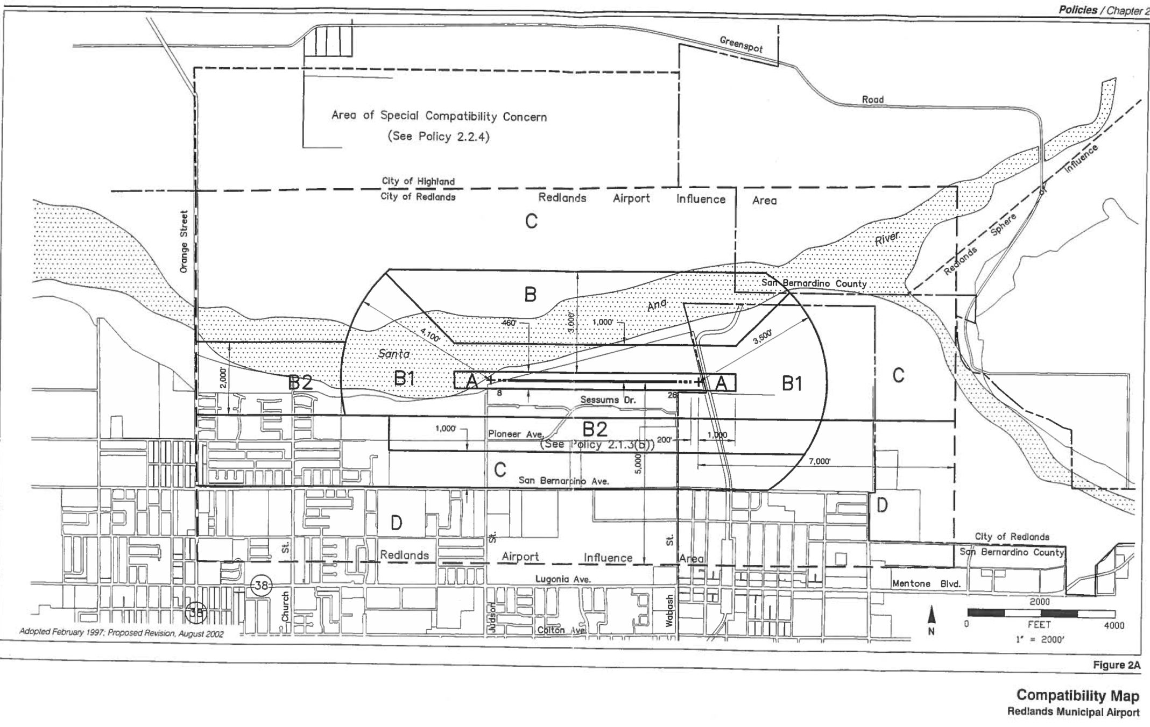
Project Site Location

f) No Impact. Adoption of the proposed project will not result in impairing implementation of, or physically interfering with, an adopted emergency response plan or emergency evacuation plan. The City of Redlands Emergency Disaster Plan identifies a number of hazardous situations to which City personnel would respond, and outlines procedures to follow during such events. Emergency response measures are based upon the basic Standardized Emergency Management System (SEMS). The proposed project would have no impact on the City’s ability to implement the Emergency Disaster Plan. There will be no impact, and mitigation is not required.

g) No Impact. According to the City of Redlands 2035 General Plan, Figure 7.4 (Fire Hazard Area), the project site is not located in an area identified as having fire hazard threat that might expose people or structures to a significant risk of loss, injury, or death involving wildland fires. Therefore, no impact is anticipated.

Issues: | Potentially Significant Impact | Less Than Significant With Mitigation Incorporated | Less Than Significant Impact | No Impact
X. HYDROLOGY & WATER QUALITY. Would the project:
- Violate any water quality standards or waste discharge requirements or otherwise substantially degrade surface or ground water quality? | ___ | __ | ___ | ___
b) Substantially decrease groundwater supplies or interfere substantially with groundwater recharge such that the project may impede sustainable groundwater management of the basin. | ___ | ___ | ___ | __
c) Substantially alter the existing drainage pattern of the site or area, including through the alteration of the course of a stream or river or through the addition of impervious surfaces, in a manner which would: | ___ | ___ | ___ | __
(i) result in substantial erosion or siltation on- or off-site; | ___ | ___ | ___ | __
(ii) Substantially alter the existing drainage pattern of the site or area, including through the alteration of the course of a stream or river, or substantially increase the rate or amount of surface runoff in a manner which would result in flooding on- or off-site? | ___ | ___ | ___ | __
(iii) Create or contribute runoff water which would exceed the capacity of existing or planned storm water drainage systems or provide substantial additional sources of polluted runoff? | ___ | ___ | ___ | __
(iv) impede or redirect flood flows? | ___ | ___ | ___ | __
d) In flood hazard, tsunami, or seiche zones, risk release of pollutants due to project inundation? | ___ | ___ | ___ | __
e) Conflict with or obstruct implementation of water quality control plan or sustainable groundwater management plan? | ___ | __ | ___ | ___
f) Inundation by seiche, tsunami, or mudflow? | ___ | ___ | ___ | __

Hydrology & Water Quality – Discussion

a, e) Less Than Significant with Mitigation Incorporated. Construction activities for the project involves paving of permeable pavement for the parking lot area, as well as paving of the remainder of the site with crushed aggregate base. Potential water quality impacts during construction activities include potential erosion/sedimentation and accidental hazardous material discharge during equipment and vehicle refueling, cleaning, and/or repairs. If not properly controlled, sedimentation or spilled hazardous substances could potentially be washed off-site during a rainstorm, blown off site during high winds, or could possibly percolate into the subsurface, where it could eventually reach the water table. If loose soils, litter, vegetation debris or hazardous substances are allowed to flow off-site, nearby drainage inlets and storm drains could become clogged or could carry contaminated runoff into downstream waters, potentially resulting in adverse or significant water quality impacts.

When grading and site preparation activities would disturb more than one acre of ground, a Storm Water Pollution Prevention Plan (SWPPP) must be prepared and submitted to the Santa Ana Regional Water Quality Board for review and enforcement. The State Water Resources Control Board has issued General Construction Permit under the Federal National Pollutant Discharge Elimination System (NPDES), a program created pursuant to the federal Clean Water Act (CWA). Such permits are intended to ensure compliance with applicable water quality, anti-degradation and beneficial use objectives, and typically entail the implementation of Best Management Practices (BMPs) to meet these requirements. Such BMPs would typically include erosion, sedimentation, spillage, work area good housekeeping and waste control measures, tailored to site-specific conditions.

Although the project site is approximately 5-acres, the area where the soil would be disturbed for any construction activity, including, but not limited to, clearing, grading, grubbing is less than one acre. Therefore, preparation of a SWPP is not required. Nevertheless, the following Mitigation Measure is recommended to ensure that if during construction it is determined that more than one acre will be disturbed for any construction activity, that a SWPP will be required to ensure that all State and Federal water quality standards are met.

Mitigation Measure HYDROL-1:
If during construction it is determined that more than one acre will be disturbed for any construction or demolition activity, including, but not limited to, clearing, grading, grubbing, or excavation, or any other activity that results in a land disturbance of equal to or greater than one acre, the site owner will file for a General Construction Permit, also knowns as a Storm Water Pollution Prevention Plan (SWPPP), with the State of California.

- No Impact. Due to the size and scope of the proposed project, adoption of the proposed project will not substantially deplete groundwater supplies or interfere substantially with groundwater recharge such that there would be a net deficit in aquifer volume or a lowering of the local groundwater table level. Therefore, no mitigation is required.

- No Impact. Due to the size and scope of the proposed project, approval of the proposed project will not substantially alter the existing drainage pattern of the site or area, nor alter the course of a stream or river. The project will not result in substantial erosion or siltation on- or off-site, or contribute runoff water which would exceed the capacity of existing or planned storm water drainage system or provide substantial additional sources of polluted water. In addition, according to FEMA Flood Insurance Rate Map (FIRM) No. 06071C8709H revised August 28, 2008, the project site is located within Zone X. The Geotechnical Investigation prepared for the project by RMA Associates also confirms the project site is located within Zone X, which is defined as, “Areas determined to be outside the 0.2% annual chance flood.” Therefore the project will not place housing within a 100-year flood hazard area or redirect flows associated with a 100-year flood. Therefore, no impacts are anticipated, and no mitigation is required.
Therefore, no mitigation measures are required.

d) No Impact. Per the General Plan EIR, Figure 3.9-2, Flood Hazards Map, the project site is located outside of the Seven Oaks Dam inundation area. Therefore, no impacts are anticipated, and no mitigation is required.

f) No Impact. A seiche is a standing wave in an enclosed or partially enclosed body of water. Seiches and seiche-related phenomena have been observed on lakes, reservoirs, bays, harbors, and seas. The key requirement for formation of a seiche is that the body of water be at least partially bounded, allowing the formation of the standing wave within the body of water. Approval of the proposed project will not expose people to seiche hazards, as there are no lakes, reservoirs, bays, harbors, and seas in the vicinity of the project site. Therefore, there will be no impacts, and no mitigation is required.

Issues: | Potentially Significant Impact | Less Than Significant With Mitigation Incorporated | Less Than Significant Impact | No Impact
XI. LAND USE & PLANNING.
Would the project:
- Physically divide an established community? | ___ | ___ | ___ | __
- Cause a significant environmental impact due to a conflict with any applicable plan, policy, or regulation adopted for the purpose of avoiding or mitigating an environmental effect? | ___ | ___ | __ | ___

Land Use & Planning – Discussion

a) No Impact. The closest residential community is approximately 0.25 miles away from the project site. Therefore, the project will not physically divide an established community.

- Less than Significant Impact. The proposed commercial landscape maintenance use is not presently listed as a permitted use for the Industrial (I-P) District under Section 18.112.030 of the Redlands Zoning Code. However, the proposed use is similar in operation, trip generation, storage of plant materials, and other characteristics to a lumberyard which is a permitted use in the Industrial (I-P) District. Therefore, the applicant has submitted for an application for Commission Determination No. 64 for the Planning Commission to make a determination that a landscape maintenance facility is a similar use to a lumberyard. With the approval of the Commission Determination application, the proposed project will have a less than significant environmental impact due to a conflict with any applicable plan, policy, or regulation in the City of Redlands.

Issues: | Potentially Significant Impact | Less Than Significant With Mitigation Incorporated | Less Than Significant Impact | No Impact
XII. MINERAL RESOURCES.
Would the project:
- Result in the loss of availability of a known mineral resource that would be of value to the region and the residents of the state? | ___ | ___ | ___ | __
- Result in the loss of availability of a locally-important mineral resource recovery site delineated on a local general plan, specific plan or other land use plan? | ___ | ___ | ___ | __

Mineral Resources – Discussion

a, b) No Impacts. According to the Figure 6-15 (Mineral Resources) of the City of Redlands 2035 General Plan, the project site is within a large region classified as MRZ-2 – areas where geologic data indicate that significant PCC-Grade aggregate resources are present. However, construction aggregate is located throughout this region within the jurisdictions of the City of Redlands, City of Highland, and large portions of the County of San Bernardino. A plan, referred to locally as the Upper Santa Ana River Wash Land Management and Habitat Conservation Plan was approved in 2009 by the San Bernardino Valley Water Conservation District which establishes ongoing mining contracts within the upper Santa Ana River Area and identifies areas where mining can continue into the future. The subject property is not located within the Wash Plan. Therefore, mining of aggregate material is able to continue within the Upper Santa Ana River Area, while still allowing for use of lands known to be sources of construction aggregate. Furthermore, the subject is located within close proximity to the City-owned Sports Complex that would be impacted significantly if the site were to be utilized for the mining of Construction Aggregate. Therefore, the proposed project would not result in a substantial loss of availability of a known mineral resource that would be of value to the region and the residents of the state, nor would it result in the loss of availability of a locally-important mineral resource recovery site delineated on a local general plan, specific plan or other land use plan. No impacts to mineral resources would occur, and no mitigation is required.

Issues: | Potentially Significant Impact | Less Than Significant With Mitigation Incorporated | Less Than Significant Impact | No Impact
XIII. NOISE. Would the project:
- Exposure of persons to or generation a substantial temporary or permanent increase in ambient noise levels in the vicinity of the project excess of standards established in the local general plan or noise ordinance, or applicable standards of other agencies? | ___ | ___ | __ | ___
- Generation of excessive ground borne vibration or ground borne noise levels? | ___ | ___ | __ | ___
c) For a project located within the vicinity of a private airstrip or an airport land use plan or, where such a plan has not been adopted, within two miles of a public airport or public use airport, would the project expose people residing or working in the project area to excessive noise levels? | ___ | ___ | __ | ___

Noise – Discussion

a,b) Less Than Significant Impact. The proposed landscape maintenance facility will primary function as an operation yard for storage of plant stock, bulk materials, landscape maintenance vehicles and equipment/tools. It will be staffed by between 1 to 3 employees only, and the daily vehicular trip generation (discussed further in Transportation & Traffic section) is expected to be minimal. No ground born vibration or ground borne source is proposed with this project. Therefore, this project will not generate excessive ground borne vibration or ground born noise levels beyond what had been analyzed for permitted Industrial Uses for this area by the General Plan EIR.

- Less Than Significant Impact. The project site is separated from the Redlands Municipal Airport by Sessums Drive, and the northern property line of the project site is approximately 570 feet from the edge of the runway. The Redlands Municipal Airport is the primary source of noise for the project site, primary from takeoffs and landings. There are on average 120 inbound and outbound flights from this airport. Aircraft includes single and multi-engine airplanes, jet airplanes, helicopters, gliders, and ultralight aircrafts. General Plan policy 7-A.142 addresses airport noise, and it requires that projects within the Redlands Municipal Airport Influence Area, the Redlands Municipal Airport ALUCP, as well as the noise standards contained in Chapter 7 – Healthy Community, be utilized.

Figure 7-8 of the General Plan illustrates existing noise level contours for the City. According to Figure 7-8, the northern approximately 300’ portion of the project site facing the airport to approximately is within the 60 decibel contour, while the remainder of the property does not fall in any noise contour area. Table 7-10 of the General Plan provides noise/land use standards. According to Table 7-10, commercial industrial uses is “clearly compatible” with CNEL 60 decibel level. Therefore, the proposed use is compatible with the existing noise level of the airport. Furthermore, Table 2B of the Redlands Municipal Airport ALUCP also provides guidance for land use acceptability for noise impacts within the airport influence area. According to Table 2B of the Redlands Municipal Airport ALUCP, light industrial uses which the proposed landscape maintenance facility is most similar to is “normally acceptable” within areas with CNEL between 60 to 65 decibel.

Based on the analysis above, the proposed use, given its close proximately to the Redlands Municipal Airport, will not expose persons working in the project area to excessive noise level. Therefore, the impact is less than significant and no mitigation measures are required.

Issues: | Potentially Significant Impact | Less Than Significant With Mitigation Incorporated | Less Than Significant Impact | No Impact
XIV. POPULATION & HOUSING. Would the project:
- Induce substantial unplanned population growth in an area, either directly (for example, by proposing new homes and businesses) or indirectly (for example, through extension of road or other infrastructure)? | ___ | ___ | __ | __
- Displace substantial numbers of existing people or housing, necessitating the construction of replacement housing elsewhere? | ___ | ___ | ___ | __

Population & Housing – Discussion

a,b) No Impact. The project is a landscape maintenance facility that is light-industrial in nature. It will not directly or indirectly generate population growth or displace existing people or housing. Therefore, the project has no impact on population and housing. No mitigation measures are required.

Issues: | Potentially Significant Impact | Less Than Significant With Mitigation Incorporated | Less Than Significant Impact | No Impact
XV. PUBLIC SERVICES. Would the project:
- Result in substantial adverse physical impacts associated with the provision of new or physically altered governmental facilities, need for new or physically altered governmental facilities, the construction of which could cause significant environmental impacts, in order to maintain acceptable service ratios, response times or other performance objectives for any of the public services:
i) Fire protection? | ___ | ___ | _ | ___
ii) Police protection? | ___ | ___ | _ | ___
iii) Schools? | ___ | ___ | _ | ___
iv) Parks? | ___ | ___ | _ | ___
v) Other public facilities? | ___ | ___ | _ | ___

Public Services – Discussion

a) Less Than Significant Impact. The proposed project is not expected to significantly impact or result in a need for new or altered public services provided by the City of Redlands, the Redlands Unified School District, or other government agencies. Police and fire protection for the project site will be provided by the City of Redlands. The proposed project will not result in the need for new or additional public facilities such as public libraries or meeting facilities. The project will not induce any residential growth requiring additional school facilities, nor will it directly generate the need for new additional park land. In terms of cumulative effects, the proposed project would not create any public services or facilities issues beyond that anticipated in the General Plan EIR. Therefore, impacts will be less than significant.

Issues: | Potentially Significant Impact | Less Than Significant With Mitigation Incorporated | Less Than Significant Impact | No Impact
XVI. RECREATION. Would the project:
- Increase the use of existing neighborhood and regional parks or other recreational facilities such that substantial physical deterioration of the facility would occur or be accelerated? | ___ | ___ | ___ | __
- Does the project include recreational facilities or require the construction or expansion of recreational facilities which have an adverse physical effect on the environment? | ___ | ___ | ___ | __

Recreation – Discussion

a, b) No Impact. The proposed project is for a commercial landscape maintenance facility. The business will have a maximum of three employees on site during business hours. The proposed project will not generate population growth or increase the need for recreation facilities. It will not increase the use of existing neighborhood and regional parks such that substantial physical deterioration of the facility would occur or be accelerated, or require the construction or expansion of recreational facilities.

Issues: | Potentially Significant Impact | Less Than Significant With Mitigation Incorporated | Less Than Significant Impact | No Impact
XVII. TRANSPORTATION
Would the project:
- Conflict with program plan, ordinance or policy addressing the circulation system, including transit, roadway, bicycle and pedestrian facilities? | ___ | __ | ___ | __
- Would the project conflict or be inconsistent  with CEQA Guidelines section 15064.3,  subdivision (b)? | ___ | __ | ___ | __
c) Substantially increase hazards due to a geometric design feature (e.g., sharp curves or dangerous intersections) or incompatible uses (e.g., farm equipment)? | ___ | ___ | ___ | __
d) Result in inadequate emergency access? | ___ | ___ | ___ | __

Transportation & Traffic – Discussion

a) No Impact. The project is proposed to be located along the south side of Sessums Drive, which is a local collector street. Figure 5-3 of the City of Redlands 2035 General Plan identified a proposed bicycle route, however, the proposed project will not conflict with the proposed bicycle route or future sidewalk installation. There are no existing or proposed transit system in the vicinity. Therefore, the project will have no impact with any program, plan, ordinance or policy addressing the circulation system including transit, roadway, bicycle and pedestrian facilities.

b) No Impact. Section 15064.3 of the CEQA Guidelines provides guidance on analyzing transportation impacts of a proposed project using the Vehicle Mile Travelled (VMP) metric when a project. Although this project site is not served by transit, the proposed landscape maintenance facility anticipates 27 roundtrips maximum to and from the project site from Monday through Friday, between the hours of 5:30am to 5:30pm. The anticipated trip generation is lower than other manufacturing or service uses such as parcel delivery and professional offices that are permitted in the Industrial (I-P) District. Therefore, by permitting a landscaped maintenance facility at this location, the trip generation and vehicle mile travelled from this site is anticipated to be reduced compared to a scenario where this site were to be occupied by other permitted uses for the zone. Therefore, the project will have no conflict with CEQA 15064.3 of CEQA Guidelines.

c) No Impact. The proposed project will not alter existing roadways or introduce new design features such as sharp curves or dangerous intersections. Therefore, the project will have no impact on substantially increase hazards due to a design feature or incompatible uses.

d) No Impact. The proposed project will not have any conflicts with any programs or policies that support alternative modes of transportation. No mitigation is needed.

Issues: | Potentially Significant Impact | Less Than Significant With Mitigation Incorporated | Less Than Significant Impact | No Impact
XVIII. TRIBAL CULTURAL RESOURCES. Would the project:
a) Would the project cause a substantial adverse  change in the significance of a tribal cultural resource, defined in Public Resources Code section 21074 as either a site, feature, place, cultural landscape that is geographically defined in terms of the size and scope of the landscape, sacred place, or object with cultural value to a California Native American tribe, and that is:  i) Listed or eligible for listing in the California Register of Historical Resources, or in a local register of historical resources as defined in Public Resources Code section 5020.1(k); or, | ___ | ___ | __ | ___
ii) A resource determined by the lead agency, in its discretion and supported by substantial evidence, to be significant pursuant to criteria set forth in subdivision (c) of Public Resources Code Section 5024.1. In applying the criteria set forth in subdivision (c) of Public Resource Code Section 5024.1, the lead agency shall consider the significance of the resource to a California Native American tribe. | ___ | ___ | __ | ___

Tribal Cultural Resources – Discussion

a) Less Than Significant Impact with Mitigation. The project would not cause a substantial adverse change in the significance of a tribal cultural resource, as defined in Public Resources Code section 21074 (as either a site, feature, place, cultural landscape that is geographically defined in terms of the size and scope of the landscape, sacred place, or object with cultural value to a California Native American tribe), and the property is not listed or eligible for listing in the California Register of Historical Resources, or in a local register of historical resources as defined in Public Resources Code section 5020.1(k). No resources have been determined by the lead agency, in its discretion and based on substantial evidence or other information submitted by California Native American tribes, to be significant pursuant to criteria set forth in Public Resources Code Section 5024.1(c). In applying the criteria set forth in Public Resource Code Section 5024.1(c), the lead agency has considered the information submitted by California Native American tribes.

A Cultural Resources Investigation, dated January 2017, was prepared by ECORP Consulting for Tentative Parcel Map 20079 to allow for a residential development approximately 2,000 feet southwest from the proposed project site, is incorporate by reference herein as allowed by under Section 15150 of the CEQA Guidelines. The Cultural Resources Investigation prepared by ECORP included records search conducted at the SCCIC. Results of the records search indicated that no previous tribal cultural resources investigations have been conducted within the project area, and there were no previously recorded tribal cultural resources within the project area. A search of the Sacred Lands File by the State’s Native American Heritage Commission (NAHC) did not reveal any Native American cultural resources within one mile of the project area. Based on a field survey of the project site conducted by ECORP Consulting, no potential tribal cultural resources were identified.

State law was revised effective 2015 with Public Resources Code (PRC) Sections 21073, 21074, 21080.3.1, 21080.3.2, 21080.3.3, 21083.09, 21084.2, and 21084.3 (commonly referred to as “AB 52”) pertaining to Tribal Cultural Resources (“TCR”) and CEQA. In accordance with PRC 21080.3.1(d), the Planning Division sent notices of the proposed project by certified mail on May 2, 2019, to local Tribal Governments that had previously requested notification in accordance with AB 52 (Morongo Band of Mission Indians; San Manuel Band of Mission Indians; Soboba Band of Luiseno Indians; Gabrieleno Band of Mission Indians).

One email correspondence was received from Morongo Band of Mission Indians on May 14, 2019. The Tribe stated that its office is not independently requesting tribal monitoring as mitigation. However, the Tribe requested that if the city does for any reason require tribal monitoring that they be included for rotation purposes.

Written request to consult were received from Soboba Band of Luiseno Indian and San Manuel Band of Mission Indians on June 3, 2019 and June 4th, respectively. Planning Planning staff held a tribal consultation conference call with Soboba Band of Luiseno Indian on June 5th and received recommendations from the tribe for Tribal Cultural Resources Mitigation Measures. Planning staff also had email correspondence with San Manuel Band of Mission Indians on June 5th, and received recommendations from the tribe for Tribal Cultural Resources Mitigation Measures.

No communications were received from the Gabrieleno Band of Mission Indians.

The following Tribal Cultural Resources Mitigation Measures are required as conditions of approval for this project to reduce potential impacts on tribal and cultural resource to a level below significant.

TCR-1: If human remains are encountered during grading and other construction excavation, work in the immediate vicinity (60 feet radius) shall cease and the County Coroner shall be contacted pursuant to California Health & Safety Code Section 7050.5. California Health & Safety Code Sections 7050.5 through 7055: As required by state law, the requirements and procedures set forth in Public Resources Code Section 5097.98 would be implemented, including notification of the County Coroner, notification of the Native American Heritage Commission and coordination with the individual identified by the Native American Heritage Commission to be the “most likely descendant.”

TCR-2: In the event that Native American cultural resources are discovered during project development/construction, all work in the immediate vicinity (60 feet radius) of the find shall cease and a qualified archaeologist meeting Secretary of the Interior’s Standards shall be hired to assess the find. Work on the overall project may continue during this assessment period.

  - If significant Native American cultural resources are discovered, for which a Treatment Plan must be prepared by the archaeologist, in coordination with consulting tribes, and all subsequent finds shall be subject to this Plan. This Plan shall allow for a monitor representing each consulting tribe to be present for the remainder of the project, should any consulting tribe elect to place a monitor on-site.

b. If requested by the consulting Native American Tribe(s), the developer or the project archaeologist shall, in good faith, communicate and coordinate resolution efforts on the discovery and its disposition (e.g. avoidance, preservation, return of artifacts to tribe, etc.).

Issues: | Potentially Significant Impact | Less Than Significant With Mitigation Incorporated | Less Than Significant Impact | No Impact
XIX. UTILITIES & SERVICE SYSTEMS.
Would the project:
a) Require or result in the relocation or construction of new or expanded storm water drainage, electric power, natural gas, or telecommunication facilities, the construction or of which could cause significant environmental effects? | ___ | ___ | ___ | __
b) Have sufficient water supplies available to serve the project and reasonably foreseeable future development during normal, dry and multiple dry years. | ___ | ___ | ___ | __
c) Result in a determination by the wastewater treatment provider, which serves or may serve the project that it has adequate capacity to serve the project's projected demand in addition to the provider's existing commitments? | ___ | ___ | ___ | __
d) Generate solid waste in excess of State or local standards, or in excess of the capacity of local infrastructure, or otherwise impair the attainment of solid waste reduction goals? | ___ | ___ | __ | ___
e) Comply with federal, state, and local management and reduction statutes and regulations related to solid waste? | ___ | ___ | __ | ___

Utilities & Service Systems – Discussion

a) No Impact. If approved by the Planning Commission, the project will result in a commercial landscape maintenance facility locating its operation yard on this site. The operation yard will involve storage of nursery stock, landscaping tools, bulk materials such as bark and gravel, as well as parking of approximately 12 landscape maintenance vehicles and minor services of the vehicles when needed. It will be staffed by between 1 to 3 employees during operating hours. The proposed project will not require or result in the relocation or construction of new or expanded storm water drainage, electric power, natural gas, or telecommunication facilities. Therefore, no impact will be observed in this area.

b, c) If approved by the Planning Commission, the project will result in a commercial landscape maintenance facility locating its operation yard on this site. The operation yard will involve storage of nursery stock, landscaping tools, bulk materials such as bark and gravel, as well as parking of approximately 12 landscape maintenance vehicles and minor services of the vehicles when needed. It will be staffed by between 1 to 3 employees during operating hours. As such it is not anticipated to demand the City’s water supply or waste water treatment system beyond what is needed by a typical industrial use allowed for the Industrial (I-P) District. In terms of cumulative effects, the proposed project would not create any public services or facilities issues beyond that anticipated in the General Plan EIR. The City’s Municipal Utilities & Engineering Department has reviewed the project, and determined that sufficient capacity exists in the storm water and waste water treatment systems for the needs of this project. Therefore, impacts will be less than significant.

d,e) Less Than Significant Impact. The City’s California Street Landfill is currently being planned and permitted to provide capacity to approximately the year 2031. The remaining capacity of the landfill is estimated to be about 5 million cubic yards/tons. Current average daily tonnage is estimated by the City to be about 300 tons per day, or about 109,500 tons per year. The proposed project would not create any solid waste issues beyond that anticipated in the Redlands General Plan EIR, and would comply with federal, state and local statutes and regulations related to solid waste. The applicant would also be required to pay a development impact fee which would ensure that the project’s potential incremental solid waste impacts are reduced to a less than significant level. Impacts would be less than significant, and no mitigation is required.

Issues: | Potentially Significant Impact | Less Than Significant With Mitigation Incorporated | Less Than Significant Impact | No Impact
XX. WILDFIRE – If located in or near state responsibility areas or lands classified as very high fire hazard severity zones, would the project:

- Substantially impair an adopted emergency response plan or emergency evacuation plan? | ___ | ___ | ___ | __
- Due to slope, prevailing winds, and other factors, exacerbate wildfire risks, and thereby expose project occupants to, pollutant concentrations from a wildfire or the uncontrolled spread of a wildfire? | ___ | ___ | ___ | __
c) Require the installation or maintenance of associated infrastructure (such as roads, fuel breaks, emergency water sources, power lines or other utilities) that may exacerbate fire risk or that may result in temporary or ongoing impacts to the environment? | ___ | __ | ___ | __
d) Expose people or structure to significant risks, including downslope or downstream flooding or landslides, as a result of runoff, post-fire slope instability, or drainage changes? | ___ | ___ | __ | __

Wildfire – Discussion

a-d) Figure 7-4 (Fire Hazards Map) of the City of Redlands 2035 General Plan identifies the areas in the City, as well as surrounding region outside the City’s boundary, that are classified as very high fire hazard areas. This project is not located within or near an area classified as very high fire hazard severity zone, therefore, the proposed project will have no impact on wildfire.

Issues: | Potentially Significant Impact | Less Than Significant With Mitigation Incorporated | Less Than Significant Impact | No Impact
XXI. MANDATORY FINDINGS OF SIGNIFICANCE.
- Does the project have the potential to degrade the quality of the environment, substantially reduce the habitat of a fish or wildlife species, cause a fish or wildlife population to drop below self-sustaining levels, threaten to eliminate a plant or animal community, reduce the number or restrict the range of a rare or endangered plant or animal or eliminate important examples of the major periods of California history or prehistory? | ___ | _ | ___ | ___
b) Does the project have impacts that are individually limited, but cumulatively considerable? (“Cumulatively considerable” means that the incremental effects of a project are considerable when viewed in connection with the effects of past projects, the effects of other current projects, and the effects of probable future projects.) | ___ | ___ | _ | ___
c) Does the project have environmental effects which will cause substantial adverse effects on human beings, either directly or indirectly? | ___ | ___ | __ | ___

Mandatory Findings of Significance – Discussion

  - Less Than Significant with Mitigation Incorporated. As identified in Biological Resources section of this Initial Study, the project site is not identified in the Biotic Resources Map (Figure 7.1 of the City’s General Plan EIR), and is not in an area potentially containing significant biological resources. However, properties within the vicinity of the project site have trapped San Bernardino Kangaroo Rats (SBKR). A survey of the site was conducted by a qualified biologist, and the results are discussed in detail in the Biological Resources section as well as the supporting technical reports (incorporated by reference into this Initial Study). Mitigation Measures Bio-1 through Bio-5 will be included as conditions of approval for the project; as such, the project will not result in a substantial adverse effect (either directly or through habitat modifications) on any species identified as a candidate, sensitive, or special status species in local or regional plans, policies, or regulations, or by the California Department of Fish & Wildlife or the U.S. Fish & Wildlife Service. Nor will the project have a substantial adverse effect on any riparian habitat or other sensitive natural community identified in local or regional plans, policies, regulations, or by the California Department of Fish & Wildlife or the U.S. Fish & Wildlife Service. The project will not result in a substantial adverse effect on federally protected wetlands as defined by Section 404 of the Clean Water Act (including, but not limited to, marsh, vernal pool, coastal, etc.) through direct removal, filling, hydrological interruption, or other means. Adoption of the proposed project will not cause a conflict with a Natural Communities Conservation Plan (NCCP) or Habitat Conservation Plan (HCP), or other approved local, regional, or state habitat conservation plan. The potential impacts, levels of impacts, and the applicable mitigation measures are discussed in detail in the preceding sections of this Initial Study (e.g., Biological Resources section). Therefore, with implementation of mitigation measures stated previously (see Biological Resources section) and included as conditions of approval, the impacts would be less than significant.

Another area where mitigation measure(s) are included is Hydrology and Water Quality. As discussed in detail in the Hydrology and Water Quality section of this Initial Study, the proposed project, as presented, does not require preparation of a Storm Water Pollution Prevention Plan (SWPPP). However, Mitigation Measure HYDRO-1 has been incorporated to ensure federal and state water quality compliance in the event if during construction, it was determined that the area of top land disturbance were to be increased beyond one acre, the applicant would be required to prepare a SWPPP and submit it to the Santa Ana Regional Water Quality Board for review, approval, and enforcement.

In regards to Tribal Cultural Resources, pursuant to AB 52, the Planning Division sent notices of the proposed project by certified mail on May 2, 2019, to local Tribal Governments that had previously requested notification in accordance with AB 52 (Morongo Band of Mission Indians; San Manuel Band of Mission Indians; Soboba Band of Luiseno Indians; Gabrieleno Band of Mission Indians).

One email correspondence was received from Morongo Band of Mission Indians on May 14, 2019. The Tribe stated that its office is not independently requesting tribal monitoring as mitigation. However, the Tribe requested that if the city does for any reason require tribal monitoring that they be included for rotation purposes.

Written request to consult were received from Soboba Band of Luiseno Indian and San Manuel Band of Mission Indians on June 3, 2019 and June 4th, respectively. Planning Planning staff held a tribal consultation conference call with Soboba Band of Luiseno Indian on June 5th and received recommendations from the tribe for Tribal Cultural Resources Mitigation Measures. Planning staff also had email correspondence with San Manuel Band of Mission Indians on June 5th, and received recommendations from the tribe for Tribal Cultural Resources Mitigation Measures. No communications were received from the Gabrieleno Band of Mission Indians.

Mitigation Measures TCR-1 and TCR-2 were incorporated and will be required as conditions of approval for this project to reduce potential impacts on tribal and cultural resource to a level below significant.

- Less Than Significant Impact. Through the analysis of the preceding sections of this Initial Study, no cumulative impacts were identified as part of the proposed project. The project will not significantly impact the environment by itself or in conjunction with other projects, and with the mitigation measures identified within this Initial Study, any impacts will not be cumulatively significant. The proposed project would not create any impacts or issues beyond that anticipated in the Redlands General Plan or the General Plan EIR. Therefore, the overall impacts would be less than significant.

- Less Than Significant Impact. Approval of the proposed project will not cause substantial adverse effects on human beings, either directly or indirectly. The potential impacts (such as noise), and levels of impacts, are discussed in detail in the preceding sections of this Initial Study (e.g., Noise section). The proposed project would not create any impacts or issues beyond that anticipated in the Redlands General Plan or the General Plan EIR. Therefore, implementation of the project will not cause any substantial adverse effects on human beings (either directly or indirectly), and for the project as a whole, the impacts are considered to be less than significant.

LIST OF REFERENCES

City of Redlands, 2035 General Plan, adopted December 5, 2017.

City of Redlands, General Plan Update and Climate Action Plan Final EIR (herein referred to as “Final EIR” or “General Plan EIR”), SCH No. 2016081041, dated July 21, 2017 and adopted/certified on December 5, 2017.

City of Redlands, Redlands Municipal Airport Land Use Compatibility Plan, adopted February 18, 1997, and revised May 6, 2003.

City of Redlands (prepared by Coffman Associates, Inc.), (November 10, 2015). Land Use Compatibility Review for Redlands Municipal Airport.

City of Redlands, Redlands Municipal Code (including Title 17: Subdivision Regulations, and Title 18: Zoning Regulations), current edition, available online at: http://www.sterlingcodifiers.com/codebook/index.php?book_id=550

City of Redlands (prepared by Water Systems Consulting, Inc.), (June 2016 – Draft). 2015 San Bernardino Valley Urban Water Management Plan, Draft edition, available online at: http://www.cityofredlands.org/sites/default/files/pdfs/MUED/Water/SBV_RUWMP.pdf

Nelson, Arthur C. (2004). Planners Estimating Guide: Projecting Land-Use and Facility Needs. American Planning Association, Planners Press: Chicago, IL.

Nationwide Environmental Title Research, LLC. (2019). Historic Aerials. Available online at https://www.historicaerials.com/

Aerials available: 1938, 1959, 1966, 1968, 1980, 1995, 2002, 2005, 2009, 2010, 2012.

State of California, Governor’s Office of Planning & Research, State Clearinghouse, https://www.opr.ca.gov/m_stateclearinghouse.php

State of California, Governor’s Office of Planning & Research, CEQA Statutes and Guidelines, current edition, available online at: https://www.opr.ca.gov/s_ceqastatutes.php

State of California, California Environmental Quality Act Air Quality Handbook, current edition.

State of California, Natural Resources Agency, California Environmental Resources Evaluation System (CERES), current edition, available online at: http://ceres.ca.gov/ceqa

State of California, Department of Conservation, California Important Farmland Finder, available online at: http://www.conservation.ca.gov/dlrp/fmmp/Pages/CIFF.aspx

State of California, Department of Toxic Substances Control, Cortese List (Envirostor), current edition, available online at: http://www.envirostor.dtsc.ca.gov/public/

State of California, Mining & Geology Board, Regionally Significant Construction Aggregate Resource Area, 2013, available online at: https://maps.conservation.ca.gov/

U.S. Federal Emergency Management Agency, FEMA Flood Insurance Rate Map (FIRM) No. 06071C8709H.

Technical Reports Prepared for this Project (incorporated by reference)

ECORP Consulting, Inc. (February 21, 2019). Results of a San Bernardino Kangaroo Rat Habitat Assessment conducted at the Approximately 5-acre Property (APN 0168-041-50 and 0168-041-13), in the City of Redlands, California. ECORP Consultants, 215 North Fifth St., Redlands, CA 92373.

ECORP Consulting, Inc. (February 21, 2019). Results of a San Bernardino Kangaroo Rat Trapping Survey Conducted at an Approximately 5-acre Property (APN 0168-041-50 and 0168-041-13), in the City of Redlands, California. ECORP Consultants, 215 North Fifth St., Redlands, CA 92373.

ELMT Consulting. (May 21, 2019). Peer Review of ECORP Consulting’s San Bernardino Kangaroo Rat (Dipodomys merriami parvus; SBKR) Habitat Assessment and a SBKR Trapping Study Prepared for the 5-Acre Sessums Drive Property (APN 0168-041-50 and 0168-041-13) Located in the City of Redlands, San Bernardino County, California. ELMT Consulting, 2201 N. Grand Avenue, #10098, Santa Ana, CA 92711.

MITIGATION MONITORING & REPORTING PROGRAM

Commission Determination No. 64

Introduction

The Mitigation Monitoring & Reporting Program (MMRP) is a CEQA-required component of the Mitigated Negative Declaration (MND) process for the project. The results of the environmental analyses, including proposed mitigation measures, are documented in the Final MND. CEQA requires that agencies adopting MNDs take affirmative steps to determine that approved mitigation measures are implemented subsequent to project approval. As part of the CEQA environmental review procedures, Public Resources Code (PRC) Section 21081.6 requires a public agency to adopt a monitoring and reporting program to ensure efficacy and enforceability of any mitigation measures applied to a proposed project. The lead agency must adopt an MMRP for mitigation measures incorporated into the project or proposed as conditions of approval. The MMRP must be designed to ensure compliance during project implementation. As stated in PRC Section 21081.6(a)(1):

The public agency shall adopt a reporting or monitoring program for the changes made to the project or conditions of project approval, adopted in order to mitigate or avoid significant effects on the environment. The reporting or monitoring program shall be designed to ensure compliance during project implementation. For those changes which have been required or incorporated into the project at the request of a responsible agency or a public agency having jurisdiction by law over natural resources affected by the project, that agency shall, if so requested by the lead agency or a responsible agency, prepare and submit a proposed reporting or monitoring program.

The following list is the proposed MMRP for the project. This MMRP lists each of the mitigation measures proposed in the Final MND, specifies the agency responsible for implementation of the mitigation measure, and specifies the time period (or phase of project implementation) for the mitigation measure.

Biological Resources

To mitigate the potential impacts identified in Section IV of the Environmental Checklist, the following mitigation measures shall be implemented:

Mitigation Measure Bio-1: High level of diligence is required to ensure the effectiveness of the SBKR proof fencing. On an on-going basis, for as long as the commercial landscape maintenance facility is operating on the site, the integrity of the entire fence line shall be checked quarterly to ensure that no breaches of the chain link fence or buried SBKR-proof fencing has occurred. Even a small opening or sagging wire can be climbed by SBKR. Written documentation shall be provided to the City of Redlands Planning Division each quarter verifying that no breaches have occurred and the both fences are intact. Accompanying photographs shall be submitted with each quarterly report (email reports are acceptable if detail and visual documentation is adequate). The City may require monthly reports in its sole discretion. If a breach is discovered, it shall be repaired within 48 hours. The City shall be notified within 24 hours of both the discovery of the breach and repair of the fence. Photographs shall be taken that document the extent of the breach and the subsequent repair. The written report shall be submitted to the City’s Planning Division within 48 hours of the repair. Failure to comply with Mitigation Measures Bio-1, as determined by the City’s Planning staff, shall require that a certified SBKR biologist conduct a habitat assessment of the site to determine if the failure has resulted in access to and recolonization of the site SBKR. Once the biologist can verify that there are not visually signs (e.g., burrows, tail drags, dusting baths) of kangaroo rat, monthly monitoring shall resume as defined in Mitigation Measures Bio-1. Quarterly monitoring shall continue until the start of site construction including or the use of the site, but not limited to, clearing, grading, grubbing, or excavation, or any other activity that results in land disturbance.

Mitigation Measure Bio-2: Current site conditions shall be maintained at all times in order to ensure that site will not become suitable for SBKR. The site shall be maintained free of vegetation, non-native and native, and the soils shall be re-compacted following each grading event or clearing of vegetation. This is needed to ensure soil characteristic remain unsuitable for SBKR burrowing. Photographs of soil condition, as well as documentation of weed abatement activities, disking of the property, and compacting of the soil shall also be provided in the quarterly report required under Mitigation Bio-1. The City may require monthly reports from the applicant in its sole discretion. Failure to comply with Mitigation Measures Biol-2, as determined by the City’s Planning staff, shall require that a certified SBKR biologist conduct a habitat assessment of the site to determine if the failure has resulted in access to and recolonization of the site SBKR. Once the biologist can verify that there are not visually signs (e.g., burrows, tail drags, dusting baths) of kangaroo rat, monthly monitoring shall resume as defined in Mitigation Measures Bio-2. Quarterly monitoring shall continue until the start of site construction including or the use of the site, but not limited to, clearing, grading, grubbing, or excavation, or any other activity that results in land disturbance.

Mitigation Measure Bio-3: Prior to construction or the use of the site, including, but not limited to, clearing, grading, grubbing, or excavation, or any other activity that results in land disturbance, a certified SBKR biologist shall conduct a habitat assessment of the site to determine if the site has been maintained free of vegetation, that the soils remain heavily compacted soils and burrow free, and that the SBKR-proof fence system is still intact and fully functioning to prevent SBKR from entering the site. If the SBKR biologist can verify that the site conditions (free of vegetation, heavily compacted soils, and that the site is still isolated by the SBKR-proof fence) have been properly maintained and that there is no evidence of SBKR or other rodent use of the site, then a final written report will document that the pending development of the site will not impact SBKR and a federal Incidental Take Permit from USFWS will not be required. Development can proceed.

Mitigation Measure Bio-4: If the SBKR-certified biologist conducting the habitat assessment in accordance to Mitigation Measure Bio-4 cannot verify that that the site conditions (free of vegetation, heavily compacted soils or that the site is still isolated by the SBKR-proof fence) have been properly maintained and that there is no evidence of SBKR or other rodent use of the site, then a 5-night trapping study for the site for SBKR shall be conducted prior to the start of construction or the use of the site by a USFWS certified biologist. If the 5-night trapping program is negative (no SBKR caught), then development of the site can proceed. If the 5-night trapping program traps a SBKR on the project site, construction cannot be initiated until the City and/or the applicant consult with USFWS. USFWS is expected to require that an Incidental Take Permit be acquired prior to the start of construction. This shall require the preparation and processing of a single species habitat conservation plan through USFWS.

Mitigation Measure Bio-5: After occupancy of the site by the applicant, the applicant shall continue to monitor the site and submit quarterly reports (or monthly reports, if required by the City) as in accordance with Mitigation Measure Bio-1 and Bio-2 to ensure that undeveloped areas do not become less compacted and available for borrowing by SBKR. Once native habitat or loose soils are re-established on the property, those areas(s) should be inspected by a SBKR certified biologist to ensure SBKR have not recognized the site. If SBKR are found to occupy the site, the City and the applicant shall be required to consult with USFWS regarding remedies for isolating the occupied site to avoid take of SBKR or to initiate acquisition of an Incidental Take Permit.

To be monitored by the Planning Division during all phases of the construction and continuously for as long as the use operate on the site.

Hydrology & Water Quality

To mitigate the potential impacts identified in Section IX of the Environmental Checklist, the following mitigation measures shall be implemented:

Mitigation Measure HYDROL-1:
If during construction it is determined that more than one acre will be disturbed for any construction or demolition activity, including, but not limited to, clearing, grading, grubbing, or excavation, or any other activity that results in a land disturbance of equal to or greater than one acre, the site owner will file for a General Construction Permit, also knowns as a Storm Water Pollution Prevention Plan (SWPPP), with the State of California.

To be verified by the Municipal Utilities & Engineering Department prior to issuance of grading permits, and monitored by the Building & Safety Division and Municipal Utilities & Engineering Department during grading and construction activities.

Tribal Cultural Resources

To mitigate the potential impacts identified in Section XVIII of the Environmental Checklist, the following mitigation measures shall be implemented:

TCR-1: If human remains are encountered during grading and other construction excavation, work in the immediate vicinity (60 feet radius) shall cease and the County Coroner shall be contacted pursuant to California Health & Safety Code Section 7050.5. California Health & Safety Code Sections 7050.5 through 7055: As required by state law, the requirements and procedures set forth in Public Resources Code Section 5097.98 would be implemented, including notification of the County Coroner, notification of the Native American Heritage Commission and coordination with the individual identified by the Native American Heritage Commission to be the “most likely descendant.”

TCR-2: In the event that Native American cultural resources are discovered during project development/construction, all work in the immediate vicinity (60 feet radius) of the find shall cease and a qualified archaeologist meeting Secretary of the Interior’s Standards shall be hired to assess the find. Work on the overall project may continue during this assessment period.

- If significant Native American cultural resources are discovered, for which a Treatment Plan must be prepared by the archaeologist, in coordination with consulting tribes, and all subsequent finds shall be subject to this Plan. This Plan shall allow for a monitor representing each consulting tribe to be present for the remainder of the project, should any consulting tribe elect to place a monitor on-site.

b. If requested by the consulting Native American Tribe(s), the developer or the project archaeologist shall, in good faith, communicate and coordinate resolution efforts on the discovery and its disposition (e.g. avoidance, preservation, return of artifacts to tribe, etc.).

To be verified and enforced by the Planning Division during construction activities.

End of MMRP

