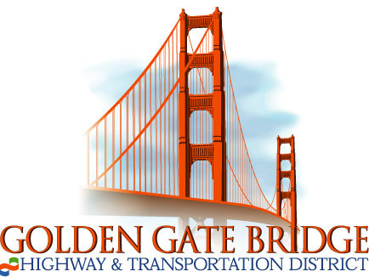
Notice of Availability of the Draft Environmental Impact Report and

Notice of Public Meetings for the San Rafael Transit Center Replacement Project

State Clearinghouse No. 2018102042
NOTICE IS HEARBY GIVEN: that the Golden Gate Bridge, Highway and Transportation District (District), has prepared a Draft Environmental Impact Report (Draft EIR) for the San Rafael Transit Center Replacement Project. This Draft EIR is now available for public review and comment from August 11 to October 12, 2021. The Draft EIR may be accessed on the District’s website at https://www.goldengate.org/district/district-projects/san-rafael-transit-center/. Copies of the Draft EIR are available for review at two local libraries: the San Rafael Public Library Main Branch located at 1100 E Street, San Rafael, CA 94901, and the San Rafael Public Library Pickleweed (Canal Neighborhood) Branch located at 50 Canal Street, San Rafael, CA 94901.
PROJECT LOCATION: The existing San Rafael Transit Center is in Downtown San Rafael, between 2nd Street, 3rd Street, Tamalpais Avenue, and Hetherton Street. All project alternatives are within Downtown San Rafael. Each alternative is within 500 feet of the existing San Rafael Transit Center and is bordered with a mix of office, residential, and retail uses.
PROJECT DESCRIPTION: The Draft EIR analyzes a preferred alternative and three build alternatives; the Move Whistlestop Alternative (the preferred alternative), Adapt Whistlestop Alternative, 4th Street Gateway Alternative, and Under the Freeway Alternative. The preferred alternative and the three build alternatives would include provisions for 17 bus bays, pick-up/drop-off areas for passenger vehicles or taxis, bicycle parking, customer service and security space, passenger amenities such as weather protection and seating, bus operator restrooms, and parking for operations staff. The District estimates that construction activities would occur over 18 months following approval of the final design. Construction is estimated to start in 2023 or 2024. The project alternatives are not located on any list of hazardous materials waste sites compiled pursuant to Section 65962.5 of the Government Code. As required by CEQA, the Draft EIR also analyzes a No-Project Alternative.
SIGNIFICANT ENVIRONMENTAL IMPACTS: The preferred alternative would not result in significant and unavoidable impacts. Significant impacts related to Air Quality, Biological Resources, Cultural Resources, Energy, Greenhouse Gas Emissions, Hazards and Hazardous Materials, Hydrology and Water Quality, Noise and Vibration, and Tribal Cultural Resources would be reduced to less-than-significant levels after implementation of mitigation measures. Please see the Draft EIR for impacts related to other alternatives.
COMMENT PERIOD: The District is soliciting comments regarding the analysis in the Draft EIR. All comments must be received by the District on October 12, 2021. Written comments on the Draft EIR may be addressed to Raymond Santiago, Principal Planner, Golden Gate Bridge, Highway and Transportation District, 1011 Andersen Drive, San Rafael, CA 94901-5318 and sent via U.S. mail. Comments may also be sent via email to SRTC@goldengate.org. All comments on environmental issues received during the public comment period will be considered and addressed in the Final EIR, which is anticipated to be available for public review by early 2022.
PUBLIC MEETINGS: Two virtual public meetings are planned. The first virtual public meeting will be held in English on September 14, 2021 from 6:00 p.m. to 7:00 p.m. to provide an overview of the project and Draft EIR. During the virtual public meeting, the District will collect written comments from the public. Spanish language support will available during the meeting. The virtual public meeting can be accessed via Zoom meetings at: Meeting ID: 884 3461 0186; pass code: 051792; or by telephone number: (408) 638-0968 or (669) 900-6833and use passcode 051792. Zoom Link: https://us06web.zoom.us/j/88434610186
A second Spanish-language only public meeting will be held on September 15, 2021 from 6:00 p.m. to 7:00 p.m. to provide an overview of the project and environmental impacts examined in the Draft EIR. During the virtual public meeting, the District will collect written comments from the public. The virtual public meeting can be accessed via https://www.facebook.com/events/273074834164705/

