STATE OF CALIFORNIA—CALIFORNIA STATE TRANSPORTATION AGENCY GAVIN NEWSOM, Governor
DEPARTMENT OF TRANSPORTATION  DISTRICT 7  100 S. MAIN STREET, SUITE 100  LOS ANGELES, CA 90012  PHONE (213) 897-0362  FAX (213) 897-0360  TTY 711  www.dot.ca.gov | Making Conservation  a California Way of Life.
May 22, 2020

Mr./Ms./The Honorable FirstName Last Name
Title if not in line above
Organization
Address
City, ST ZIP

Dear Mr./Ms./Senator/Assembly Member Last Name:

Notice of Public Hearing and Availability of Environmental Impact Report/ Environmental Assessment (EIR/EA)
Interstate 105 - High Occupancy Toll Lanes

The California Department of Transportation (Caltrans), in cooperation with the Los Angeles County Metropolitan Transportation Authority (Metro), are studying the possible implementation of dynamically-priced High Occupancy Toll (HOT) Lanes, also called HOT Lanes or ExpressLanes, along Interstate 105 (I-105) between Interstate 405 and Interstate 605 in Los Angeles County. Caltrans and Metro have completed the Draft EIR/EA for the I-105 ExpressLanes Project.

The proposed project would convert existing High Occupancy Vehicles (HOV) Lanes to either one or two ExpressLanes in each direction. The purpose of this project is to enhance traffic flow, improve trip reliability and travel time, and to sustain and manage mobility.

In-person public hearings will not be held to maintain social distancing requirements, based on the Governor’s Executive Order and Department of Public Health recommendations to stay at home, except as needed.

Please join a live presentation with Q&A via the web or phone
on Thursday, June 11, 2020 at 6 p.m.

To read or review the Draft EIR/EA, or for more information, visit Metro’s project website at metro.net/105ExpressLanes.
Supporting technical studies and printed copies of the reports are available upon request via the project email at 105ExpressLanes@metro.net or the helpline at (213) 922-6565.

Written comments on the Draft EIR/EA must be submitted by Monday, July 6, 2020 via the following:
- By email at: 105ExpressLanes@metro.net
- By mail to: Ronald Kosinski, Deputy District Director
Attn: I-105 ExpressLanes Project
Caltrans District 7
Division of Environmental Planning
100 South Main Street, MS-16A
Los Angeles, CA 90012
Thank you for your interest in this important transportation study.

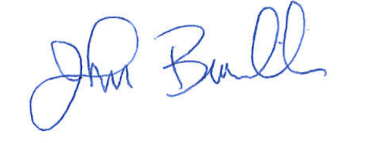
Sincerely,

JOHN C. BULINSKI
District Director

