CITY OF COLUSA Planning Department

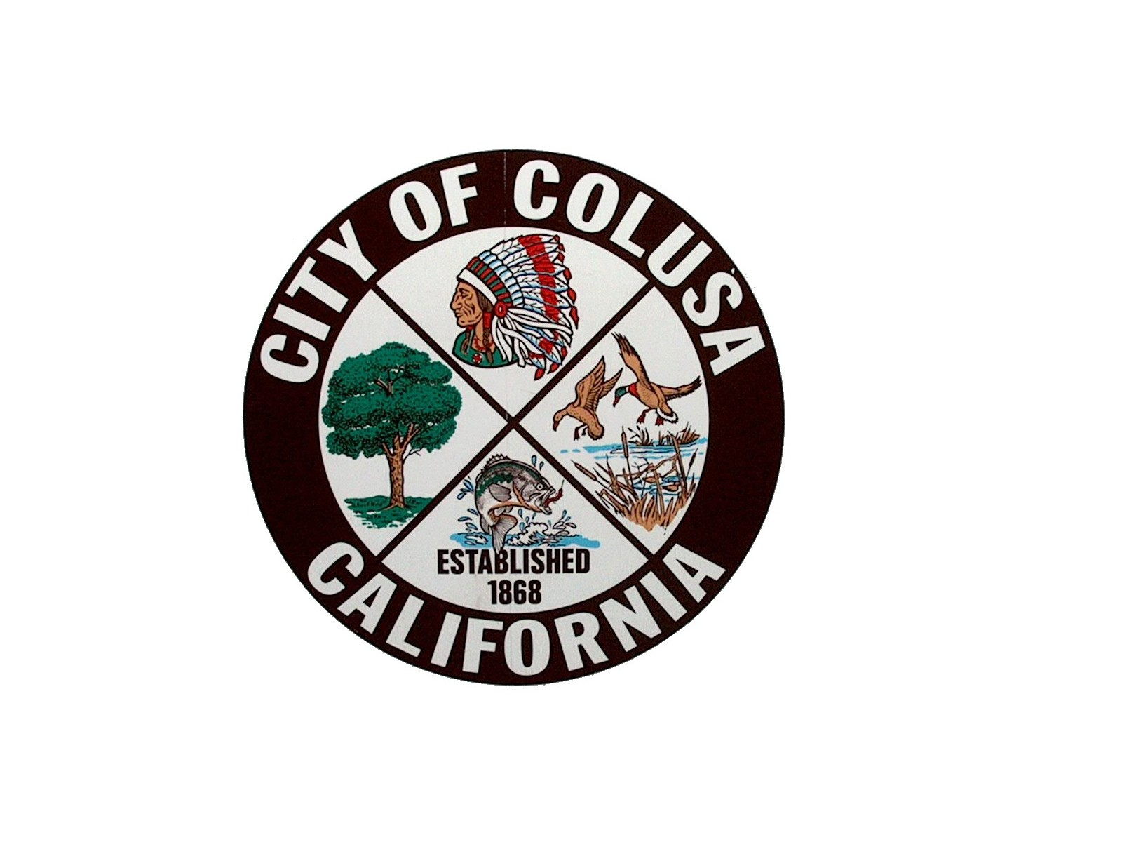

425 Webster St. * COLUSA, CA 95932 * (530) 458-4740 * [planning@cityofcolusa.com](mailto:planning@cityofcolusa.com)

Addendum of Project Changes to The City of Colusa Wastewater Treatment Plant Upgrade Project

SCH No. 2014122049

Public Comment Period: January 4 – 17th, 2023

Direct Comments to: Jesse Cain, City Manager

Email: citymanager@colusa.com

1. Introduction

This Addendum presents a summary of project changes to the City of Colusa’s Wastewater Treatment Plant Upgrade Project and a brief analysis of the need for any additional environmental review required under CEQA. The Colusa City Council certified and adopted a CEQA Initial Study Mitigated Negative Declaration (ISMND) and Mitigation Monitoring and Reporting Plan in March 2015. The City’s Notice of Determination was filed and posted on March 24, 2015. These documents were reviewed and approved by the SRF Program’s Environmental Unit as fulfilling environmental review requirements for the project’s SRF grant. This document serves as an addendum to the original January 2015 certified ISMND and includes information from new technical studies for a recycled water line that is in the same project corridor. These new technical studies were conducted to meet SRF federal funding requirements for this new element of the project. Since 2015, the Project’s design team has made the following change to the original project description:

* Addition of recycled wastewater treatment facilities, pump stations, and pipelines to convey recycled water to various areas within the City. This addition is described in further detail in the following Sections 2 and 3.

1. Recycled Water Upgrades

The City of Colusa (City) owns and operates a wastewater treatment plant (WWTP) located southwest of the City limits on Will S. Green Ave. The City’s WWTP currently operates under Waste Discharge Requirements Order No. R5-2016-0062-001 and NPDES Permit No. CA0078999 (Permit). The Permit was adopted in August 2016 and subsequently amended in April 2018 to reflect recent studies of the receiving water. The WWTP currently provides extended aeration (nitrification) and tertiary-level treatment, disinfection, and discharge to the unnamed tributary to Powell Slough.

The proposed recycled water system upgrades involve new sewers and sewer pump station, WWTP reliability improvements, and new pipelines and a pump station for recycled water. Treated water will be transported for reuse on City-owned farmland, City landscaping, and dust control. Specific project elements are described below:

New Sewers and Recycled Water Pipelines

The new recycled water pipeline, new sewer pipeline, and associated pump stations will be constructed along Will S. Green Ave. The new sewers and new sewer pump station will replace existing facilities which are in poor condition and in need of replacement. The sewers were previously described in the City’s approved 2014 environmental clearance documents (City of Colusa 2014) but were not constructed due to budget constraints. The new proposed recycled water pipelines will supply areas in the City including the Colusa County Fairgrounds, High School ballfields, frontage landscaping, and the CalTrans corporation yard (Figure 1). These pipelines will be constructed within existing roads and/or existing City right-of-ways.

Improvement projects to be constructed and shown in Figure 1 include:

* About 6,000 feet of 6 to 21 inch diameter sewer pipelines along Will S Green and between the County Fairgrounds and the High School
* About 6,000 feet of 6 to 18 inch diameter recycled water pipelines along Will S Green and between the County Fairgrounds and the High School and along the HW 20 frontage
* Retrofit of existing irrigation systems to use recycled water. Potable water irrigation systems will be separated from recycled water to avoid cross-contamination.
* A new sewer pump station and recycled water booster pump station along Will S Green
* Decommissioning of two older sewer pump stations

The Project’s staging area during construction is anticipated to be within the City’s WWTP which is directly south of these construction areas.

Figure 1. City of Colusa Recycled Water Project

Treatment Plant and City-Owned Farmland Upgrades

The location of proposed upgrades within the existing WWTP boundary are shown in green in Figure 2. The areas of potential impact on adjacent city-owned farmland are shown in green in Figure 3. These upgrades were generally described and cleared in the City’s 2014 IS/MND documentation. The specific upgrades will include:

* A new aeration basin parallel to the existing aeration basin.
* Additional filters within the existing filter structure and associated pumping and piping.
* A new enclosure over the existing UV system, which will protect it from debris and bird impacts.
* A new chlorine disinfection system, including chemical storage, feed system, and contact tank.
* Various drainage improvements on city-owned farmland adjacent to the WWTP.
* Levee improvements to the existing WWTPs pond as shown in Figure 2.
* A new maintenance building.
* A new recycled water booster pump station and irrigation system improvements.

All proposed upgrades to the existing treatment plant are located within the established WWTP site boundary. These upgrades will therefore be completed on pre-disturbed land. The city will implement all pertinent mitigation measures prescribed in the IS/MND.

Figure 2. City of Colusa Recycled Water Project Treatment Plant Upgrades

Figure 3. City of Colusa Recycled Water Project Irrigated Land Area

Table 1 below describes each portion of this project in relation to depth of excavation, area disturbed by construction (if applicable), and the location of work in the right-of-way.

Table 1 **Project Elements and Expected Depth of Excavation**

|  |  |  |  |
| --- | --- | --- | --- |
| **Project Item** | **Depth of  Excavation (feet)** | **Previously Disturbed Area Yes/No** | **Comments** |
| Recycled Water & Collection Pipelines and Pump Stations | 4 - 15’ | Y | Within Public Right of Way |
| Emergency Storage Slope Stabilization | 0 | Y | Within WWTP |
| Public Works and Maintenance Building | 1 | Y | Within WWTP |
| Farmland Irrigation and Drainage Improvements | 8 - 10 | Y | Previously Cleared in 2014 IS/MND |
| Aeration Basin & Chlorine Contact Tank | 4 | Y | Within WWTP |
| UV Enclosure and Additional Filters | 0 | Y | Previously Cleared in 2014 IS/MND |
| Chlorine Chemical Feed and Storage | 1 | Y | Previously Cleared in 2014 IS/MND |
| Chlorination System Yard Piping | 4 | Y | Within WWTP |
| Booster Pump Station | 0 | Y |  |

1. CEQA Review of Project Changes

Three new technical studies were prepared in 2022 by the City for the additional recycled waterline. All three reports were prepared with technical assistance from ECORP Consulting, Rocklin CA. All technical reports were peer reviewed and approved by Brewer Environmental Consulting, a CEQA consultant to the City and NEXGEN Engineering to meet SRF environmental review requirements:

* Biological Resources Assessment Final Report, November 2022,
* Air Quality Assessment Report, September 2022,
* Historic Properties Identification Report, November 2022.

Hardcopies of all of these studies are available for public review at the front desk of City’s Planning Department and the City’s website at: <https://cityofcolusa.com/public-notices/> No new significant environmental impacts requiring additional mitigation beyond what was previously approved by City Council were disclosed from these various studies. All mitigations are presented in the original CEQA Mitigation Monitoring and Reporting Plan (MMRP) adopted by the City. These environmental protective measures (e.g., pre-construction biological surveys, stormwater erosion protection, air quality best management practices) will be implemented as required by the City’s construction contractor or a separate environmental consultant retained by the City to ensure implementation.

The addition of the recycled water pipeline along Will S. Green Ave. parallels the previously proposed new sewer main. The layout of the new sewer and recycled water pipes in relation to existing water lines will conform with State separation requirements. Specifically, Article 4, Chapter 16, Division 4 of California’s Title 22 Code of Regulations require at least one foot of vertical separation between pipes, ten feet of horizonal separation between water and sewer pipes, and four feet of vertical separation between water and recycled water pipes. This area was covered in both biological and cultural resources surveys for the original project.

**Biological Resources**: As shown in Figure 1, the additional recycled water pipeline follows an existing gravel road that has little to no biological value. The primary issue in the area along Will S. Green Ave. is the potential for nesting birds and raptors in tall trees adjacent to the road that could be disrupted primarily due to construction noise. An updated Biological Resources Assessment was prepared by the City for this new element (City of Colusa 2022a). A small cluster of elderberry trees were observed near the pump station but these trees are outside of project boundaries and will be completely avoided and meet USFWS construction buffer requirements. No trees would be removed in the construction of either pipeline. The City has adopted appropriate biological mitigation measures in the previous CEQA document and MMRP. No state or federally-listed species would be impacted with the new addition. The City will conduct pre-construction nesting bird surveys and take appropriate measures if nesting birds are observed. Therefore, there are no new biological impacts resulting from this project addition. .

The proposed improvements inside the WWTP boundary described above are in areas that are highly disturbed and have no biological habitat value. Therefore these improvements do not impose new biological impacts.

**Cultural Resources and Historical Property Identification Assessment** : The new recycled water pipeline alignment falls within the original Area of Potential Effect (APE) in the City’s 2014 Cultural Resources Study prepared by Registered Professional Archeologist Trish Fernandez (Western Properties 2014). No cultural materials were identified on the ground surface that would indicate the presence of archeological deposits. The area is highly disturbed from prior construction activities for both the existing sewer and roadway to the treatment plant. The likelihood of unearthing previously unknown archeological deposits is low. Two built resources were identified in the study: 1) A segment of Unit 132 Levee of the Sacramento River flood control project and 2) the Colusa Branch of the Southern Pacific Railroad. The study concluded that neither resource were recommended eligible for listing in the National Register of Historic Places or the California Register of Historic Resources. The addition of the recycled water pipeline would also not have an effect on these two resources. An updated cultural resources survey and historic properties identification and assessment report was prepared by ECORP Consulting specialists for this new addition to the project (City of Colusa 2022c). ECORP recorded eight cultural resources inside the Project Area as a result of the 2022 field survey: CW-01,Colus Avenue; CW-02, Will S. Green Avenue; CW-03, the Will S. Green Avenue Lift Station; CW-04, an electrical distribution line; CW-05, sewage aeration ponds; CW-06, the Colusa Sewage Treatment Works; CW-07, SR 20; and CW-08, a drainage ditch. ECORP evaluated these resources, as well as the railroad segment (P-6-586), using the National Register of Historic Places and California Register of Historical Resources eligibility criteria. Recommendations for the management of unanticipated discoveries are also provided. ECORP did not evaluate P-6-634 because no portion of the resource was observed within the Project Area. ECORP evaluated cultural resources CW-01 through CW-08 and P-6-586 using NRHP and CRHR eligibility

criteria and determined that none of the cultural resources are eligible for listing in the NRHP and CRHR. One resource, CW-06, the Colusa Sewage Treatment Works, contains a dedication plaque attached to the facility’s lift station that should be preserved and housed in an archival facility prior to the building’s demolition. Therefore, there are no new cultural or historical impacts resulting from the additional pipeline. Previously adopted mitigation measures in the City’s MMRP will be implemented for protection of cultural and historical resources during pipeline construction.

The proposed improvements inside the plant described above are situated in highly disturbed areas that were surveyed as part of the original WWTP project and included in the 2014 ISMND analyses. The installation of a cover over the existing UV system may involve minor surface grading. The proposed new oxidation pond would require minor excavation to a depth of four feet. This excavation could potentially unearth resources or artifacts, however this area is highly disturbed from previous construction activities and is therefore considered unlikely. Laying of riprap on the existing equalization basin slopes does not involve any grading or excavation. The City will implement adopted cultural resources mitigation measures in their Mitigation Monitoring and Reporting Plan in the event that an inadvertent discovery is made during any minor surface grading or minor excavation performed inside the WWTP boundary

1. Summary

The additional recycled water pipeline and WWTP plant improvements included in the Project described above do not result in any new significant adverse impacts requiring disclosure under CEQA. No special status species would be impacted with the new pipeline. No historic properties would be negatively impacted by the project. This memo is intended to be an addendum with supporting information to the original 2014 certified ISMND and to comply with current SRF environmental review standards. This CEQA Addendum shall be included in the administrative record for the Project in City of Colusa project files for future reference and circulated via the State Clearinghouse for a two-week public review period. City Clerk will prepare required Resolution for adoption of the amendment by City Council to meet SRF funding requirements. The City of Colusa will implement all the mitigation measures that were adopted in the original MMRP and prepare required reports to fulfill CEQA compliance for the SRF grant.

**Citations**

City of Colusa Public Works Department 2014 CEQA Initial Study Mitigated Negative Declaration. Prepared by Brewer Environmental Consulting.

City of Colusa 2022a, Biological Resources Assessment (BRA) for the City of Colusa Recycled Water pipeline, prepared by ECORP Consulting August 2022,

City of Colusa 2022b, Air Quality Assessment for the City of Colusa Recycled Water Pipeline Project, prepared by ECORP Consulting September 2022.

City of Colusa 2022c, Cultural Resources Survey and Historical Resources Properties Report prepared by ECORP Consulting September 2022.

Western Properties Inc. 2014 Cultural Resources Inventory Report prepared for City of Colusa WWTP Improvement Project. Prepared by Trish Fernandez, Registered Professional Archeologist.

CITY OF COLUSA

Jesse Cain ( December 27, 2022)

City Manager