Darren Nash

City Planner

City of El Paso de Robles

1000 Spring Street

Paso Robles, CA 93446

June 17, 2020

Governor’s Office of Planning and Research

1400 Tenth Street

Sacramento, CA 95814

*Submitted via CEQAnet web portal*

RE: Notice of Determination Fish and Game Filing Fee Declaration for SCH#2013101050

To Whom It May Concern:

Pursuant to Executive Order N-54-20 and the Governor’s Office of Planning and Research

recommendation, the City of El Paso de Robles intends to file the Notice of Determination for the Paso Robles Gateway Annexation Project EIR (SCH#2013101050) with the San Luis Obispo County Clerk-Recorder (via mail or drop off box) within five working days of the date of this letter. All filing fees required by Fish and Game Code section 711.4 will be properly remitted at the time of filing.

Sincerely,

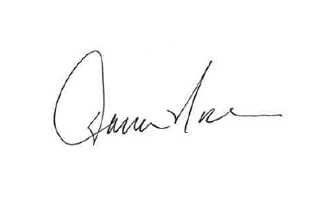

Darren Nash, City Planner