DRAFT
SUPPLEMENTAL ENVIRONMENTAL ASSESSMENT/INITIAL STUDY
MARYSVILLE RING LEVEE PROJECT
PHASES 2B AND 3

YUBA RIVER BASIN, YUBA COUNTY, CALIFORNIA
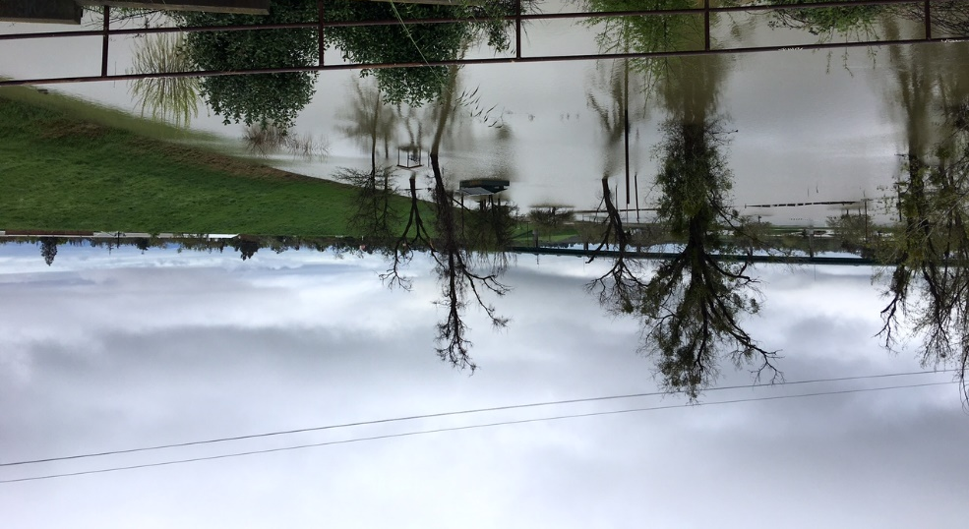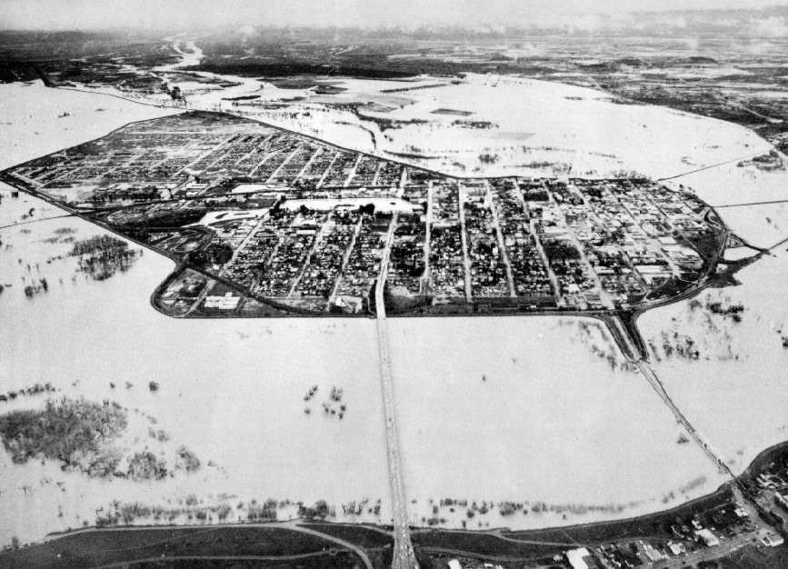

March 2019

US Army Corps of Engineers  Sacramento District |  | 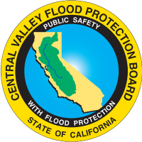  State of California Central Valley Flood Protection Board
State Clearing House Number 2010024001

DRAFT
SUPPLEMENTAL ENVIRONMENTAL ASSESSMENT/INITIAL STUDY
MARYSVILLE RING LEVEE PROJECT
PHASES 2B AND 3

YUBA RIVER BASIN
YUBA COUNTY, CALIFORNIA

MARCH 2019

US Army Corps of Engineers  Sacramento District |  | State of California Central Valley Flood Protection Board

TABLE OF CONTENTS

1.0 PURPOSE AND NEED FOR THE ACTION 1
1.1 Introduction 1
1.1.1 Project Authorization 1
1.1.2 Marysville Ring Levee Project Location and Background 1
1.2 Purpose and Need for the Proposed Action 1
1.3 Purpose and Need for Supplemental Environmental Documentation 1
1.4 SEA/IS Organization and Previous Environmental Documentation 2
1.5 Decisions to Be Made 2
1.6 Laws, Regulations, and Policies 2
1.6.1 Federal Requirements 2
1.6.2 State of California Requirements 2
1.6.3 Local Laws, Programs, and Permit Requirements 2
2.0 PROPOSED ACTION AND ALTERNATIVES 2
2.1 SEA/IS Marysville Ring Levee Alternatives 2
2.1.1 Alternative 1 (No Action) 2
2.1.2 Alternative 2 (Proposed Action) 2
2.2 Proposed Action Project Descriptions 19
2.2.1 Phase 2B 19
2.2.2 Phase 3 26
2.2.3 Phases 2B and 3 Common Elements 31
3.0 ENVIRONMENTAL EFFECTS AND AFFECTED RESOURCES 32
3.1 Resources Not Considered in Detail 33
3.1.1 Public Utilities 33
3.1.2 Land Use and Socioeconomics 34
3.1.3 Agriculture and Prime and Unique Farmland 35
3.1.4 Water Resources and Quality 35
3.2 Resources Considered in Detail 38
3.2.1 Air Quality 38
3.2.2 Greenhouse Gases 43
3.2.3 Vegetation and Wildlife 46
3.2.4 Special Status Species 52
3.2.5 Recreation 61
3.2.6 Cultural Resources 66
3.2.7 Traffic and Circulation 78
3.2.8 Noise and Vibration 82
4.0 CUMULATIVE IMPACTS 85
4.1 Geographic Scope 86
4.2 Local Projects 86
4.2.1 Local Development Projects 87
4.3 Analysis of Potential Cumulative Effects 88
4.3.1 Traffic 88
4.3.2 Air Quality 89
4.3.3 Greenhouse Gases (GHGs) 89
4.4 Growth-Inducing Effects 90
5.0 COORDINATION AND REVIEW OF SEA/IS 90
6.0 LIST OF PREPARERS 91
7.0 REFERENCES 92
APPENDICES 95
APPENDIX A 96
USFWS BIOLOGICAL OPINION (BO) 96
APPENDIX B 97
USFWS SUPPLEMENTAL COORDINATION ACT REPORT (CAR) 97
APPENDIX C 113
SPECIAL STATUS SPECIES LISTS 113
APPENDIX D 130
AIR QUALITY EMISSIONS SPREADSHEETS 130
APPENDIX E 149
HTRW ENVIRONMENTAL SITE ASSESSMENTS (PHASES 2B AND 3) 149
APPENDIX F 194
PUBLIC INVOLVEMENT 194
INTRODUCTION 195

APPENDICES

Appendix A. USFWS Biological Opinion (BO)
Appendix B. USFWS Supplemental Coordination Act Report (CAR)
Appendix C. Endangered, Threatened, and Candidate Species List
Appendix D. Air Quality Emission Spreadsheets
Appendix E. HTRW Environmental Site Assessments
Appendix F. Public Involvement

FIGURES
Figure 1. MRL Project (Vicinity) Map. 2
Figure 2. MRL Project Phasing. 1
Figure 3. Project Area Map (Phase 2B). 20
Figure 4. Cutoff Wall Excavation Equipment. 22
Figure 5. MRL Phase 2B Proposed Haul Routes. 25
Figure 6. Project Area Map (Phase 3). 27
Figure 7. DMM Cutoff Wall Construction. 29
Figure 8. MRL Phase 3 Proposed Haul Routes. 30
Figure 9. Phase 2B Bike Route Detour. 63
Figure 10. Phase 3 Bike Route Detour. 65
Figure 11. MRL Phase 2B Cultural Resources (APE) Map. 70
Figure 12. MRL Phase 3 Cultural Resources (APE) Map. 71

TABLES
Table 1. Summary of the Proposed Action for Phase 2B Levee Improvements. 16
Table 2. Summary of the Proposed Action for Phase 3 Levee Improvements. 17
Table 3. Beneficial Uses of Yuba River and Feather River in the Project Area. 36
Table 4. Wetlands Types Near the Phases 2B and 3 Project. 37
Table 5. Current Federal, State, and Local Air Quality Emissions Thresholds. 38
Table 6. Air Quality Significance Criteria. 40
Table 7. Phases 2B and 3 Maximum Annual Construction Emissions. 41
Table 8. Air Quality Mitigation Measures. 42
Table 9. Green House Gas (GHG) Mitigation Measures. 46
Table 10. Tree Removals Phase 2B. 48
Table 11. Vegetation Mitigation Measures. 51
Table 13. Special Status Species Mitigation Measures. 59
Table 14. Recreation Mitigation Measures. 66
Table 15. Buildings contributing to the NRHP-listed Marysville Historic Commercial District. 74
Table 16. Maximum Allowable Interior Space Noise Exposure from Transportation Noise Sources at Noise Sensitive Land Uses. 83
Table 17. Maximum Allowable Noise Exposure from Non-Transportation Noise Sources at Noise-Sensitive Land Uses. 83
Table 18. Noise Emissions Reference Levels for Construction Equipment. 83

ACRONYMS & ABBREVIATIONS

AB Assembly Bill
ADT Average Daily Traffic
APE Area of Potential Effects
BMPs Best Management Practices
CAA Clean Air Act
CAAQS California Ambient Air Quality Standards
CalTrans California Department of Transportation
CAR Coordination Act Report
CARB California Air Resources Board
CCAA California Clean Air Act
CDC California Department of Conservation
CDFG California Department of Fish and Game
CDFW California Department of Fish and Wildlife
CEQ Council on Environmental Quality
CEQA California Environmental Quality Act
CESA California Endangered Species Act
CFR Code of Federal Regulations
CH Critical Habitat
CH₄ Methane
CNDDB California Natural Diversity Database
CNEL community noise equivalent level
CNPS California Native Plant Society
CO Carbon Monoxide
CO₂ Carbon Dioxide
CVFPB Central Valley Flood Protection Board
CVRWQCB Central Valley Regional Water Quality Control Board CWA Clean Water Act
dB Decibel
dBA A-weighted Decibel
DDR Design Documentation Report

DMM Deep Mix Method
DPS Designated Population Segment
EA Environmental Assessment
EA/IS Environmental Assessment/Initial Study
ECOS Environmental Conservation Online System
EDR Engineering Document Report
EIR Environmental Impact Report
EIS Environmental Impact Statement
ESA Environmental Site Assessment
EO Executive Order
°F Degrees Fahrenheit
FEIS/EIR Final Environmental Impact Statement/Environmental Impact Report FESA Federal Endangered Species Act
FONSI Finding of No Significant Impact
FRAQMD Feather River Air Quality Management District
FT Federal Threatened
GGS Giant Garter Snake
GHG Greenhouse Gases
GPS Global Positioning System
GRR General Reevaluation Report

HAP Hazardous Air Pollutants
HEP Habitat Evaluation Procedure
HTRW Hazardous, Toxic and Radiological Wastes
IDR Integral Determination Report
IPaC Information, Planning, and Consultation System
IS Initial Study
LED Light-Emitting Diode
Leq Equivalent Energy Noise Level
Ldn Day-Night Average Noise Level
Lmax Peak Noise Level
LOS Level of Service
MBTA Migratory Bird Treaty Act
MLD Marysville Levee District
MOA Memorandum of Agreement
MRL Marysville Ring Levee
msl mean sea level
N₂O Nitrous Oxide
NAAQS National Ambient Air Quality Standards
NEPA National Environmental Policy Act
NMFS National Marine Fisheries Service
NO2 Nitrogen Dioxide
NOX Nitrogen Oxides
NPDES National Pollutant Discharge Elimination System
NRCS National Resource Conservation Service
NRHP National Register of Historic Places
NSVAB North Sacramento Valley Air Basin
O3 Ozone
OHWM Ordinary High Water Mark
O&M Operation and Maintenance
PADR Post Authorization Documentation Report
Pb Lead
PG&E Pacific Gas and Electric Company
PM2.5 Fine Particulate Matter
PM10 Particulate Matter (Less than 10 Microns in Diameter)
ROG Reactive Organic Gases
ROW Right-Of-Way
SCB Soil Cement Bentonite
SCE State Candidate Endangered
SEA Supplemental Environmental Assessment
SEA/IS Supplemental Environmental Assessment/Initial Study
SHPO State Historic Preservation Officer
SMAQMD Sacramento Metropolitan Air Quality Management District
SMND Supplemental Mitigated Negative Declaration
SO2 Sulfur Dioxide
SPCP Spill Preventions and Countermeasure Plan
ST State Threatened
SWHA Swainson’s hawk
SWPPP Storm Water Pollution Prevention Plan
SWRCB State Water Resources Control Board
System Evaluation Sacramento River Flood Control System Evaluation
TCR Transportation Concept Report
UAIC United Auburn Indian Community
UPRR Union Pacific Railroad
USACE U.S. Army Corps of Engineers
USEPA United States Environmental Protection Agency
USFWS United States Fish and Wildlife Service
VELB Valley Elderberry Longhorn Beetle
WPIC Western Pacific Interceptor Canal
WRDA Water Resources Development Act

1.0 PURPOSE AND NEED FOR THE ACTION

1.1 Introduction
Pursuant to the National Environmental Policy Act of 1969 (NEPA) and the California Environmental Quality Act of 1970 (CEQA), as amended, this Supplemental Environmental Assessment (SEA)/Initial Study (IS) has been prepared to update, discuss, and disclose potential effects, beneficial or adverse, that may result from the proposed design refinements to Phases 2B and 3 of the Marysville Ring Levee Project (MRL Project).
In April 2010, the U.S. Army Corps of Engineers (USACE) published its Final Environmental Assessment/Initial Study (EA/IS) for the MRL Project. The 2010 EA/IS described the anticipated direct and indirect impacts expected to occur as a result of the proposed levee improvements. The MRL Project is a cooperative effort between the U.S. Army Corps of Engineers (USACE), the State of California, acting by and through the Central Valley Flood Protection Board (CVFPB), and the Marysville Levee District (MLD).

1.1.1 Project Authorization
The Yuba River Basin, California Project (“Authorized Project”) was authorized for construction in the Water Resources Development Act of 1998, Pub. L. 106-53, § 101(a)(10), 112 Stat. 269, 275 (hereinafter “WRDA 1999”), as amended by the Water Resources Development Act of 2007, Pub. L. No. 110-114, § 3041, 121 Stat. 1041, 1116 (hereinafter “WRDA 2007”), and consists of three reaches: Reach 1 (Linda/Olivehurst), Reach 2 (Best Slough/Lower RD 784), and Reach 3 (Marysville).
A General Reevaluation of the Authorized Project was initiated to re-assess the project for new under-seepage criteria, and a General Reevaluation Report (GRR) was being prepared. Prior to completion of the GRR, local interests began constructing improvements to the Yuba, Feather and Bear Rivers and Western Pacific Interceptor Canal (WPIC) levees in Reaches 1 and 2. During post-authorization studies, Reach 3, the MRL Project, was approved for construction as a separable element of the Authorized Project. An Engineering Documentation Report (EDR) was completed in April 2010 which found that, although design changes were necessary, they did not constitute a change in scope, and the MRL Project was approved to proceed to construction as a separable element of the Authorized Project. As a result, a Project Partnership Agreement (MRL PPA) was executed in 2010 and federal construction of the MRL Project commenced in 2010.
In order to apply credit for advance work completed in Reach 1 towards the non-Federal cost share of the Marysville Ring Levee element of the Authorized Project, a Post Authorization Documentation Report (PADR) was completed and approved in December 2012, a subsequent Integral Determination Report (IDR) was completed and approved in February 2014, and the MRL PPA was amended on March 17, 2017 to include Reach 1 within the scope of the MRL Project.

1.1.2 Marysville Ring Levee Project Location and Background
The City of Marysville is located in Yuba County approximately 50 miles north of Sacramento, California. The City is bordered by Yuba River to the south, Jack Slough to the north and Feather River to the West (Figure 1). The Marysville Ring Levee (MRL) surrounds and protects the City from potential flooding from these three water sources. The MRL consists of 7.5 miles of levee ranging in height from 17 to 28 feet.
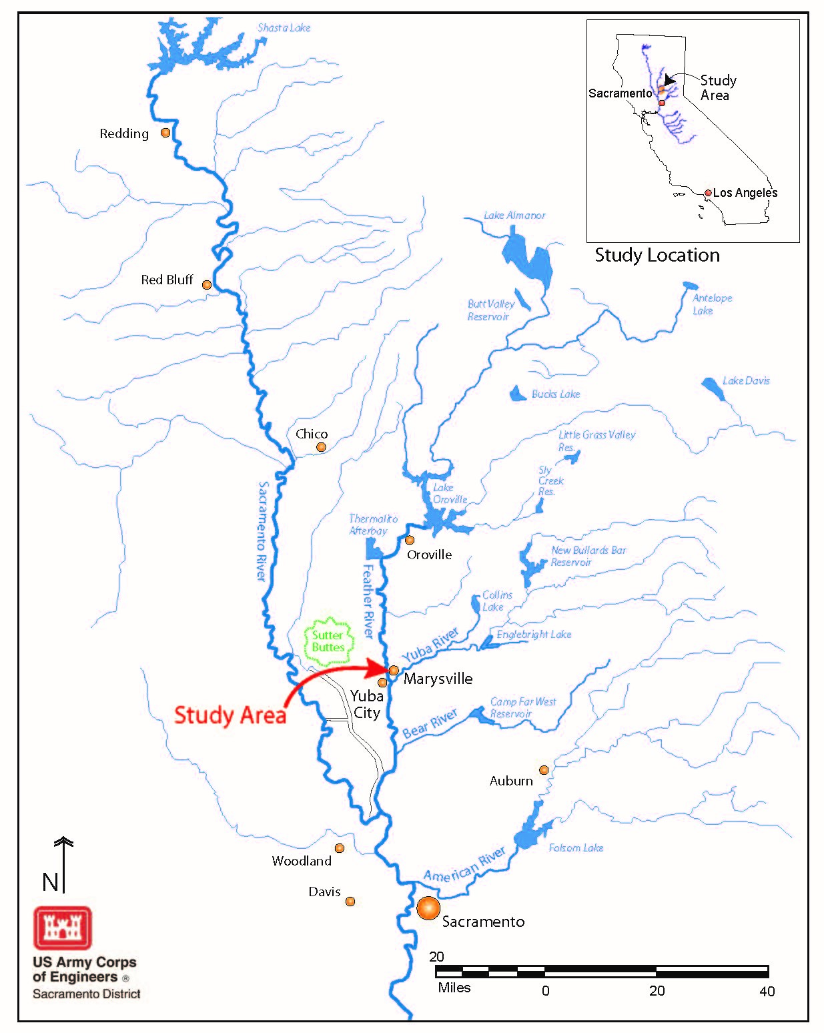
Figure 1. MRL Project (Vicinity) Map.
The 2010 MRL Engineering Document Report (EDR) and EA/IS address the engineering and environmental aspects of the proposed levee improvements for the entire Marysville flood protection system. Planned levee improvements address under-seepage, through-seepage, embankment slope stability, utility penetrations, constructability, settlement and geometrical corrections to the levee embankment. The 2010 EA/IS recommended and analyzed implementation of these improvements over multiple phases, as a result, the MRL Project activities were initially divided into Phases 1 through 4.
After development of the 2010 EDR, Phase 2 was further sub-divided into 2A, 2B, and 2C, to better facilitate design and construction (Figure 2). Phase 1 was constructed in 2011 and portions of Phase 4 were constructed in 2016 and 2017. Construction of Phase 2A-North was completed in fall 2018. Since release of the 2010 EA/IS, one Supplemental Environmental Assessment/Initial Study has been completed for 2A-South and 2C with construction for those phases scheduled for 2019 and 2020 respectively (USACE 2018).
Design Documentation Reports (DDR) and supplemental environmental documentation, where necessary, are being prepared and utilized to document changes in design, costs, benefits and environmental effects since completion of the 2010 EDR and the 2010 EA/IS.

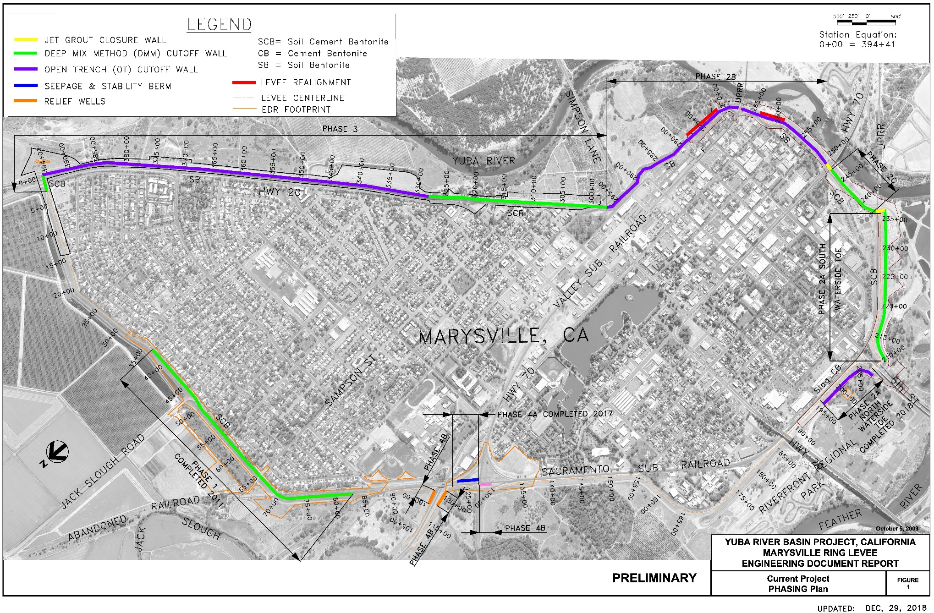
Figure 2. MRL Project Phasing.

1.2 Purpose and Need for the Proposed Action
The proposed Marysville Ring Levee (MRL) improvements would reduce the risk of levee failure along Phases 2B and 3 (the Project Area), therefore reducing the risk of flooding to the city of Marysville. Since authorization, significant geotechnical concerns have been identified, including levee under-seepage and through-seepage. Design refinements to the MRL are necessary to maintain structural integrity and prevent damage during a future flood event.
Current design refinements address the geotechnical concerns related to the seepage and stability of the MRL. All levee segments in the Project Area require improvements to meet current levee design standards set by USACE. These improvements include the addition of a cutoff wall in each segment, levee realignment in specific locations, and a levee slope increase to meet the new standard (3H:1V).

1.3 Purpose and Need for Supplemental Environmental Documentation
This Supplemental Environmental Assessment/Initial Study (SEA/IS), is being prepared to assess the potential direct, indirect and cumulative environmental effects associated with proposed levee design refinements to Phases 2B and 3 of the MRL Project not originally discussed in Alternative 2 (Proposed Action) of the 2010 EA/IS (USACE 2010). The Council on Environmental Quality (CEQ) regulations specify that supplements are required if: (i) USACE makes substantial changes in the Proposed Action that are relevant to environmental concerns; or (ii) there are significant new circumstances or information relevant to environmental concerns and bearing on the Proposed Action or its impacts. CEQA specifies that a supplemental document is necessary when (i) any of the conditions for a subsequent document are met (2018 CEQA Guidelines Section 15162) and, (ii) only minor additions or changes would be necessary to make the previous environmental document adequately apply to the project in the changed situation.
The current design refinements address geotechnical concerns related to the seepage and stability of the MRL. This SEA/IS describes the proposed design refinements and evaluates the changes in effects (if any) to the Proposed Action or its impacts. In addition, recent hydraulic analyses and designs (USACE 2017a, 2017b), have indicated a need for erosion protection measures to include placement of additional rock slope protection in Phase 2B. Erosion protection measures are not required in Phase 3, however, monitoring and maintenance is recommended in locations that are susceptible to erosion (see Section 2.2.3). Any recommended erosion protection measures for the MRL would be constructed under a separate Phase (i.e., Phase 4B), following completion of the current construction plan. Once engineering designs are complete, supplemental environmental documentation would be developed, if needed, to ensure compliance with all applicable environmental laws, regulations, and policies.
This SEA/IS is in compliance with the National Environmental Policy Act (42 U.S.C. § 4321 et seq.) (NEPA) and the California Environmental Quality Act (California Public Resources Code § 21000 et seq.) (CEQA), and provides full disclosure of the effects of the proposed action.

1.4 SEA/IS Organization and Previous Environmental Documentation
This SEA/IS, prepared by USACE and CVFPB as cooperating agencies, supplements existing analyses and updates potential environmental effects resulting from proposed levee design refinements. USACE and CVFPB identified and reviewed new information to determine if any resources and effects previously analyzed should be re-evaluated or if the new information could alter previous effects determinations.
Previous joint NEPA/CEQA documentation (USACE 2010) described the Affected Environment in detail and evaluated the potential effects on resources of concern. The conclusions of the existing effects analyses for most resources, except those resources discussed in more detail herein, have been determined to be valid since the scope has remained the same, and because the relevant Federal and State laws have not changed in a manner that would require re-evaluation of these resources. Those environmental effects are summarized in Section 3 of the MRL EA/IS (USACE 2010).

1.5 Decisions to Be Made
This SEA/IS supplements the previous analyses or information presented in existing joint NEPA/CEQA documentation (USACE 2010), however, the analyses in Sections 3.2.1 through 3.2.6 of the existing joint NEPA/CEQA documentation have not changed and will not be reiterated in this supplement. This supplement presents updated information regarding Public Utilities, Land Use and Socioeconomics, Agriculture and Prime and Unique Farmlands, Water Resources and Quality, Air Quality, Greenhouse Gases, Vegetation and Wildlife, Special Status Species, Recreation, Cultural Resources, Traffic and Circulation, as well as Noise and Vibration. Resources not considered herein would remain consistent with the 2010 EA/IS.
The District Engineer, commander of the Sacramento District, must decide whether or not the Proposed Action qualifies for a Mitigated Finding of No Significant Impact (FONSI) under NEPA or whether an Environmental Impact Statement (EIS) must be prepared. In addition, the CVFPB must decide if the Proposed Action qualifies for a Supplemental Mitigated Negative Declaration (SMND) under CEQA or whether an Environmental Impact Report (EIR) must be prepared.

1.6 Laws, Regulations, and Policies

1.6.1 Federal Requirements
Bald and Golden Eagle Protection Act of 1940, as amended, 16 U.S.C. § 668-668c,
et seq. Full Compliance. This Act prohibits anyone, without a permit issued by the Secretary of the Interior, from "taking" bald eagles, including their parts, nests, or eggs. The Act provides criminal penalties for persons who "take, possess, sell, purchase, barter, offer to sell, purchase or barter, transport, export or import, at any time or any manner, any bald eagle ... [or any golden eagle], alive or dead, or any part, nest, or egg thereof." The Act defines "take" as "pursue, shoot, shoot at, poison, wound, kill, capture, trap, collect, molest or disturb." Preconstruction surveys would be conducted by a qualified Corps biologist—if any eagle nests are sighted in or near the Project Area, an appropriately sized protective buffer would be established in coordination with USFWS and the area would be avoided until the nests were no longer active.
Clean Air Act of 1972, as amended, 42 U.S.C. § 7401, et seq. Full Compliance. Section 3.2.1 of this document discusses the effects of the Proposed Action on local and regional air quality. The analysis indicates that the expected emissions for each phase of construction would not exceed federal de minimis thresholds and is therefore compliant with the Federal Clean Air Act. However, the Phases 2B and 3 Project is both operationally significant under CEQA and it is anticipated that local Feather River Air Quality Management District (FRAQMD) thresholds for NOx and PM₁₀ would be exceeded. Mitigation measures to reduce emissions are discussed in Section 3.2.1.4.
Clean Water Act of 1972, as amended, 33 U.S.C. § 1251, et seq. Partial Compliance. The CWA is the primary Federal law governing water pollution. It established the basic structure for regulating discharges of pollutants into waters of the U.S. and gives U.S. Environmental Protection Agency authority to implement pollution control programs. In some states, including California, USEPA has delegated authority to regulate the CWA to State agencies. The Proposed Action is not expected to have impacts on water quality.
Section 303. Section 303 of the CWA requires states to adopt water quality standards that "consist of the designated uses of the navigable waters involved and the water quality criteria for such waters based upon such uses." See Section 1.6.2 State of California Requirements, California Water Code.
Section 401. Section 401 of the CWA regulates the water quality for any activity that may result in discharge into navigable waters; these actions must not violate Federal water quality standards. In California, the State Water Resources Control Board (SWRCB) and Central Valley RWQCB administer Section 401 and either issue or deny water quality certifications that typically include project-specific requirements established by the RWQCB. The MRL Phases 2B and 3 Project incorporates a work exclusion buffer beginning at the Ordinary High Water Mark (OHWM) and extending 25 feet landward. No construction, construction-related work, or operation and maintenance activities for the levee improvements would occur within the work exclusion buffer or below the OHWM.
Section 402. National Pollutant Discharge Elimination System (NPDES) permit. In California this Federal program has been delegated to the State of California for implementation through the SWRCB and the RWQCBs. The NPDES Permit Program regulates point sources that discharge pollutants into waters of the United States. Construction that involves clearing, grading, and excavating activities that disturb one acre or more, including smaller sites in a larger common plan of development or sale must obtain coverage under a General NPDES permit (Construction General Permit) for their stormwater discharges. A project-specific Stormwater Pollution Prevention Plan (SWPPP) is required for NPDES permit coverage for stormwater discharges. Since the Phases 2B and 3 Project would disturb more than one acre of land and involve possible storm water discharge to surface waters, the contractor would be required to obtain a National Pollutant Discharge Elimination System (NPDES) permit from the CVRWQCB. As part of the permit, the contractor would be required to prepare a Storm Water Pollution Prevention Plan (SWPPP) identifying best management practices to be used in order to avoid or minimize any adverse effects of construction on surface waters.
Section 404. Section 404 of the CWA regulates discharge of fill material into waters of the United States. When USACE is the action agency it complies with the substantive requirements of the CWA but does not permit itself. The Phases 2B and 3 Project would not discharge dredge or fill material into waters of the United States, therefore, a Clean Water Act Section 404(b)(1) evaluation is not required.
Fish and Wildlife Coordination Act of 1958, as amended, 16 U.S.C. § 661, et seq. Partial Compliance. USACE has coordinated with the USFWS to determine the effects on vegetation and wildlife. The USFWS previously prepared a Coordination Act Report (CAR) to address the effects on these resources for the MRL Project in the 2010 EA/IS. A draft Supplemental CAR was prepared by USFWS for the Project Area. This document contains additional recommendations to mitigate any adverse impacts to fish and wildlife resources and their habitat resulting from the proposed levee improvements within the Project Area (Appendix B). To the extent feasible, these recommendations have been integrated into the mitigation measures for vegetation and special status species.
Federal Endangered Species Act of 1973, as amended, 16 U.S.C. § 1531, et seq. Partial Compliance. A list of threatened and endangered species that may be affected by the Phases 2B and 3 Project was obtained from the USFWS website on September 18, 2018 (Appendix C). Two federally-listed species have the potential to be affected by the Project—the valley elderberry longhorn beetle (VELB) and giant garter snake (GGS). USACE formally consulted with USFWS for potential project effects on the VELB and GGS, and received a Biological Opinion (BO) on April 12, 2009. The construction activities discussed in this SEA/IS would result in additional effects (i.e., beyond those addressed in the 2009 consultation) on the VELB or its designated critical habitat and may affect, but is not likely to adversely affect GGS. Informal consultation with USFWS to address potential project effects on GGS is in progress and formal Section 7 ESA consultation is currently being reinitiated with USFWS to address project effects on VELB.
Additionally, USACE, as the action agency, has made the determination that there would be no effect on any listed fish species under the jurisdiction of the National Marine Fisheries Service because there would be no in-water work. As a result, no formal consultation is required with NMFS under Section 7 of the Endangered Species Act.
Executive Order 11988, Flood Plains Management. Full Compliance. This order directs all Federal agencies approving or implementing a project to consider the effects that project may have on flood plains and flood risks. The Phases 2B and 3 Project would reduce flooding to parts of the flood plain that are already urbanized, specifically, the City of Marysville. The Phases 2B and 3 Project would improve existing levees that are part of a ring levee that immediately surrounds the city. No new or undeveloped flood plains would be added to the area protected by the ring levee, thus the project would not induce or encourage development of flood plains in the Project Area.
Executive Order 11990, Protection of Wetlands. Full Compliance. This order directs USACE to provide leadership and take action to minimize the destruction, loss, or degradation of wetlands and to preserve and enhance the natural and beneficial values of wetlands in implementing civil works. Wetlands are present in the project vicinity. A wetland delineation was completed in 2009 by USFWS for the MRL project and concluded that Project would not affect wetlands in the area. The USFWS wetlands mapper was accessed in June 2018 and again in October 2018 to review results for mapped wetlands in the Project Area. A general pedestrian survey of the Project Area confirmed the findings in the wetlands mapper and did not locate any additional wetlands within the Project Area footprint.
A field survey would be conducted again in the spring prior to construction. All construction activities would avoid wetlands and BMP and a SWPPP would be in place to avoid and minimize indirect effects on wetlands.
Invasive Species and Executive Order 13751, Safeguarding the Nation from the Impacts of Invasive Species. Full Compliance. Best management practices (BMPs) would be implemented during construction and operations phases to reduce the risk of introducing invasive species to the Project Area or transporting such species from the Project Area. California Invasive Plant Council (https://www.cal-ipc.org) identifies BMP suitable for the Project Area. The California Sudden Oak Mortality Task Force (http://www.suddenoakdeath.org) current information on Sudden Oak Death (SOD) and BMP relevant to construction phase project work, including oak tree removal and transport protocols and planting and maintenance guidelines. California Department of Fish and Wildlife’s Invasive Species Program (https://www.wildlife.ca.gov/conservation/invasives) provides information on invasive wildlife and has produced the California Aquatic Invasive Species Management Plan. These state resources and the National Invasive Species Council (https://www.doi.gov/invasivespecies) would be consulted for the most current BMP for construction- and operations-phase work. Applicable cost-efficient BMP would be incorporated into construction and operations requirements.
Comprehensive Environmental Response, Compensation, and Liability Act of 1980, as amended, 42 U.S.C. § 9601, et seq. Full Compliance. In 2010, USACE completed an Environmental Site Assessment (ESA) for the MRL project. The report is included in the 2010 EA/IS (Appendix G). This report concluded that “there are no recognized environmental conditions within the 200-foot corridor along the levees.”
On August 28, 2017, a Hazardous, Toxic and Radiological Waste (HTRW) ESA was conducted for Phase 2B (Appendix E). The ESA determined that there were “no recognized environmental conditions observed along the Phase 2B limits of construction. All of the adjacent properties on the landside appeared well maintained and clean. Private industries along the levees do not appear to use significant amounts of hazardous materials; therefore, the threat of releases from industrial operations is negligible”. However, additional investigations in areas where hazardous materials (including petroleum products) are currently or were historically used may be necessary if construction activities would be impacted. There are two abandoned sewer tunnels that may be uncovered during construction activities. The sewer tunnels are located at B Street and D Street respectively and were partially filled with refuse from an old gas plant. The debris may contain hazardous material and would be tested if the tunnel is found during the proposed set-forward levee construction in Phase 2B. The potentially hazardous debris would be sampled and tested in conformance with the Phases 2B and 3 specifications. If the contents of the tunnels exceeds the allowable limits for a Class II landfill, the material would be considered hazardous and would be disposed of at a hazardous waste disposal site.
In November 2018, an ESA was also completed for Phase 3, providing the first update since 2010 (Appendix E). The ESA determined that there were “no recognized environmental conditions observed along the MRL Phase 3 limits of construction. All of the adjacent properties on the landside appeared well maintained and clean. Private industries along the levees do not appear to use significant amounts of hazardous materials; therefore, the threat of releases from industrial operations is negligible”.

Uniform Relocation Assistance and Real Property Acquisition Act, 42 U.S.C. § 61 et seq. Full Compliance. There would be no full real property acquisitions (parcel takes), nor would there be impacts to permanent dwellings as a result of the Proposed Action. Additionally, there would be no significant impacts to any businesses, tenants, or owners as a result of any partial parcel takes. All of the parcel takes are currently being used as open space, yards of residential properties, or other similar uses that do not affect habitation or business operations.
Currently, no individuals have been identified as "displaced persons". Transient or encamped populations as identified in the Phase 2B Design Documentation Report (DDR) would not be considered "displaced" since they can move to another location on a parcel. In terms of "squatter’s rights", this is known as adverse possession, and must be awarded by a judge prior to construction implementation, for the individual to be considered displaced from "their" property. It is likely that the encamped individuals are in unlawful occupancy, and as such, are not considered to be displaced persons. Per 49 CFR § 24.2(a)(9)(ii), a person whom the agency determines is not displaced as a direct result of a partial acquisition, is not a displaced person. Lastly, if someone has written permission or a contract to occupy, then they would be considered tenants, and would possibly be entitled to relocation assistance. However, this would assume they are camping on private property, in an area not prohibited under City ordinance. We have not identified anyone that meets this criteria at this point.
Executive Order 12898, Federal Actions to Address Environmental Justice in Minority Populations and Low-Income Populations. Full Compliance. The Proposed Action would not adversely affect any minority or low-income populations. No relocations would be associated with the Phases 2B and 3 Project. Any minority or low-income populations within the Project Area would be benefited by the construction of the MRL Project as a result of reduced flood risk to the city of Marysville.
There is a homeless encampment waterward of Segment L1 in Phase 2B. While the encampment does not directly conflict with the Phases 2B and 3 Project, entry and egress from the encampment may be impacted during construction. For the purposes of public safety, the city of Marysville would notify those at the encampment of the coming construction and encourage them to vacate the area. There are additional resources for homeless populations located in Sutter and Yuba Counties including the Sutter Yuba Homeless Consortium (http://sutter.networkofcare.org/mh/services/agency.aspx?pid=SutterYubaHomelessConsortium_161_2_0), this agency connects homeless populations with programs and services to assist in overcoming obstacles that are preventing permanent housing solutions. Additionally, the Sutter Yuba Homeless Consortium works with local non-profit organizations and government agencies that provide services to homeless populations in Sutter and Yuba Counties.
Farmland Protection Policy Act, 7 U.S.C. § 4201 et seq. Full Compliance. There would be no permanent loss of prime or unique farmlands, or farmlands of statewide importance associated with this Project. Small areas of Prime and Unique Farmland are present on the waterside of the eastern portion of the Project Area. These lands are currently in orchards. The physical features of the project would remain within the existing footprint in most areas, including where prime and unique farmlands are present. Staging areas are situated to avoid prime and unique farmlands. A paved levee service (O&M) road would be constructed on the landside of Phase 3 extending 15 feet from the toe of the levee.
Levee features are also accessible from the existing, paved service road located on the crown of the levee. Although there would be no service roads located on the waterside, a 15-foot offset (flood safety easement) is necessary. The 15-foot flood safety easement may encroach onto one row of orchard trees in some places, preserving most if not all existing orchard trees. Unique Farmland and Farmland of Statewide Importance is located along the northeastern portion of the Project Area. Lands within the Project Area footprint are not farmed. Agricultural production would continue in the area at its current level after the completion of the levee improvements in the Project Area.
Magnuson-Stevens Fishery Conservation and Management Act 16 U.S.C. § 1801 et seq. Full Compliance. This legislation requires that all Federal agencies consult with National Marine Fisheries Service regarding all actions or proposed actions permitted, funded, or undertaken that may adversely affect essential fish habitat. Essential fish habitat is defined as “waters and substrate necessary to fish for spawning, breeding, feeding, or growth to maturity.” USACE has determined that the Phases 2B and 3 Project would have “no effect” on federal special-status fish species and essential fish habitat.
Migratory Bird Treaty Act of 1936, as amended, 16 U.S.C. § 703 et seq. Full Compliance. The Proposed Action could result in the removal of suitable nesting habitat. To ensure the Phases 2B and 3 Project would not adversely affect migratory birds, preconstruction surveys by a qualified biologist would be conducted. If active nests are found in the Project Area, a protective buffer would be delineated in coordination with USFWS and/or CDFW as appropriate.
National Environmental Policy Act of 1969, as amended, 42 U.S.C. § 4321, et seq. Partial Compliance. This SEA/IS is currently in partial compliance with this Act. After the draft SEA/IS is circulated for public review and all comments received are considered and addressed, as appropriate, in the final SEA/IS, USACE would decide to either sign a Mitigated FONSI or prepare an EIS for the proposed action. Full compliance would be achieved when either a FONSI is signed or an EIS is prepared and a Record of Environmental Consideration (ROD) is signed.
National Historic Preservation Act of 1966, as amended, 16 U.S.C. § 470, et seq.
Full Compliance. Section 106 of the National Historic Preservation Act requires federal agencies to take into account the effects of a proposed undertaking on properties that have been determined to be eligible for listing in, or are listed in, the National Register of Historic Places. USACE has concluded that there are historic properties within the APE. The Phases 2B and 3 Project, as proposed, would not affect the characteristics that make the Marysville Ring Levee eligible for listing in the NRHP—therefore, there would be no adverse effects to any historic properties listed in, or eligible for listing in, the National Register of Historic Places. A letter to the SHPO documenting these findings was sent on January 22, 2010. In a letter dated January 27, 2010, the State Historic Preservation Officer (SHPO) concurred with USACE findings on condition of the execution of the MOA. The MOA was executed in 2010.
After the original 2010 consultation on the MRL Project APE, additional historic property identification measures were undertaken. These measures include an ethnographic study, an updated cultural resources inventory and geoarchaeological subsurface testing. The additional measure were completed to update the cultural resource inventory and to address concerns regarding the potential for prehistoric sites within the APE, which were expressed by Native American tribes after Section 106 consultation was complete. As a result of the additional inventory and subsurface testing, ten potential historic properties were identified. Consultation concerning these potential properties was completed in accordance with 36 CFR § 800.13, post review discoveries. Consultation under 36 CFR § 800.13 was completed with the SHPO and two interested Native American Tribes (United Auburn Indian Community and the Enterprise Rancheria-Estom Yumeka Maidu Tribe) on November 30, 2018.
In accordance with 36 CFR § 800.13(b)(1), USACE has imposed conditions to ensure avoidance of effects to potential historic properties during the levee improvement. Moreover, no impacts will occur to any of the existing railroad grades and bridges as these are active railroad lines. Only three of the ten potential historic properties are within construction-related activity areas associated with the MRL seepage cutoff wall construction and have the potential to be impacted by the Proposed Action. Imposed conditions will avoid direct impacts to these potential historic properties.
Noise Control Act of 1972, 42 U.S.C. § 4901 to 4918. Full Compliance. This Act establishes a national policy to promote an environment for all Americans free from noise that jeopardizes their health and welfare. Compliance with this Act is being addressed though compliance with the Yuba County Noise Ordinance and CEQA.
Mitigation measures to reduce any potential effects from noise and vibration were documented in Section 3.3.8 of the 2010 EA/IS (USACE, 2010) and would be incorporated during construction. There is night work associated with the Proposed Action, the Contractor would be responsible for obtaining a permit from the Director of the Planning and Building Services Department prior to initiation of construction.
Wild and Scenic Rivers Act, 16 U.S.C. § 1271 et seq. Full Compliance. There are no components of the Federal Wild and Scenic River system in the Project Area.
Executive Order 13007, Indian Sacred Sites; Indian Trusts Act. Compliance.
Executive Order 13175, Consultation with Tribal Governments. Compliance.

1.6.2 State of California Requirements
California Clean Air Act of 1988, California Health and Safety Code § 40910, et seq. Full Compliance. Section 3.2.1 of this document discusses the effects of the Proposed Action on local and regional air quality. Construction of the proposed levee improvements would result in temporary, short-term effects on air quality. There would be no long-term operational emission sources other than vehicle emissions associated with routine levee inspection and maintenance. Construction emissions are expected to exceed existing local thresholds of the California Clean Air Act (CCAA) as administered by the FRAQMD for NOx and PM₁₀—however, with implementation of mitigation measures described in Section 3.2.1.4 and participation in FRAQMD's off-site mitigation program emissions would be reduced to less-than-significant.
California Environmental Quality Act of 1970, California Public Resources Code § 21000-21177. Partial Compliance. The Central Valley Flood Protection Board (CVFPB), as the non-federal sponsor and CEQA lead agency, would undertake activities to ensure compliance with the requirements of this Act. CEQA requires the full disclosure of the environmental effects, potential mitigation, and environmental compliance of the Phases 2B and 3 Project.
Adoption of this SEA/IS and FONSI/SMND by the CVFPB would provide full compliance with the requirements of CEQA.
California Endangered Species Act, 14 C.C.R. § 783-786.6. Full Compliance. This Act requires the non-federal agency to consider the potential adverse effects of a proposed action on State-listed species. A list of threatened and endangered species that may be affected within the Project Area was obtained from the California Natural Diversity
Database (CNDDB) website on September 19, 2018 (Appendix C). As a joint NEPA/CEQA document, this SEA/IS has considered potential effects of the proposed action on State-listed species and has incorporated conservation measures where appropriate. With the implementation of the listed conservation measures, no effects on State-listed species are expected.
California Native Plant Protection Act of 1977, California Fish and Game Code § 1900, et seq. Full Compliance. This Act allows the Fish and Game Commission to designate plants as rare and endangered; California Rare Plant Rank 1B constitutes the majority of taxa in the CNPS Inventory (CNPS 2018), with more than 1,000 plants assigned to this category of rarity. All of the plants constituting California Rare Plant Rank 1B meet the definitions of the California Endangered Species Act under the California Department of Fish and Game Code, and are eligible for state listing. Impacts to these species or their habitat must be analyzed during preparation of CEQA environmental documents—as a joint NEPA/CEQA document, this SEA/IS has considered the potential effects and has provided conservation measures where appropriate.
California Water Code. The MRL Phases 2B and 3 are located within the Central Valley RWQCB’s jurisdiction. The preparation and adoption of water quality control plans, or Basin Plans, and State-wide plans, is the responsibility of the State Water Resources Control Board (SWRCB). State law requires that Basin Plans conform to policies set forth in the California Water Code beginning with Section 13000 and any State policy for water quality control. These plans are required by the California Water Code (Section 13240) and supported by the Federal CWA. Section 303 of the CWA requires states to adopt water quality standards that "consist of the designated uses of the navigable waters involved and the water quality criteria for such waters based upon such uses." According to Section 13050 of the California Water Code, Basin Plans consist of a designation or establishment for the waters within a specified area of beneficial uses to be protected and water quality objectives to protect those uses. Adherence to Basin Plan water quality objectives protects continued beneficial uses of water bodies. Because beneficial uses and corresponding water quality objectives can be defined per Federal regulations as water quality standards, the Basin Plans are regulatory references for meeting State and Federal requirements for water quality control (40 CFR 131.20). The potential effects of the Proposed Action on water quality were evaluated and are discussed in Section 3.1.4. Compliance with the California Water Code would be accomplished by obtaining certifications from the Central Valley RWQCB.
Central Valley Flood Protection Board Encroachment Permit. Under California law, no reclamation project may be started or carried out on or near the Sacramento and San Joaquin Rivers or their tributaries until plans have first been approved by the CVFPB. The CVFPB’s efforts focus on controlling floodwater, reducing flood damage, protecting land from floodwater erosion that would affect project levees and controlling encroachment into flood plains and onto flood control works, such as levees, channels, and pumping plants. Proposed measures would result in beneficial impacts by reducing flood risk to the City of Marysville and would not promote indirect development within the flood plain or onto flood control works.
Banks, levees and channels of floodways along any stream, its tributaries or distributaries may not be excavated, cut, filled, obstructed or left to remain excavated during the flood season, which is November 1 through April 15 for the Sacramento River system. The CVFPB, at prior written request of SACE, may allow work to be done during the flood season within the floodway, provided that, in the judgment of the CVFPB, forecasts for weather and river conditions are favorable.
Levees constructed, reconstructed, raised, enlarged or modified within a floodway must be designed and constructed in accordance with the USACE manual, “Design and Construction of Levees” (EM 1110-2-1913). Evaluation of levee embankment and foundation stability and a detailed settlement analysis must be conducted to ensure long0-term stability during full flood stage. Additional standards for levee construction, including easement conditions, are provided in Title 23, Code of California Regulations, Division 1, Article 8, Section 120, Levees.
The CVFPB is a NFS of the Phases 2B and 3 Project; therefore an encroachment permit would not be sought.
Assembly Bill (AB) 52, 09/2014. Compliance. The California Legislature passed Assembly Bill (AB) 52, which added provisions to the Public Resources Code regarding the evaluation of impacts on tribal cultural resources under CEQA, and consultation requirements with California Native American tribes. In particular, AB 52 requires lead agencies to analyze project impacts on “tribal cultural resources,” separately from archaeological resources (PRC § 21074; 21083.09). The Bill defines “tribal cultural resources” in a new section of the PRC Section 21074. AB 52 also requires lead agencies to engage in additional consultation procedures with respect to California Native American tribes (PRC § 21080.3.1, 21080.3.2, 21082.3). Finally, AB 52 requires the Office of Planning and Research to update Appendix G of the CEQA Guidelines by July 1, 2016 to provide sample questions regarding impacts to tribal cultural resources (PRC § 21083.09).
While compliance with AB 52 is not required due to the MRL Project authorization occurring prior to AB 52 being legalized, consultation and coordination with California Native American tribes is being met through compliance with federal laws and regulations and the California Natural Resources Agency’s Tribal Consultation Policy.
Assembly Bill (AB) 1473, 07/2002. Full Compliance. Directs the California Air Resources Board (CARB) to establish fuel standards for non-commercial vehicles that would provide the maximum feasible reduction of GHGs. Reduction of GHG emissions from non-commercial vehicle travel.
Assembly Bill (AB) 32, 09/2006. Executive Order (EO) S-3-05, 06/2005. Full Compliance. Establishment of statewide GHG reduction targets and biennial science assessment reporting on climate change impacts and adaptation and progress toward meeting GHG reduction goals. Projects required to be consistent with statewide GHG reduction plan and reports would provide information for climate change adaptation analysis.
California Fish and Game Code. Full Compliance. CDFW provides protection from take for various species under the Fish and Game Code. CDFW also regulates work that would substantially affect resources associated with rivers, streams and lakes in California, pursuant to the Fish and Game Code Sections 1600 to 1607, Section 1602 requires project proponents to notify CDFW before any project that would divert, obstruct or change the natural flow, bed, channel or bank of any river, stream or lake. CDFW’s jurisdiction extends to the top of banks and often to the outer edge of riparian vegetation canopy cover. Riparian trees with a diameter of 6 inches or greater also fall within CDFW’s jurisdiction. Preliminary notification and project review generally occur during the environmental review process. When an existing fish or wildlife resource may be substantially adversely affected, CDFW is required to propose reasonable changes to the project to protect the resources that are formalized in a streambed alteration agreement (permit) that becomes part of the plans, specifications, and bid documents. In the Project Area, the streambed alteration agreement is regulated and enforced by Region 2 of CDFW. Since USACE is the Federal lead for the Phases 2B and 3 Project, the CDFW considers it to be a Federal project, exempt from this State requirement under Section 1602 regulations.
California Land Conservation Act of 1965 (Williamson Act). Full Compliance. Yuba County does not participate in the Williamson Act program; therefore no Williamson Act lands would be affected by the MRL Phases 2B and 3 Project.
Executive Order (EO) S-14-08, 11/2008. Senate Bill (SB) 107, 09/2006. Senate Bill (SB) 1078, 09/2002. Full Compliance. Establishment of renewable energy mandates and goals as a percentage of total energy supplied in the State. Reduction of GHG emissions from purchased electrical power.
Executive Order (EO) B-30-15, 04/2015. Full Compliance. The order established a new interim greenhouse gas (GHG) reduction target to reduce GHGs to 40% below 1990 levels by 2030 in order to meet the target of reducing GHGs to 80% below 1990 levels by 2050.
Executive Order (EO) B-10-11, 09/2011. Full Compliance. Directs state agencies to encourage effective cooperation, collaboration, communication, and consultation with tribes concerning the development of legislation, regulations, rules, and policies on matters that may affect Tribes in California. In November 2012 the Natural Resources Agency adopted a Final Tribal Consultation Policy that implemented the Executive Order, including but not limited to: recognition of tribal sovereignty over their territories and members, acknowledgment that tribes and tribal communities possess distinct cultural, spiritual, environmental, economic and public health interests, and unique traditional cultural knowledge about California resources, recognition of tribal interests, and defining effective consultation as open, inclusive, regular, collaborative and implemented in a respectful manner, sharing responsibility, and providing free exchange of information concerning Natural Resources Agency regulations, rules, policies, programs, projects, plans, property decisions, and activities. Please see Section 3.2.6 for additional information.
Executive Order (EO) S-13-08, 11/2008. Full Compliance. Directs the Resource Agency to work with the National Academy of Sciences to produce a California Sea Level Rise Assessment Report, and directs the Climate Action Team to develop a California Climate Adaptation Strategy. Information in the reports would provide information for climate change adaptation analysis.
Executive Order (EO) S-1-07, 01/2007. Full Compliance. Establishment of Low Carbon Fuel Standard. Reduction of GHG emissions from transportation activities.

Executive Order (EO) S-1-07, 08/2007. Full Compliance. Directs Office of Planning and Research (OPR) to develop guideline amendments for the analysis of climate change in CEQA documents. Requires climate change analysis in all CEQA documents.
Porter-Cologne Water Quality Control Act. Partial Compliance. The Porter-Cologne Water Quality Control Act of 1970 established the SWRCB and nine RWQCBs within California. These groups are the primary State agencies responsible for protecting California water quality to meet present and future beneficial uses, and regulating appropriative surface rights allocations. The preparation and adoption of water quality control plans, or Basin Plans, and State-wide plans, is the responsibility of the SWRCB. State law requires that Basin Plans conform to the policies set forth in the California Water Code (Section 13240) and supported by the Federal CWA. Section 303 of the CWA requires states to adopt water quality standards which “consist of the designated uses of the navigable waters involved and the water quality criteria for such waters based upon such uses.” According to Section 13050 of the California Water Code, Basin Plans consist of a designation or establishment for the waters within a specified area of beneficial uses to be protected, and water quality objectives to protect those uses. Adherence to Basin Plan water quality objectives protects continued beneficial uses of water bodies. The potential effects of the Proposed Action on water quality have been evaluated and are discussed in Section 3.1.4.
In 1992, the SWRCB adopted a general NPDES permit (Order No. 92-08-DWQ, General Permit No. CAS000002) that applies to construction projects resulting in land disturbance of 5 acres or greater. In order to obtain a State-wide NPDES general construction permit, an action must comply with CVRWQCB’s Water Quality Control Plan for the Sacramento and San Joaquin River Basins, the Ventral Valley Pesticide TMDL and Basin Plan Amendment, San Joaquin River Organophosphorous Pesticide TMDL, San Joaquin River Dissolved Oxygen TMDL, and the San Joaquin River Upstream. Prior to construction, USACE would obtain an NPDES general construction permit. Conditions of the permit would require development and implementation of a storm water pollution prevention plan to limit effluent discharge as a result of storm water runoff and performance of inspections of storm water pollution prevention measures during and after construction.
The Phases 2B and 3 Project expects to achieve full compliance with the Act by achieving compliance with RWQCB certification mandates for Section 401 of the Federal CWA.
Senate bill (SB) 375, 09/2008. Full Compliance. Requires metropolitan planning organizations to included sustainable community strategies in their regional transportation plans. Reduction of GHG emissions associated with housing and transportation.
Senate Bill (SB) 1368, 09/2006. Full Compliance. Establishment of GHG emission performance standards for base load electrical power generation. Reduction of GHG emissions from purchased electrical power.
Senate Bill (SB) 1771, 09/2000. Full Compliance. Establishes California Climate Registry to develop protocols for voluntary accounting and tracking of GHG emissions. In 2007, the Department of Water Resources (DWR) began tracking GHG emissions for all departmental operations.

1.6.3 Local Laws, Programs, and Permit Requirements
Feather River Air Quality Management District. Full Compliance. Effects of the Proposed Action on local and regional air quality are discussed in Section 3.2.1. The analysis indicates that construction-related emissions for the Phases 2B and 3 Project is both operationally significant under CEQA and it is anticipated to exceed local FRAQMD thresholds for NOx and PM₁₀. After implementation of on-site mitigation measures, any emissions that remain in excess of local thresholds would be reduced by the Contractor contributing to the
FRAQMD’s off-site mitigation program (Carl Moyer Program), to reduce emissions to less-than-significant. Impacts to air quality and GHGs resulting from construction activities associated with the Proposed Action would be temporary and considered less-than-significant with implementation of the mitigation measures described in Section 3.2.1.4.
Yuba County General Plan. Full Compliance. The Project Area is located within the jurisdiction of the Yuba County General Plan and General Plan Update (Yuba County 2030), and would comply with all relevant local plans.

2.0 PROPOSED ACTION AND ALTERNATIVES

2.1 SEA/IS Marysville Ring Levee Alternatives
This section describes the alternative development process, including the alternative that was not considered and removed from further assessment (No Action). One alternative is identified to meet the purpose and need. This alternative is referred to as the Proposed Action and is evaluated in detail in this SEA/IS. All recently proposed design refinements and levee improvements are included and their descriptions are based on the most current information available. The No Action alternative sets the baseline to illustrate potential effects of not implementing the Proposed Action.

2.1.1 Alternative 1 (No Action)
As construction has not yet commenced in the Phases 2B and 3 locations, the No Action Alternative remains a possible scenario for these areas. Phase 1 was constructed in 2011 and portions of Phase 4 were constructed in 2016 and 2017. Construction of Phase 2A-North was completed in the fall 2018. A contract for the construction of Phases 2A-South has been awarded and work activities are scheduled to begin in 2019. Phase 2C is scheduled for contract award in August 2019 and construction is anticipated to occur in 2020. No MRL actions would occur for Phase 2B and 3 under the No Action and the safety risks would remain the same in this section of the levee.

2.1.2 Alternative 2 (Proposed Action)
This alternative includes implementation of levee design refinements specific to Phases 2B and 3. The design refinements for these phases addresses geotechnical concerns associated with the seepage and stability of the MRL identified after the 2010 EA/IS was finalized. The 2010 EA/IS addressed the planned levee improvements to Phases 1 through 4 of the Marysville flood protection system; however, since the preparation of the 2010 EDR, updated designs for Phases 2B and 3 were developed utilizing new geotechnical data, topographic surveys, and utility research. A detailed description of the levee modifications is discussed in Section 2.2 and a summary of Phases 2B and 3 are included in Tables 1 and 2 respectively.

Table 1. Summary of the Proposed Action for Phase 2B Levee Improvements.
Description
Phase 2B is identified in segments described as K1, K2, and L1. All levee segments require improvements to meet current levee design standards set by USACE, including the addition of a soil bentonite (SB) cutoff wall in each segment to prevent through-seepage and under-seepage. The differences between the proposed levee improvements for the Phase 2 Proposed Action area as outlined in the 2010 EDR and the updated design as described in the Phase 2B Design Documentation Report (DDR) dated February 2018, are listed below.
MRL Project Phase | Features | 2010 EA/IS | Current Design
2 | Sub-division of levee improvements (phasing) | Phase 2 | Sub-division of Phase 2:  Phase 2A-North Phase 2A-South  Phase 2B Phase 2C
MRL Project Phase | Features | 2010 EA/IS | Current Design
2B | Wall Type | Soil Cement Bentonite | Soil Bentonite (SB)
 | Construction Method | Open Trench | Open Trench
 | Alignment | Centerline of Levee | Centerline of Levee
 | Staging Area(s) | Approximately 13 acres for all Phase 2 construction | Approximately 12.25 acres for Phase 2B
 | Through-seepage | Cutoff wall | Cutoff wall
 | Under-seepage | Cutoff wall | Cutoff wall
 | Utilities | The existing design did not identify any adverse effects to utilities. | There are utilities located in the vicinity of the existing levee and the proposed levee realignment. These utilities would either be protected in place, relocated, or removed. Additionally, there are two abandoned sewer tunnels that may be uncovered during construction activities (see Section 2.2.1).
 | Levee Service (O&M) Roads | The 2010 EA/IS did not include additional levee service roads (beyond those already existing as Project features). | Where feasible, minimum 15-foot-wide patrol roads would be constructed on both the landside and waterside of all levee segments that would ultimately connect to the existing patrol road—discontinuities in the patrol roads are necessary at the UPRR ROW. The addition of the landside patrol road in Segment L1 would require permanent degrade of the existing levee to match the grade of the K1 patrol road. Connecting routes would require use of Marysville surface streets which is the current arrangement.
 | Haul Routes | The haul route proposed for all material and equipment transportation would be Levee Road/HWY 20 to 3rd Street to F Street to Biz Johnson Drive to the waterside toe or the levee crown. | The proposed haul route for all material and equipment transportation in Segments K1 and K2 is HWY 70 to 4th Street to F Street to Biz Johnson Drive to the waterside toe or levee crown. However, due to the distance from HWY 70 and restricted access along the UPRR ROW, an alternate route is proposed for Segment L1 along HWY 70 to Beale Road to Smartville Road to Simpson Lane/Ramirez Road to the waterside toe or levee crown.

Table 2. Summary of the Proposed Action for Phase 3 Levee Improvements.
Description
Phase 3 is identified in segments described as Reach 1, Reach 2, and Reach 3. All levee segments require improvements to meet current levee design standards set by USACE
, including a SB and/or soil cement bentonite (SCB) cutoff wall to prevent through-seepage and under-seepage. The differences between the proposed levee improvements for the Phase 3 Proposed Action area as outlined in the 2010 EDR and the updated design as described in the Phase 3 Design Documentation Report (DDR) dated August 2018, are listed below.
MRL Project Phase | Features | 2010 EA/IS | Current Design
3 | Wall Type | Soil Cement Bentonite | Soil Bentonite (SB) and Soil Cement Bentonite (SCB)
 | Construction Method | Open Trench | Open Trench/Conventional Method and Deep Mix Method (DMM)/In-Situ
 | Alignment | Centerline of the Levee or along Levee Slope | Centerline of Levee
 | Wall Length | Construction of a cutoff wall in two locations (1) 3,400 linear feet along the northeast corner of the levee and (2) 4,000 feet extending northeast of Simpson Lane/Ramirez Road | Construction of a cutoff wall in three locations approximately 9,700 linear feet (includes an additional 200 linear feet of wall connecting Phase 3 to Phase 2B).
 | Staging Area | Approximately 13 Acres | Approximately 4 Acres
 | Through-seepage | Cutoff Wall | Cutoff Wall
 | Under-seepage | Cutoff Wall | Cutoff Wall
 | Haul Routes | The 2010 EA/IS proposed three potential haul routes: (1) Ramirez Street/Simpson Lane to HWY 20/Levee Road to the crown of the levee for the southern slurry wall, (2) HWY 20/Levee Road for the northern slurry wall, and (3) HWY 20/Levee Road between slurry wall construction sites and staging. | There are two potential haul routes proposed for Phase 3: (1) Simpson Lane/Ramirez Road with construction of a temporary ramp for access from the landslide slope to the crown of the levee, and (2) the Levee Road/HWY 20 to E Street to 12th Street.
 | Levee Service (O&M) Roads | The 2010 EA/IS did not include additional levee service roads (beyond those already existing as Project features). | A paved levee service (O&M) road would be constructed on the landside of Phase 3 extending 15 feet from the toe of the levee slope. Although there would be no service roads located on the waterside, a 15-foot offset (flood safety easement) is necessary.
 | Construction Schedule | Construction hours would be limited to 7 a.m. to 7 p.m. seven days a week. | To minimize effects to traffic and circulation, construction hours would include night work when localized lane shifts are required at Levee Road/HWY 20 and the county road at Simpson Lane. Hours of operation would include 8:00 p.m. to 5:00 a.m. and extend up to 2 months during a full construction season..

2.2 Proposed Action Project Descriptions
Descriptions of the proposed levee improvements are outlined in the sections below and include detailed construction information for Phases 2B and 3.

2.2.1 Phase 2B
Levee improvements in Phase 2B are identified in segments described as K1, K2, and L1 (Figure 3). All levee segments require improvements to meet current levee design standards set by USACE, including the addition of a soil bentonite (SB) cutoff wall in each segment to prevent through-seepage and under-seepage. Design challenges include management of existing utilities and encroachments such as the historic sewer tunnels, proximity to the Union Pacific Railroad (UPRR), as well as a Pacific Gas & Electric (PG&E) substation and service center. Cutoff wall windows are to remain at State Highway 70 and the UPRR..

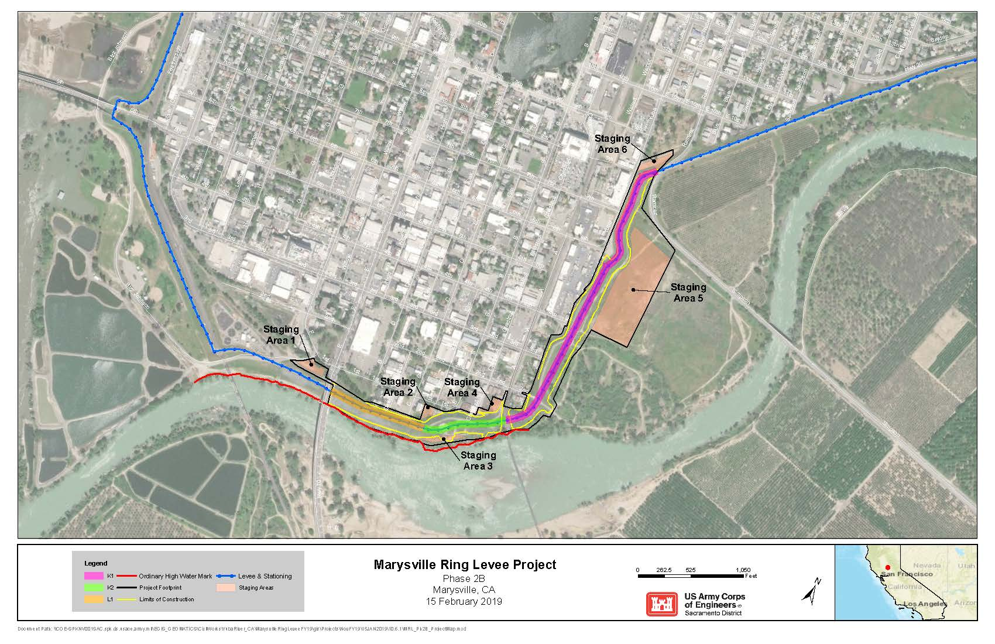
Figure 3. Project Area Map (Phase 2B).

Segment K1
Segment K1 would be degraded to allow construction of a soil-bentonite cutoff wall and then reconstructed to existing dimensions and alignment. Existing sheetpile below the levee crown is expected and would be removed during levee degrade. Cutoff wall construction would begin approximately 10 feet east of HWY 70. The levee crown would be reconstructed to the existing 20-foot-wide crown width with a 12-footwide paved levee road and 4-foot-wide aggregate base shoulders. Current rock slope protection would be removed and stockpiled up to one foot below the levee degrade and replaced after construction is complete.
Segment K2
Segment K2 is currently aligned north of an abandoned sand plant. The segment would be realigned to the south with the cutoff wall construction terminating 55 feet from the centerline of the UPRR line on the existing levee alignment. This window at UPRR also limits earthwork to a minimum 5 feet distance away from the Kinder Morgan gas line which must be protected in place. However, the primary motivation for realignment of the levee in this segment is to allow for construction of a landside patrol road. This realignment would require demolition of walls, foundations, and appurtenances remaining at the abandoned sand plant site. A new waterside ramp from the levee crown would be added in the vicinity of the abandoned sand plant to facilitate access to the waterside of the levee between HWY 70 and UPRR. An existing waterside access ramp would also be removed and replaced along the realigned levee. The levee crown would be 20-feet-wide with a 12-foot-wide paved surface.
Segment L1
Segment L1 begins east of the UPRR right-of-way (ROW). This segment would require construction of a soil bentonite cutoff wall beginning 50 feet from the UPRR centerline, continuing north on an alignment shifted to the east, and terminating at Simpson Lane/Ramirez Road. However, the primary motivation for realignment of the levee in this segment is to allow for construction of a landside patrol road. Realignment of the levee would necessitate relocation of overhead utilities.
Construction Methods
Cutoff Wall Construction. All levee segments require the addition of a shallow SB cutoff wall to prevent through-seepage and under-seepage. Conventional construction would require degrade of portions of the existing levee where realignment would not occur. The cutoff wall would be constructed through the center of the levee crown and would span approximately 5,100 feet (0.97 miles) in length, have a maximum depth of 55 feet, and a minimum thickness of 3 feet.
There is a proposed levee degrade of 8 feet which would facilitate the use of a minimum 30-foot-wide working platform. In segments K2 and L1 where the levee is fully realigned, it would be necessary to build the levee to the degrade elevation. Union Pacific Railroad (UPRR) would remain a window in the cutoff wall, extending 50 feet on either side of the UPRR centerline. Based on the proposed levee degrade, a maximum of 260,000 cubic yards of soil would be hauled and same amount of material in cubic yards would be imported.
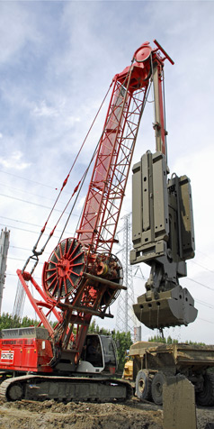
The cutoff wall would be constructed utilizing the open trench method (used when the wall depth does not exceed 80 feet). This method requires excavation of a trench backfilled with a soil bentonite slurry—a clamshell would be used for excavation in all segments (Figure 4). The trench serves dual purposes both as a working platform for construction equipment and for through-seepage protection should the cutoff wall experience excessive settlement post- construction. A tremie would be used to place cutoff wall material in all segments of construction. After the cutoff wall is complete a temporary clay cap composed of impervious fill would be constructed and settlement plates would be placed on top. After a prescribed monitoring period, a portion of the temporary clay cap would be removed and replaced with a permanent clay cap. General levee fill material would be placed to re-grade the levee to the existing height.

Figure 4. Cutoff Wall Excavation Equipment.
Operation and Maintenance (O&M) Roads. Public access to the levee would remain limited to pedestrians and bicyclists. Existing landside and waterside levee service (O&M) roads would be maintained and improved with an aggregate surface course. Where feasible, minimum 15-foot-wide O&M roads would be constructed on both the landside and waterside of all levee segments that would ultimately connect to the existing O&M road—discontinuities in the O&M roads are necessary at the UPRR ROW. The addition of the landside O&M road in Segment L1 would require permanent degrade of the existing levee to match the grade of the K1 patrol road. Connecting routes would require use of Marysville surface streets which is the current arrangement.
Landslide Drained Berms at UPRR Crossing. Landside drained berms adjacent to the Union Pacific Railroad (UPRR) are recommended to mitigate for levee through-seepage at the UPRR cutoff wall gap. The minimum dimensions of the landside drained berms are 7 feet high, 15 feet wide and 100 feet long on each side of the UPRR ROW. Two alternatives for the landside toe drains have been considered; however, due to the ease of construction, the recommended alternative includes installation of a fine aggregate that provides both drainage and filtration.
Historic Sewer Tunnels. Historic sewer tunnels have been identified and are located at B
Street and D Street within levee Segments K1 and K2. It is recommended that any existing tunnels be located, demolished and removed from the embankment foundation through open excavation. It is possible that the sewer tunnels may not be encountered nor interfere with the installation of the cutoff wall. However, there is a lack of definitive information on the extent of the sewer tunnels and whether or not they are located within the excavation limits. Historically, the sewer tunnels were partially filled with refuse from an old gas plant. The debris may contain hazardous material and would be tested if the tunnel is found during the proposed set-forward levee construction in Phase 2B. The potentially hazardous debris would be sampled and tested in conformance with the Phases 2B and 3 specifications. If the contents of the tunnels exceeds the allowable limits for a Class II landfill, the material would be considered hazardous and would be disposed of at a hazardous waste disposal site.
Utilities. There are utilities located in the vicinity of the existing levee and the proposed levee realignment. These utilities would either be protected in place, relocated by others, or removed as needed to meet USACE design criteria and the State of California, Central Valley Flood Protect Board, California Code of Regulations, Title 23. Where the levee is to be realigned in K2 and L1, an inspection trench would be required to help identify any previously unidentified utilities and/or abandoned infrastructure.
Additional Considerations. Segment K1—it is unclear whether there are remaining portions of demolished and abandoned D Street bridge abutments east of HWY 70 Bridge. The abutment and foundation of this structure may require removal if encountered during cutoff wall construction. There is a wood staircase on the levee in close proximity to the Bok Kai temple that would be removed and replaced in kind after construction is complete. East of the wood staircase, an existing concrete retaining wall runs the length of Segment K1, this structure would be protected in place during construction.
Segments K1 and K2—there may be existing sheet pile below the levee crown on the landside. Sheet pile has been deemed ineffective against through-seepage and has been retired as a flood protection feature. Any sheet pile or associated structures encountered during cutoff wall construction would be removed by cutting to the degrade elevation. The proposed levee realignment in Segment K2 has been designed to prevent conflict with construction of the cutoff wall and any portion of the sheet pile or associated structures remaining in place.
There is existing rock slope protection on the waterside portion of segment K1. Up to 6.6 acres of rock slope protection would be removed, stockpiled, and reset after construction of the SB cutoff wall. Based on previous hydraulic analyses and designs (USACE 2017a, 2017b), there is a need for erosion protection measures along the MRL in Phase 2B (e.g., the levee slope extending from the HWY 70 Bridge to downstream where the waterside ramp ties into Phase 2C). Any recommended erosion protection measures for the MRL would be constructed under a separate Phase (i.e., Phase 4B), following completion of the current construction plan. Once engineering designs are complete, supplemental environmental documentation would be developed, if needed, to ensure compliance with all applicable environmental laws, regulations, and policies.
Access and Staging
The proposed haul route for all material and equipment transportation in Segments K1 and K2 is HWY 70 to 4th Street to F Street to Bizz Johnson Drive to the waterside toe or levee crown. However, due to the distance from HWY 70 and restricted access along the UPRR ROW, an alternate route is proposed for Segment L1 along HWY 70 to Beale Road to Smartville Road to Simpson Lane/Ramirez Road to the waterside toe or levee crown (Figure 5).

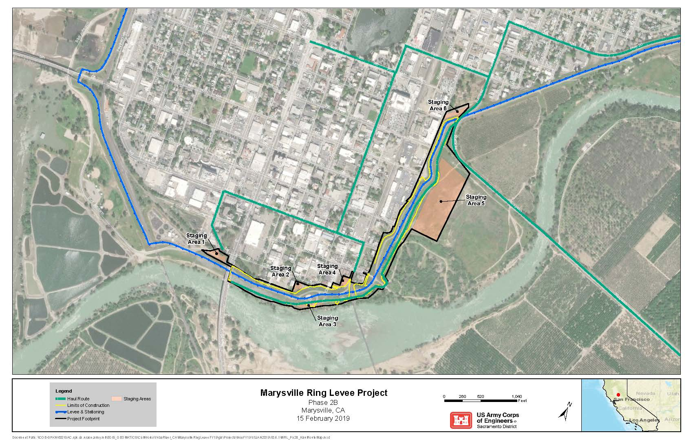
Figure 5. MRL Phase 2B Proposed Haul Routes.

Phase 2B is approximately 12.60 acres with a maximum area disturbed per day of approximately 10.90 acres. Staging areas that would be used during construction of Phase 2B not originally identified in the 2010 EA/IS include the lot adjacent to the Marysville Flood District office on 1st Street, the lot adjacent to the A Street ramp, and a portion of the open space area east of the PG&E yard in segment L1 (Figure 3). Staging areas would provide parking and supply-delivery locations for the construction crew. Storm water pollution prevention (SWPP) materials (silt fence, straw waddles, etc.) would be installed to prevent the transfer of sediments outside staging area locations. The staging areas are described below:
- Staging Area #1 is west of State Road 70, adjacent to Bizz Johnson Drive. Total area is approximately 0.5 acres and the surface is not entirely level on the southern edge. The vegetation would be removed and the area leveled before stockpiling.
- Staging Area #2 is approximately 0.25 acres and located adjacent to the Marysville Levee District field office, bounded by 1st street and the landslide embankment of the existing levee.
- Staging Area #3 is approximately 0.5 acres and located on the waterside opposite the Levee District field office.
- Staging Area #4 is approximately 0.5 acres adjacent to the landside levee access ramp between Chestnut Street, A Street and the UPRR tracks.
- Staging Area #5 is approximately 10 acres and located on the waterside of levee Segment L1, adjacent to Simpson Lane/Ramirez Road. This is the only area for Segment L1 suitable for stockpiling, equipment storage, and mixing.
- Staging Area #6 is approximately 0.5 acres and is positioned between Yuba Square Park and the landside embankment of levee Segment L1.
Construction Workers and Schedule
Although the numbers of workers on site would vary during construction, a maximum of 50 construction workers would be onsite each day while the cutoff wall is being constructed. These workers would access the area via regional and local roadways and park their vehicles at one of the identified staging areas. Construction activities would be limited to the hours of 7:00 a.m. and 7:00 p.m. Monday through Saturday, and 8 a.m. to 7 p.m. on Sunday. Construction is expected to last approximately two full seasons with an estimated duration of 4 to 6 months each year (April-October), for a total of 8 to 12 months from 2022-2023.

2.2.2 Phase 3
Current levee improvements along Phase 3 have been identified in segments described as Reach 1, Reach 2, and Reach 3 to define the cutoff wall type and method of construction (Figure 6). All levee segments require improvements to meet current levee design standards set by USACE, including a SB and/or soil cement bentonite (SCB) cutoff wall (depending on wall depth) to prevent through-seepage and under-seepage.
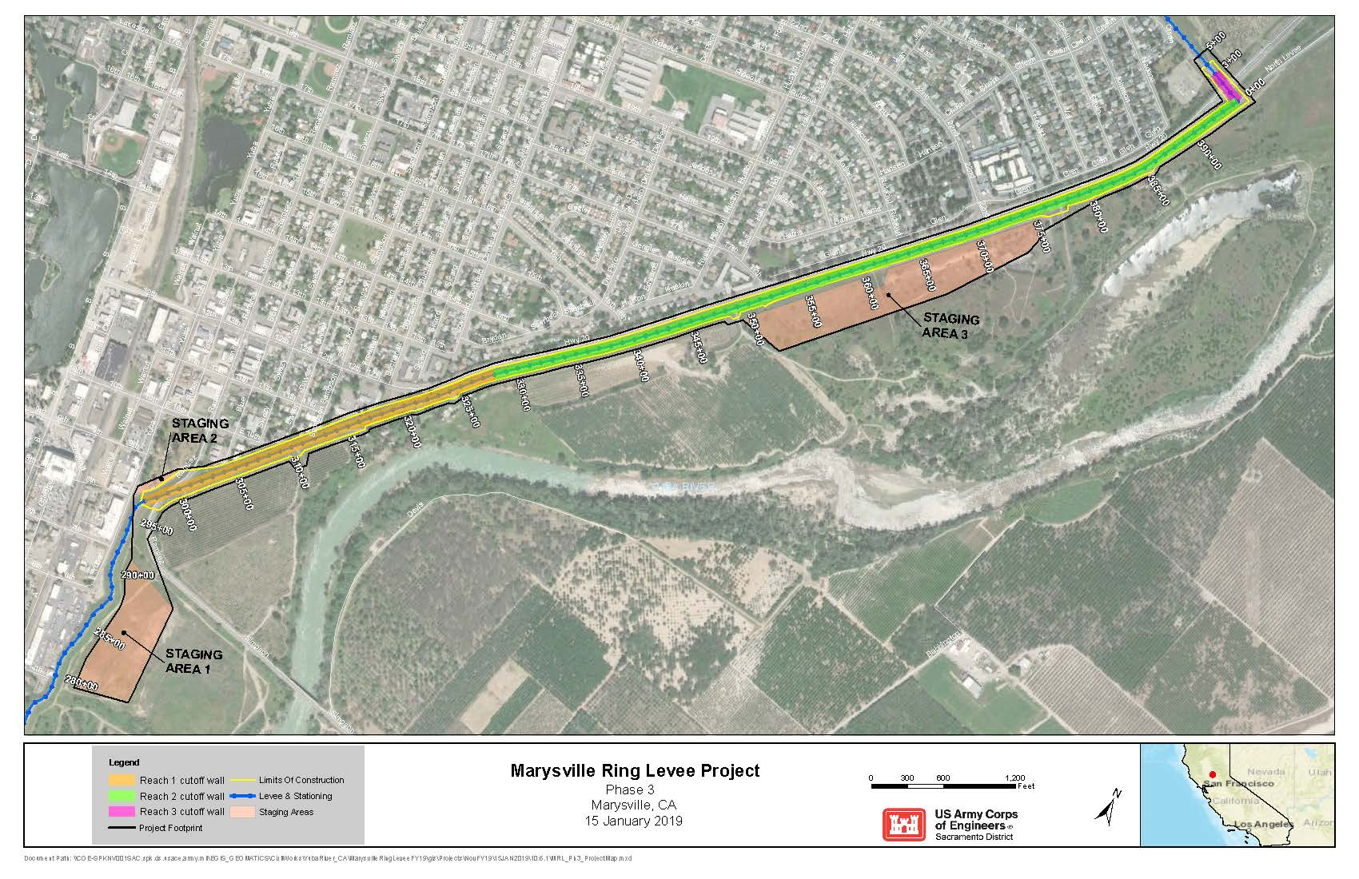
Figure 6. Project Area Map (Phase 3).

Reach 1
Located on the south end of Phase 3. The cutoff well begins just south Simpson Lane/Ramirez Road to Approximately 300 feet north off the intersection of East 13th Street and Covillaud Street. The stationing for this reach is from Station 297+00 to 328+00. The cutoff wall would be composed of Soil-Cement-Bentonite, and the method of construction would be deep mix method/mix in place technique. The height of the wall is approximately 100 to 130 feet and the length is approximately 3,100 feet and would cross Simpson Lane/Ramirez Road. Night work would be performed at this location to minimize disruption to traffic.
Reach 2
Located approximately 300 feet north off the intersection of East 13th Street and Covillaud Street and end at the north end of Phase 3, where the levee turns to the west across State Highway 20. The stationing for this reach is from Station 328+00 to 394+41. The cutoff wall would be composed of Soil Bentonite (SB), slurry material and the method of construction would be open trench. The height of the wall for this reach is approximately 30 to 60 feet and the length is approximately 6,641 feet.
Reach 3
Located on the north end of Phase 3, where State Highway 20 crosses over the MRL Levee. The stationing for this reach is from Station 0+00 to 3+00. The cutoff wall would be composed of Soil-Cement-Bentonite, and the method of construction would be deep mix method/mix in place technique. The height of the wall is approximately 68 feet and the length would extend approximately 150 feet to the west and east side from the highway centerline. Night work would be performed at this location to minimize disruption to traffic.
Construction Methods
Cutoff Wall Construction. The cutoff wall would be constructed along the centerline of the levee crown between Ramirez Street and the PG&E substation. Minor adjustments in the levee alignment would be required to maintain the 20-foot standard levee crown width. The levee crown would be partially degraded to a maximum of 8 feet below the existing crown elevation to establish a temporary 55-foot wide construction platform. Based on the proposed levee degrade, a maximum of 87,000 cubic yards of soil would be hauled and a maximum of 120,100 cubic yards would be imported. The combined length of the walls would be approximately 9,700 feet (1.84 miles), have a maximum depth of 130 feet, and a minimum thickness of 3 feet.
Cutoff wall construction would include a combination of open trench (refer to Section 2.2.1 for a detailed description) and Deep Mix Method (DMM) (Figure 7). DMM or “in-situ” construction is used for wall depths that exceed 80 feet. A “demonstration section” is required for this method and would be located within the footprint of the proposed alignment for the cutoff wall. The demonstration section would be 50 to 60 feet in length and would extend down to the deepest section of the cutoff wall.
Levee material would be removed from the trench and brought to a nearby location, mixed with soil, cement, and bentonite clay then replaced to create the wall.
In addition to conventional equipment, specialized equipment including a DMM apparatus, mixing batch plant/tubing, and cutter crane would be required during construction.
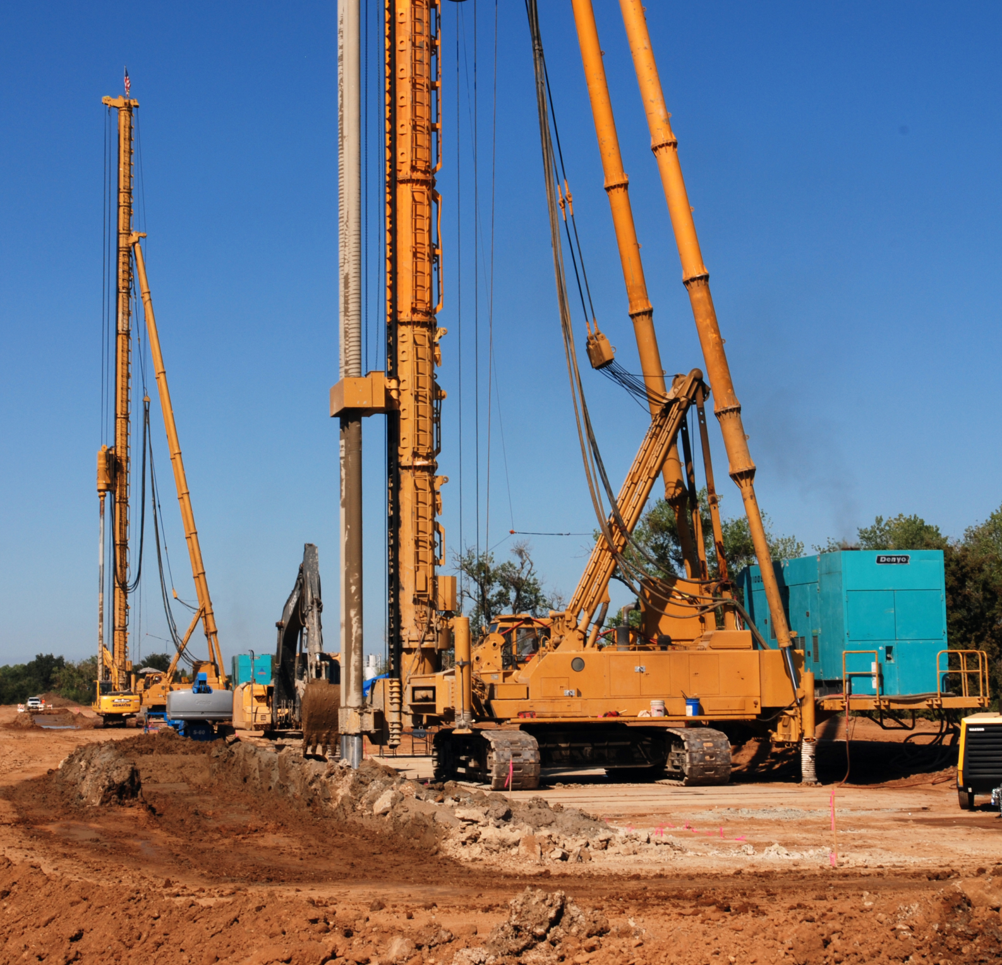
Figure 7. DMM Cutoff Wall Construction.
Utilities. There are publicly and privately owned utilities located in the vicinity of the existing levee including water and gas lines that penetrate the levee. Existing utilities would either be re-located or protected in place. Where possible, relocations would be accomplished in advance of the construction. Additionally, there are two utilities that interfere with construction of the cutoff wall along a portion of the Phase 3 levee (see Section 3.1.1 for further details).
Operation and Maintenance (O&M) Roads. Public access to the levee would remain limited to pedestrians and bicyclists. A paved levee service (O&M) road would be constructed on the landside of Phase 3 extending 15 feet from the toe of the levee slope. Levee features are also accessible from the existing, paved service road located at the crown of the levee. Although there would be no service roads located on the waterside, a 15-foot offset (flood safety easement) is necessary.
Access and Staging
There are two potential haul routes proposed for Phase 3: (1) Simpson Lane/Ramirez Road with construction of a temporary ramp for access from the landslide slope to the crown of the levee, and (2) the Levee Road/HWY 20 to E Street to 12th Street (Figure 8). Haul routes would be used for work zone and staging area access, personnel, equipment, unsuitable material export, fill material import, disposal of demolished levee features, and import of new levee feature materials.

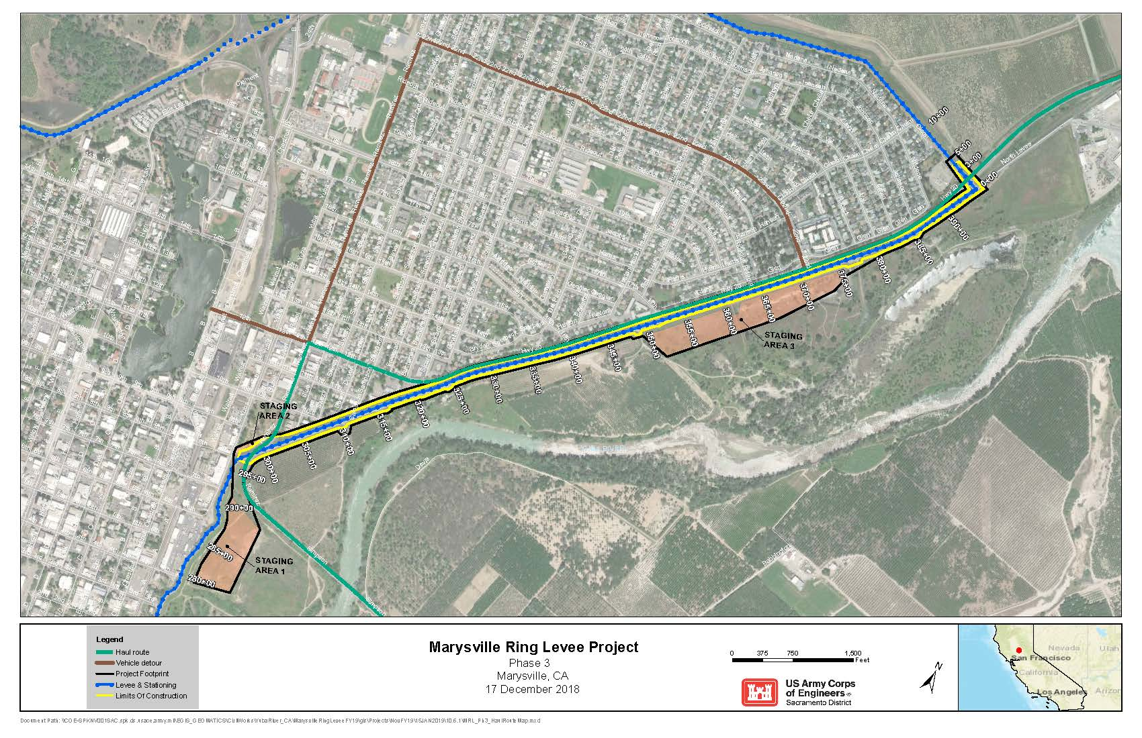
Figure 8. MRL Phase 3 Proposed Haul Routes.

The maximum area disturbed per day in Phase 3 is approximately 46 acres. There are three staging areas that would be used during levee construction (Figure 6). Staging areas would provide parking and supply-delivery locations for the construction crew. Storm water pollution prevention (SWPP) materials (silt fence, straw waddles, etc.) would be installed to prevent the transfer of sediments outside staging area locations. The staging areas are described below:
- Staging Area #1 is approximately 10.3 acres and located on the waterside of the levee south of Simpson Lane/Ramirez Road. Access would be from Simpson Lane/Ramirez Road and existing waterside O&M roads. Use of this area would be to temporarily stockpile levee degrade material, place batch plant equipment (tanks and containers), and store construction equipment and material.
- Staging Area #2 is approximately 0.56 acres and located on the landside of the levee, south of Simpson Lane/Ramirez Road. Access to this staging area would be from Yuba Street. Use of this area would be primarily for parking or job trailers.
- Staging Area #3 is approximately 18.3 acres located on the waterside, east of HWY 20. Access to this area would be from Simpson Lane/Ramirez Road (from the south end) and HWY 20 (from the north end). The levee crown road would be used as well as waterside ramps and O&M roads. Use of this area would be temporarily stockpile levee degrade material, place batch plant equipment (tanks and containers), and store construction equipment and material.
Construction Workers and Schedule
Although the numbers of workers on site would vary during construction, a maximum of 50 construction workers would be onsite each day while the cutoff wall is being constructed. These workers would access the area via regional and local roadways and park their vehicles at one of the identified staging areas. A localized lane shift would occur at Levee Road/HWY 20 and along the county road at Simpson Lane. Night work construction activities would be implemented to minimize impacts to traffic. Hours of operation would include 8:00 p.m. to 5:00 a.m., and extend up to 2 months during a full construction season. Construction is expected to last approximately two full seasons with an estimated duration of 4 to 6 months each year (April-October), for a total of 8 to 12 months from 2020-2022. 2.2.3

2.2.3 Phases 2B and 3 Common Elements
Site Preparation
Prior to construction, all construction areas, including staging areas, would be fenced off to limit access. The Project Area footprint is the temporary construction easement and limits the contractor to the indicated areas as described above and shown in Figures 3 and 4. This boundary includes all areas to be disturbed by construction activities including: staging areas, levee degrade, stockpile, and construction of the seepage cutoff walls (haul routes are identified separately from the Project Area footprint). Additionally, permanent easements for Operation and Maintenance (O&M) have been identified and include paved O&M access roads.

The levee is setback from the river in most locations along Phases 2B and 3. Temporary erosion controls would be implemented along the waterside toe of the levee to prevent soils from running onto adjacent properties and into local waterways. No construction, construction-related work, or operation and maintenance activities for the levee improvements would occur within the work exclusion buffer or below the OHWM.
Temporary erosion controls would remain consistent with those described in Section 2.4.2 of the 2010 EA/IS (USACE, 2010).
Restoration and Cleanup
Procedures for restoration and clean-up would remain consistent with Section 2.4.2 of the 2010 EA/IS (USACE, 2010).
Borrow and Disposal Sites
Borrow and disposal site requirements and Contractor responsibilities would remain consistent with Section 2.4.2 of the 2010 EA/IS (USACE, 2010).
Operation and Maintenance
Additional levee service (O&M) roads would be constructed in Phases 2B and 3 where feasible. There are existing O&M roads in both Phases that are currently being maintained, therefore, this would incrementally increase existing activities. Monitoring and maintenance is recommended in specific locations along Phase 3 in areas susceptible to erosion (USACE 2017b). These recommendations would remain consistent with the applicable portions of the Flood Control Regulations, paragraph 208.10(b)(1) pertaining to levee maintenance. Therefore, the procedures for operation and maintenance would remain consistent with Section 2.4.2 of the 2010 EA/IS (USACE, 2010).

3.0 ENVIRONMENTAL EFFECTS AND AFFECTED RESOURCES
This section describes the resources within the Project Area, as well as the effects of the Alternatives on these resources. Each section below presents the existing resource conditions, environmental effects, and when necessary, mitigation measures that are proposed to avoid, reduce, minimize, or compensate for any significant effects. Impacts are identified as direct, indirect, or cumulative.
The placement of additional erosion protection measures as outlined in recent hydraulic analyses and designs (USACE 2017a), are not anticipated to have any additional impacts on environmental resources discussed herein beyond what has already been analyzed. Any recommended erosion protection measures for the MRL would be constructed under a separate Phase (i.e., Phase 4B), following completion of the current construction plan. Once engineering designs are complete, supplemental environmental documentation would be developed, if needed, to ensure compliance with all applicable environmental laws, regulations, and policies.
For this SEA/IS, the NEPA criteria applies to all resources and is not repeated for each individual resource. The CEQA requirements are more specific to each resource and are listed in the original MRL EA/IS (USACE, 2010) and detailed below where needed.
These requirements, as well as other applicable agency criteria and significance thresholds, are identified under the appropriate resource. Resources not considered herein would remain consistent with the 2010 EA/IS.

3.1 Resources Not Considered in Detail
Previous joint NEPA/CEQA documents (USACE 2010) have described the Affected Environment in detail and evaluated the potential effects on resources of concern, including: geology and seismicity; mineral resources; topography and soil types; aesthetics and visual resources; hazards, hazardous materials, toxic, and radiological waste; fisheries; environmental justice; and population and housing. The conclusions of the existing effects analyses for most resources, except those resources discussed below, are determined to be consistent with the previous joint NEPA/CEQA document or would not be significantly impacted, as construction methodologies, scope, and seasonality would remain the same, and the relevant Federal and State laws have not changed in a manner that would require re-evaluation of these resources.

3.1.1 Public Utilities
Public utility facilities that could be affected by construction vary by phase, but generally include power lines leading to a substation adjacent to the Project Area, fiber optic lines, an underground natural gas distribution line, and a 60kV line.
Phase 2B
Existing utilities that do not interfere with construction of the proposed levee improvements in Phase 2B would be protected in-place (e.g., where the levee crosses the active UPRR ROW between segments K2 and L1).. Other utilities would be relocated by the owner prior to construction and abandoned utilities would be removed by the Contractor.
There are two abandoned sewer tunnels that may be uncovered during construction activities. The sewer tunnels are located at B Street and D Street respectively and were partially filled with refuse from an old gas plant. The debris may contain hazardous material and would be tested if the tunnel is found during the proposed set-forward levee construction in Phase 2B.
The Contactor would be required to conduct a pre-construction survey of the utilities. Additionally, the levee realignment in this phase would necessitate relocation of overhead utilities. A buried fuel line and a buried fiber-optic cable are located adjacent to the UPRR; since the location of these utilities does not prevent installation of the proposed cutoff wall, these utilities would remain in place.
Phase 3
The proposed alignment of the cutoff wall conflicts with some publicly and privately owned utilities. These utilities include overhead and underground electrical wires, water lines, storm drain structures, gas lines, sewer lines, and communication cables. Some of the utilities interfere with construction of the cutoff wall and would require relocation or a temporary plan to maintain the current construction plans. Unless otherwise identified within the limits of grading, all exiting utilities would be protected in place. Where possible, relocations would be accomplished prior to construction. Advance coordination with utility agencies is ongoing.
Lastly, there are two utilities (a non-pressurized sewer line and a pressurized water line), that interfere with construction of the cutoff wall along a portion of the Phase 3 levee. Once engineering designs outlining the utility relocation are complete, supplemental environmental documentation for the utility relocations would be developed, if needed, to ensure compliance with all applicable environmental laws, regulations, and policies.
Alternative 1 (No Action)
Under the No Action Alternative, USACE would not construct the MRL improvements. As a result, there would be no adverse effects on public utilities in the Project Area. There would be no change in type, quality, or availabilities of utility services in the Project Area.
Alternative 2 (Proposed Action)
No public services would be disrupted as a result of Phases 2B and 3 Project construction. Utility line relocations would be conducted in a manner that would not affect any of the services provided. Additionally, if the abandoned sewer tunnels in Phase 2B are uncovered the potentially hazardous debris in these tunnels would be sampled and tested in conformance with the Phases 2B and 3 specifications. If the contents of the tunnels exceeds the allowable limits for a Class II landfill, the material would be considered hazardous and would be disposed of at a hazardous waste disposal site. Therefore, construction activities would not result in a significant adverse effect.

3.1.2 Land Use and Socioeconomics
The predominant land use in Marysville is residential and agricultural, with some commercial, industrial and open space. Although the MRL Project footprint has changed since the 2010 EA/IS, the impacts to land use and socioeconomics within the Project Area have not changed.
Phase 2B
Construction would include levee realignment and levee slope increase to meet the new USACE standard of a 3 horizontal to 1 vertical (3H:1V). The levee realignment is variable and would determine the extent of the waterside toe increase. Additionally, 15-foot wide O&M roads along the waterside toe of the levee would be maintained or constructed. These proposed levee improvements would have minimal impact on land use.
Phase 3
Phase 3 includes a new levee alignment that is consistent with the EDR alignment; however, at various locations, the alignment moves slightly landward and slightly waterside to maintain an approximate standard 20 feet wide levee crest width. O&M roads spanning a maximum width of 15 feet would be constructed primarily along the levee crown and landside levee toe. Additionally, construction of Phase 3 would require access 15 feet off the waterside toe of the levee which could temporarily impact access to private landowners in this location. However, these residents would be allowed full access to their property during construction through normal routes or vehicle detours as necessary. The Contractor would be responsible for developing a Traffic Plan to coordinate access to these properties during construction. Any road closure(s) would require advance warning and detour signs.
Alternative 1 (No Action)
Under the No Action Alternative, USACE would not construct the MRL improvements and the primary land use and land use designations in Marysville would remain the same.
Alternative 2 (Proposed Action)
The reshaping and realignment of the levee in Phases 2B and 3 would have minimal impact on land use. No relocations would be associated with the Phases 2B and 3 Project and no populations would be displaced as a result of construction activities. All staging areas would be returned to pre-construction condition.

3.1.3 Agriculture and Prime and Unique Farmland
Small areas of Prime and Unique Farmland are present on the waterside of the eastern portion of the levee; these lands are currently in orchards. Staging areas are situated to avoid Prime and Unique Farmlands. Although there would be no access roads located on the waterside, a 15-foot offset (flood safety easement) is necessary. The 15-foot flood safety easement may encroach onto one row of orchard trees in some places, preserving most if not all existing orchard trees. Unique Farmland and Farmland of Statewide Importance is located along the northeastern portion of the Project Area. Lands within the Project Area footprint are not farmed.
All use of privately owned farmland would need to be negotiated with the landowners prior to the start of construction. The effects to these lands would be temporary and landowners would be able to return to their normal agricultural operations following completion of the construction season. Since there would be no permanent loss of farmland, no further mitigation would be required outside of the compensation to the landowners for the loss of their seasonal profits.
Alternative 1 (No Action)
Under the No Action Alternative, USACE would not construct the MRL improvements. Agriculture and Prime or Unique Farmland designations within the Project Area would not change. Additionally, soil types would not be altered and their classifications would remain the same.
Alternative 2 (Proposed Action)
There would be no permanent loss of Prime or Unique Farmlands, or Farmlands of Statewide Importance associated with the Phases 2B and 3 Project. The physical features of the Phases 2B and 3 Project would remain within the existing footprint in most areas, including where Prime and Unique Farmlands are present. There would be some temporary, short-term effects to Prime and Unique Farmlands and local agriculture. Agricultural production would continue in the area at its current level after the completion of the levee improvements.

3.1.4 Water Resources and Quality
In the 2010 EA/IS surface waters were addressed in Section 3.2.6 Fisheries and groundwater was addressed in Section 3.2.2 Geology and Seismicity. The current environmental review for MRL Phases 2B and 3 takes a refreshed look specifically at water resources.

3.1.4.1 Groundwater
MRL Phases 2B and 3 and the lands they protect from flooding are located in the North Yuba Sub-basin (DWR 5-21.60). The groundwater basin is managed by the Yuba County Water Agency (YCWA), which is the Groundwater Sustainability Agency (GSA) under the California Sustainable Groundwater Management Act of 2014 (SGMA) (DWR, 2018a).
This sub-basin is identified as a high priority groundwater basin, however, groundwater levels have been stable for several years as a result of careful management and supplementation with surface water from New Bullard’s Bar Reservoir (DWR, 2018b). YCWA developed a 2005 Groundwater Management Plan and updated this plan in November 2010.
Currently groundwater in this basin is at historic levels and is in good health (DWR, 2018b). The YCW, as the GSA, is developing a groundwater sustainability plan, as required by SGMA and consistent with the implementing regulations published by DWR. YCWA was recently awarded a grant from DWR to support basin plan development. All urban areas in the sub-basin, including Marysville, Olivehurst, Linda, and Wheatland, and Beale Air Force Base, depend on pumped groundwater for their municipal and industrial water supply. North of the Yuba River most agriculture relies on surface water.
Alternative 1 (No Action)
Under the No Action Alternative, groundwater would continue to be managed consistent with the requirements of SGMA and groundwater levees are expected to remain stable and at historic levels.
Alternative 2 (Proposed Action)
Implementing the proposed MRL Phases 2B and 3 would not affect groundwater availability or use. No change from the existing or the No Action Alternative condition is expected.

3.1.4.2 Surface Waters
The Yuba and Feather Rivers are the largest waterways in the Phases 2B and 3 Project vicinity. The Project Area is located just west of the Yuba River. The Yuba River drains into the Sacramento River. An agricultural ditch located along the northeast portion of Phase 3 is connected to Jack Slough which drains into the Feather River and from there into the Sacramento River. These waterbodies are all waters of the United States and protected under the CWA. Beneficial uses of these waters are shown in Table 3.
Table 3. Beneficial Uses of Yuba River and Feather River in the Project Area.
Beneficial Use | Yuba River – Englebright Dam to Feather River | Feather River – Fish Barrier Dam to Sacramento River
Municipal and Domestic Supply | -- | X
Agriculture - Irrigation | X | X
Agriculture – Stock Watering | X | --
Power | X | --
Recreation – Contact | X | X
Recreation – Canoeing and Rafting | X | X
Recreation – Other Noncontact | X | X
Freshwater Habitat – Warm | X | X
Freshwater Habitat – Cold | X | X
Migration – Warm | X | X
Migration – Cold | X | X
Spawning - Warm | X | X
Spawning - Cold | X | X
Wildlife Habitat | X | X
Navigation | -- | --
Source: Basin Plan 2018

No wetlands are present within the Project Area footprint, including the staging areas. Wetland types near the Project Area but outside of the construction and operations footprint are identified in Table 4. Implementation of BMPs would ensure that the Proposed Action would not affect these wetlands. A depression that occasionally holds unclassified waters is located on the east side of Phase 3 outside of the Project Area footprint and would not be affected by the construction or operation of Phase 3.
Table 4. Wetlands Types Near the Phases 2B and 3 Project.
 | System | Subsystem | Class | Water Regime
R2UBH | Riverine | Lower Perennial | Unconsolidated Bottom | Permanently Flooded
R2USC | Riverine | Lower Perennial | Unconsolidated Shore | Seasonally Flooded
PFOC | Paulustrine | -- | Forested | Seasonally Flooded
PSS/EM1C | Palustrine | Scrub-shrub | Emergent,  subclass Persistent | Seasonally Flooded
R5UBFx¹ | Riverine | Unknown Perennial | Unconsolidated Bottom | Semipermanently Flooded
¹ x indicates human modification by excavation. The agriculture ditch along the northeast edge of Phase 3 is classified as R5UBFx.
Source: Wetlands Mapper, National Wetlands Inventory (USFWS, 2018)
Alternative 1 (No Action)
Under the No Action Alternative surface waters, including wetlands, would remain in their existing conditions, except that water quality is reasonably expected to improve through basin-wide planning and regulation.
Alternative 2 (Proposed Action)
Implementing Phases 2B and 3 would be accomplished entirely outside of surface waters, including the agricultural ditch on the northeast portion of Phase 3. A final field survey would be completed in the spring prior to construction to ensure that all potentially affected wetlands have been identified. The Phases 2B and 3 Project incorporates a work exclusion buffer beginning at the Ordinary High Water Mark (OHWM) and extending 25 feet landward. No construction, construction-related work, or operation and maintenance activities for the levee improvements would occur within the work exclusion buffer or below the OHWM. Potential adverse effects on water quality from construction-related runoff would be avoided through implementation of BMPs and any requirements of the SWPPP and NPDES permit. The Proposed Action would not affect beneficial uses.

3.2 Resources Considered in Detail

3.2.1 Air Quality

3.2.1.1 Regulatory Setting
Air quality management is administered by federal, state, and local government agencies. The Federal Clean Air Act (CAA) is administered by the U.S. Environmental Protection Agency (USEPA). The California Clean Air Act (CCAA) is administered by the California Air Resources Board (CARB). Local Air Quality Management Districts are responsible for monitoring the attainment and maintenance of federal and state air quality standards.
Federal Air Quality Management. Air quality in the United States is governed by the CAA, which has adopted federal air pollutant standards, known as National Ambient Air Quality Standards (NAAQS). These standards apply to the following criteria air pollutants: carbon monoxide (CO), ozone (O₃), sulfur dioxide (SO₂), nitrogen dioxide (NO₂), lead (Pb), particulate matter less than 10 microns in diameter (PM₁₀), and fine particulate matter (PM_{2.5}). Under existing regulations, de minimis emission thresholds are listed for each criteria air pollutant.
State Air Quality Management. Air quality in California is also governed by the CCAA. The California criteria air pollutant standards are known as the California Ambient Air Quality Standards (CAAQS) and are generally more stringent than NAAQS.
Under the CCAA, designation of attainment or non-attainment is based on pollutant levels and whether they are below or in excess of the current standards. “Attainment” status for a pollutant means that the Air District meets the standards set by the USEPA. Continuous air monitoring ensures that these standards are met and maintained. An “unclassified” status indicates insufficient data for determining attainment or non-attainment. Both the CAA and the CCAA require plans to be developed for areas designated as non-attainment (with the exception of areas designated as non-attainment for the State PM₁₀ standard).
Local Air Quality Management. The Project Area is within Yuba County, which forms part of the Yuba-Sutter federal Ozone attainment area (FRAQMD 2009). The Feather River Air Quality Management District (FRAQMD) has established air pollution thresholds for projects within Yuba County (FRAQMD 2010). Yuba County is currently in attainment for all criteria air pollutants (EPA 2018). Current federal, state, and local air emission thresholds applicable to the Project Area are listed in Table 5.
Table 5. Current Federal, State, and Local Air Quality Emissions Thresholds.
Criteria Pollutant | NAAQS (Tons/Year) | CAAQS | FRAQMD  (Tons/Year) | FRAQMD  (Pounds/Day)
¹Reactive Organic Gases (ROG)  Volatile Organic Compounds (VOC) | 50 | .070 ppm  (8-Hour) | 4.5 | 25  (Multiplied by Project Length in Days)
Carbon Monoxide (CO) | 100 | 20 ppm  (1-Hour) | N/A | N/A
Nitrogen Oxides (NO_{x}) | 100 | .03 ppm  (Annual) | 4.5 | 25  (Multiplied by Project Length in Days)
PM₁₀ | 70 | 20 μg/m³  (Annual) | 14.5 | 80
PM_{2.5} | 100 | 12 μg/m³  (Annual) | N/A | N/A
Sulfur Dioxide (SO₂) | 100 | .25 ppm  (1-Hour) | N/A | N/A
Lead | 0.15 μg/m³  (90-Day Avg.) | 1.5 μg/m³  (30-Day Avg.) | N/A | N/A
¹ROG/VOC = Precursor compounds to ozone and smog
Source: EPA 2016, CAAQS 2009, and FRAQMD 2010

3.2.1.2 Environmental Setting
The Air Quality Section of the 2010 EA/IS (USACE 2010) sufficiently characterizes the affected environment and management for this resource.

3.2.1.3 Effects
The 2010 EA/IS evaluated the potential effect on air quality for the MRL Project based on a quantitative evaluation of the types and levels of emissions associated with construction activities. However, the 2010 EA/IS does not discuss in detail the effects on air quality specific to Phases 2B and 3. This section discusses the effects of the Proposed Alternatives on air quality in the Project Area.
Significance Criteria
General significance criteria have been established by the California Office of Planning and Research, to determine if the potential air quality impacts of a proposed project are significant, and would therefore require mitigation in an attempt to reduce the potential impacts to a less-than-significant level. Where available, these general criteria are supplemented with quantitative thresholds in terms of air quality parameters, separated into the three following categories:
- Criteria pollutants relative to emission limits and ambient air quality standards;
- TACs relative to public health impacts; and
- Cumulative impacts.
Additionally, where available, the significance criteria established by the applicable air quality management district may be relied upon to make the following determinations (using CEQA guidelines)—adverse effects on air quality standards would be considered significant if the alternative:
Table 6. Air Quality Significance Criteria.
AQ 4-1 | Would conflict with or obstruct implementation of the applicable air quality plan?
AQ 4-2 | Would violate any air quality standard or contribute substantially to an existing or projected air quality violation.
AQ 4-3 | Would result in a cumulatively considerable net increase of any criteria pollutant for which the project region is in non-attainment under an applicable Federal or State ambient air quality standard (including releasing emissions which exceed quantitative thresholds for ozone precursors).
AQ 4-4 | Would expose sensitive receptors to substantial pollutant concentrations.
AQ 4-5 | Would create objectionable odors affecting a substantial number of people.
State of California, 2018 California Environmental Quality Act (CEQA) Statutes and Guidelines http://resources.ca.gov/ceqa/docs/2018_CEQA_Statutes_and_Guidelines.pdf
Alternative 1 (No Action)
Under the No Action Alternative, USACE would not construct the MRL improvements. Routine operation and maintenance would continue on the existing levee. Air quality would continue to be influenced by existing climatic conditions, vehicle emissions, agricultural activities, and industry.
Alternative 2 (Proposed Action)
Construction of the proposed levee improvements would result in temporary, short-term effects on air quality. There would be no long-term operational emission sources other than vehicle emissions associated with routine levee inspection and maintenance. Construction of the levee improvements would result in air pollution emissions from mobile and stationary sources including construction equipment, haul trucks, and worker vehicles. Diesel-powered construction equipment is the primary source of Green House Gas (GHG) and exhaust emissions. Equipment pollutants such as nitrogen oxides, carbon monoxide, and particulate matter (PM_{2.5} and PM₁₀) endanger people’s health and the surrounding environment (H. Fan 2017).
There are four main factors that impact construction equipment exhaust emissions including equipment type and condition, equipment maintenance, equipment operations and operating conditions (H. Fan 2017). The operation and maintenance of construction equipment is an important factor for achieving fuel economy and reducing exhaust emissions. Since other emission reduction strategies may involve large capital investment or financial spending, improving operations and maintenance practice has proved to be more feasible for equipment owning organizations, especially for small and medium sized contractors (H. Fan 2017).
Sacramento Metropolitan Air Quality Management District (SMAQMD) has developed a comprehensive model to calculate construction emissions. The model utilizes project data (e.g., construction duration, material import and export, equipment type and number) to calculate emission estimates.

Due to the linear nature of the levee improvement projects undertaken by the Corps, SMAQMD has suggested the use of their Road Construction Emissions Model (Model), Version 9.0.0 (May 2018). The FRAQMD has approved and recommended the use of this Model for the Project Area.
The Model was used to calculate the maximum annual emission estimates for criteria pollutants in each phase of the Phases 2B and 3 Project construction (Appendix D). The results from the Model were compared to the NAAQS de minimis thresholds and FRAQMD’s standard emissions thresholds (Table 7). This comparison was used to determine the overall significance of construction emissions on air quality.
Table 7. Phases 2B and 3 Maximum Annual Construction Emissions.
Total Emissions | Pollutant (Tons/Year)
 | ROG | CO | NO_{x} | PM₁₀ | PM_{2.5} | CO_{2e}
Phase 2B Construction (2022-2024)
Total Mitigated1 | 2.80 | 60.35 | 20.04 | 16.15 | 2.99 | 19,160.70
Phase 3 Construction (2020-2022)
Total Mitigated1 | 3.72 | 80.99 | 14.5 | 58.85 | 12.74 | 18,193.03
Federal De Minimis Thresholds | 50 | 100 | 100 | 70 | 100 | N/A
FRAQMD Thresholds | 4.5 | N/A | 4.5 | 14.5 | N/A | N/A
¹ Mitigated numbers include on-model measures including 2010 and newer on-road vehicle fleet and Tier 4 off-road equipment (SMAQMD 2017).
Based on the air quality analysis, emissions for each phase of construction would not exceed federal de minimis thresholds; however, the Phases 2B and 3 Project is both operationally significant under CEQA and is anticipated to exceed local (FRAQMD) thresholds for NOx and PM₁₀. After implementation of on-site mitigation measures, any emissions that remain in excess of local thresholds would be reduced by the Contractor contributing funds to the FRAQMD’s off-site mitigation program (Carl Moyer Program) to reduce construction emissions to less-than-significant. Impacts to air quality and GHGs resulting from construction activities associated with the Proposed Action would be temporary and considered less-than-significant with implementation of the mitigation measures described in Section 3.2.1.4.

3.2.1.4 Mitigation
Mitigation measures to reduce air quality impacts during a project’s construction phase are provided in FRAQMD’s Indirect Source Review Guidelines (FRAQMD 2016). These measures were documented in the 2010 EA/IS and would be incorporated during construction. Additional mitigation measures applicable to the Phases 2B and 3 Project are listed in Table 8.

Table 8. Air Quality Mitigation Measures.
Number | Measure
AQ-1 | The Contractor would submit to the Corps and FRAQMD, a comprehensive inventory of all off-road construction equipment, equal to or greater than 50 horsepower, that would be used an aggregate of eight (8) or more hours during any phase of construction.  - The inventory would include the CARB equipment identification number, equipment type, horsepower rating, engine model year, and projected hours of use for each piece of off-road equipment.  - The Contractor would submit a current Certificate of Reported Compliance for CARB’s In-Use Off-Road Regulation to FRAQMD.  - At least 4 business days prior to equipment use, the Contractor would submit the construction equipment inventory information, the anticipated construction timeline including start date, as well as the name, phone number and email address of the project manager and on-site foreman to FRAQMD. The SMAQMD Construction Mitigation Tool, Version 7.0 (October 2016) would be used to submit this information (or the most recent version).  - At the end of the season, phase, or calendar year, the Contractor would be responsible for updating the off-road equipment inventory information as well as haul truck activity to FRAQMD.
AQ-2 | Off-road equipment used forconstruction would meet CARB Tier 4 Standards.
AQ-3 | Diesel-fueled on-road equipment manufactured in 2010 and newer would be used. Equipment manufactured prior to 2010 would require installation of engine retrofit technology. Low-emission diesel products, alternative fuels, after-treatment products, zero emission technologies and/or other options as they become available.
AQ-4 | A Fugitive Dust Control Plan would be submitted to FRAQMD for approval prior to commencing site activities or delivering materials to the site. The Plan would include mitigation measures and BMPs identified in the 2010 EA/IS and this environmental document.
AQ-5 | Minimize the amount of concrete for paved surfaces or utilize a low carbon concrete option. Produce concrete on-site if determined to be less emissive than transporting ready mix.
Number | Measure
AQ-6 | Encourage and provide carpools, shuttle vans, transit passes and/or secure bicycle parking for construction worker commutes.
AQ-7 | Reduce electricity use in the construction office by using light-emitting diode (LED) bulbs, powering off computers every day, and replacing heating and cooling units with more efficient ones.
AQ-8 | Use locally sourced or recycled materials for construction materials (goal of at least 20% based on costs for building materials, and based on volume for roadway, parking lot, sidewalk and curb materials). Wood products utilized should be certified through a sustainable forestry program.
AQ-9 | Recycle or salvage non-hazardous construction and demolition debris (goal of at least 75% by weight).
AQ-10 | Minimize vehicle and equipment idling time either by shutting off when not in use or reducing the time of idling to no more than 3 minutes, which would save fuel and reduce emissions. Provide clear signage that posts this requirement for workers at the entrances to the site.
AQ-11 | SmartWay certified trucks would be utilized for deliveries and equipment transport.
AQ-12 | After implementation of on-site mitigation measures, any emissions that remain in excess of local thresholds would be reduced by the Contractor contributing to the FRAQMD’s off-site mitigation program (Carl Moyer Program) to further reduce air quality impacts below the applicable threshold of significance.
AQ-13 | The Corps, FRAQMD, and/or other responsible officials may conduct periodic site inspections to determine compliance with applicable federal, state, and/or local air quality laws and regulations.

3.2.2 Greenhouse Gases
On August 1, 2016, the Council on Environmental Quality issued final guidance on considering greenhouse gas (GHG) emissions and climate change in NEPA reviews. Fundamental to this guidance are the recommendations that when addressing climate change, agencies should consider:
(1) The potential effects of a proposed action on climate change as indicated by assessing GHG emissions (e.g., to include, where applicable, carbon sequestration); and,
(2) The effects of climate change on a proposed action and its environmental impacts.

3.2.2.1 Environmental Setting
In California’s Global Warming Solutions Act of 2006 (California Health and Safety Code § 35000 et seq.), the California Legislature recognized California’s vulnerability to weather events triggered by global warming. The Legislature found that global warming would “have detrimental effects on some of California’s largest industries.” Assembly Bill 32 mandates that emissions of GHGs be reduced to 1990 levels by 2020.
The term “greenhouse gas” refers to a gas that traps heat in the atmosphere and contribute to global climate change. The primary GHGs of concern include carbon dioxide (CO₂), methane (CH₄), nitrous oxide (N₂O) and fluorinated compounds (Yuba County 2030). The United States is the 2nd largest contributor to worldwide CO₂ emissions resulting from fossil fuel combustion (USEIA 2017)—additionally, according to State-level CO₂ emissions, California is the 2nd largest emitter of energy-related CO₂ in the United States (USEIA 2017). Transportation is the largest source of ozone and GHG production in the region and a reduction in vehicle emissions is necessary to achieve significant GHG reduction (Yuba County 2030).

3.2.2.2 Effects
Significance Criteria
The following criteria would be used to determine the significance of GHG emissions:
- The relative amounts of GHG emissions resulting from implementation of the Proposed Alternatives are substantial compared to emission standards set by adjacent air quality management districts, [10,000 metric tons CO_{2e} per year (Placer County 2016)]; or
- The amount of GHG emissions resulting from implementation of the Proposed Alternatives results in a substantial effect to global climate change; or
- If the Proposed Alternatives has the potential to contribute to a substantially lower carbon future.
FRAQMD has not established thresholds for GHG emissions at this time; instead, each project is evaluated on a case-by-case basis using the most up-to-date methods of calculation and analysis. The Phases 2B and 3 Project impacts to climate change would be evaluated using the criteria listed below. According to the CEQA Guidelines, a project could result in significant impacts if it would do any of the following:
- Generate GHG emissions, either directly or indirectly, that may have a significant impact on the environment;
- Exceed a threshold that is applicable to the project; or
- Conflict with an applicable plan, policy, or regulation adopted for the purpose of reducing the emissions of GHGs.

Alternative 1 (No Action)
Under the No Action Alternative, USACE would not construct the MRL improvements. Routine operation and maintenance would continue on the existing levee. Greenhouse gases would continue to be influenced by existing primary GHGs of concern.
Alternative 2 (Proposed Action)
GHG emissions associated with the Phases 2B and 3 Project would be primarily associated with construction. GHG emissions would be emitted due to fuel combustion from onsite construction vehicles, as well as indirect emissions from the electricity used to operate machinery. In addition to the construction vehicles, there would be GHG emissions from the vehicles used for worker commutes.
By providing decreased risk of catastrophic flooding with associated loss of infrastructure, the Phases 2B and 3 Project is expected to prevent extra carbon production which would be associated with demolition, repair, and reconstruction of flood-induced infrastructure losses. Additionally, there would be minimal long-term operational emissions associated with maintenance of the Phases 2B and 3 Project.
In response to concerns regarding GHG emissions, the SMAQMD Road Construction Emissions Model (Model), now generates an output for CO₂. Although CO₂ emissions can be calculated, there is currently no federal, state, or local (FRAQMD) thresholds to meet. The USEPA has also stated that GHG emissions below 25,000 metric tons do not commonly require reporting (USEPA 2013). However, the local neighboring county of Placer has recommended a GHG threshold of 10,000 metric tons of CO₂ per year for construction and operational phases of land use and stationary source projects (Placer County 2016).
The Model was used to calculate emission estimates for all construction activities related to the Phases 2B and 3 Project (shown in Table 5). The results of the modeling determined that the project’s CO₂ emissions would not exceed 25,000 metric tons per year but would violate the 10,000 metric tons per year threshold.
As a result, mitigation measures would be implemented, as discussed below, to increase energy efficiency and minimize GHG emissions. With mitigation, GHG emissions would be reduced to less-than-significant.

3.2.2.3 Mitigation
To successfully adapt to future changes in Yuba County’s climate, the General Plan suggests several measures to provide GHG efficient development including incorporation of emission control measures recommended by the FRAQMD (Yuba County 2030). In addition, replacement of the paved roads on top of the levee crown are anticipated to reduce GHGs by contributing to a decrease in levee operations and maintenance, while potentially encouraging residents to increase its recreational use. The best management practices (BMPs) and mitigation measures listed in Section 3.2.1.4 and below (Table 9), as well as those applicable from the 2010 EA/IS, would be implemented to minimize CO₂ and reduce GHG emissions to less-than-significant.

Table 9. Green House Gas (GHG) Mitigation Measures.
Number | Measure
GHG-1 | The Contractor would submit monthly construction emissions to the Corps and FRAQMD. If these monthly reports show that emissions may exceed the CO_{2e} thresholds, the Contractor would be required to prepare a GHG emissions reduction plan for approval by the Corps and sponsors, and implement the approved plan. Elements of such a plan could include one or more of the following:  - Minimize the idling time of construction equipment to no more than 3 minutes, or shut equipment off when not in use.  - Encourage carpools, shuttle vans, and/or alternative modes of transportation for construction worker commutes.  - Use of CARB-approved low carbon fuel.  - Use of equipment with new technologies (repowered engines, electric drive trains).  If actual CO_{2e} emissions during construction of a given phase exceed any of the thresholds, then compensatory mitigation would be provided in the form of purchasing sufficient carbon credits to mitigate for the excess CO_{2e}. Carbon offset credits would be purchased by the Contractor and potential sources for these credits include; California Air Pollution Control Officers Association GHG Reduction Exchange Program, the Climate Action Reserve, the American Carbon Registry, or a similar carbon credit registry that is acceptable to FRAQMD, the Corps, and sponsors. Thus, if the actual CO_{2e} emissions exceed the established significance threshold for CO_{2e}, the purchase of carbon credits would reduce the climate change effect to less-than-significant.

3.2.3 Vegetation and Wildlife

3.2.3.1 Regulatory Setting
The Vegetation and Wildlife Section of the 2010 EA/IS (USACE 2010) sufficiently characterizes the regulatory setting for this resource; however, the original 2010 EA/IS did not discuss invasive species. The applicable laws and regulations, current environmental setting, and appropriate mitigation measures applicable to the Project Area are discussed in the following sections.

Executive Order 13751, directs federal agencies not to authorize, fund, or carry out actions that they believe are likely to cause or promote the introduction or spread of invasive species. To avoid introduction or spread of invasive species, the Corps is required to ensure implementation of appropriate control measures in compliance with applicable federal, state and local invasive species control regulations.

3.2.3.2 Environmental Setting
The Vegetation and Wildlife Section of the 2010 EA/IS (USACE 2010) sufficiently characterizes the affected environment and management for this resource. Additionally, the environmental setting for the MRL Project was described in the USFWS CAR (USACE 2010; USFWS 2010), and there are no significant changes to this description for Phases 2B and 3.
Invasive Species. The yellow starthistle (Centaurea solstitialis L.) is an invasive plant species found throughout the Project Area. Yellow starthistle spreads by seed with each seedhead producing approximately 35 to 80 seeds. The seeds have no wind-dispersal mechanisms so few seeds move more than two feet from the parent plant without assistance. Human activities such as vehicle undercarriages, contaminated crop seed, hay or soil, and road maintenance equipment, greatly contribute to the plant’s rapid and long-distance spread. Additionally, hair-like barbs on the seed head readily adhere to clothing, hair and fur allowing transportation over short to medium distances by animals and humans.

3.2.3.3 Effects
Significance Criteria
An action would be considered to have a significant effect on vegetation and wildlife if it would result in any of the following:
    - Substantial loss, degradation, or fragmentation of any sensitive natural communities or wildlife habitat identified by the CDFW, USFWS, or in any local or regional plans policies, or regulations.
    - Substantial adverse impact on a sensitive natural community including federally protected wetlands and other waters of the U.S. as defined by Section 404 of the Clean Water Act (CWA), including but not limited to seasonal wetlands, rice fields, and irrigation ditches through direct removal, filling, hydrologic interruption, or other means.
    - Substantial reduction in the quality or quantity of important habitat, or access to such habitat, for wildlife species.
Alternative 1 (No Action)
Under the No Action Alternative, USACE would not construct the MRL improvements. Routine operation and maintenance would continue on the existing levee. Therefore, this alternative would have be no effect on vegetation or wildlife communities.

Alternative 2 (Proposed Action)
The draft supplemental USFWS Coordination Act Report (CAR) evaluates the impacts on fish and wildlife resources resulting from construction of the proposed levee improvements and provides recommendations to mitigate these impacts (Appendix B). In order to quantify impacts to woodland habitat, a Habitat Evaluation Procedure (HEP) analysis was necessary. The HEP analysis quantifies suitability and measures the aerial extent of habitat occurrence within the Project Area. Although a HEP analysis was completed in 2010 for the MRL Project, that data is now over 20 years old. The HEP analysis for the Project Area was completed in December 2018 and is included as part of the draft supplemental CAR.
Phase 2B
Woodland Habitat. Woodland habitat acreage on the waterside of the levee would be permanently affected by construction activities. A total of 29 trees were identified for removal in Phase 2B and previous survey data is listed in Table 10.
Table 10. Tree Removals Phase 2B.
Species | Diameter at Breast Height (DBH) | Location  (Decimal Degrees) | Notes
Box Elder  (Acer negundo) | 6" | N 39.13486  W -121.58750 | Located approximately 15 feet from coordinate
Willow  (Salix spp.) | — | N 39.13572  W -121.58534 | Very large clump of shrubbery
Tree of Heaven  (Ailanthus altissima) | — | N 39.13614  W -121.58430 | Linear stretch about 30 feet long, mixed
Tree of Heaven  (Ailanthus altissima) | 3" | N 39.13602  W -121.58406 | 7 stems
Tree of Heaven  (Ailanthus altissima) | — | N 39.13620  W -121.58381 | Medium cluster
Box Elder  (Acer negundo) | 24" | N 39.13627  W -121.58370 | Approximately 10 feet from coordinate, cluster and surrounded by berries
Tree of Heaven  (Ailanthus altissima) | — | N 39.13635  W -121.58382 | 8 stems
Willow  (Salix spp.) | 7” | N 39.13673  W -121.58298 | Cluster of 3
Oak  (Quercus spp.) | 24” | N 39.13677  W -121.58293
Tree of Heaven  (Ailanthus altissima) | 36” | N 39.13695  W -121.58278
Willow  (Salix spp.) | — | N 39.13695  W -121.58278 | Many stems
Tree of Heaven  (Ailanthus altissima) | 30” | N 39.13708  W -121.58272 | Species questionable, possibly dead, burned at the base
Eucalyptus | — | N 39.13753  W -121.58265
Tree of Heaven  (Ailanthus altissima) | 12” | N 39.13754  W -121.58260
Eucalyptus | 24” | N 39.13787  W -121.58277
Tree of Heaven  (Ailanthus altissima) | 16” | N 39.13793  W -121.58278
Tree of Heaven  (Ailanthus altissima) | — | N 39.13805  W -121.58296 | 2 trees together
Walnut  (Juglans spp.) | 12” | N 39.13814  W -121.58299
Walnut  (Juglans spp.) | 24” | N 39.13815  W -121.58296
Walnut  (Juglans spp.) | — | N 39.13822  W -121.58299 | 7 stems
Walnut  (Juglans spp.) | 30” | N 39.13824  W -121.58295
Walnut  (Juglans spp.) | — | N 39.13827  W -121.58291
Walnut  (Juglans spp.) | — | N 39.13834  W -121.58294 | Single leaf visible, cluster of approximately 7
Kumquat  (Citrus japonica) | 10” | N 39.13857  W -121.58298
Walnut  (Juglans spp.) | — | N 39.13881  W -121.58293 | Several stems
Walnut  (Juglans spp.) | 18” | N 39.13874  W -121.58299
Walnut  (Juglans spp.) | 6” | N 39.13879  W -121.58297
Walnut  (Juglans spp.) | 12” | N 39.13883  W -121.58293 | Cluster
Almond  (Prunus spp.) | 8” | N 39.13936  W -121.58275

Approximately 35 acres of riparian woodland habitat exists in the immediate area of Phase 2B and implementation of the Proposed Action would result in a relatively small loss of trees (3.00 acres), in comparison to the total available woodland habitat. There is acreage overlap between the northern portion of Phase 2B and the southern portion of Phase 3. Permanent impacts within the overlap are assumed to occur during Phase 2B work (included in the 3.00 acres). The loss of woodland acreage would be mitigated for as described in Section 3.2.3.4. In addition, approximately half of the trees identified for removal in Phase 2B (Table 10) are invasive species. Mitigation for woodland habitat loss in Phase 2B would create better quality habitat (native woodland vegetation), in a different location while removing less favorable habitat along the MRL. Therefore, no significant adverse effects on riparian woodland habitat, or the species dependent on this habitat type, are expected in Phase 2B.
Phase 3
More than 20 acres of riparian woodland habitat exists in the vicinity of Phase 3 and construction activities would permanently affect habitat along the waterside of the levee. A tree survey was not performed for Phase 3, therefore, the Project Area footprint was mapped in the HEP analysis. The mapping results indicate 8.76 acres of riparian woodland habitat would be permanently impacted by construction. It is unlikely that removal of 8.76 acres of woodland habitat would be required and where possible, woodland habitat would be protected in place; however, woodland habitat loss would be mitigated for as described in Section 3.2.3.4. Therefore, no significant adverse effects on woodland habitat are expected in Phase 3.

3.2.3.4 Mitigation
Construction activities resulting in a loss of riparian woodland habitat would be reduced to less-than-significant levels with implementation of the mitigation measures listed in Table 9, in addition to those applicable from the 2010 EA/IS.
As discussed in the draft supplemental CAR (USFWS 2018; Appendix B), implementation of the Proposed Action requires mitigation of 12.21 acres to compensate for removal of riparian woodland habitat. Based on mitigation requirements for prior MRL phases, only 3.39 acres remain available at the existing USACE mitigation site along Anderson Road (USACE 2010). Woodland habitat has been successfully established at this site and no further monitoring would be necessary; long-term maintenance would be accomplished by the non-federal sponsor. Mitigation acreage remaining in excess of those available at the Anderson Road site (8.82 acres), would be compensated for by purchasing credits at a USFWS-approved conservation bank within the MRL Phases 2B and 3 approved service area.
Additionally, BMPs (including those listed in Table 11), would be implemented during construction and operations phases to reduce the risk of introducing invasive species to the Project Area or transporting such species from the Project Area. California Invasive Plant Council (https://www.cal-ipc.org) identifies BMP suitable for the Project Area. California Department of Fish and Wildlife’s Invasive Species Program (https://www.wildlife.ca.gov/conservation/invasives) provides information on invasive wildlife and has produced the California Aquatic Invasive Species Management Plan.

These state resources and the National Invasive Species Council (https://www.doi.gov/invasivespecies) would be consulted for the most current BMPs for construction- and operations-phase work. Applicable cost-efficient BMPs would be incorporated into construction and operations requirements.
Table 11. Vegetation Mitigation Measures.
Number | Measure
Tree Removal Avoidance and Minimization Measures
VEG-1 | Where possible, protect in place all mature trees (13 inches diameter breast height or larger) in the Project Area.
VEG-2 | The draft supplemental CAR (USFWS 2018; Appendix B), discusses the total mitigation acreage requirements necessary to compensate for the loss of riparian woodland habitat permanently impacted by the Proposed Action. The mitigation acreage totals 12.21 acres for combined impacts in Phases 2B and 3. The acreage calculations are a product of the HEP analysis conducted by the USFWS in December 2018 and represent increases from the totals assessed in 2010 (USFWS 2010).  No tree trimming or removal would occur within the drip-line of any elderberry shrub. If tree trimming must occur within the established buffer of any elderberry shrub a Corps biologist would monitor the work area during all trimming activities.
VEG-3 | For oak tree removals and transport protocols as well as planting and maintenance guidelines, the Contractor would be required to follow the California Sudden Oak Mortality Task Force (http://www.suddenoakdeath.org) best management practices (BMPs) relevant to construction work.
Invasive Species Avoidance and Minimization Measures
VEG-4 | All off-road equipment and vehicles used for construction are required to be weed-free. All equipment and vehicles would be cleaned of all attached mud, dirt, and plant parts prior to arriving to the Project Area. This would be done at a vehicle washing station or steam cleaning facility (power or high-pressure cleaning) before the equipment and vehicles enter the Project Area.
VEG-5 | Weed infestations identified before construction that are within the Project Area would be hand treated or “flagged and avoided” according to the species present and Phases 2B and 3 Project constraints.
VEG-6 | Staging areas for equipment, materials, or crews would not be sited in weed infested areas.
VEG-7 | Use weed-free equipment, mulches, and seed sources. Salvage topsoil from Project Area for use in onsite revegetation, unless contaminated with noxious weeds.
VEG-8 | Minimize the amount of ground and vegetation disturbance in the construction areas. Reestablish vegetation on all disturbed bare ground with native forbs and grasses to minimize weed establishment and infestation.
Wildlife Avoidance and Minimization Measures
WILD-1 | An overview of general bat ecology would be included in the worker awareness training (see Table 12 for a complete description of this measure).
WILD-2 | Down case lighting would be implemented during night work to minimize potential impacts to local wildlife.

3.2.4 Special Status Species

3.2.4.1 Regulatory Setting
The Special Status Species Section of the 2010 EA/IS (USACE 2010) sufficiently characterizes the regulatory setting for this resource.

3.2.4.2 Environmental Setting
Special status species include both state- and federal- proposed, candidate, threatened, or endangered species and their designated critical habitats (if applicable). It also includes migratory birds protected under the Migratory Bird Protection Act and raptors protected under the Bald and Golden Eagle Protection Act. Special status species lists were generated from the USFWS ECOS IPaC website and the California Natural Diversity Data Base (CNDDB) (USFWS September 18, 2018, CNDDB August 24, 2018). The USFWS and CNDDB lists are included in Appendix C. The December 10, 2018, draft Supplemental Fish and Wildlife Coordination Act Report for Phases 2B and 3 was reviewed for information related to special status species. USFWS made recommendations regarding migratory birds. These recommendations have been integrated in to mitigation measure SSS-17 and into vegetation mitigation measures (see Table 11). When the final supplemental CAR is received it will also be reviewed for information on special status species.
Because no instream water work would occur and there would be no interference with the movement of migratory fish, the proposed action is not expected to affect fisheries or aquatic resources. Therefore, special status fish species are not addressed in this document. BMPs would be implemented to avoid debris, soils, or fuel spills; therefore, fish habitat would not be affected. Excluding listed fish species, a total of five special status species were identified as having the potential to occur within the Project Area. The federal and state listed special status species that could be impacted by construction activities are identified in Table 12 with a description of status, basic habitat requirements, and potential to occur in the Project Area.
Any special status species and/or associated designated Critical Habitat (CH) that is unlikely to occur, whose known range falls outside the Project Area, or where suitable habitat is not present, have been eliminated from further consideration in this document. These species include: fisher (West Coast DPS); bald eagle, great gray owl, California black rail, song sparrow (Modesto DPS), least Bell’s vireo, western yellow-billed cuckoo and CH; California red-legged frog and CH, foothill yellow-legged frog, Sierra Nevada yellow-legged frog; conservancy fairy shrimp, vernal pool fairy shrimp, vernal pool tadpole shrimp; and, Pine Hill flannelbush, Hartweg’s golden sunburst. No further discussion of these species is provided.
Table 12. Special Status Species with the Potential to Occur in the Project Area.

Species | Status¹ | Habitat | Potential for Occurrence
Birds
Bank Swallow (Riparia riparia) | ST | Colonial nester; nests primarily in riparian and other lowland habitats west of the desert but often populate human-made sites, such as sand and gravel quarries or road cuts. Requires vertical banks/cliffs with fine-textured/sandy soils near streams, rivers, and lakes to dig nest hole. | Potential to occur in the Project Area; a survey would be conducted prior to construction.
Swainson’s Hawk (Buteo swainsoni) | ST | Restricted to portions of the Central Valley and Great Basin regions where suitable nesting and foraging habitat is still available. Requires large, open grasslands (may use croplands) with abundant prey in association with suitable nest trees. | Potential to occur in the Project Area; a survey would be conducted prior to construction.
Tricolored Blackbird (Agelaius tricolor) | SCE | Highly colonial species, most numerous in the Central Valley and vicinity; largely endemic to California. Requires open water, protected nesting substrate, and foraging area with insect prey within a few kilometers of the colony. | Potential to occur in the Project Area; a survey would be conducted prior to construction.
Reptiles
Giant Garter Snake (Thamnophis gigas) | FT  ST | Open water associated with marshes, rivers, streams, sloughs, and irrigation/drainage ditches within the Central Valley; requires emergent herbaceous wetland vegetation for escape and foraging habitat, grassy banks, and opening in waterside vegetation for basking, and higher elevation upland habitat for cover and refuge from flooding. | Potential to occur in the Project Area near the northwest portion of Phase 3. Exclusion fencing would be in place prior to construction and surveys would be conducted prior to construction.
Insects
Valley Elderberry Longhorn Beetle (Desmocerus californicus dimorphus) | FT | Occurs only in the Central Valley of California, in association with blue elderberry (Sambucus mexicana); primarily in riparian woodland and scrub habitat. | Elderberry shrubs occur in the Project Area, providing suitable habitat for the VELB. There are 15 existing elderberry shrubs² in the Phase 2B Project Area footprint and 28 shrubs² within the Phase 3 Project Area footprint.
¹ Listing Status Definitions:
FT = Federal Threatened Species
ST = State Threatened Species
SCE = State Candidate Endangered Species
² or indistinguishable shrub clusters.
Bank swallow (Riparia riparia). The bank swallow is state-listed as threatened. They nest in dense colonies some of which are often quite large. Individuals usually dig their own nesting burrows in dirt or sand banks along riverbanks, lake shores, road cuts, gravel pits, or similar sites. Nest sites are in burrows excavated in steep banks and are usually 2-3 feet in length but can be up to 5 feet long. Bank swallows forage in flocks, typically flying low and feeding almost entirely in flight and over water (rarely feeds on the ground, mainly only in severe weather). They feed on a wide variety of flying insects including many flies, beetles, wasps, winged ants, small bees, true bugs, as well as some dragonflies, stoneflies, moths, and caterpillars. While foraging habitat exists in the Project Area, suitable nesting habitat does not.
A CNDDB records search identified an active colony with 205 to 211 burrows that was observed along the Feather River in June of 2010. Although in the vicinity, this colony is outside the Project Area.
Swainson’s hawk (Buteo swainsonii). The Swainson’s hawk (SWHA) is state-listed as threatened. It is an uncommon breeding resident and migrant in the Central Valley, Klamath Basin, Northeastern Plateau, Lassen County, and the Mojave Desert. They nest primarily in riparian areas adjacent to suitable foraging habitat such as agricultural fields or pastures, and have been known to use isolated trees or roadside trees (CDFG 2009a). Nests are situated in mature trees, preferably valley oak, cottonwood, willows, sycamores, and walnuts. Suitable foraging areas for Swainson’s hawk include native grasslands or lightly grazed pastures, alfalfa and other hay crops, and certain grain and row croplands. Swainson’s hawks primarily feed on voles; however, they will feed on a variety of prey including small mammals, birds, and insects. Potential nesting and foraging habitat exists in the riparian areas along the Yuba River.
Although there have been recent sightings of SWHAs near the Project Area, nesting occurrences have not been recorded since 2009 (according to a CNDDB records search). In July 2004, a nest with an adult was observed on the west side of the Feather River, one mile north of Yuba City. In July 2009, a nest with young was observed on the south bank of the Yuba River approximately 3 miles east-northeast of Hwy 70 at Hwy 20 in Marysville.
Tricolored blackbird (Agelaius tricolor). The tricolored blackbird is designated as a state candidate for listing as endangered (SCE). The tricolored blackbird inhabits open valleys and foothills and may be found in streamside forests, alfalfa and rice fields, marshes, and along reservoirs. This blackbird usually nests in marshes but may also nest in willow and blackberry thickets and on the ground in clumps of nettles. They forage in wet meadows, rice and alfalfa fields, and in rangelands. They commonly roost in trees or marshes. Whether they are roosting, foraging, or nesting, these birds are always found in large flocks. The tricolored blackbird both nests and winters in interior valleys from southern Oregon (east of the Cascades) to northwest Baja California (Terres 1980). Once abundant in Yolo County, the tricolored blackbird has been eliminated from the county and breeds only in a few scattered areas in California and Oregon.
A CNDDB records search revealed numerous recent sightings of tri-colored blackbirds in the Project Area (within the Olivehurst quad). The closest of these was sightings was in May 2008 an documented an active colony foraging with some females carrying nesting material about 3 miles northeast of the Project Area.
Giant Garter Snake (GGS) (Thamnophis gigas). The GGS is Federally- and State-listed as threatened. It is endemic to emergent wetlands in the Central Valley and is still presumed to occur in the rice production zones of Sutter, Butte, Colusa, and Glenn Counties (USFWS 1999). Habitat for the snake includes marshes, sloughs, ponds, small lakes, and low-gradient waterways, such as small streams, irrigation and drainage canals, and rice fields (58 FR 54053). The GGS requires adequate water with herbaceous emergent vegetation for protective cover and foraging habitat. All three habitat components (i.e., cover and foraging habitat, basking areas, and protected hibernation sites) are needed (Hansen and Brode 1980). The snake is active from approximately May through October and in a dormant state (brumation) during the remainder of the year.
Suitable aquatic and upland habitat for GGS is present in the northeastern portion of the Phase 3. Mitigation measures, including use of exclusion fencing and preconstruction monitoring would avoid and minimize effects on GGS.
Valley Elderberry Longhorn Beetle (Desmocerus californicus dimorphus). Elderberry shrubs are the host plant of the valley elderberry longhorn beetle (VELB), which is federally-listed as threatened. Current information on the habitat of the beetle indicates that it is found only with its host plant, the blue or red elderberry (Sambucus species). The beetles mate March through June and females lay eggs on living elderberry shrubs. Larvae bore through the stems of the shrubs to create an opening in the stem, within which they pupate. Prior to pupating, the larvae chews a circular exit hole, through which it later emerge (Barr 1991; Halstead and Oldham 1990). Adults can be found on elderberry foliage, flowers, or stems, or on associated plants. Adult VELB feed on foliage and are active from early March through early June. The VELB requires established elderberry plants one inch in stem diameter at ground level. The presence of exit holes in elderberry stems is evidence of previous beetle use.
Elderberry shrubs in the Central Valley are commonly associated with riparian habitat but are also known to occur in oak woodlands and savannas, as well as in disturbed areas.
USACE biologists mapped elderberry shrub locations for Phases 2B and 3 on June 25 to June 27, 2018. Their locations (latitude and longitude) were recorded. For Phase 3, all shrubs were inventoried for height, width, general health, and stem size. For Phase 2B all shrub were inventoried for height, width, and general health. A sample (8 shrubs) was inventoried for stem size. This sample was used to estimate the number of stems in each size class for all shrubs in Phase 2B. This information is detailed in the federal Endangered Species Act biological assessment for the Phases 2B and 3 Project, which was prepared to support reinitiation of formal consultation on the effects of Phases 2B and 3 on VELB.
Migratory Birds
Migratory birds include many species of raptors, passerines, and swallows. Raptors and passerines frequently nest in trees and shrubs near the Project Area (where suitable habitat exists). Swallows commonly nest underneath bridges and other structures in close proximity to water. Migratory birds are protected from disturbance during the nesting season (typically February 1st through September 30th), by the Migratory Bird Treaty Act (MBTA).

3.2.4.3 Effects
Significance Criteria
An action would be considered to have a significant effect on special status species if it would result in any of the following:
    - Direct or indirect reduction in growth, survival, or reproductive success of species listed or proposed for listing as threatened or endangered under the FESA or CESA.
    - Direct mortality, long-term habitat loss, or lowered reproductive success of Federal or State-listed threatened or endangered animal or plant species or candidates for Federal or State listing.
    - Direct or indirect reduction in the growth, survival, or reproductive success of substantial populations of Federal species of concern, State-listed endangered or threatened species, plant species listed by the CNPS, or species of special concern or regionally important commercial or game species.
    - Have a substantial adverse effect, either directly or through habitat modifications, on any species identified as a candidate, sensitive, or special status species by CDFW, USFWS, or in any local or regional plans, policies, or regulations.
    - An adverse effect on a species’ designated critical habitat.
    - Interfere substantially with the movement of any native resident or migratory fish or wildlife species or with established native resident or migratory wildlife corridors, or impede the use of native wildlife nursery sites.
Alternative 1 (No Action)
Under the No Action Alternative, USACE would not construct the MRL improvements. Routine operation and maintenance would continue on the existing levee. The amount and condition of special status species and their habitat in the Project Area would remain similar to existing conditions. Therefore, this alternative would have be no effect on federally-listed, federal candidate, state-listed, or species of special concern, and their habitats.
Alternative 2 (Proposed Action)
Bank swallow. Construction of the levee improvements could potentially result in direct and/or indirect effects to the bank swallow if this species begins nesting adjacent to the Project Area prior to construction. Construction activities in the vicinity of a nest have the potential to result in forced fledging or nest abandonment. Suitable nesting habitat does not exist within Phases 2B and 3 Project Area and construction activities would occur on the levees and staging areas which are set back from the banks of the river. Implementation of avoidance measures listed in the 2010 EA/IS would ensure construction activities would not adversely affect this species or its habitat.
Swainson’s hawk. Construction of the levee improvements could potentially result in direct and indirect effects to Swainson’s hawk (SWHA). In the most recent occurrence, SWHAs were reported nesting approximately 3 miles east-northeast of the Project Area on the south bank of the Yuba River in 2009. Construction of the Phases 2B and 3 Project could potentially result in direct and/or indirect effects to the SWHA if this species begins nesting adjacent to the Project Area prior to construction. Construction activities in the vicinity of a nest have the potential to result in forced fledging or nest abandonment by adult hawks.
CDFW guidelines state that no intensive new disturbances, such as construction, should be initiated within ¼ mile of an active SWHA nest in an urban setting or within ½ mile in a rural setting between March 1st and September 15th (PER 2016). The Project Area would be surveyed by a USFWS-approved biologist prior to construction to locate nest sites and identify appropriate avoidance and minimization measures, in coordination with CDFW, for nests that could be adversely affected.
Implementation of the avoidance and minimization measures listed in the 2010 EA/IS, in addition to those listed below, would ensure construction activities would not adversely affect this species or its habitat.
Tri-Colored blackbird. Construction of the levee improvements is not likely to result in direct or indirect effects to the tri-colored blackbird. Although suitable nesting habitat exists within Phases 2B and 3, construction activities are not expected to adversely affect this habitat. Implementation of avoidance measures listed in the 2010 EA/IS would ensure construction activities would not adversely affect this species or its habitat.
Giant Garter Snake (GGS). Aquatic and terrestrial GGS habitat is present within or adjacent to the Project Area, specifically, along the northeast portion of Phase 3. This habitat is assumed to be occupied. Implementation of MRL Phases 2B and 3 would not permanently alter the quantity or quality of GGS habitat. All potential effects would take place during one construction season and would be considered temporary.
Potential direct effects to the GGS during construction would be avoided by placement of exclusion fencing or k-rails along the Phase 3 reach that has suitable GGS habitat. There is a potential for temporary effects to GGS upland habitat. There would be truck traffic on the levee crown and adjacent to the levee and work would occur on both the levee crown and slopes.
All affected upland habitat would be returned to pre-construction conditions after construction is completed. USACE is informally consulting with USFWS under Section 7 of the ESA to address the potential effects of the Proposed Action on GGS and the measures listed in Table 13 would be implemented, as applicable, to further avoid any adverse effects to the snake or its habitat.
Valley Elderberry Longhorn Beetle. Construction of the levee improvements could potentially result in direct and indirect affects to the VELB. Field surveys conducted in June 2018 identified 28 elderberry shrubs (or clusters) within the Phase 3 Project Area footprint and 15 shrubs (or clusters) within the Phase 2B project footprint. Three of these shrubs had beetle exit holes. All of the shrubs would be transplanted prior to construction either to a USFWS approved mitigation bank or to an approved mitigation site. Formal Section 7 ESA consultation is currently being reinitiated with USFWS to address the effects of the Proposed Action on VELB. Additional elderberry shrubs are present outside of the Project Area footprint but within 100 feet of the footprint. These shrubs would be protected in place. The mitigation measures listed in the 2010 EA/IS and those listed below would avoid and minimize effects to elderberries located within 100 feet of the Project Area footprint. Compensatory mitigation would be implemented to offset adverse effects associated with transplanting elderberry shrubs from the Project Area footprint. All requirements of the biological opinion issued by USFWS would be implemented.
Migratory Birds. Construction of the levee improvements could potentially result in direct and indirect effects to swallows, passerines, raptors, as well as other migratory birds. Swallow nests have been previously observed on the undersides of Highway 70/E Street Bridge over the Yuba River, and under the 5th Street and Highway 20/Colusa Ave. Bridges over the Feather River. Other migratory birds have also been seen actively nesting in trees/shrubs near staging areas. Construction activities in the vicinity of a nest have the potential to result in forced fledging or nest abandonment by these species during the breeding season. However, with implementation of appropriate avoidance and minimization measures, the Phases 2B and 3 Project construction is not expected to adversely affect these species or their habitat.

3.2.4.4 Mitigation
Construction of the MRL Phases 2B and 3 may affect the VELB and its habitat, GGS and its habitat, and may potentially affect special-status raptor species or other migratory birds.
In 2009, USACE consulted with USFWS for the VELB and USFWS issued a biological opinion. Because constructing Phases 2B and 3 would affect additional elderberries, beyond what was identified during the 2009 consultation, USACE is reinitiating Section 7 consultation to address the effects of the Proposed Action on VELB. All elderberry shrubs within the Project Area footprint (16 for Phase 2B and 28 for Phase 3) would be transplanted to a USFWS-approved mitigation bank or a project mitigation area. All elderberries within 100 feet of the Project Area footprint would be protected through implementation of BMP’s and avoidance and minimization measures like protective fencing. To the extent feasible given the location of the elderberry shrubs in relation to the flood risk management system, implementation of the USFWS 1999 Conservation Guidelines would be incorporated into the Phases 2B and 3 Project to further avoid and minimize effects to the VELB.
GGS habitat is present in the northeast portion of Phase 3 within and adjacent to an agricultural ditch that connects to Jack Slough. Rice is farmed immediately adjacent to this ditch and on other lands in the vicinity. USACE is informally consulting with USFWS under Section 7 of the ESA to address the potential effects of the Proposed Action on GGS. Effects on GGS would be mitigated through implementation of avoidance and minimization measures, including preconstruction surveys and exclusion fencing. A need for compensatory mitigation is not anticipated but would be confirmed during consultation with USFWS.
Additionally, to mitigate any potential impacts to migratory birds every reasonable effort would be made to protect trees. Trees identified for removal in Section 3.2.3.3 would be removed outside the typical nesting season (October 1st through January 31st). Any trees removed during nesting season would require surveying prior to removal to identify active nests. Appropriate avoidance and minimization measures (in coordination with CDFW), would be incorporated to ensure that migratory bird species are not adversely affected during construction activities.
Table 13. Special Status Species Mitigation Measures.
Number | Measure
General Avoidance and Minimization Measures
SSS-1 | A USFWS-approved biologist would identify boundaries of woodland habitat, individual trees and elderberry shrubs that are to be avoided, and would have the contractor fence those areas with orange construction fencing. Erosion control fencing would be placed at the edges of construction where the construction activities are upslope of wetlands and channels to prevent washing of sediments offsite. All fencing would be installed prior to initiating any construction activities and would be maintained throughout the construction period.
SSS-2 | During construction, stockpiling of construction materials, portable equipment, vehicles, and supplies would be restricted to the designated construction staging areas. To eliminate an attraction to predators of listed species, all food-related trash items, such as wrappers, cans, bottles, and food scraps, would be disposed of in closed containers. Revegetation would occur on all areas temporarily disturbed during construction.
SSS-3 | The number of access routes, number and size of staging areas, and the total area of the proposed project activity would be limited to the minimum necessary. Routes and boundaries would be clearly demarcated. Movement of heavy equipment to and from the project site would be restricted to established roadways to minimize habitat disturbance. Project-related vehicles would observe a 20-mile-per-hour speed limit within construction areas, except on country roads and on state and federal highways.
SSS-17 | Trees identified for removal in Section 3.2.3.3 would be removed outside the typical nesting season (October 1st through January 31st). Any trees removed during nesting season would require surveying prior to removal to identify active nests. Appropriate avoidance and minimization measures (in coordination with USFWS and CDFW), would be incorporated to ensure that migratory bird species are not adversely affected during construction activities.
VELB Avoidance and Minimization Measures
SSS-4 | Prior to beginning construction activities, a USFWS-approved biologist would provide worker awareness training to identify GGS, VELB, and their habitat. Workers would be provided with information on their responsibilities with regard to the GGS and the VELB, a life history overview, measures to minimize potential for take, and an explanation of the possible penalties for not properly implementing. All on-site personnel would be required to attend a worker awareness training seminar prior to the initiation of ground disturbing activities. Special status raptor species and migratory birds would also be discussed in the training. Written documentation of the training by all personnel would be submitted to the USFWS within 30 days of its completion.
SSS-5 | Pre-construction and post-construction surveys would be done of the elderberry shrubs in the project area. Pre-construction surveys are designed to detect elderberry shrubs that may have become established in the work areas since the original surveys. The post-construction survey would confirm that there was no additional damage to any of the elderberry shrubs described in this reinitiation package.
SSS-6 | Forty-six (46) elderberry shrubs or shrub clusters are present within the construction footprint and would be transplanted to a USFWS-approved conservation bank or to an approved mitigation area in the vicinity of the project. To the extent feasible given their location on flood risk management levees or within the floodway, shrubs would be transplanted between November and the first two weeks of February, as specified in the USFWS’s 1999 Conservation Guidelines for the Valley Elderberry Longhorn Beetle (Conservation Guidelines).
SSS-7 | A USFWS-approved biologist (monitor) would be on-site for the duration of the excavation and transplanting of the elderberry shrubs to ensure that procedures outlined in the Conservation Guidelines are followed. The monitor would have the authority (working through the Contracting Officer’s Representative) to stop work until corrective measures have been completed if those procedures are not being followed. If a conservation bank accomplishes the excavation and transplanting, they may provide a USFWS-approved biological monitor from their staff. In this case, the monitor would have the authority to stop the excavation and transplanting work until corrective measures have been completed.
SSS-8 | All areas to be avoided during construction activities would be fenced and flagged. In most cases, fencing would be placed at least 100 feet from the dripline of the shrub. In some cases, construction activity may be required within 100 feet of a shrub. In these cases, exclusion fencing would be placed at the greatest possible distance from the shrubs.
SSS-9 | Signs would be posted every 50 feet along the edge of the avoidance areas with the following information: “This area is the habitat of the valley elderberry longhorn beetle, a threatened species, and must not be disturbed. This species is protected by the Endangered Species Act of 1973, as amended. Violators are subject to prosecution, fines, and imprisonment.”
SSS-10 | Dirt roadways and other areas of disturbed bare ground within 100 feet of Elderberry shrubs would be watered at least twice a day to minimize dust emissions.
GGS Avoidance and Minimization Measures
SSS-4 | A worker awareness training (see Table 12 “VELB Avoidance and Minimization Measures” for a complete description of this measure).
SSS-11 | All construction activity within snake habitat (i.e., upland areas within 200 feet of aquatic habitat) would be conducted between May 1 and October 1. This is the active period for the snake and direct mortality is lessened because the snakes can actively move to avoid danger.
SSS-12 | In potential GGS habitat (i.e., upland areas within 200 feet of aquatic habitat) a GGS survey would be conducted by a USFWS-approved biologist within 24 hours of the start of construction. This area would be re-inspected when a lapse in construction activity of two weeks or greater occurs. The biologist would be available throughout the construction period and would conduct regular monitoring visits to ensure avoidance and minimization measures are being properly implemented.
SSS-13 | Habitat designated as environmentally sensitive to the GGS would be flagged and avoided by all construction personnel.
SSS-14 | Within two weeks of the start of construction activities, K-rails (or an equivalent barrier) would be placed along the Jack Slough ditch to reduce the potential for snakes to enter the construction area and to keep equipment and people out of the snake habitat.
SSS-15 | All GGS habitat temporarily affected during construction would be restored by October 1 of the year in which the construction occurs, as specified in the Guidelines for Restoration and/or Replacement of Giant Garter Snake Habitat and the Standard Avoidance and Minimization Measures during Construction Activities in Giant Garter Snake Habitat (USFWS 1997).
SSS-16 | If a GGS is encountered during construction, activities would cease until the snake moves away from the area on their own volition. If any incidental take occurs, report to the USFWS immediately by telephone at (916) 414-6600.

3.2.5 Recreation

3.2.5.1 Environmental Setting
The Recreation Section of the 2010 EA/IS (USACE 2010) sufficiently characterizes the affected environment and management for this resource.

3.2.5.2 Effects
Significance Criteria
An action would be considered to have a significant effect on recreation if it would result in any of the following:
    - Eliminate or severely restrict access to recreational facilities and resources.
    - Result in substantial long-term disruption of use of an existing recreation facility.
    - Substantially diminish the quality of the recreation experience.
    - Increase the use of existing neighborhood and regional parks or other recreational facilities such that substantial physical deterioration would occur or be accelerated.’
    - Include recreational facilities or require the construction or expansion of recreational facilities which might have an adverse physical effect on the environment.

Alternative 1 (No Action)
Under the No Action Alternative, USACE would not construct the MRL improvements. The parks, bikeways, and levee roads would remain open and there would be no changes to the Project Area.
Alternative 2 (Proposed Action)
Phase 2B
Construction of levee improvements in Phase 2B would have short-term effects on recreational use along the levee crown. The road on top of the levee in Phase 2B would be closed to public use during the construction period, which would occur between April and October from 2023 to 2024; Figure 9 identifies the alternate bike route through adjacent neighborhoods. The paved road on top of the levee crown would be restored to preconstruction condition. The following pedestrian access points would be fenced off and closed during construction:
- Bizz Johnson and the levee crown
- D Street at the Bok Kai Temple (stairwell)
- 2nd Street and the levee crown
- Simpson Lane/Ramirez Road and the levee crown

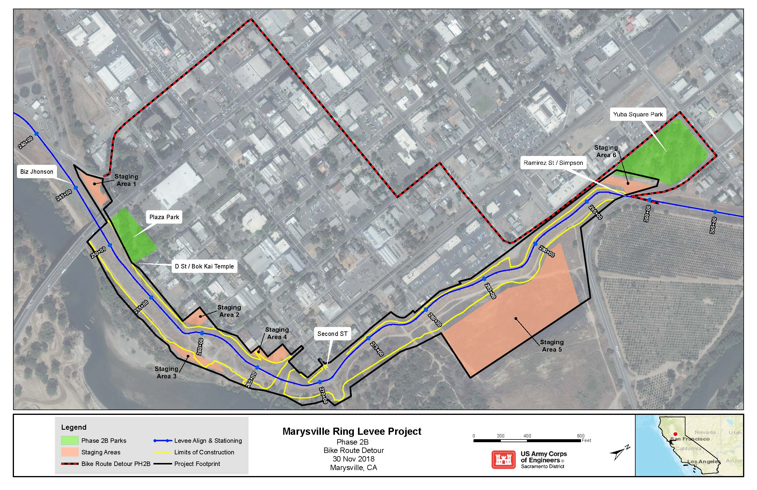
Figure 9. Phase 2B Bike Route Detour.

There would be six staging areas in Phase 2B that would provide useable locations for parking, deliveries, equipment storage, and stockpiling. Staging Area #6 is positioned between Yuba Square Park and the landside embankment of levee Segment L1. Use of this staging area would have short-term effects on the recreational use in Yuba Square Park during construction activities due to increased traffic and noise. Additionally, this could have short-term impacts on the Juneteenth celebration due to traffic and noise from construction and vehicles. Staging Area #1 is located less than 400 feet from Plaza Park with Levee Road/HWY 20 and Simpson Lane/Ramirez Road as access points and haul routes, there would be an increase in traffic along entry routes used by recreationalists. Use of this staging area would have short-term effects on the recreational use in Plaza Park during construction activities due to increased traffic and noise.
Phase 3
Construction of the levee in Phase 3 would have short-term effects on recreational use along the levee crown. The road on top of the levee in Phase 3 would be closed to public use during the construction period, which would occur between April and October from 2020 to 2022; Figure 10 identifies the alternate bike route through adjacent neighborhoods. The paved road on top of the levee crown would be restored to preconstruction condition. The following pedestrian access points would be fenced off and closed during construction:
- Simpson Lane/Ramirez Road and the levee crown
- East 26th Street at Jack Slough Road and the levee crown
- Cheim Blvd and Olson Court (stairwell)

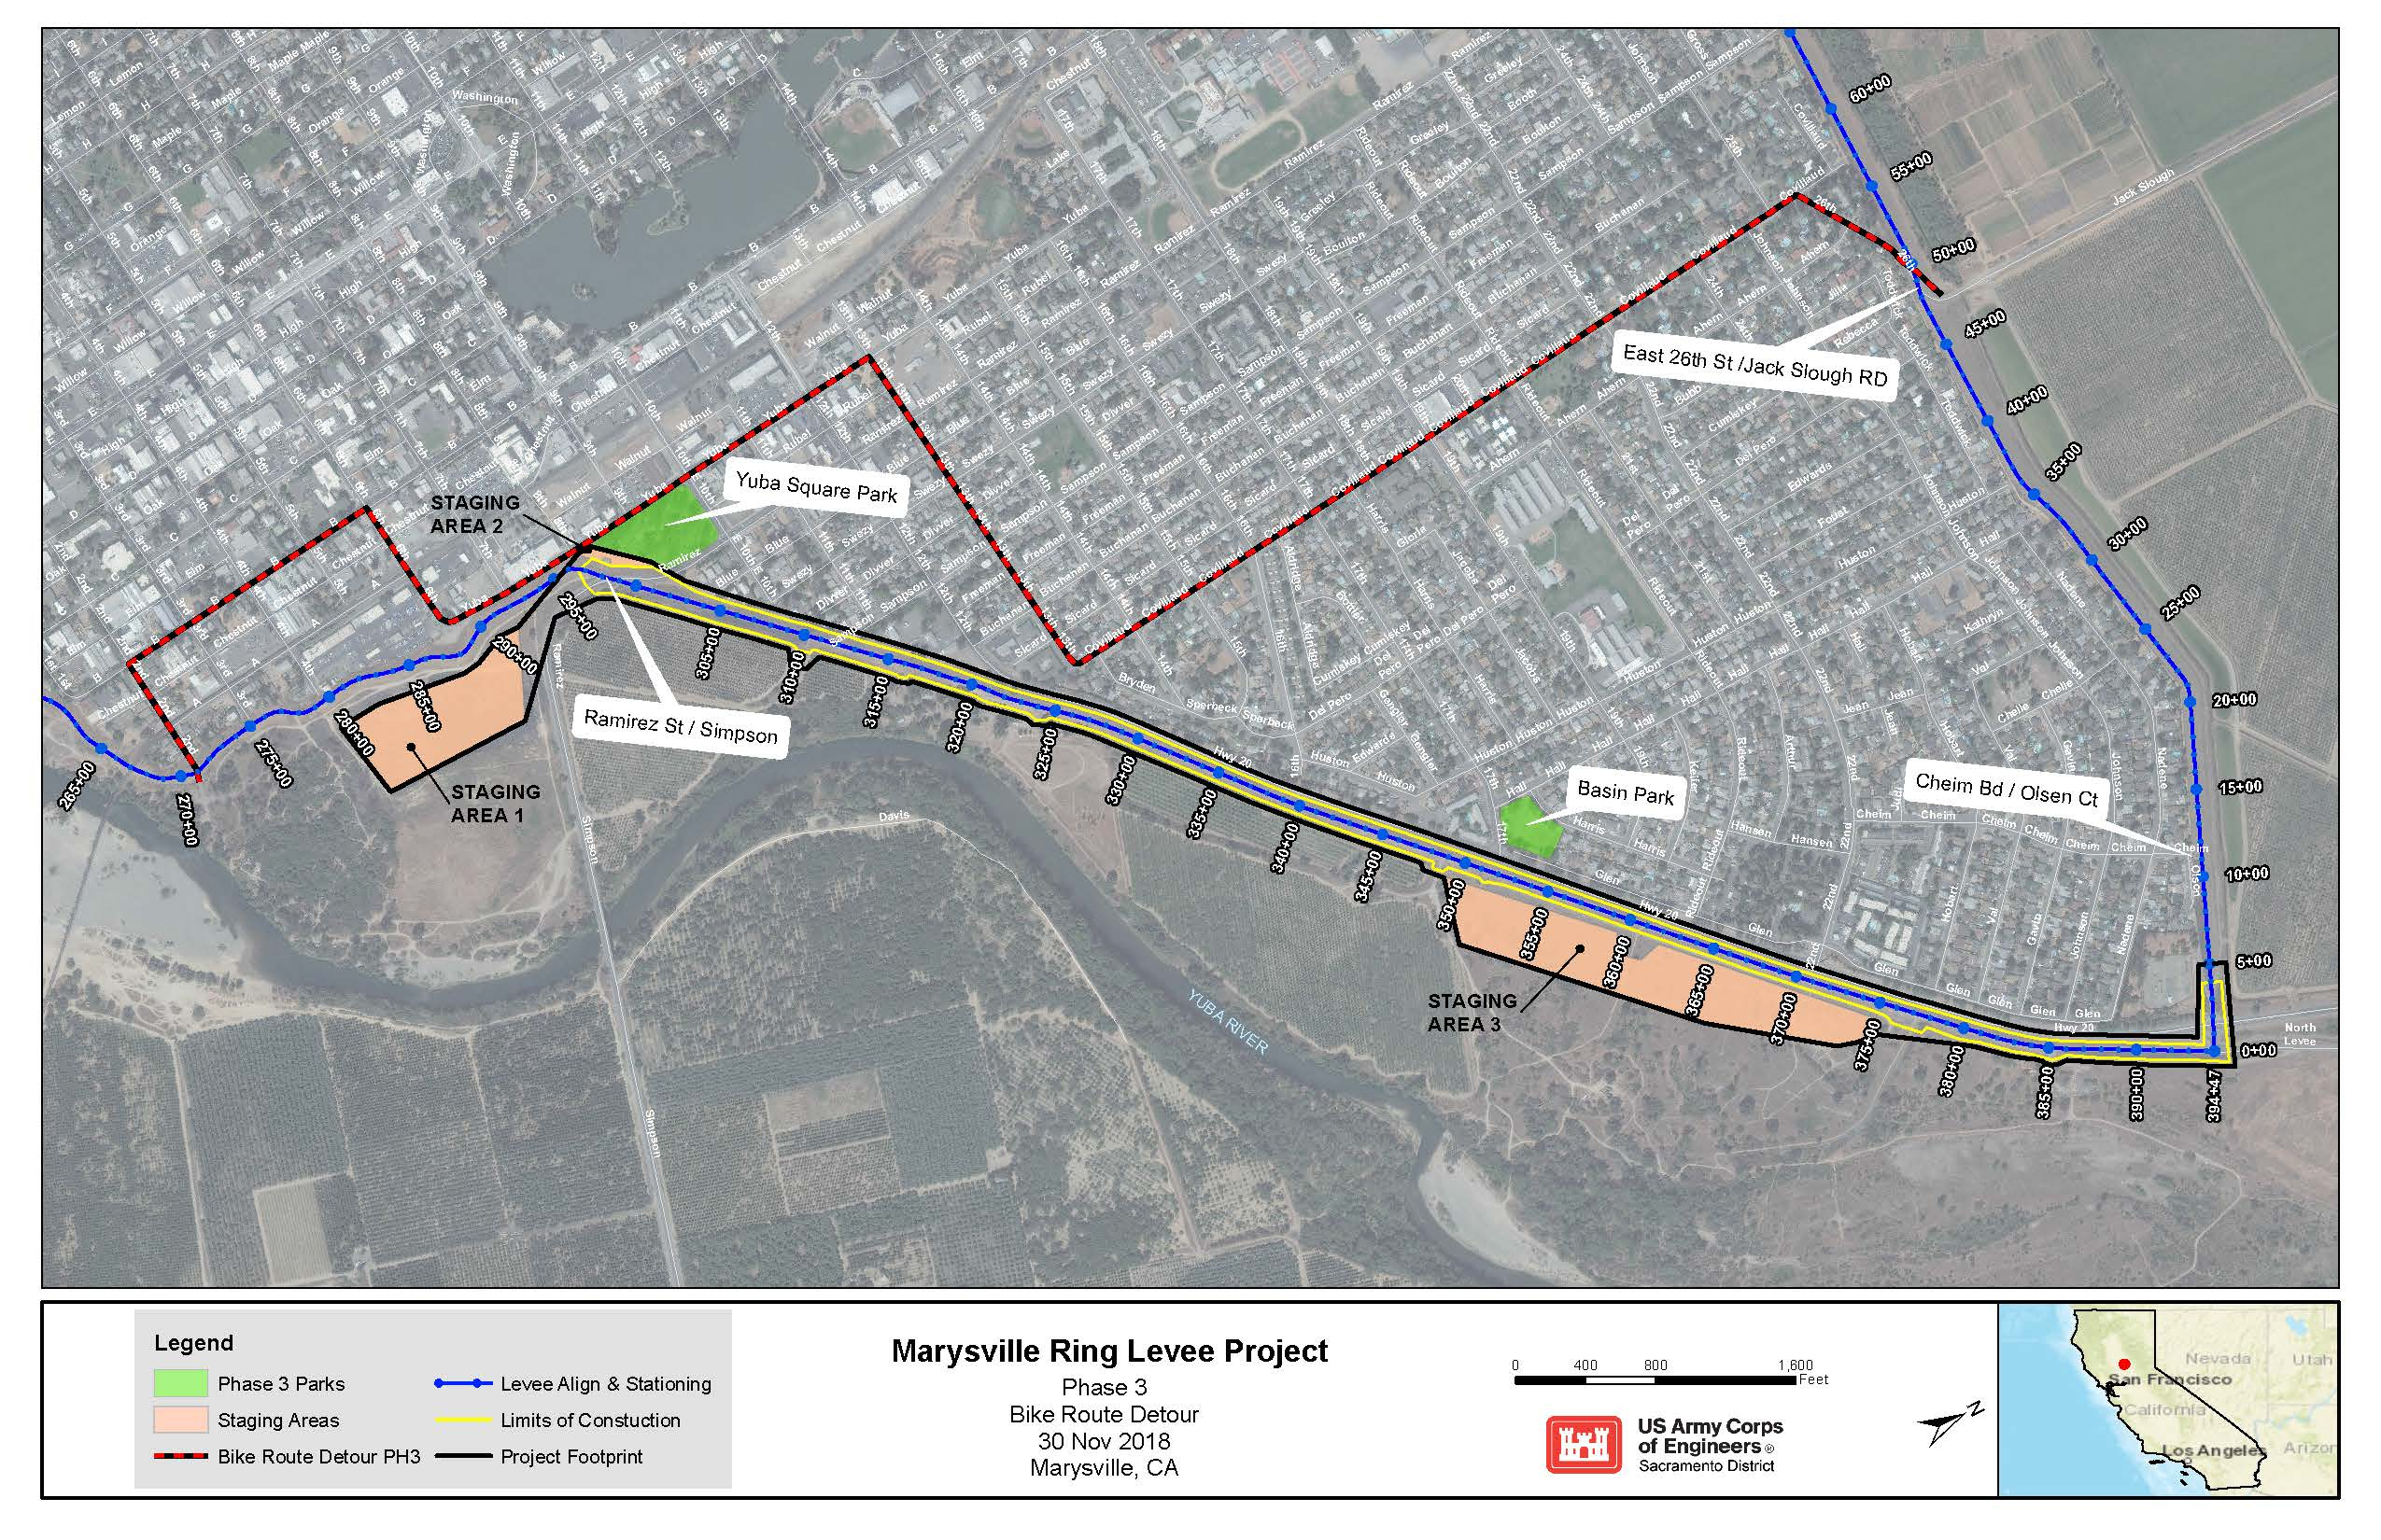
Figure 10. Phase 3 Bike Route Detour.

There are two staging areas in Phase 3 along the waterside toe of the levee that would provide useable locations for parking, deliveries, equipment storage, and stockpiling. The staging areas are not adjacent to any community, residential or passive parks. However, there is also a staging area (Staging Area #2) located along the landside levee toe with an access point and haul route along Simpson Lane/Ramirez Road adjacent to Yuba Square Park. This could have short-term impacts on the Juneteenth celebration due to traffic and noise from construction and vehicles. Additionally, construction in Phase 3 is located less than 400 feet from Basin Park with a construction access point and haul route along HWY 20. This would result in an increase in traffic along entry routes used by recreationalists. The increase in traffic and noise due to construction would have short-term effects on recreational use in Basin Park.

3.2.5.3 Mitigation
Although there would be short-term disruptions to recreation in and adjacent to the Project Area, these disruptions would be reduced to less-than-significant levels with implementation of the mitigation measures described in Table 14, in addition to those applicable from the 2010 EA/IS.
Table 14. Recreation Mitigation Measures.
Number | Measure
REC-1 | All areas affected by construction activities as well as any recreational roadways and paths would be restored to their original condition.
REC-2 | All closed construction and recreational areas would have large and identifiable closure signs to assist in public safety.
REC-3 | Closed recreational routes would have detour signs to provide recreationists with an alternate route.

3.2.6 Cultural Resources

3.2.6.1 Environmental Setting
The term cultural resources is broadly defined as the buildings, structures, objects, sites, districts, and archeological resources associated with historic or prehistoric human activity. These cultural resources are listed in, or eligible for listing in, the National Register of Historic Places (NRHP) and are referred to as “historic properties” when they have been determined eligible for listing or are listed in the NRHP. Such properties may be significant for their historic, architectural, scientific, or other cultural values and may be of national, state, or local significance.
Cultural resources are representative of broad patterns, themes, events and people in prehistory and history. For the purposes of this Proposed Action, prehistory includes the Native groups that inhabited the Project Area before contact with the Spanish and later Europeans and white explorers; history includes the broader scope of exploration of northern California and the people and events that brought settlement to the Marysville area.
Prehistory
Centuries before modern influences invaded the area around the Yuba and Feather Rivers the Valley Nisenan inhabited the area. The Nisenan were the dominant Native American group between modern Sacramento and Marysville. The Nisenan have ethnographic origins in the Maidu people and their homeland in the northern Sierra Nevada.
The Nisenan were a southern linguistic group of the Maidu people, sometimes referred to as the “Southern Maidu.” The name “Nisenan” was a self-designation by the native groups occupying the Yuba and American River drainages (Wilson and Towne 1978). Along with the Maidu and Konkow, the Nisenan formed a subgroup of the California Penutian linguistic family. The Nisenan covered a significant portion of the Central Valley and reached into the Sierra Nevada.
The Nisenan often inhabited areas near rivers; some major areas of significance included sites on the American, Sacramento, Bear, Feather, and Yuba Rivers. The basic political unit was a village community or tribelet with one primary village and a few satellite villages under one head authority. The Nisenan mostly settled in permanent or winter settlements and followed a yearly gathering cycle that led them away from the lowlands and into the hill country each summer. During the annual gathering cycle, the Nisenan harvested acorns, nutmeg, pine nuts, buckeyes, and sunflower seeds and often stored these for long periods. Other vegetation such as greens, tule and cattail roots, brodiaea bulbs, manzanita berries, blackberries, and California grapes was harvested and eaten as they ripened. All valley groups, including the Nisenan, fished trout, perch, chub, sucker, hardhead, eel, sturgeon, and Chinook salmon. Fishing methods included hook, net, harpoon, trap, weir, and poison (Moratto 1984).
History
Early Spanish contact occurred at the southern end of Nisenan territory as the Spanish, notably José Canizares in 1776, explored Miwok land. Although there is no record of the Nisenan removal to the Spanish missions, by the late 1820’s, white settlement began to encroach on Nisenan land as American and Hudson’s Bay Company trappers began to trap beaver in the Nisenan territory under peaceful occupation. In 1833, a disease, believed to be malaria, swept through the Sacramento Valley and decimated the valley Nisenan. An estimated 75 percent of the native population was killed; as a result, there were very few Nisenan left in the valley to face the settlers and gold miners who came soon after the epidemic.
By January 1850, the discovery of gold in Coloma in 1848 encouraged development in the area, and a town was laid. Mary Murphy Covillaud, wife of Charles Covillaud and Donner party survivor, received the honor of having the new town of Marysville named for her (Hoover, et al. 1990). With the discovery of gold in the Nisenan territory, the remaining natives were killed; their villages were destroyed; and they were persecuted. White settlers and miners called the Nisenan “diggers” and quickly destroyed them as a viable culture (Wilson and Towne 1978).
The location of Marysville made it an ideal center of trade for the northern mines. As the head of navigation on the Feather River, Marysville had the superior location along the river because the distance to the north and east mines was not great. Riverboat cargoes could be readily transported via pack-mule to gold fields farther afield, and as a result, the city of Marysville experienced amazing growth due to its position along the Yuba and Feather Rivers (Hoover, et al. 1990).

Marysville history is intertwined with the history of the Gold Rush. Due to the promise of massive fortune, thousands of people flooded the area starting in 1849. The Chinese came to Marysville at the same time, and their influence in the city’s development is still visible in the old town area of Marysville and the Bok Kai Temple at the lower end of D Street. To the Chinese, Marysville was known as Sam Fou, or “the third city,” due to its large population, only exceeded by the populations of San Francisco and Sacramento (California Office of Historic Preservation 2002). The earlier Chinese settlers of Marysville emigrated from the Canton Province of the Kwang Tung state of China (Marysville Chinese Community 2002).
As the Chinese came to the Marysville area, they brought along their myths, idols, customs, and religion. In 1854, the Chinese of Marysville erected the Bok Kai Mui Temple to house their gods and worship. After the original temple was destroyed, a new location of worship, the Bok Kai Temple, was built in 1880 about two blocks from the original structure. Since 1974, the Bok Kai Temple has been the focus of a continual restoration project supported by the entire Marysville community (Marysville Chinese Community 2002).
After the mining activities in the Marysville area diminished, the building of the Central Pacific Railroad quickly took over as a major source of Chinese employment. Eventually, both the Southern Pacific and Northern Pacific Railroads ran through the city as supply routes. Before construction of the Central Pacific Railroad began, engineer Theodore Judah suggested that Marysville was an ideal town to connect to the direct Central Pacific line. Although he was overruled, the railroad did eventually connect with Marysville, which further shortened the length of time supplies took to reach the city and therefore increased business (Shouter 2000).

3.2.6.2 Effects
Significance Criteria
Any adverse effects on cultural resources that are listed or eligible for listing in the NRHP are considered to be significant. Cultural resources listed or eligible for listing in the NRHP are considered “historic properties” and must undergo particular evaluation of effects in order to determine if an alternative is adverse. An alternative would be considered to have a significant adverse effect on historic properties if it diminishes the integrity of the resource’s location, design, setting, materials, workmanship, feeling, or association. Types of effects include:
    - Physical destruction, damage, or alteration of all or part of the historic property;
    - Isolation of the historic property from or alteration of the character of the historic property’s setting when that character contributes to the historic property’s qualifications for the NRHP;
    - Introduction of visual, audible, or atmospheric elements that are out of the character with the historic property or alter setting;
    - Neglect of a historic property, resulting in its deterioration or destruction; and,
    - Transfer, lease, or sale of the historic property.
Significance criteria is also provided under CEQA Guidelines, which include:
- Substantial adverse change in the significance of a historical resource as defined in § 15064.5 of the CEQA Guidelines;
- Directly or indirectly destroy a unique; paleontological resource or site or unique geologic feature;
- Disturb any human remains, including those interred outside of formal cemeteries;
- Listed or eligible for listing in the California Register of Historical Resources, or in a local register of historical resources as defined in Public Resources Code section 5020.1(k);
- A resource determined by the lead agency, in its discretion and supported by substantial evidence, to be significant pursuant to criteria set forth in subdivision (c) of Public Resources Code Section 5024.1. In applying the criteria set forth in subdivision (c) of Publics Resources Code Section 5024.1, the lead agency shall consider the significance of the resource to a California Native American tribe.
Alternative 1 (No Action)
Under the No Action Alternative, USACE would not construct the MRL improvements. As a result, there would be no adverse effect on existing cultural resources or historic properties in or near the APE.
Alternative 2 (Proposed Action)
The history of the city of Marysville shares many common themes with other northern California towns established during the Gold Rush. Native Americans, the railroad, mining, and the Chinese all had considerable influence in Marysville’s history. As a result, the majority of the known resources within the Project Area are related to these historic themes. For the purposes of the Proposed Action, the archeological area of potential effects (APE) includes an area more expansive than the Phase 2B and 3 Project Area (Figures 11 and 12). There are known historic resources that are partially within the Project Area and expand to areas outside this area. Although those portions of the historic resources are not within the Project Area, they must be inventoried and evaluated as being potentially affected by the Proposed Action.

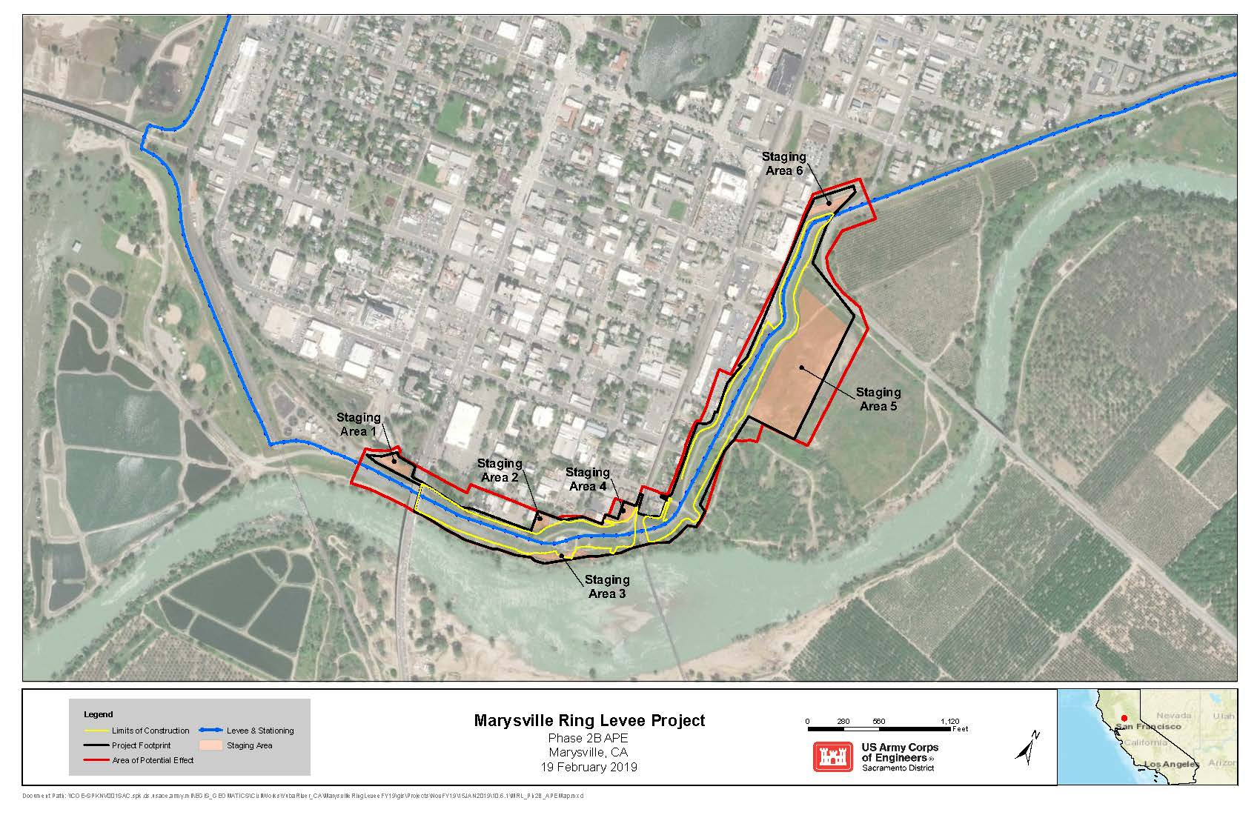
Figure 11. MRL Phase 2B Cultural Resources (APE) Map.
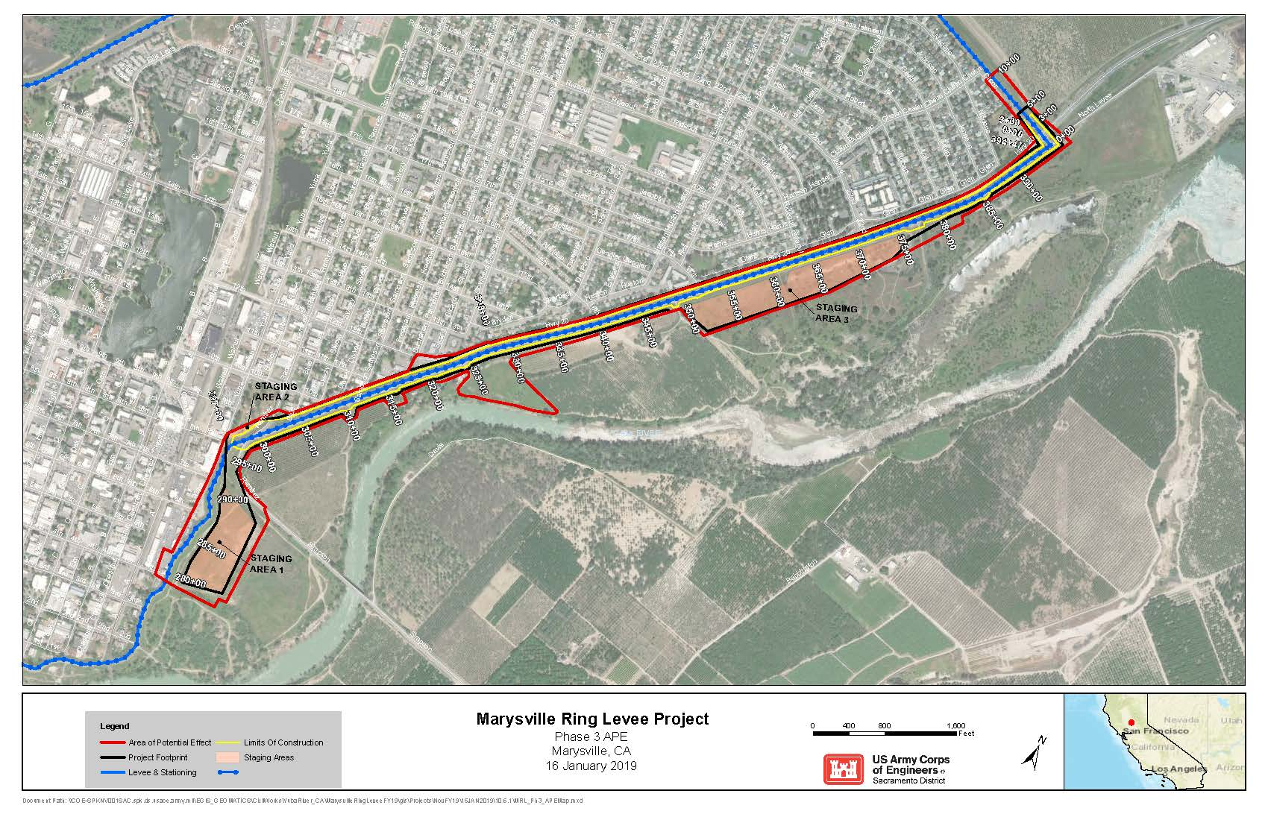
Figure 12. MRL Phase 3 Cultural Resources (APE) Map.

Existing Cultural Resources and Historic Properties
Within the APE there are no known existing prehistoric sites. Since the city of Marysville was established in 1850 there has been extensive development in the city and surrounding areas, including the construction of the levees and areas along the river banks. The 2010 cultural resources inventory identified three known cultural resources within the Phase 2B and 3 APEs, including the Bok Kai Temple, the Marysville Ring Levee, and the Yuba River Sand Company Plant. A short description of each resource is given below. In addition to these, one other potential historic property, the Southern Pacific Railroad Bridge, Grade, and Viaduct, was also identified, however, the grade is still active and the Proposed Action will not have direct or indirect adverse effects on the grade.
Bok Kai Temple. The Bok Kai Temple is located in Marysville’s Chinatown and was built in 1880. Located on D Street immediately adjacent to the landside levee slope and toe, the temple is also the focal point of the Bomb Day festival, which is held every year on the second day of the second month of the Chinese lunar year. The Bok Kai Temple is listed as a California Registered Historical Landmark and a State Point of Historic Interest. In addition, it is included in the California Inventory of Historic Resources, is listed in the NRHP and in 2001 the National Trust for Historic Preservation listed the Bok Kai Temple as one of America’s 11 Most Endangered Historic Places. The temple was nominated to the NRHP in 1974 for consideration as a site of significance due to its architectural and religious aspects. The Bok Kai Temple is the only temple in the United States that honors Bok Eye, the Chinese Water God, and is unique for its interior wall paintings and murals, gilded alters, painted statuary, and elaborately embroidered ceremonial banners and lanterns.
The Bok Kai Temple is not within the direct Project Area of construction, but due to the close proximity of construction and the sensitivity of the historic resource, the temple is considered within the archaeological APE. At this location a secant pile wall would be constructed. A series of 3- to 4-foot diameter holes would be drilled into the earth by a drill rig. These holes may be cased with a steel pipe which can be vibrated or oscillated into the ground at the perimeter of the holes. The boreholes are backfilled with Portland cement concrete using a concrete pump truck. Steel reinforcing may be added to provide additional strength. Due to the close proximity of the temple and the sensitivity of the structure and artwork the temple has undergone specific investigation to determine its ability to withstand vibration and construction effects.
Marysville Ring Levee. After the floods of 1875 the MRL was modified from its original 1868 construction to generally the same location and design as is seen today.
There have been substantial additions and modifications such as earth fill (1907, 1942 and 1956), dredge tailings (1908), and various raises and reshaping in the 134 years since the levee construction. The levee surrounds the city of Marysville in its entirety and is a standard trapezoidal shaped earthen levee. In some places railroad tracks, berms, roads and other utilities cross or run parallel to the levee. The MRL would undergo a number of different construction methods, including jet grouting, construction of slurry walls, installation of secant pile walls, and construction of berms. Except for the Phase 4 construction where seepage/stability berms would be constructed, upon completion of construction it would not be outwardly visible that construction has occurred at the location. Additionally, the MRL has undergone countless physical modifications in its 134 year history in order to keep the system viable as flood protection for the city and as a result any NRHP eligibility of the levee would not be related to its visual integrity. Due to its significance as a flood protection feature for Marysville and because it has played an important role in the city’s history the Marysville Ring Levee has been found eligible for listing in the NRHP.
Marysville Sand Company Plant. The remains of the Marysville Sand Company Plant are located on the waterside of the southern portion of the MRL, near 1st Street and between B and C Streets in downtown Historic Marysville. The Marysville Sand Company is located on a wide portion of the berm between the ring levee and the Yuba River. The Marysville Sand Company originally began to dredge and process sand from this location in 1915. There were prior sand and gravel dredging operations at this location in the 1880s and 1890s when the Western Pacific Railroad drove much of the sand and gravel business. Sand was dredged from the Yuba River located south of the site location, processed through various methods such as fire kilns to dry it, or directly loaded onto railroad cars from the Western Pacific and Southern Pacific railway lines located nearby. The sand was generally used by the railroad companies to help cool the friction that occurred on the railway tracks and as engine sand for steam engines. Sand processing continued at this location well into the 1960s and 1970s and was abandoned sometime in the last 30 years (Lamon 2009).
Since abandonment, most of the features that typified a sand processing plant have been removed and very little remains to indicate the original use of the site. In the last decade the concrete walls and foundations have been heavily vandalized and the area has been used for dumping and other illegal activities. At this location the area would be used for staging of equipment and materials and the remaining features of the sand plant would be removed. The Marysville Sand Company Plant has been found not eligible for listing in the NRHP. Although sand processing was an important contributor to the railroad industry in this area it is not a unique activity since several other sand and gravel plants operated nearby. Additionally, most of the original features of the plant have been removed and the integrity of the plant has been heavily compromised.
In 2017, additional historic property identification measures were undertaken within the Phase 2 and 3 APEs. These measures included an ethnographic study, an updated cultural resources inventory, and geoarchaeological subsurface testing. The additional measure were completed to update the cultural resource inventory and to address concerns regarding the potential for prehistoric sites within the APE, which were expressed by Native American tribes after the 2010 Section 106 consultation was complete. As a result of the additional inventory and testing, nine potential historic properties were identified. These include:
- Sacramento Northern Railroad Grade
- Southern Pacific Railroad Bridge, Grade, and Viaduct
- SL-02–three historic-era concrete foundations
- SL-03–historic-era, concrete loading platform
- Levee Road, Hipped-Roof Residence
- Nelson Spur Levee
- Industrial Building (1474 Levee Road)
- SW-02–buried historic-era materials
- SW-03–buried discreet ash lens (thermal feature)
In addition, to the potential historic properties previously outlined, 12 buildings contributing to the National Register-listed Marysville Historic Commercial District are also within the APE. A full list of these properties are presented in Table 15 below. Planned construction measures will avoid all of these buildings and will have no adverse effects to the characteristics that make these properties eligible for listing in the National Register.
Table 15. Buildings contributing to the NRHP-listed Marysville Historic Commercial District.
Address | Description | Parcel No. | Construction Date
226 1st Street | One-story brick | APN 010 300 017 | circa 1888
228 1st Street | Two-story brick | APN 010 300 015 | 1858
230 1st Street | Two-story brick | APN 010 300 014 | 1860
232 1st Street | Two-story brick | APN 010 300 013 | 1858
310 1st Street | Two-story brick | APN 010 300 055 | circa 1860
312 1st Street | Two-story brick | APN 010 300 055 | circa 1860
320 1st Street | Two-story brick | APN 010 300 005 | circa 1860
322 1st Street | Two-story brick | APN 010 300 004 | 1858
330 1st Street | Two-story brick | APN 010 300 052 | circa 1854
25 C Street | One-story brick building with stucco finish | APN 101 300 035 | circa 1860
East of 25 C Street | One-story brick | APN 010 300 034 | circa 1925
7 D street | Two-story brick | APN 010 300 053 | circa 1887
Following USACE’s November 30, 2018, consultation under 36 CFR § 800.13, post review discoveries, carried out with interested Native American Tribes and the SHPO, only three of the potential historic properties (SL-03, SW-02, and SW-03) were found to be within areas of potential impacts, thus they could not be avoided by the Proposed Action undertaking. Descriptions of these three properties are provided below.
SL-03. SL-03 is within Staging Area 6 that will also be used during Phase 2B construction activities. It is a split-elevation, concrete, loading dock with steel, angle-iron, and wooden edging that is situated on the landside of the levee. This rebar reinforced structure is approximately 37 feet long by 22 ½ feet wide. The eight-foot-wide southern tier is just over three feet high on the western end, while the sloping ramp on the eastern end is approximately 12 feet long from grade to the height of the loading platform.
The northern tier is approximately 14 feet wide and just over two feet high at the western end; the eastern ramp is roughly 17 feet long. Aside from the structure, no other artifacts, structure, buildings, or objects were found in association.
SW-02 Area of Archaeological Potential. SW-02, is within Staging Area 2 to be used during cutoff wall construction on Phase 2B. The SW-02 area consists of a discrete feature representing historic-era trash pit or backfilled privy. It was discovered in an empty lot adjacent and south of 1st Street during subsurface testing. A rectangular dark brown stain with butchered bone and other refuse was observed at 70 centimeters below surface (cmbs), measuring roughly 70 cm in length (long axis of trench) by 105 cm in width. However, the feature extended into the eastern and western trench walls and was not fully defined. Screening of the disturbed feature matrix produced a large concentration of saw-cut mammal bone, Chinese ceramics and porcelain, a nearly complete opium pipe bowl, glass marble, and other glass fragments. The testing excavation was terminated when the feature was first encountered, so the full depth of the deposit remains unknown. The single temporally diagnostic artifact suggests this trash deposit dates to circa 1870–1890, and is associated with the Chinese community that historically occupied this portion of Marysville.
SW-03 Area of Archaeological Potential. SW-03 was also identified during the geoarchaeological testing. The area was identified on the waterside of the levee, approximately 54 feet from the toe of the levee, and an estimated 70 plus feet from the placement of the cutoff wall to be constructed. The SW-03 area consists of a feature exposed along the waterside (east) of the levee. It was first encountered at 210 cmbs. The discrete, basin-shaped, ash feature was observed beginning at 225 cmbs and measured 120 cm in length. As viewed in cross-section, the ash lens was 11 cm thick at the center and tapered to a common surface on both edges. No burned earth or other evidence of in situ burning (e.g., large charcoal fragments) was observed, suggesting the dense ash deposit may be a secondary dump, possibly a hearth cleanout or the remains of a burned structure. Macrobotanical samples collected from the feature suggests that it may be a mix of traditional Native California occupation residue and Euro-American material possibly associated with a post-contact, Native settlement. However, it is also possible that the historic-era feature is superimposed on an earlier, pre-contact archaeological deposit.
This alternative would have no adverse effects on existing historic properties that are listed, or are eligible, for listing in the NRHP. There are 17 known cultural resources within the APE. Two of the cultural resources, the Marysville Sand Company Plant and SL-03 (loading dock), have been determined not eligible for listing in the NRHP, with SHPO concurrence and would not be affected by the Proposed Action. Two of the historic properties, the Marysville Ring Levee and the Bok Kai Temple, are considered eligible, or are listed in the NRHP.
The Marysville Ring Levee is a historic property eligible for listing on the NRHP. The levee is eligible for listing due to its role as a flood protection feature for Marysville and because it has played an important part in the city’s history. Construction of the Proposed Action would not affect those characteristics that make the levee eligible for listing in the NRHP. As a result, there would be no effect to the Marysville Ring Levee and no mitigation would be required. This determination received SHPO concurrence in 2010.

The Bok Kai Temple is a property that is listed in a number of local and state historic registers and is listed in the NRHP. The Bok Kai Temple is located near the landside toe along a portion of the Phase 2B Project Area. Proposed activities in this area would include installation of a soil bentonite (SB) cutoff wall to a depth up to 90 feet deep constructed below the levee crown centerline. One of the advantages of this type of construction is that it minimizes the level of vibration and possible effects to the Bok Kai Temple, which is considered structurally sensitive.
In order to assess the structural sensitivity of the temple, USACE Structural Engineers completed a visual inspection of the temple on October 14, 2009. They concluded that the Bok Kai Temple appeared to be very sound structurally for its age. The foundation and footings of the overall structure were observed to be well-constructed brick spread footing, which allowed the weight of the structure to be distributed over a larger footing area, thus reducing the potential for settlement. The footings of the structure appeared robust and additional structural beams were observed in sensitive locations in the temple. Some small cracks were observed in the exterior walls of the building, but conservation work such as removal of the heavy clay tile roof and replacement of two timber columns at the temple’s entrance were noted as efforts that have improved the temple’s structural stability.
Based on the current level of design, an analysis of the Proposed Action was initiated by USACE Structural Engineers. The results of the analysis has determined that the installation of the cutoff wall and associated construction activity in the area, such as equipment hauling, would not likely result in vibrations that would have a significant effect on the Bok Kai Temple. In addition to this structural analysis, a USACE Civil Engineer conducted an evaluation of Proposed Action construction. The construction analysis was based on the structural analysis and applied vibration level equations from the Caltrans Transportation- and Construction-Induced Vibration Guidance Manual. A determination was then made on whether the Bok Kai Temple would likely be adversely affected by the proposed construction in Phase 2.
The Caltrans vibration manual provides estimates of the vibration generated by construction equipment, which is specific to the types of equipment used on the site. For the proposed construction, cutoff wall with associated earthwork, wall will be installed using an open trench, slurry method of construction. Of the proposed construction in Phase 2B, the largest vibration would be generated by trench excavation, slurry mixing, and use of heavy equipment. The Caltrans vibration manual provides the following equation to determine the vibration level from construction equipment associated with this kind of construction:
PPVEquipment = PPVRef(25/D)n (in/sec) (Equation 10)
The Caltrans vibration manual provides a reference value of 0.089 PPV (peak particle velocity) at 25 feet for drilling pile foundations. “D” is the distance from the equipment to the structure receiving the vibration. The analysis from USACE Civil Engineer used a conservative value of 40 feet for “D” and 1.1 for “n” as recommended by the Caltrans vibration manual. Based on these conservative values and the current level of design, it was determined the value of vibration would be:
PPVEquipment = 0.05

The Caltrans vibration manual lists the value for the most fragile buildings (including ruins and ancient monuments) as 0.08. It was determined (taking into account the conclusions from USACE), that the Bok Kai Temple is unlikely to be as weak as those structures, and is more likely to be in the fragile or historic category (e.g. max PPV of 0.1 to 0.25). Therefore, it was concluded that the proposed construction of a cutoff wall would likely produce less vibration than the threshold value for continuous sources for the most conservative case, and as a result, the Bok Kai Temple is unlikely to be damaged by vibrations due to cutoff wall installation.
However, during the Phase 2B detailed engineering design, and in accordance with stipulations contained in a Memorandum of Agreement (MOA) for the Bok Kai Temple for this undertaking, USACE will conduct a more extensive analysis of the potential construction affects and monitoring measures that can be implemented to protect the temple and ensure that there are no adverse effects to the resource. To ensure that vibration levels would be kept at a level that would not adversely affect the temple, a variety of precautionary construction methods and seismic monitoring would occur during Proposed Action construction in accordance with the recommendations of USACE Structural Observations and Analysis, USACE Civil Engineers, and the MOA.
Recommendations include:
    - Pre-design surveys to determine potentially affected structures;
    - Pre- and post-construction surveys for visual record;
    - Limitation of heavy equipment speeds along the work areas to reduce ground vibrations (e.g. maintain scraper speeds below five miles per hour within 500 feet of the Bok Kai Temple);
    - Choice of construction methods that would mitigate vibration effects;
    - Limitation of vibrations from compacting equipment (e.g. kneading or tamping foot compactors instead of vibrating drum rollers);
    - Use of accelerometers, seismometers and inclinometers to monitor structures;
    - Visual inspection by trained field personnel and other monitoring equipment used to measure ground motion; and,
    - Conduct pre-construction training for contractor employees.
During construction of Phase 2B vibratory equipment would be used within the APE and near the Bok Kai Temple to monitor the vibrations from the construction and equipment. In the event that vibrations reach a level that would possibly result in damage to the temple, construction activities in the area would be reduced. The seismic monitoring and compliance with the stipulations of the MOA would ensure that there would be no adverse effects to the Bok Kai Temple and therefore no mitigation would be required.
For the purposes of the Phases 2B and 3 Project, the Corps is assuming that potential historic properties SW-02 and SW-03 are eligible for listing in the National Register of Historic Places (NRHP) under Criterion D (36 CFR § 800.13[c]).

Based on the extent of buried features and materials identified, both areas have the potential for scientific archaeological data that can provide additional information important to the history of the region. Project conditions will be imposed for Staging Area 2 to avoid ground disturbance and adverse effects to SW-02. The no ground disturbance condition will be added to the Phases 2B and 3 specifications, which will also be stated in the solicited construction contract. Vegetation removal within the staging area will be restricted to mowing only and no ground leveling will be allowed.
Project conditions are also being imposed for SW-03, the second area of buried archaeological potential. The buried component was encountered at a depth between 6.5 and 7 ft. below the ground surface and it appears to be in close proximity to the construction right-of-way for the levee patrol road near the waterside toe of the levee. The constructed width of the road will be a maximum of 15 feet wide. The road will be excavated to a depth of 1.5 to 2 feet deep to allow for the installation of road base. The depth of disturbance for the road is not expected to impact the buried component, however, to ensure that additional buried deposits are not encountered in the area, an archaeological monitor will be present during all phases of ground disturbing construction.

3.2.6.3 Mitigation
Currently there are two existing historic properties, the Bok Kai Temple and the Marysville Ring Levee and two additional potential historic properties–SW-02 and SW-03 within the APE. As the Proposed Action is designed and within the previously outlined stipulations, these historic properties would not be adversely affected by the MRL Project. The Proposed Action would have no adverse effects on any historic properties listed in, or eligible for listing in, the NRHP and, therefore, mitigation measures are not warranted. USACE Civil Engineers completed a vibration level study for the Bok Kai Temple and determined that it is unlikely to be damaged by vibrations due to cutoff wall installation. However, to ensure that vibration levels would be kept at a level that would not adversely affect the temple, a variety of precautionary construction methods and seismic monitoring would occur during construction in accordance with the recommendations of USACE Structural Observations and Analysis, USACE Civil Engineers, and the MOA.

As with all earth disturbing projects, the potential for unanticipated discoveries is possible. In the event that archeological deposits are found during Phases 2B and 3 construction activities, work would be stopped pursuant to 36 CFR 800.13(b), post-review discoveries, to determine the significance of the find and, if necessary, complete appropriate discovery procedures.

3.2.7 Traffic and Circulation

3.2.7.1 Environmental Setting
The Traffic and Circulation Section of the 2010 EA/IS (USACE 2010) sufficiently characterizes the affected environment and management for this resource.

3.2.7.2 Effects
Significance Criteria
An action would be considered to have a significant effect on transportation if it would result in any of the following:
    - Substantially increase traffic in relation to existing traffic load and capacity of the roadway system.
    - Substantially disrupt the flow and/or travel time of traffic.
    - Expose people to significant public safety hazards resulting from construction activities on or near the public road system.
    - Reduce supply of parking spaces sufficiently to increase demand above supply.
    - Conflict with an applicable plan, ordinance or policy establishing measures of effectiveness for the performance of the circulation system, taking into account all modes of transportation including mass transit and non-motorized travel and relevant components of the circulation system, including but not limited to intersections, streets, highways and freeways, pedestrian and bicycle paths, and mass transit.
    - Conflict with an applicable congestion management program, including, but not limited to level of service standards and travel demand measures, or other standards established by the county congestion management agency for designated roads or highways.
    - Result in a change in air traffic patterns, including either an increase in traffic levels or a change in location that results in substantial safety risks.
    - Substantially increase hazards due to a design feature (e.g., sharp curves or dangerous intersections) or incompatible uses (e.g., farm equipment).
    - Result in inadequate emergency access
    - Conflict with adopted policies, plans, or programs regarding public transit, bicycle, or pedestrian facilities, or otherwise decrease the performance or safety of such facilities.
Alternative 1 (No Action)
Under the No Action Alternative, there would be no improvements to the Marysville Ring Levee. Routine operation and maintenance would continue on the existing levee. The existing freeway/roadway network, public transportation, bicycle and pedestrian facilities, as well as types of traffic and circulation patterns would remain the same. However, based on the Transportation Concept Reports (TCRs) for Highway 20 and Highway 70, traffic volumes are expected to increase within the current 20-year planning period (CalTrans 2013; CalTrans 2014).
Alternative 2 (Proposed Action)
Construction of the Proposed Action would have short-term effects on traffic and circulation. Construction activities could affect the type, volume, and movement of traffic, as well as public safety in and near the Project Area.
Level of Service (LOS) is commonly used to describe roadway traffic volumes. LOS is a general measure of traffic conditions, whereby a letter grade, from A (the best) to F (the worst), is assigned. Typically, within the urban areas of Sutter and Yuba counties, HWY 20 and HWY 70 are designated as LOS E.
HWY 20, HWY 70, Simpson Lane/Ramirez Road, and the crown of the levee would be the primary haul and access routes for the duration of construction. All other roads used during construction are dependent on the work Phase. Truck hauling during construction would increase traffic and could decrease the LOS on both highways from LOS E to LOS F. An increase in traffic could also slow down public transportation routes and schedules throughout Marysville. The traffic increase would result in a short-term impact to the roadways; however, after completion, roadway traffic would return to pre-construction conditions.
The peak month ADT is the average daily traffic for the month of heaviest traffic flow. On many routes, peak month ADT is more representative of traffic conditions than the annual ADT due to high traffic volumes that occur during certain seasons of the year. For the City of Marysville in Yuba County, the peak month ADT for HWY 70 South is approximately 28,000, HWY 70 North is approximately 46,900, and HWY 20 is approximately 29,650 (CalTrans 2016).
The crown of the levee is used for maintenance activities, bicycle riding, jogging, walking, and vehicle traffic. During construction, the crown of the levee would be temporarily closed to all pedestrians and bicyclists in the construction location. An alternate route through adjacent neighborhoods is identified in Section 3.2.5 (Recreation). This effect would be temporary and the road would be returned to its present condition after construction is complete.
Phase 2B
Construction would have temporary impacts on HWY 70, 4th Street, F Street and Bizz Johnson Drive for access onto the levee. A maximum of 50 construction workers would be onsite each day while the cutoff wall is being constructed. These workers would access the area via regional and local roadways, and park their vehicles at one of the staging areas identified. No construction-related vehicles would be parked along regional roadways or nearby residential areas. As a result, there would be no effects on parking supply or availability.
Rail traffic in Phase 2B occurs throughout the day in both directions. Construction activities would be permitted within 25 feet of the centerline of operational tracks only with approval from the Union Pacific Railroad (UPRR) local operating unit. No temporary railroad crossing would be permitted and construction activities closer than 25 feet from the UPRR ROW would not cause the tracks to become un-operational.
The proposed haul route for all material and equipment transportation in Segments K1 and K2 is HWY 70 to 4th Street to F Street to Bizz Johnson Drive to the waterside toe or levee crown. However, due to the distance from HWY 70 and restricted access along the UPRR ROW, Segment L1 would utilize an alternate route along HWY 70 to Beale Road to Smartville Road to Simpson Lane/Ramirez Road to the waterside toe or levee crown. The Contractor would be responsible for preparing a Traffic Control Plan to ensure that construction vehicles are able to safely enter and exit the Project Area.
Based on the hauling calculations for the number and duration of truck trips during construction, Phase 2B would increase traffic volume by a maximum of 133 round trips per day.
HWY 20 and HWY 70 are main thoroughfares for regional traffic to and from Marysville. The Proposed Action could significantly impact traffic along these highways from the heavy equipment and transport trucks entering from local roadways.
Phase 3
A portion of Phase 3 is within CalTrans ROW and construction activities within the Project Area would impact daily traffic along HWY 20. A localized lane shift would occur at Levee Road/HWY 20 and along the county road at Simpson Lane. Night work construction activities would be implemented to minimize impacts to traffic. Hours of operation would include 8:00 p.m. to 5:00 a.m. and extend up to 2 months during a full construction season. To reduce impacts to traffic and circulation during peak hours, steel road plates would be placed over the cutoff wall trenches during the day to provide a temporary road surface and secure covering for pedestrians and vehicles to pass over safely. Communication with Caltrans was initiated to facilitate a traffic mitigation plan and receive input regarding traffic rerouting—communication and coordination with Caltrans would continue until the Phases 2B and 3 Project is fully constructed. .
A maximum of 20 workers would be onsite each day during construction. These workers would access the area via regional and local roadways and park their vehicles at one of the staging areas identified. The staging areas are located on the waterside toe of the levee and do not directly impact any roadways. The staging areas would be accessed via the levee crown and/or the waterside toe. No construction-related vehicles would be parked along regional roadways or nearby residential areas. As a result, there would be no effects on parking supply or availability.
There are two potential haul routes proposed for Phase 3: (1) Simpson Lane/Ramirez Road with construction of a temporary ramp for access from the landslide slope to the crown of the levee, and (2) the Levee Road/HWY 20 to E Street to 12th Street. The Contractor would be responsible for preparing a Traffic Control Plan to ensure that construction vehicles are able to safely enter and exit the Project Area. The waterside toe of the levee would be used for access for duration of the entire phase. Construction of temporary access ramps may be necessary for equipment access from the landside slope to the crown of the levee.
Based on the hauling calculations for the number and duration of truck trips during construction, Phase 3 would increase traffic volume by a maximum of 97 round trips per day. HWY 20 is a main thoroughfare for regional traffic to and from Marysville and the Proposed Action could significantly impact traffic from the heavy equipment and transport trucks entering from local roadways.
Conclusion
Although there would be an increase in traffic in the Project Area during construction, this increase would be short-term and would be reduced to less-than-significant levels with implementation of the mitigation measures described below.

3.2.7.3 Mitigation
All applicable mitigation measures from the 2010 EA/IS would be implemented to reduce any short-term effects on traffic. Additionally, night work would be implemented during construction activities that require a localized lane shift to minimize traffic flow interference in Phase 3. The Contractor would be responsible for preparing a Traffic Control Plan to minimize traffic flow interference from construction activities. The Plan may include appropriate placement of signs, flaggers, barricades, and traffic delineation to minimize disruption and ensure public safety.
The Contractor would also be responsible for coordination with Yuba County, the City of Marysville, CalTrans, and other responsible agencies to reduce adverse effects on traffic (to include the development and implementation of a traffic mitigation plan). Additionally, the Contractor would be responsible for obtaining all applicable permits (including a Construction Encroachment Permit for work that would be performed on the public ROW).

3.2.8 Noise and Vibration

3.2.8.1 Regulatory Setting
The Noise and Vibration Section of the 2010 EA/IS (USACE 2010) sufficiently characterizes the regulatory setting for this resource.

3.2.8.2 Environmental Setting
The Noise and Vibration Section of the 2010 EA/IS (USACE 2010) sufficiently characterizes the affected environment and management for this resource. There have been no studies or new data generated to date that are relevant to the discussion of the affected environment.

3.2.8.3 Effects
Significance Criteria
Adverse effects of noise are considered significant is an alternative would result in any of the following:
    - Exposure of persons to or generation of noise levels in excess of standards established in the local general plan or noise ordinance, or applicable standards of other agencies.
    - Exposure of persons to or generation of excessive groundborne vibration or groundborne noise levels.
    - Substantial short-term or periodic increase in ambient noise levels in the project vicinity above existing levels without the project.
    - Substantial long-term increase in ambient noise levels in the project vicinity above levels without the project.
    - Vibration exceeding 0.2 in/sec within 75 feet of existing buildings.

Table 16. Maximum Allowable Interior Space Noise Exposure from Transportation Noise Sources at Noise Sensitive Land Uses.
LAND USE | INTERIOR SPACES
 | DBA L_{DN} | DBA L_{EQ}
RESIDENCES | 45 | —
HOTELS, MOTELS | 45 | —
SCHOOLS, LIBRARIES, MUSEUMS, PLACES OF WORSHIP, HOSPITALS, NURSING HOMES | 45 | 45
THEATERS, AUDITORIUMS, CONCERT HALLS, AMPHITHEATERS | 35 | —
OFFICE BUILDINGS, RETAIL, AND COMMERCIAL SERVICES | 45 | —
Notes: dBA=A-weighted decibels; L_{dn}=day-night average noise level; L_{eq}=energy-equivalent noise level
Source: Governor’s Office of Planning and Research 2003 General Plan Guidelines
Table 17. Maximum Allowable Noise Exposure from Non-Transportation Noise Sources at Noise-Sensitive Land Uses.
NOISE LEVEL DESCRIPTOR | DAYTIME (7:00 A.M. – 10:00 P.M.) | NIGHTTIME (10:00 P.M. – 7:00 A.M.)
Hourly L_{eq} | 60 dBA | 45 dBA
L_{max} | 75 dBA | 65 dBA
Notes: dBA=A-weighted decibels; L_{eq}= energy-equivalent noise level; L_{max}=maximum noise level
Source: Yuba County General Plan 2030

Table 18. Noise Emissions Reference Levels for Construction Equipment.
Construction Equipment | Noise Level (dBA, L_{max} at 50 feet)
Backhoe  Clam Shovel (Dropping)  Concrete Batch Plant  Dump Truck  Excavator  Grader  Generator  Jackhammer  Paver | 80  93  83  84  85  85  82  85  85
Source: Federal Highway Administration 2017
Alternative 1 (No Action)
Under the No Action Alternative, USACE would not construct the MRL improvements. Routine operation and maintenance would continue on the existing levee. The types of noise sources and sensitive receptors would be the same as described for the existing conditions in the Noise and Vibration Section of the 2010 EA/IS (USACE 2010)
Alternative 2 (Proposed Action)
Construction activity noise levels would vary depending on construction equipment type, number, and duration. Based on their distance from the Project Area, sensitive receptors in the Project Area would experience noise levels similar to those described in Table 18. Construction noise levels would be substantially greater than existing noise levels at nearby sensitive receptor locations. Noise-sensitive receptors that could be affected include residents, wildlife, recreationists, and businesses. Additionally, noise-sensitive land uses include residences, motels and hotels, libraries, churches, hospitals and other similar uses where noise can adversely affect use of the land.
Construction activities associated with the Phases 2B and 3 Project would be temporary in nature and related noise impacts would be short-term. However, since construction activities could substantially increase ambient noise levels at noise-sensitive locations, especially if they occur during nighttime hours, noise from construction would be potentially significant without mitigation. According to the 2010 EA/IS construction impacts on noise would be less-than-significant if construction activities fell within Yuba County’s construction exemption for noise limited to the hours of 7:00 a.m. to 7:00 p.m. (Yuba County Ordinance Code, §8.20.310). The Proposed Action is focused on the potential effect of any construction activities that would occur outside of the 7:00 a.m. to 7:00 p.m. timeframe.
Phase 2B
Construction and staging areas are located adjacent to residential neighborhoods, local businesses, Riverfront Regional Park, and a historic property (the Bok Kai Temple). There would be short-term increases in noise to these receptors during the construction period. Additionally, there is potential that vibrations associated with construction activities could cause damage to structures and/or personal property, adjacent to the Project Area. The Bok Kai Temple is located on the landside toe of the levee in Phase 2B.
A preliminary report from USACE structural and construction engineers found that vibration effects from construction activities are not likely to adversely affect the temple. This conclusion takes into account the structural vulnerability of the temple, the likely vibration output of the kinds of construction in the area, and application of vibration level equations from the Caltrans Transportation- and Construction-Induced Vibration Guidance Manual. The structural and construction impact report also found that the temple is in relatively sound and sturdy condition and that construction efforts would not likely adversely affect the temple. The report suggested a number of best management practices to lessen the likelihood of damages to the Bok Kai Temple due to construction activities on the levee. Additional information can be found in Section 3.2.6 (Cultural Resources).
Phase 3
There are no additional sensitive receptors other than those discussed above. There would likely be short term increases in noise to these receptors. Additionally, construction of the Proposed Action would require a temporary, localized lane shift in Phase 3 at Levee Road/HWY 20 and the county road at Simpson Lane. Night work construction activities would be implemented and hours of operation would include 8:00 p.m. to 5:00 a.m. and extend up to 2 months during a full construction season.
Yuba County Ordinance Code, §8.20.310states that it is unlawful to perform any outside construction or repair work on buildings, structures, or projects or operate construction type devices within a residential zone (or within a 500 foot radius of a residential zone), between the hours of 10:00 p.m. and 7:00 a.m. in such a manner that a reasonable person of normal sensitiveness residing in the area is caused discomfort or annoyance, unless a permit has been obtained. From Google Earth imaging the night work locations appear to occur outside the specified 500 foot radius for residential housing; however, the Contractor would be responsible for taking accurate field measurements and for obtaining all applicable permits prior to initiating any night work activities.
Conclusion
Although there would be an increase in noise and vibration in the Project Area during construction, this increase would be short-term and would be reduced to less-than-significant levels with implementation of the mitigation measures described below.

3.2.8.4 Mitigation
If noise levels exceed the maximum allowable levels listed in Table 17, projects are required to incorporate mitigation to reduce noise exposure in outdoor activity areas to the maximum extent feasible and include mitigation to achieve acceptable interior noise levels, as defined in Table 16 (Yuba County General Plan 2030). Mitigation measures to reduce any potential effects from noise and vibration were documented in the 2010 EA/IS and would be incorporated during construction activities. Additionally, the night work associated with the Proposed Action would fall outside of the designated hours for Yuba County’s construction exemption for noise. Therefore, the Contractor would be responsible for obtaining all applicable permits from the Community Development and Services Agency’s Director of the Planning and Building Services Department prior to initiating any night work activities.

4.0 CUMULATIVE IMPACTS
NEPA and CEQA regulations require the discussion of project effects that, when combined with the effects of other projects, result in significant cumulative effects. The NEPA regulations define a cumulative effect as:
“The impact on the environment which results from the incremental impact of the action when added to other past, present, and reasonably foreseeable future actions regardless of what agency (federal or non-federal) or person undertakes such other actions. Cumulative impacts can result from individually minor or collectively significant actions taken over a period of time” (40 CFR 1508.7).
The CEQA Guidelines define cumulative effects as:
“Two or more individual effects which, when considered together, compound or increase other environmental impacts” (Section 15355).
The cumulative impact analysis captures the effects that result from the Proposed Action in combination with the effects of other actions in the same geographic area within the timeframe of the Proposed Action. This SEA/IS considers the past, present, and reasonably foreseeable short-term and long-term effects of implementing the Proposed Action.

Chapter 3.0 of the SEA/IS identifies potential direct and indirect environmental effects of the Proposed Action. These effects are assessed in terms of their potential to combine with similar environmental effects of the local projects listed below, resulting in cumulative impacts. This analysis is focused on considering the potential for those impacts identified in Chapter 3.0 to create a considerable contribution that would result in significant adverse cumulative effects.
The Proposed Action would likely have no adverse cumulative effects on wetlands and other waters of the U.S., surface water (including water quality), public utilities, land use, or prime and unique farmlands. The effects of the Proposed Action would result in cumulative impacts to vegetation and special-status species; however, no net loss of these resources would occur as a result of mitigation measures. There would be short-term cumulative impacts on traffic and air quality as a result of the Proposed Action. The amounts of traffic and emissions would increase due to construction operations and mitigation measures would implemented to reduce these effects. Significance of cumulative effects is determined by meeting federal and state mandates as well as specified criteria identified in this document for affected resources.

4.1 Geographic Scope
The extent of the geographic area that may be affected varies depending on the resource under consideration. Each of the projects considered below are limited to those that have similar potential effects and could interact with impacts generated by the Proposed Action. The following are the general geographic areas associated with the different resources addressed in the analysis:
    - Air Quality: regional (area under the jurisdiction of the FRAQMD, consisting of Yuba and Sutter Counties).
    - Land Use and Agriculture: City of Marysville (the city is the local agency with land use authority) and Yuba County for unincorporated areas on the waterside of the levees.
    - Traffic and Circulation: regional (roadways in the Project Area where traffic generated by multiple projects might interact on a cumulative basis).
    - Cultural Resources: local (cultural resource sites are stationary and effects are typically limited to the borders of a project site).

4.2 Local Projects
This section briefly describes other major local, state, and federal projects near the Project Area. Evaluation of these projects is required to evaluate the effects of the proposed Project features on the environmental resources in the area. In addition, mitigation or compensation measures must be developed to avoid or reduce any adverse effects to less than significant based on federal, state, and local agency criteria. Effects that cannot be avoided or reduced to less than significant are more likely to contribute to cumulative effects in the area.

4.2.1 Local Development Projects
Waldo Road over Dry Creek Bridge Replacement Project
Yuba County is planning to replace and realign the existing bridge (0.2 miles) along Waldo Road over Dry Creek (0.2 miles), as well as the roadway upstream to improve safety along Waldo Road. The existing bridge is rated as structurally deficient (SD) with a Sufficiency Rating of 34.9 and would be replaced with either a multiple span flat slab or box girder concrete bridge. Project construction is expected to begin in 2019.
Spring Valley Road Bridge Replacement Project
Yuba County is planning to replace the bridge along Spring Valley. The existing bridge (0.2 miles) would be replaced with a longer structure and would have a slightly different alignment downstream. The existing structure has very tight abrupt turns at both ends of the bridge. The replacement structure would be approximately 100 feet in length with a clear width between barrier rails of 34 feet. Project construction is expected to begin in 2019.
Simmerly Slough Bridge Replacement Project
In December 2016, Caltrans proposed to replace the Simmerly Slough Bridge on SR 70 by constructing a parallel structure to the west of the existing bridge. The existing bridge would be demolished after the new bridge is constructed. Other proposed work includes realigning the approach roads at both ends of the bridge as well as constructing a new access road to Laurellen Rd. Construction is expected to begin in 2019.
Marysville Ring Levee Project (Phase 2A-South and 2C)
USACE, the Central Valley Flood Protection Board (CVFPB), and the Marysville Levee District (MLD) have proposed levee improvements to Phase 2A-South and 2C. These improvements include construction of a soil cement bentonite (SCB) cutoff wall—the cutoff wall would address throughseepage and underseepage and would be constructed using the deep mix method (DMM) in both locations. Public utilities including the fiber optic line would be permanently relocated prior to cutoff wall construction. Construction is anticipated to occur in 2019 and 2020 respectively.
Sutter Basin Flood Risk Management Project
The Sutter Basin Flood Risk Management Project would occur along the Feather River West Levee between Cypress Avenue and Tudor Road in Sutter County. USACE is proposing levee improvements including slurry cutoff walls along the entire length of the levee (approximately 4.9 miles). Construction is anticipated to occur from 2019 to 2020.
Rice’s Crossing Road over Oregon House Creek Bridge Replacement Project
Yuba County is planning to replace and realign the existing bridge along Rice’s Crossing Road over Oregon House Creek (0.2 miles). The existing bridge is rated as structurally deficient (SD) with a Sufficiency Rating of 51.2. The County is proposing to replace the existing bridge with a single span flat slab concrete bridge approximately 44 feet long.
Additionally, the County is proposing to replace the existing culverts along Oregon Hill Road. The project would also include construction of a detour road adjacent to the alignment of the existing bridge. Construction is expected to begin in 2020.
State Highway 70 Safety Improvement Project
The California Department of Transportation (Caltrans) is proposing a safety improvement project on State Route 70 in Yuba County near Marysville between Laurellen Road and the South Honcut Creek Bridge. The project need is based on a Traffic Accident and Analysis System (TASAS) Report. The number of fatal collisions along this section of the highway was 3.8 times higher compared to the statewide average, which qualified this location for safety improvements. The proposed improvements are expected to reduce the collision rates at this location. Construction is anticipated to begin in November 2020.
North Beale Road Complete Street Revitalization Project (Phase 2)
Phase 2 of the project would consist of various improvements from Hammonton-Smartville Road to Linda Avenue. Yuba County previously received funding to design the entire corridor of North Beale Road from Lindhurst Avenue to Griffith Avenue and to acquire the rights-of-way necessary for Phase 2 (completed 2016). Phase 1 construction began in 2016 and Phase 2 construction is anticipated to begin in 2021.
Natomas Basin Project
The Sacramento Area Flood Control Agency (SAFCA) implemented the Natomas Levee Improvement Project between 2007 and 2010 to improve levees surrounding the Natomas Basin, and Natomas Basin Project was authorized in 2014, allowing USACE to complete the construction of the Natomas Basin Levee improvements that SAFCA initiated. The Natomas Basin includes portions of Sacramento and Sutter Counties as well as a portion of the City of Sacramento, California. The Natomas Basin levees are divided into nine reaches including Reach D on the Natomas Cross Canal in Sutter County and Reach E on the Pleasant Grove Creek Canal in Sutter County. Construction on Reach D (and Reach I on the American River) began in 2018 and is anticipated to continue into 2020. Construction on other reaches of the Natomas project are anticipated to begin in 2019 and continue through 2024, with some reaches to be constructed concurrently.

4.3 Analysis of Potential Cumulative Effects

4.3.1 Traffic
Construction of the Proposed Action would likely overlap with the construction activities of other local projects and would result in short-term traffic level increases on some local and regional roadways which would temporarily decrease LOS. It is expected that traffic impacts from projects in the City of Marysville would be similar to the current projects in that impacts would be primarily from equipment and material hauling to and from the proposed project sites.
The Contractor would be responsible for preparing a Traffic Control Plan to minimize traffic flow interference from construction activities. The Plan may include appropriate placement of signs, flaggers, barricades, and traffic delineation to minimize disruption and ensure public safety.
The Contractor would also be responsible for coordination with Yuba County, the City of Marysville, CalTrans, and other responsible agencies to reduce adverse effects on traffic (to include the development and implementation of a traffic mitigation plan). Additionally, the Contractor would be responsible for obtaining all applicable permits (including a Construction Encroachment Permit for work that would be performed on the public ROW). Although there would be an increase in traffic in the Project Area during construction, this increase would be short-term and would be reduced to less-than-significant levels with implementation of mitigation measures. Therefore, the Proposed Action would not significantly contribute to cumulative impacts.

4.3.2 Air Quality
The Proposed Action would result in a direct effect on air quality from construction-generated criteria air pollutants and precursor compounds. It is expected that local projects impacts would be similar to the Proposed Action and would be primarily from construction activities, including truck travel (material transport) and equipment operation at excavation and staging area locations. If the local projects are implemented concurrently with the Proposed Action, the combined cumulative effect could surpass the CEQA and de minimis thresholds for air quality emissions. Without consideration for scheduling and sequence of activities, concurrent construction projects within Sutter and Yuba County could result in significant adverse cumulative air quality impacts.
However, any significant adverse cumulative impacts to air quality would be temporary and intermittent based on limitations to construction timeframes. Additionally, by decreasing the risk of catastrophic flooding with associated loss of infrastructure, the Proposed Action is expected to prevent extra carbon production which would be associated with demolition, repair, and reconstruction of flood-induced infrastructure losses. There would be minimal long-term operational emissions associated with maintenance of the Phases 2B and 3 Project and emissions generated from construction of the Proposed Action would be mitigated below significance thresholds. Therefore, based on the analysis and review, the Proposed Action would not significantly contribute to air quality cumulative impacts.

4.3.3 Greenhouse Gases (GHGs)
In September 2006, California’s Global Warming Solutions Act of 2006 (AB32) was signed. Although AB32 requires the California Air Resources Board (CARB) to establish a statewide GHG emissions cap for 2020, the environmental effects of greenhouse gas emissions as they relate to global climate change is inherently a cumulative impact issue. While GHG emissions from a single project would not cause global climate change, emissions from multiple projects around the world could result in a cumulative effect with respect to global climate change. The cumulative effect of human activities has been linked to quantifiable changes in the composition of the atmosphere and has shown to be the main cause of global climate change (IPCC 2007).
Carbon dioxide (CO₂) is one of the primary GHGs of concern and although CO₂ emissions can be calculated, there is currently no federal, state, or local (FRAQMD) thresholds to meet, which makes it difficult to fully analyze under NEPA and CEQA. The USEPA has also stated that GHG emissions below 25,000 metric tons do not commonly require reporting (USEPA 2013).
Sacramento Metropolitan Air Quality Management District (SMAQMD) has developed a comprehensive model (Road Construction Emissions Model), to estimate construction emissions using project-specific data input. In response to GHG concerns, the most recent version of the SMAQMD Model now generates an output for CO2. It is expected that the primary impacts would result from construction activities of concurrent projects with combined cumulative effects that may potentially surpass reporting requirements for GHG emissions.
Because the focus on CO2 emissions is relatively recent, specific mitigation measures, as they relate to construction, have not yet been fully developed. For these reasons, the mitigation measures (including best management practices) listed in Section 3.2.1.4 and Section 3.2.2.3, as well as those applicable from the 2010 EA/IS, would be implemented to minimize CO₂ and reduce GHG emissions to less-than-significant levels. Additionally, by implementing the Phases 2B and 3 Project, the action agencies would be reducing potential future emissions associated with flood fighting and future emergency actions. As a result, the Phases 2B and 3 Project could reduce long-term potential GHG emissions in the Yuba region. Therefore, the overall cumulative GHG emissions from these projects are considered to be less-than-significant.

4.4 Growth-Inducing Effects
The Proposed Action would not directly induce growth, result in population increases, or encourage and facilitate other activities that could significantly affect the environment. Local population growth and development would be consistent with the Land Use Element of the Yuba County General Plan Update (Yuba County 2030). The goal of the Proposed Action alternative is to construct levee improvements along the Marysville Ring Levee that meet USACE requirements for levee height and width. The proposed MRL improvements would reduce the risk of levee failure in the Project Area, therefore reducing the risk of flooding to the city of Marysville. The city of Marysville is self-contained and completely surrounded by the ring levee which inhibits potential for future growth or expansion. In addition, construction, operation, and maintenance of the improved levee would not result in a substantial increase in the number of permanent workers or employees.

5.0 COORDINATION AND REVIEW OF SEA/IS
The draft SEA/IS, draft Mitigated FONSI, and draft Mitigated Negative Declaration would be circulated for 30 days to agencies, organizations, and individuals known to have an interest in the MRL Project. Any comments received would be addressed in the final SEA/IS. Electronic copies of the draft SEA/IS would be posted on the USACE website and a link to that website would be provided on the CVFPB website. A hard copy would be available at the Yuba County library in Marysville and at the Yuba County Clerk’s Office. The document would also be provided upon request. The Phases 2B and 3Project has been coordinated with interested Native American Tribes and with all relevant government agencies including USFWS, CDFW, the SHPO, the City of Marysville, and Yuba County.
A public meeting would be held in February 2019 in the City of Marysville. The purpose of the meeting would be to present new information included in the MRL Phases 2B and 3 SEA/IS and to receive comments from the public on the Proposed Action.

6.0 LIST OF PREPARERS
USACE, Sacramento District, CVFPB (represented by DWR staff), DWR, and the Marysville Levee Commission contributed technical information or reviewed the SEA/IS. Principal report analysts, authors, and reviewers are listed below.

Lillian Corley, Biological Sciences Environmental Manager
U.S. Army Corps of Engineers, Sacramento District
NEPA Lead - Report Preparation and Coordination
David Moldoff, Environmental Scientist
Department of Water Resources (DWR), California
CEQA Lead - Report Preparation and Coordination
Jack Pfertsh, Archeologist
U.S. Army Corps of Engineers, Sacramento District
NHPA, Section 106 Lead - Report Preparation and Coordination
Tanis Toland, Environmental Compliance Regional Technical Specialist
U.S. Army Corps of Engineers, Sacramento District
Report Preparation and Coordination
Natalie McNair, Senior Environmental Manager
U.S. Army Corps of Engineers, Sacramento District
USACE District Quality Control Review
David Martasian, Senior Environmental Scientist
Department of Water Resources (DWR), California
CEQA Technical Review
Katie Charan, Senior Project Manager
U.S. Army Corps of Engineers, Sacramento District
Air Quality Emissions Calculations (Phases 2B and 3)
Art Ceballos, Civil Engineer
U.S. Army Corps of Engineers, Sacramento District
USACE Technical Review - Report Preparation and Coordination
Joaquin “Kin” Quenga, Civil Engineer
U.S. Army Corps of Engineers, Sacramento District
USACE Technical Review - Report Preparation and Coordination
Tom Goebel, Civil Engineer
U.S. Army Corps of Engineers, Sacramento District
USACE Technical Review - Report Preparation and Coordination
Richard Adams, Geographer/GIS Specialist
U.S. Army Corps of Engineers, Sacramento District
Geographical Data and Mapping
Deb Lewis, Biological Sciences Environmental Manager
U.S. Army Corps of Engineers, Sacramento District
Surveying and Data Collection
Blake Prawl, Biology Student Trainee
U.S. Army Corps of Engineers, Sacramento District
Surveying and Data Collection

7.0 REFERENCES

Barr, C. B. 1991. The Distribution, Habitat, and Status of the Valley Elderberry Longhorn Beetle (Desmocerus californicus dimorphus) Fisher (Insecta: Coleoptera: Cerambycidae). U.S. Fish and Wildlife Service. Sacramento, CA.
California Department of Fish and Game (CDFG). 2009a. California Wildlife Habitat Relationships System. http://www.dfg.ca.gov/biogeodata/cwhr/cawildlife.aspx
California Department of Fish and Wildlife (CDFW). 2018. California Natural Diversity Database (CNDDB), Rarefind Electronic Database. Accessed: September 19, 2018. https://www.wildlife.ca.gov/data/cnddb/maps-and-data
California Department of Transportation (CalTrans). 2016. Traffic Volumes on California State Highways. http://www.dot.ca.gov/trafficops/census/docs/2016_aadt_volumes.pdf
California Department of Transportation (CalTrans). 2014. Transportation Concept Report State Route 70. http://www.dot.ca.gov/dist3/departments/planning/tcr/tcr70.pdf
California Department of Transportation (CalTrans). 2013. Transportation Concept Report State Route 20. http://www.dot.ca.gov/dist3/departments/planning/tcr/SR%2020%20TCR%20-%20FINALv2013.pdf
California Department of Water Resources (DWR). 2018a. SGMA Portal. Yuba County Water Agency (5-021.6 Sacramento valley South Yuba, 5-021.69 Sacra,emtp Va;;eu Wuamdptte Creel. 5-021.60 Sacramento Valley North Yuba). Accessed 28 October 2018. https://sgma.water.ca.gov/portal/gsa/print/106
California Department of Water Resources (DWR). 2018b. Groundwater Basin Prioritization Dashboard. Draft 2018. Accessed 28 October 2018. https://gis.water.ca.gov/app/bp2018-dashboard/
California Environmental Quality Act (CEQA). 2018. Statutes and Guidelines. http://resources.ca.gov/ceqa/docs/2018_CEQA_Statutes_and_Guidelines.pdf
California Native Plant Society (CNPS). 2018. California Rare and Endangered Plant Ranking System. California Native Plant Society. Sacramento, CA. https://www.cnps.org/rare-plants/cnps-rare-plant-ranks
California Office of Historic Preservation. 2002. A History of Chinese Americans in California: The 1860’s. http://ohp.parks.ca.gov/5Views/5views3c.htm.
Fan, H. 2017. A Critical Review and Analysis of Construction equipment emission factors. Procedia Engineering 196: 351-358.
Feather River Air Quality Management District (FRAQMD). 2009. State and National Area Designations. http://www.fraqmd.org/images/AQMAP.gif
Feather River Air Quality Management District (FRAQMD). 2010. Indirect Source Review Guidelines: Thresholds of Significance. https://www.fraqmd.org/files/658e76309/Chapter+3.pdf
Feather River Air Quality Management District (FRAQMD). 2016. FRAQMD Construction Phase Mitigation Measures. https://www.fraqmd.org/files/1a123b5bb/FRAQMD+Construction+Phase+Mitigation+Measures.pdf
Halstead, J. A., Oldham, J. A. 1990. Revision of the Nearctic Desmocercus Audinet-Serville with emphasis on the federally threatened valley elderberry longhorn beetle (Coleoptera: Cerambycidae). Environmental Section Staff Report, Kings River Conservation District, Fresno, CA.
Hansen, G. E. and J. M. Brode. 1980. Status of the Giant Garter Snake, Thamnophis couchi gigas (Fitch). Inland Fisheries Endangered Species Program Special Publication Report No. 80-5. California Department of Fish and Game. Sacramento, CA.
Hoover, et al. 1990. Historic Spots in California: Fourth Edition. Stanford University Press. Stanford, CA.
Marysville Chinese Community. 1967. Historic Bok Kai Temple in Old Marysville Pamphlet. https://www.appeal-democrat.com/features/bokkai/stories/booklet.html.
Moratto, Michael J. 1984. California Archaeology. Academic Press, Inc. Orlando, FL.
Planning and Environmental Review Division (PER). 2016. Swainson’s Hawk: Environmental Impacts and Issues: A Guide for the Unincorporated Areas of Sacramento County. http://www.per.saccounty.net/EnvironmentalDocuments/Documents/Swainsons-Hawk/Swainson%27s%20Info%208_14_18.pdf
Placer County Air Pollution Control District (Placer). 2016. California Environmental Quality Act Thresholds of Significance. Auburn, CA.
Sacramento Metropolitan Air Quality Management District (SMAQMD). 2017.
CEQA Guidance and Tools. http://www.airquality.org/businesses/ceqa-land-use-planning/ceqa-guidance-tools
Shouter, D.C. 2001. The Central Pacific Railroad and the Pacific Quartet. http://www.raken.com/american_wealth/railroad_barons/central_pacific6.asp.
Terres, J. K. 1980. The Audobon Society Encyclopedia of North American Birds. A. Knopf. New York.
U.S. Army Corps of Engineers (USACE). 2018. Marysville Ring Levee, Yuba River Basin, California, Final Supplemental Environmental Assessment/Initial Study. Sacramento, CA.

U.S. Army Corps of Engineers (USACE). 2017a. Hydraulic Design Documentation Report. Marysville Ring Levee Improvement Project, Phase 2B. Sacramento, CA.
U.S. Army Corps of Engineers (USACE). 2017b. Hydraulic Design Documentation Report. Marysville Ring Levee Improvement Project, Phase 3. Sacramento, CA.
U.S. Army Corps of Engineers (USACE). 2014. Guidelines for Landscape Planting and Vegetation Management at Levees, Floodwalls, Embankment Dams, and Appurtenant Structures, ETL No. 1110-2-583. Washington, DC.
U.S. Army Corps of Engineers (USACE). 2010. Marysville Ring Levee, Yuba River Basin, California, Final Environmental Assessment/Initial Study. Sacramento, CA.
U.S. Fish and Wildlife Service (USFWS). 2018. The National Wetlands Inventory, Wetlands Mapper. Accessed 15 and 28 October 2018. https://www.fws.gov/wetlands/index.html and https://www.fws.gov/wetlands/data/mapper.html
U.S. Fish and Wildlife Service (USFWS). 2010. Fish and Wildlife Coordination Act Report for the Yuba River Basin Investigation-Marysville Ring Levee Project. Sacramento, CA
U.S. Fish and Wildlife Service (USFWS). 1999. Draft Recovery Plan for the Giant Garter Snake. Portland, OR.
U.S. Energy Information Administration (USEIA). 2017. Energy-Related Carbon Dioxide Emissions at the State Level 2000-2014. U.S. Department of Energy. Washington, DC.
U.S. Environmental Protection Agency (USEPA). 2013. Greenhouse Gases Reporting Program Implementation.
https://www.epa.gov/sites/production/files/2014-09/documents/ghgfactsheet.pdf
U.S. Environmental Protection Agency (USEPA). 2017. Global Greenhouse Gas Emissions Data.
https://www.epa.gov/ghgemissions/global-greenhouse-gas-emissions-data

U.S. Environmental Protection Agency (USEPA). 2018. Nonattainment Areas for Criteria Pollutants (Green Book). https://www.epa.gov/green-book
Wilson, Norman L. and Arlean H. Towne. 1978. Handbook of North American Indians. Volume 8. Smithsonian Institution. Washington, DC.
Yuba County. 1994. Yuba County General Plan. http://www.co.yuba.ca.us/departments/Community%20Development/Planning/De fault%20Pages/yubacountygeneralplan.aspx
Yuba County. 2030. Yuba County General Plan Update. http://www.yubavision2030.org/2030%20General%20Plan.aspx

APPENDICES

APPENDIX A

USFWS BIOLOGICAL OPINION (BO)

This page intentionally left blank.

APPENDIX B

USFWS SUPPLEMENTAL COORDINATION ACT REPORT (CAR)

This page intentionally left blank.

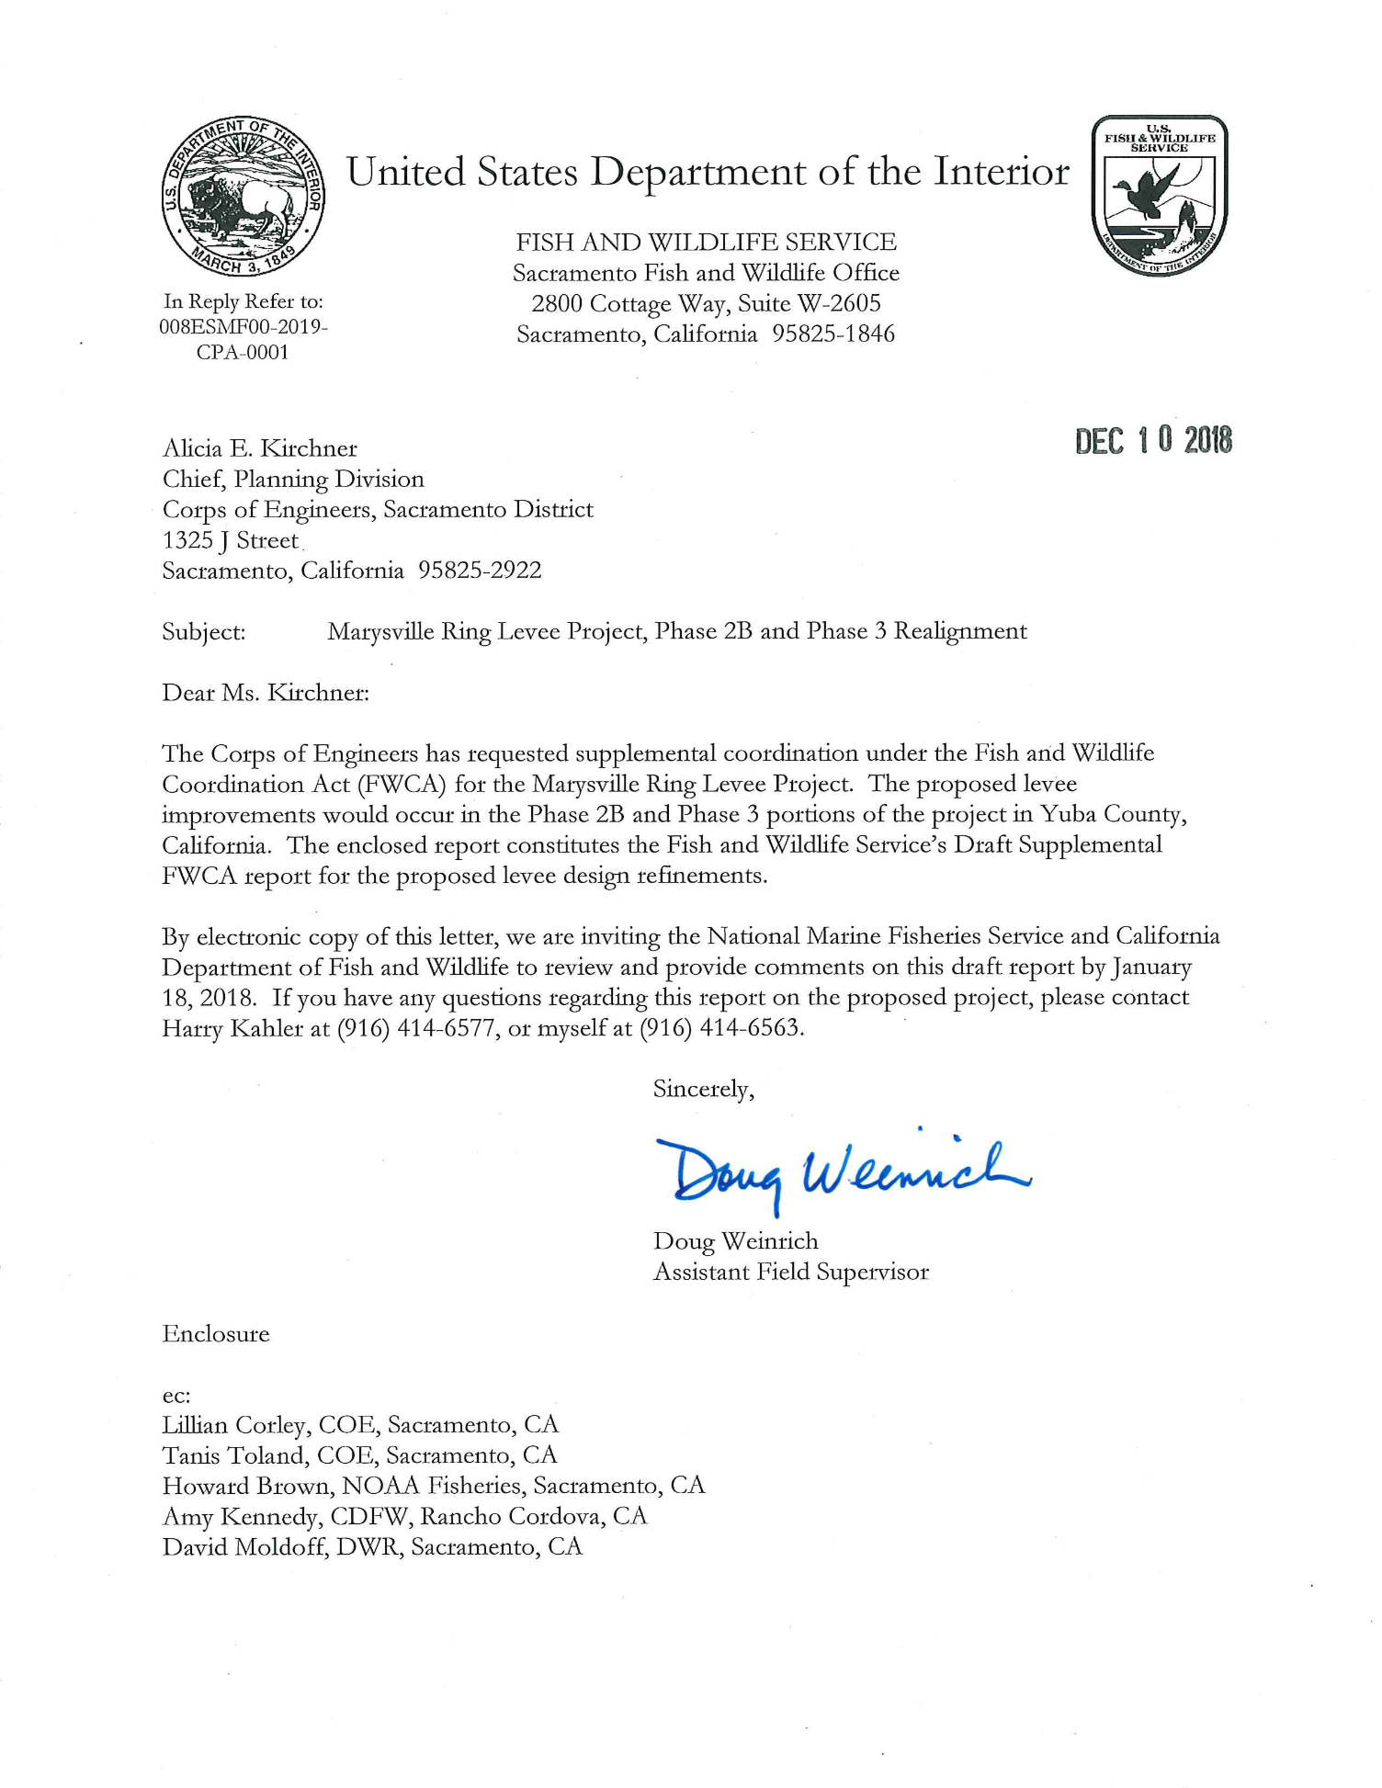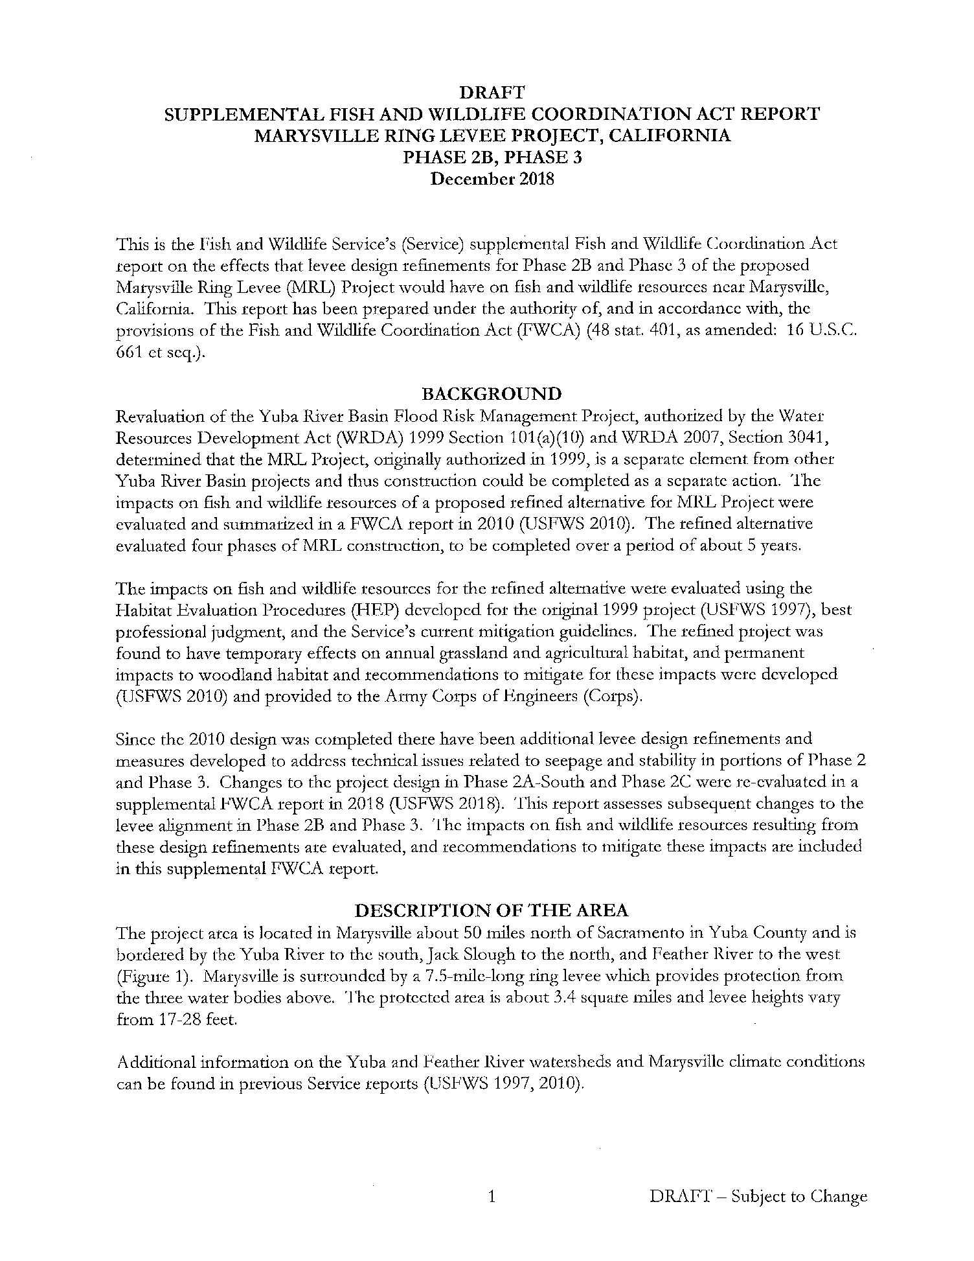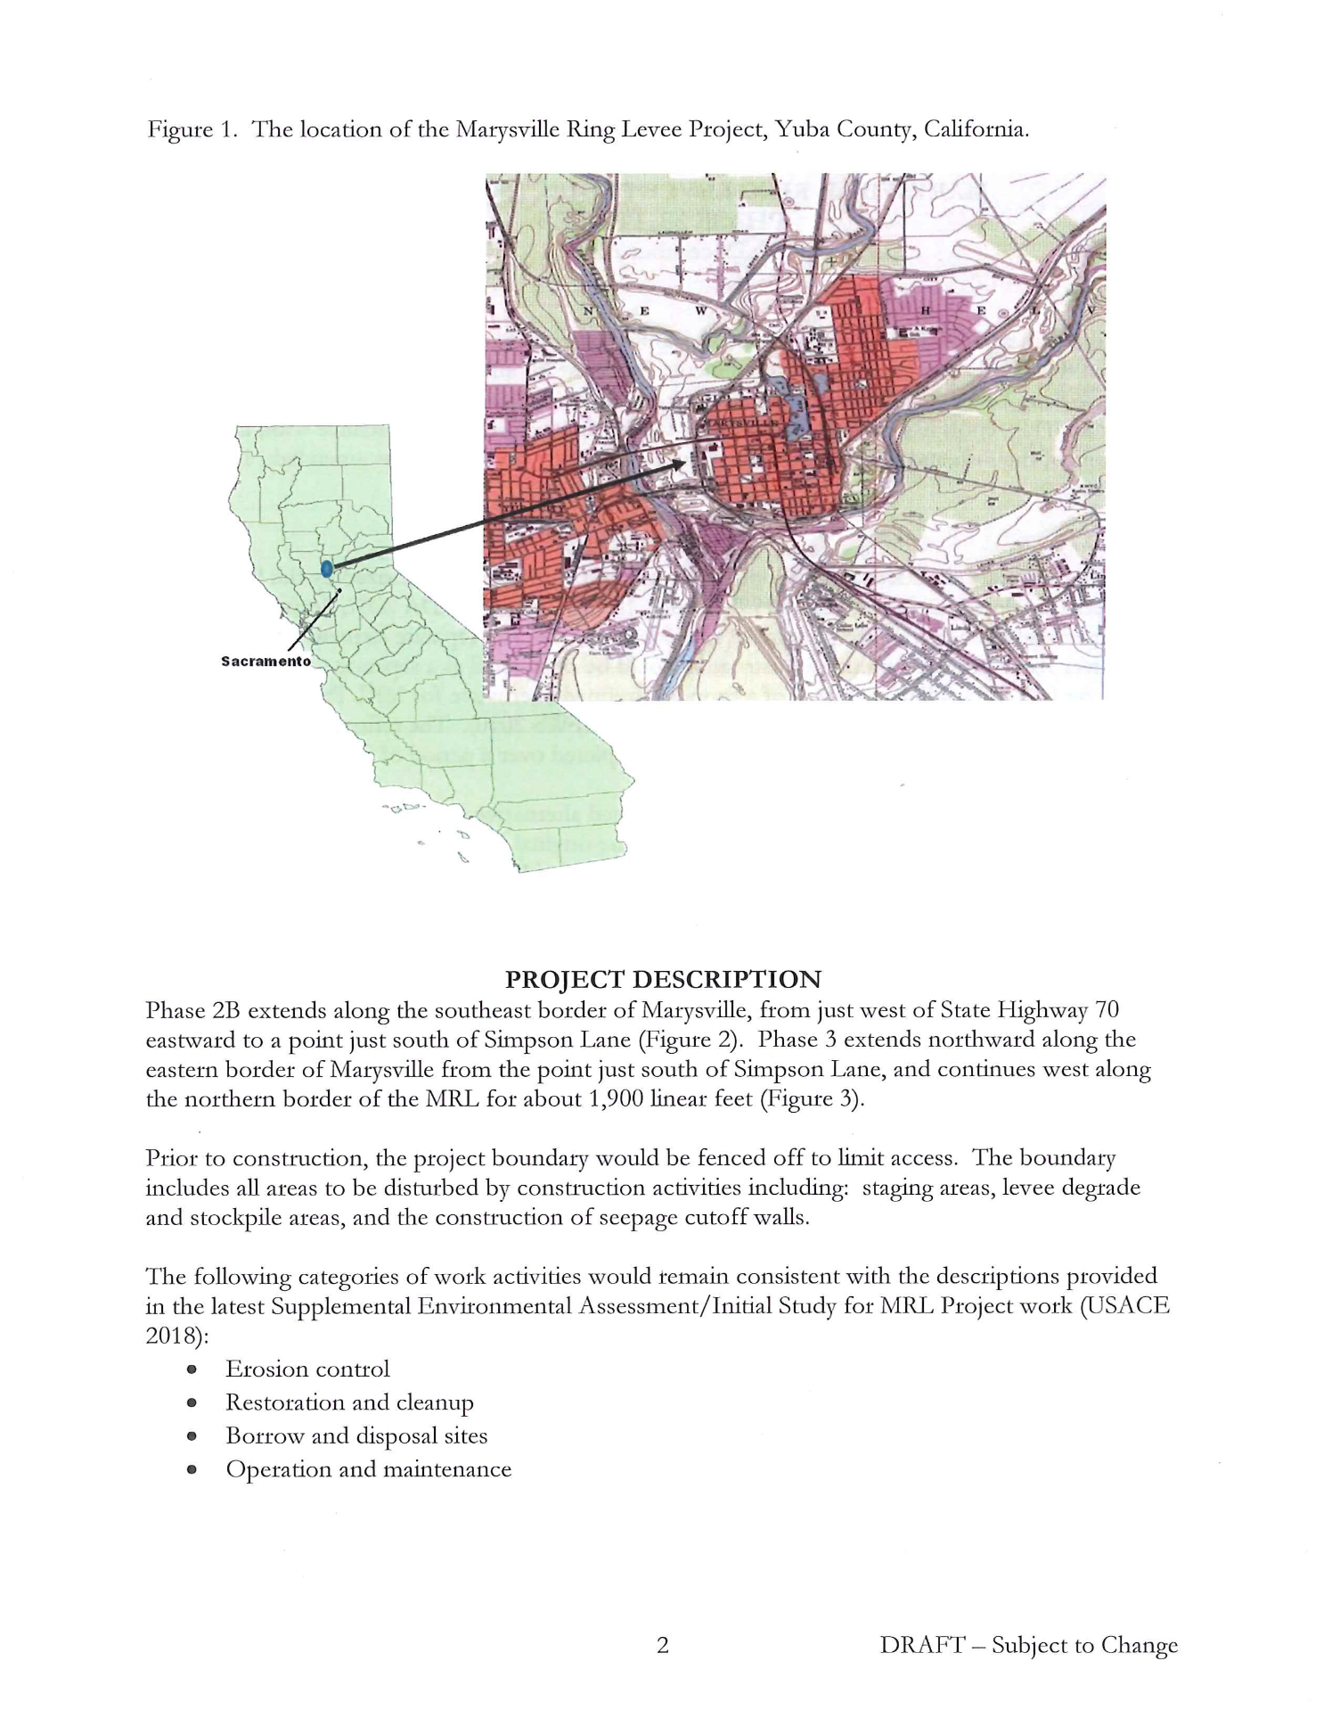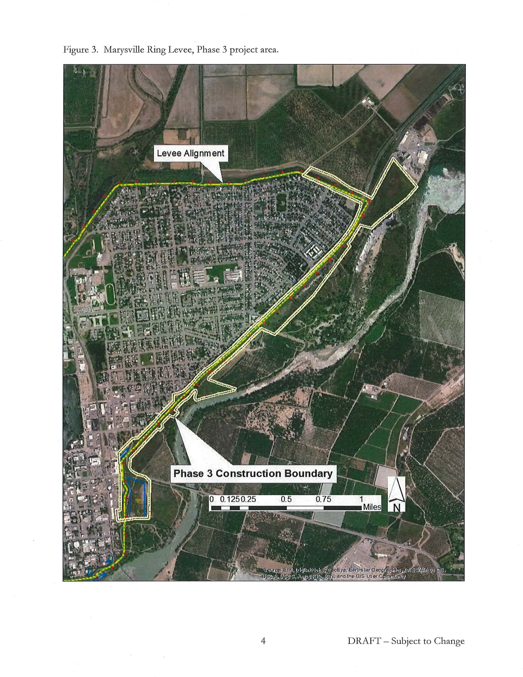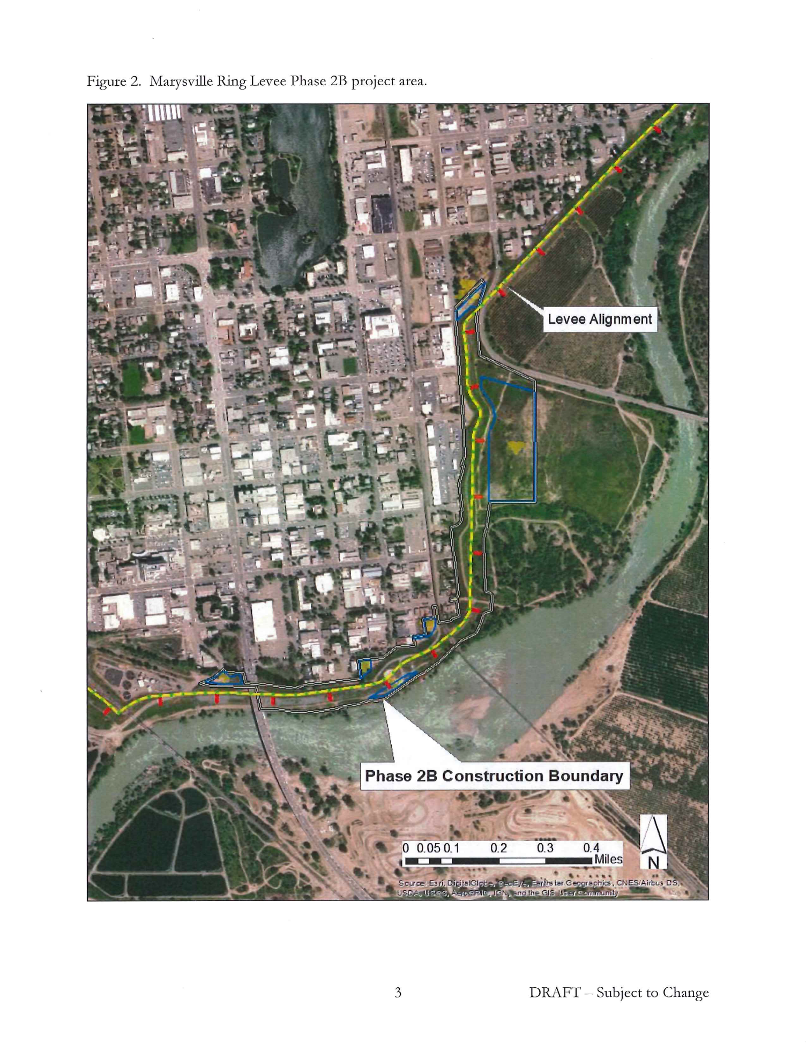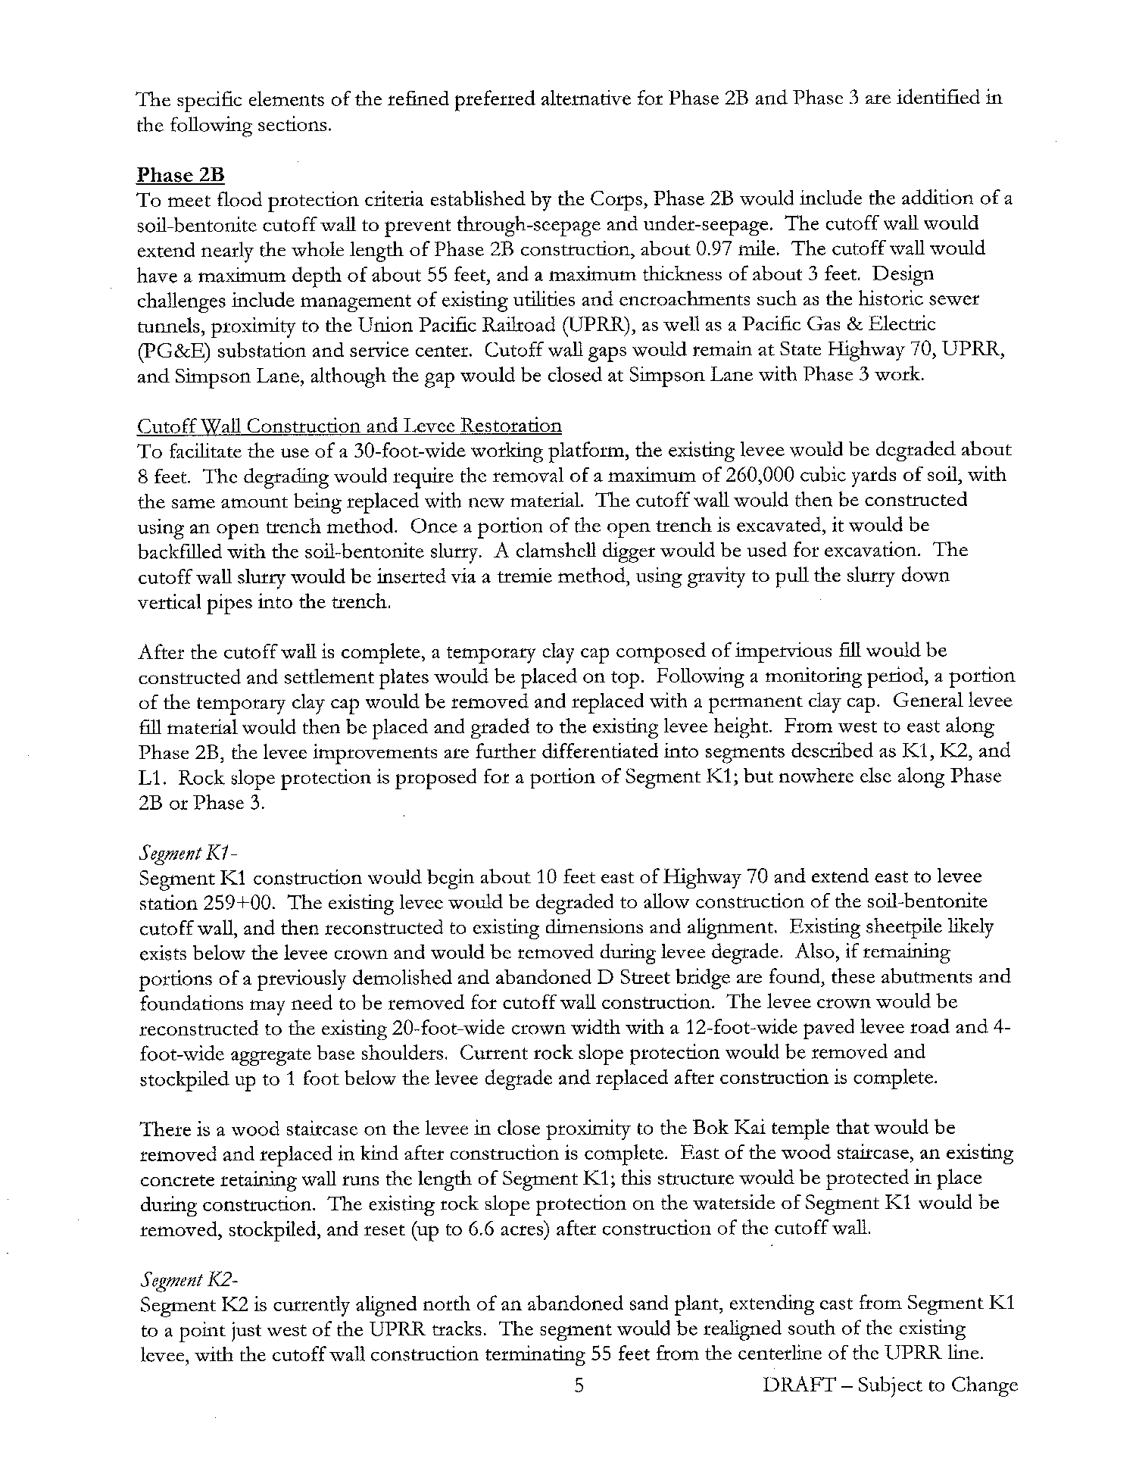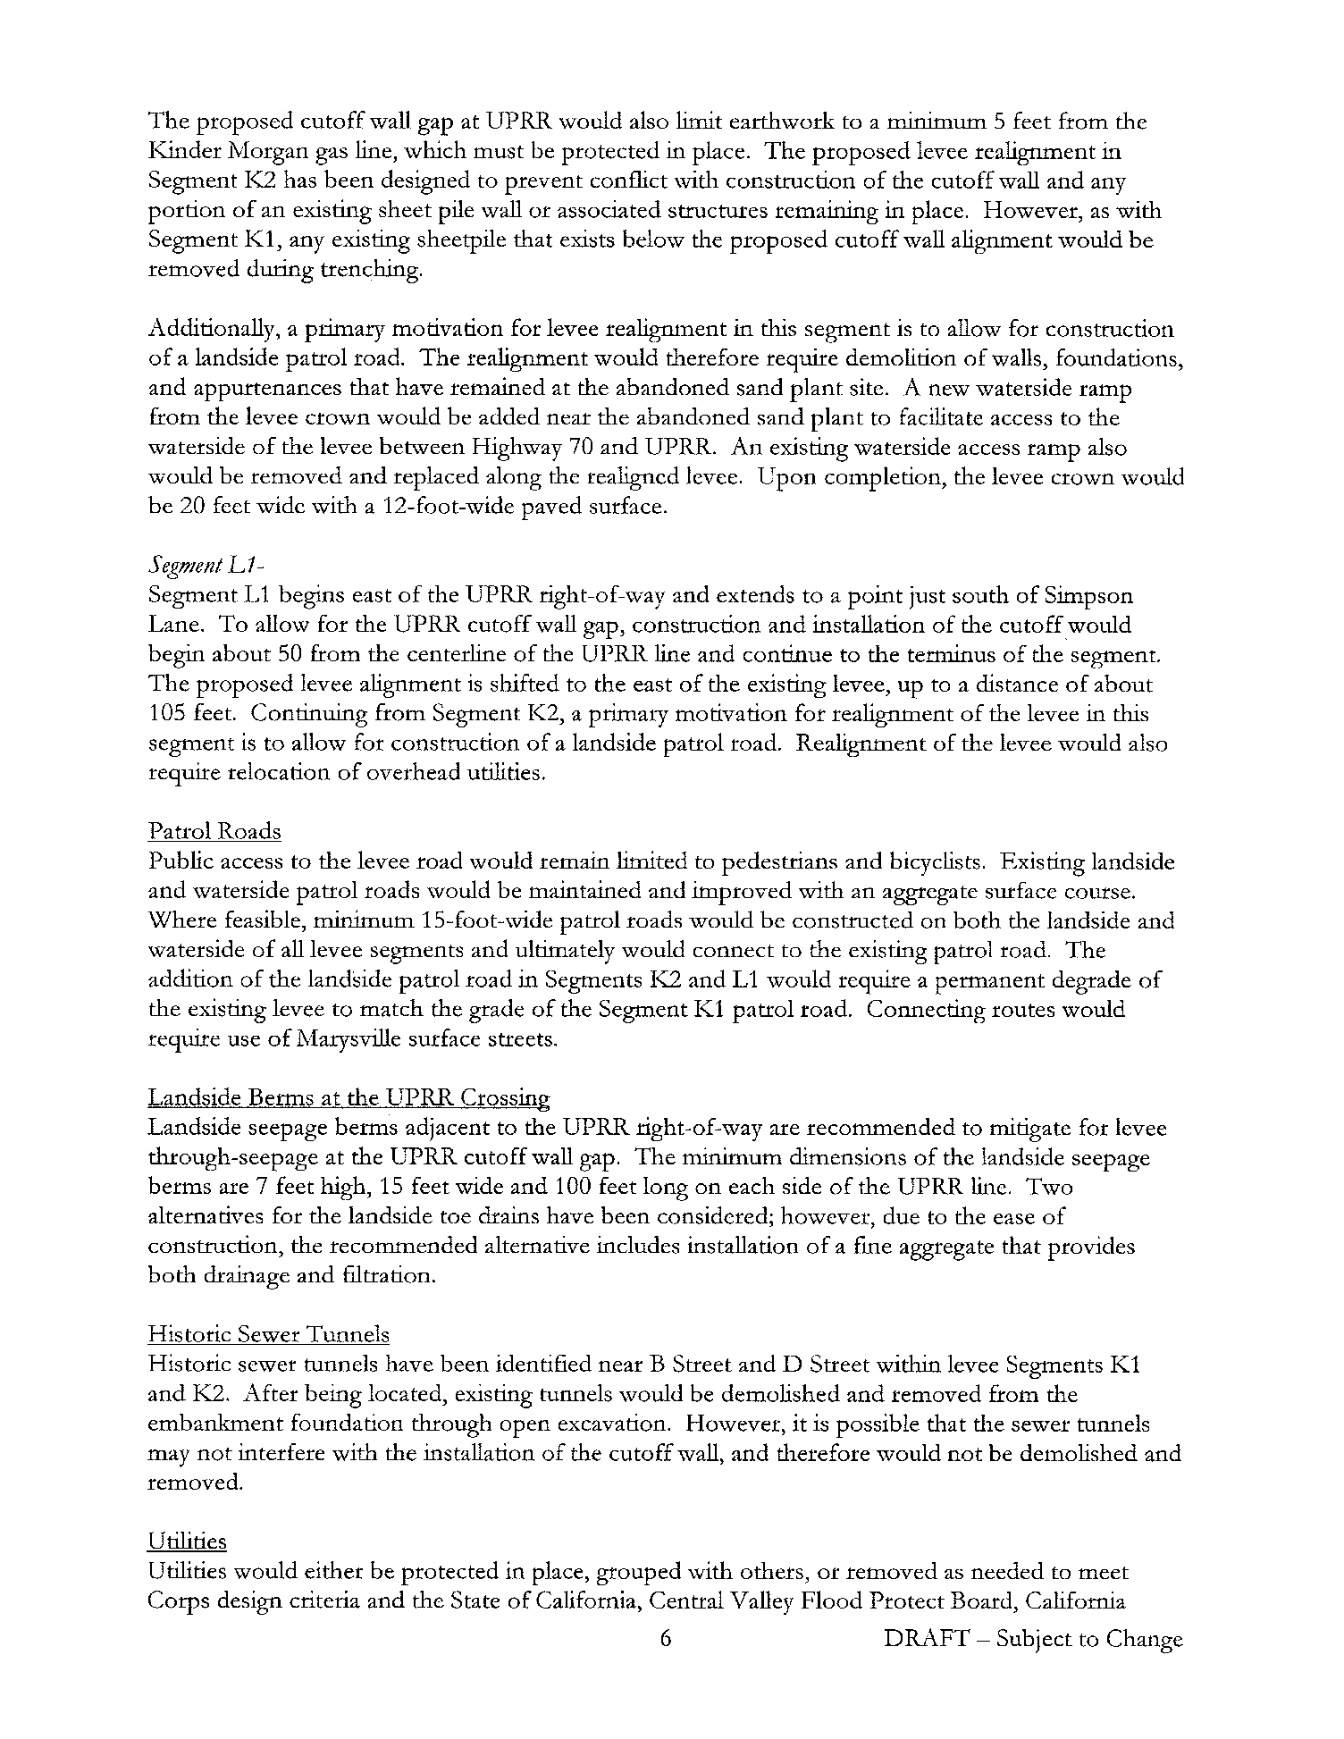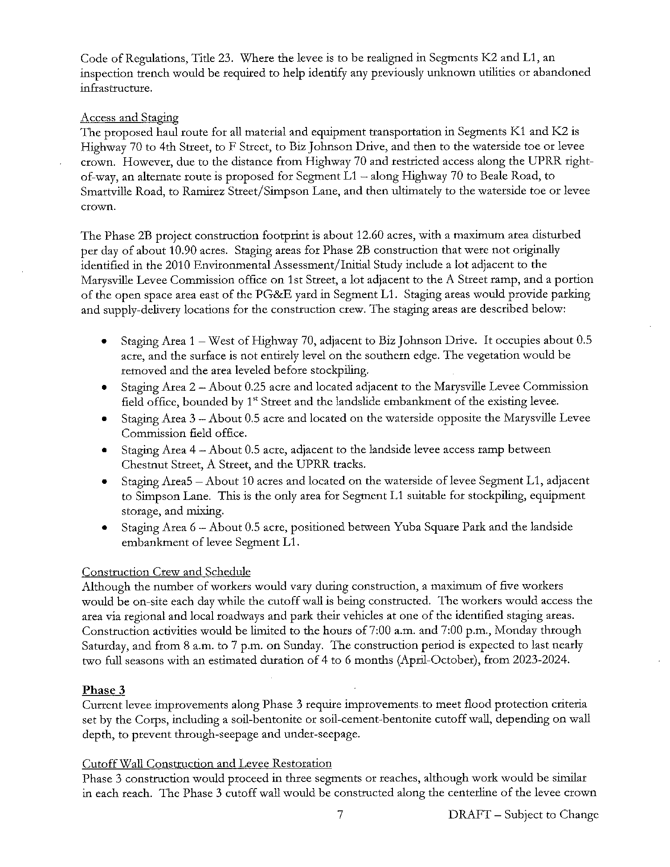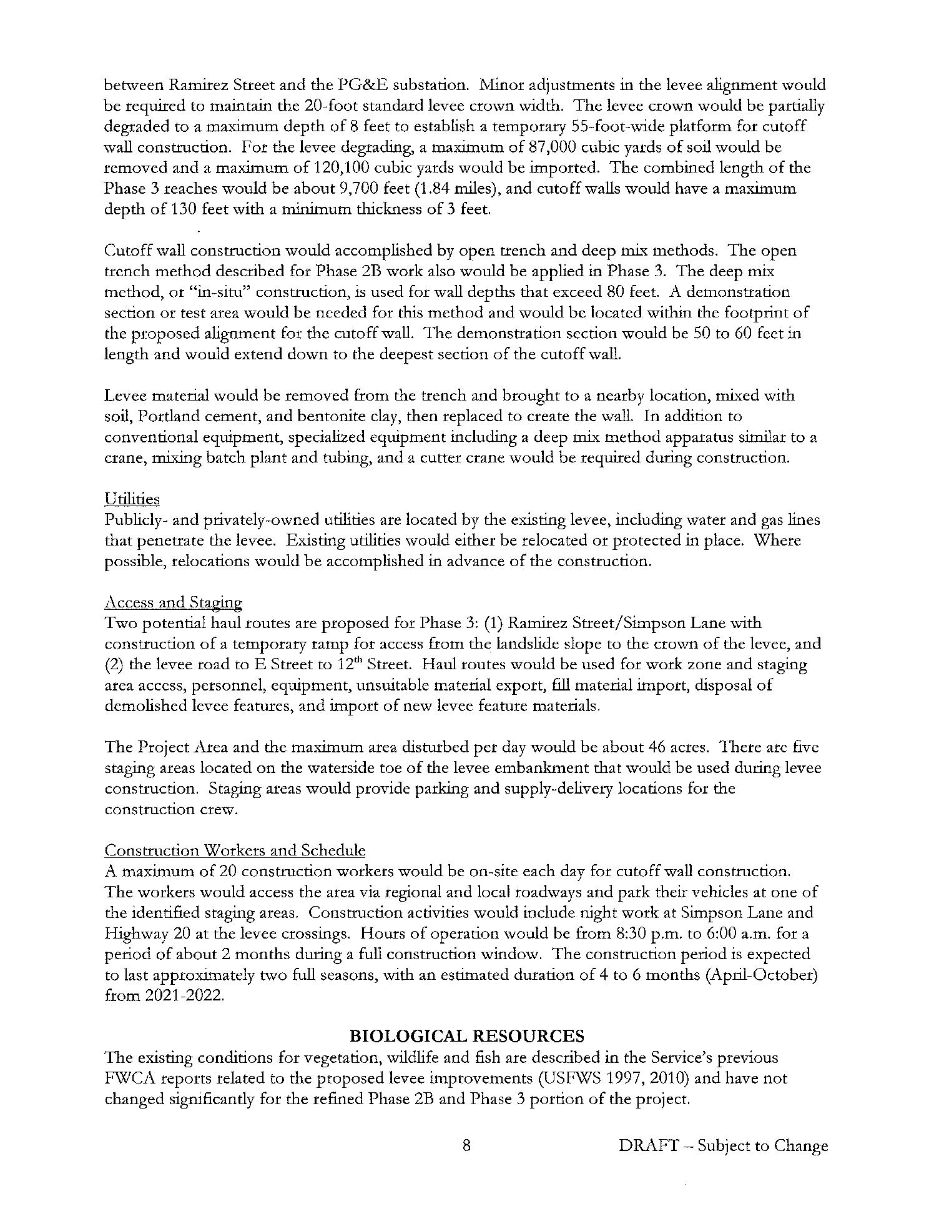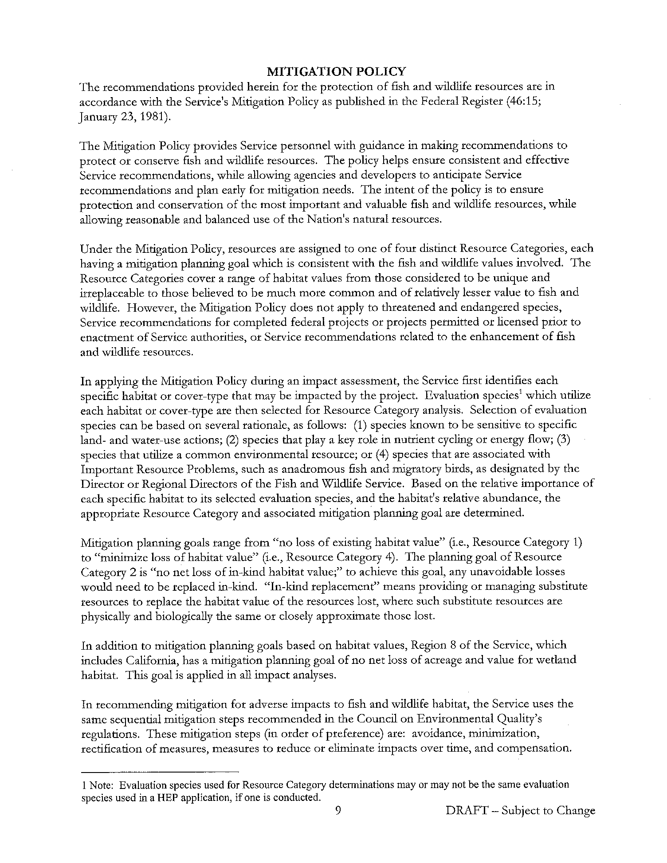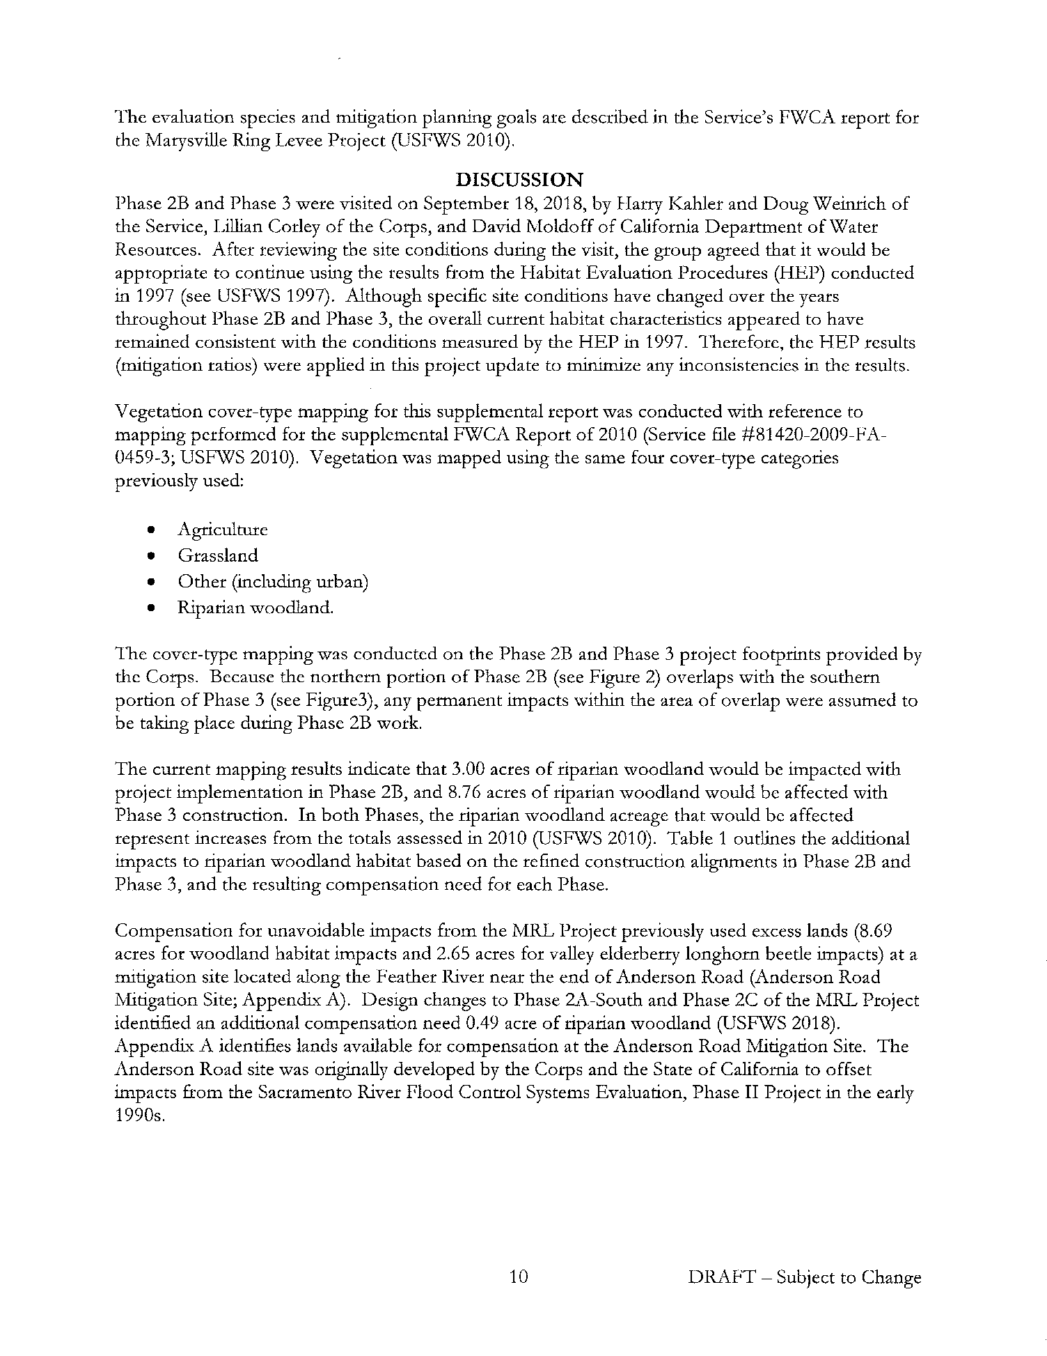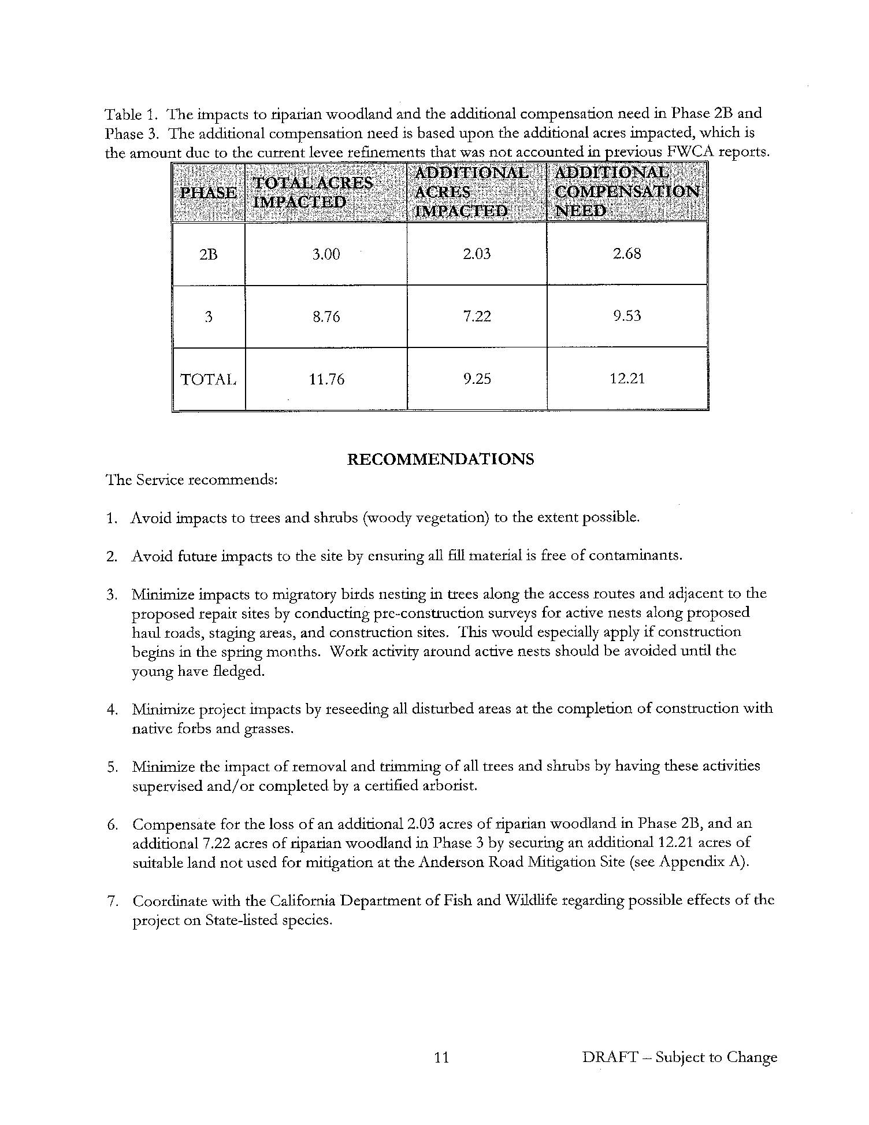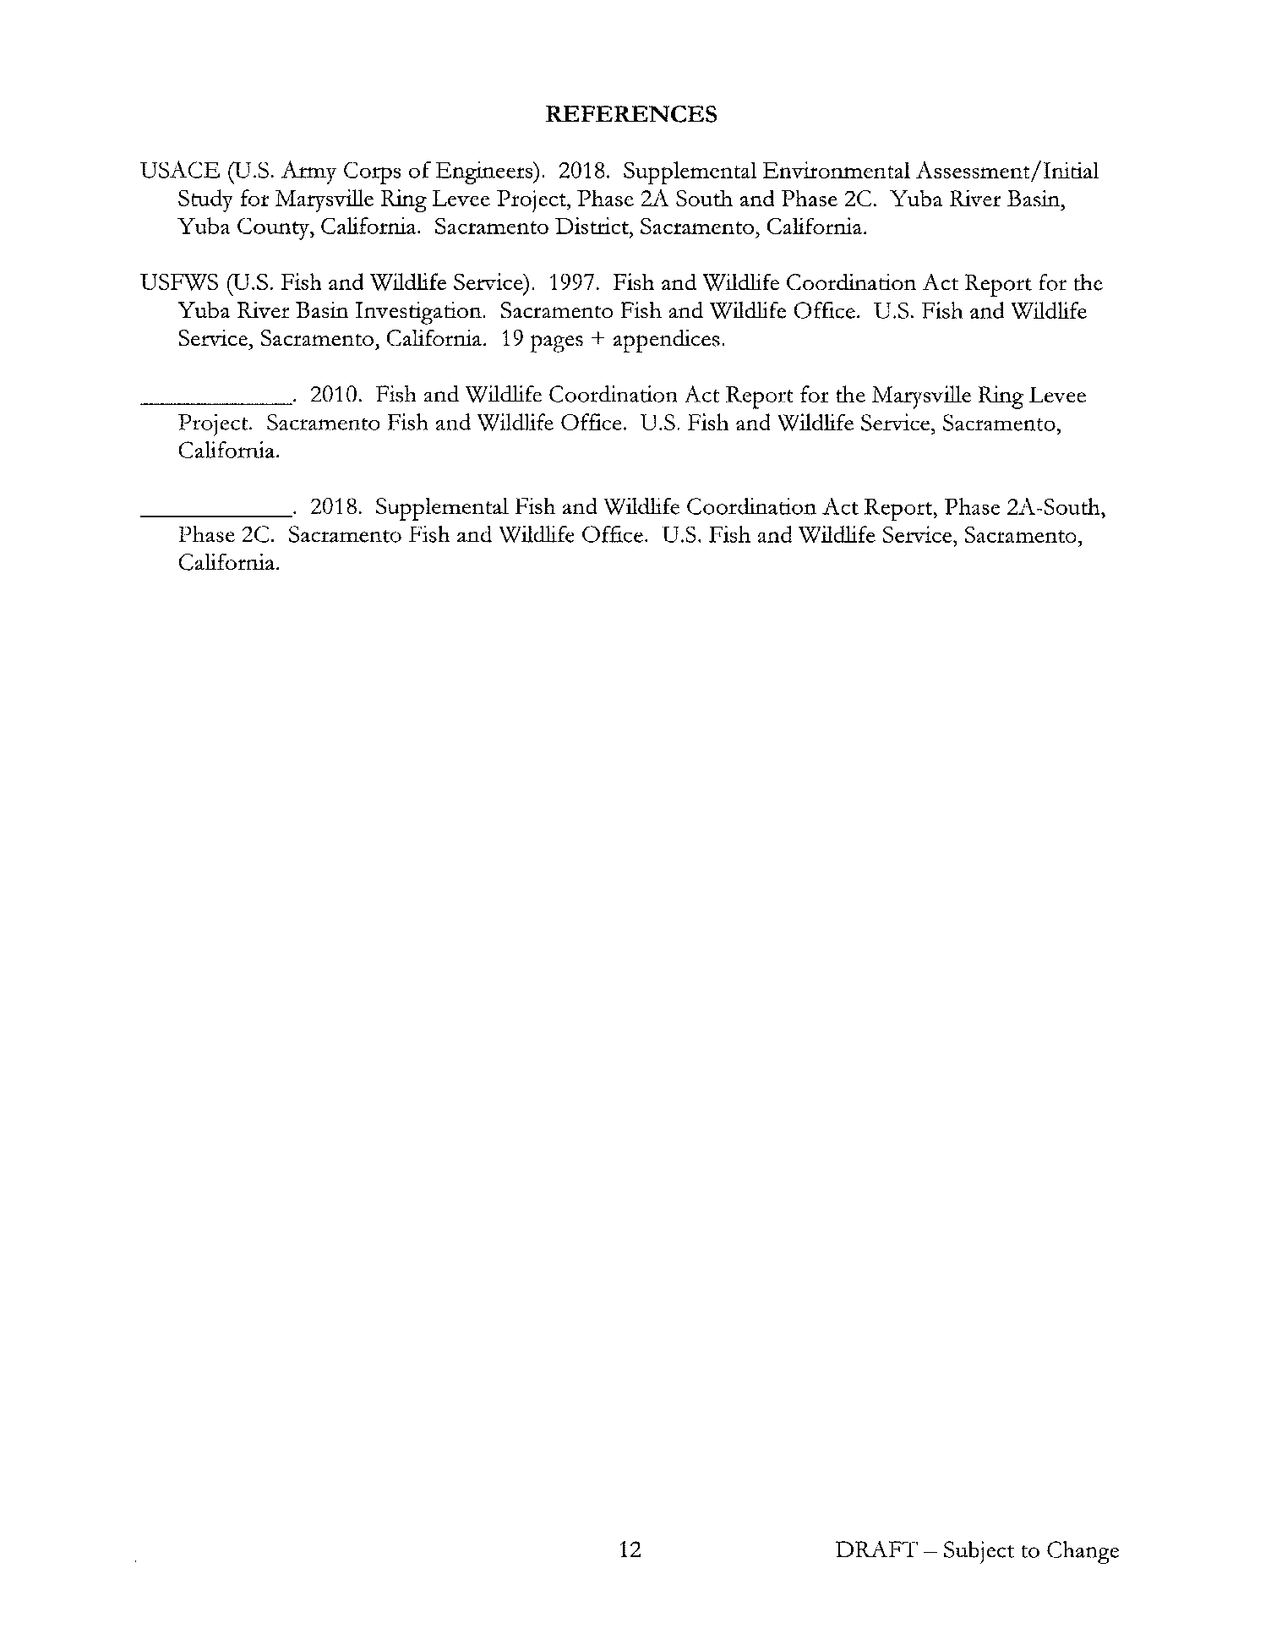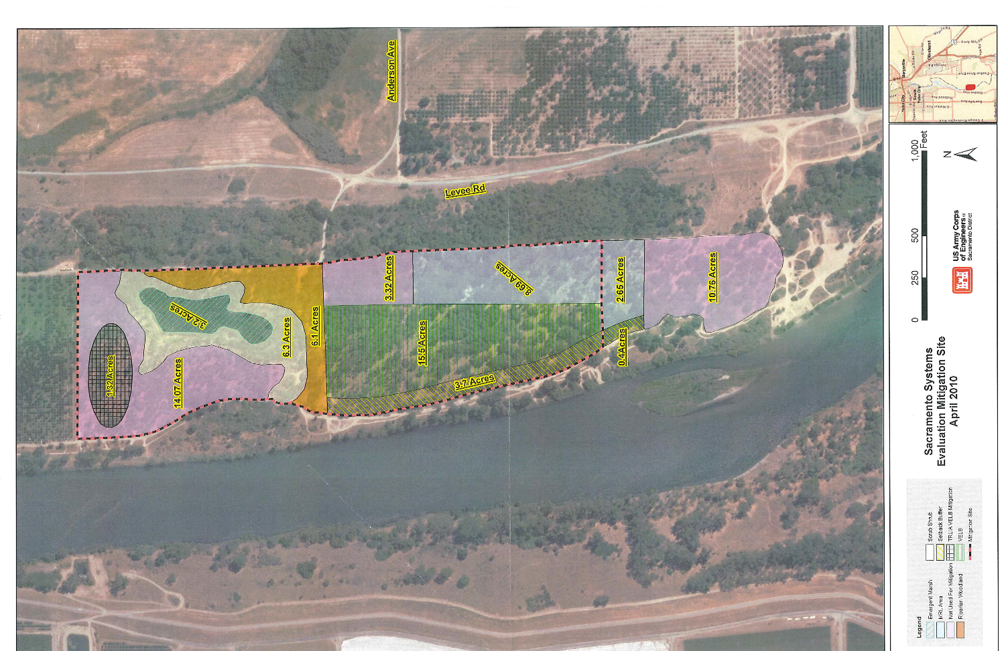

APPENDIX C

SPECIAL STATUS SPECIES LISTS

This page intentionally left blank.

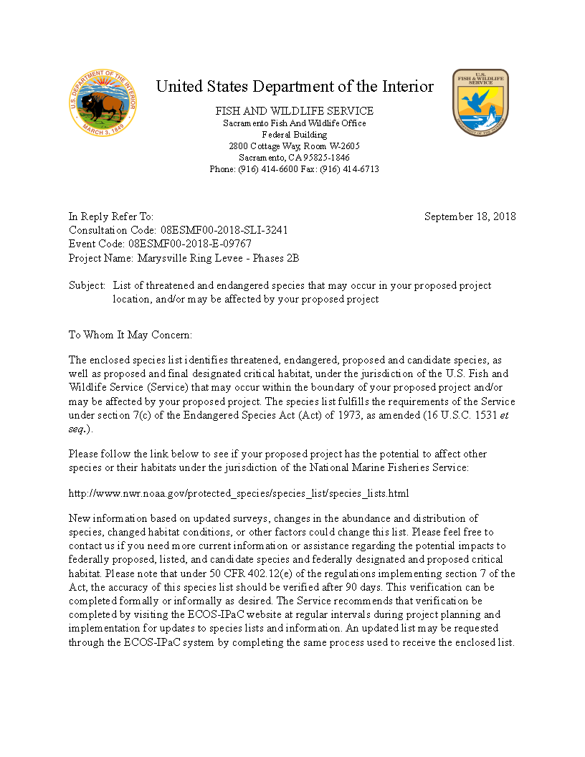
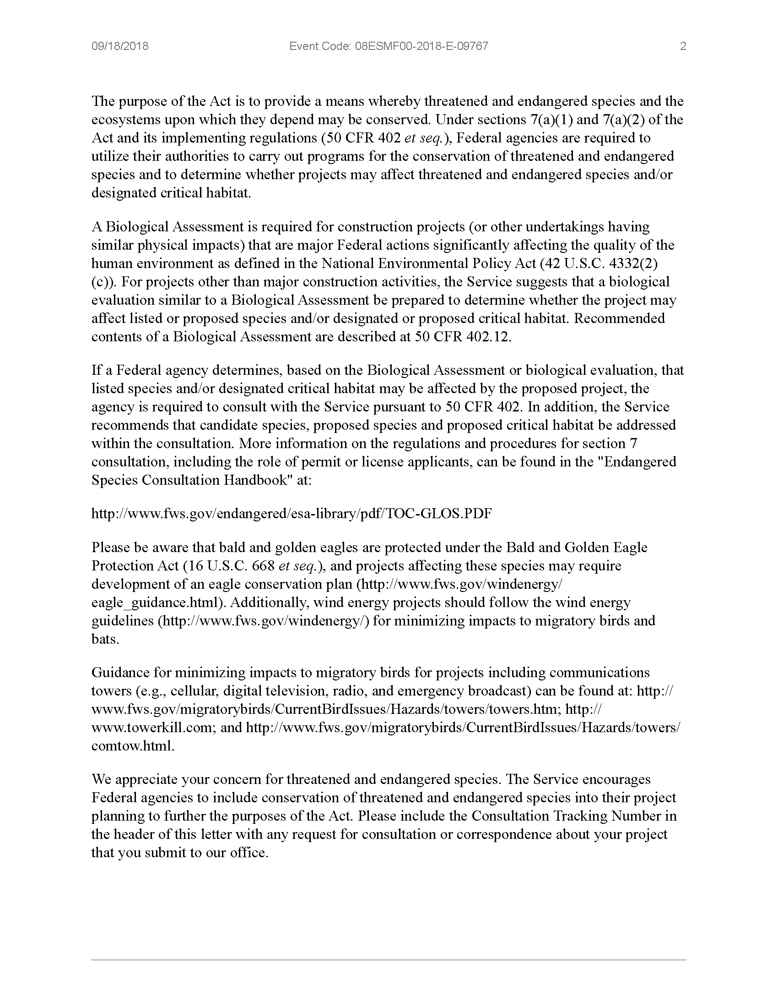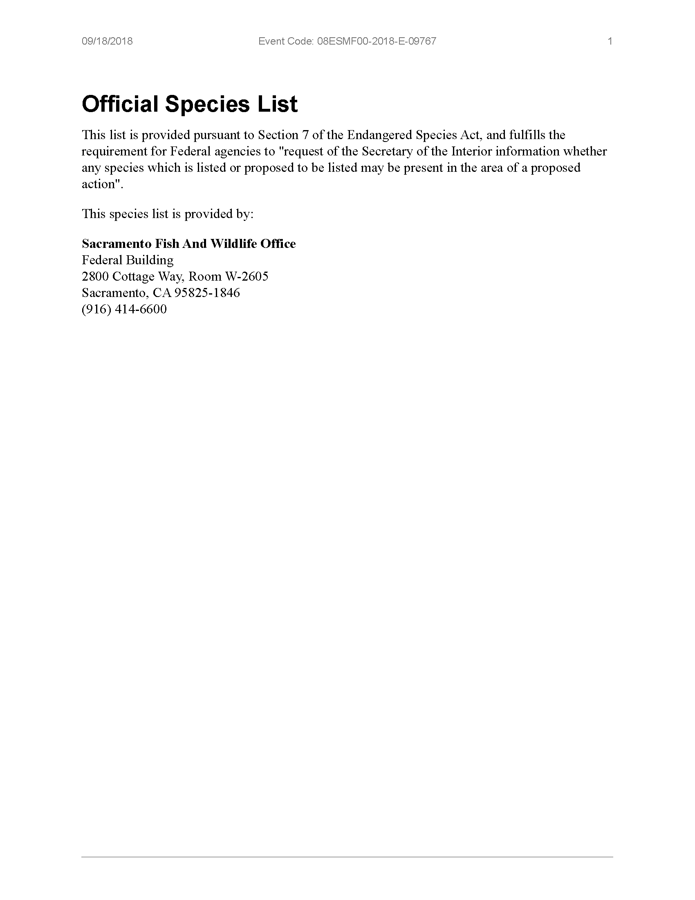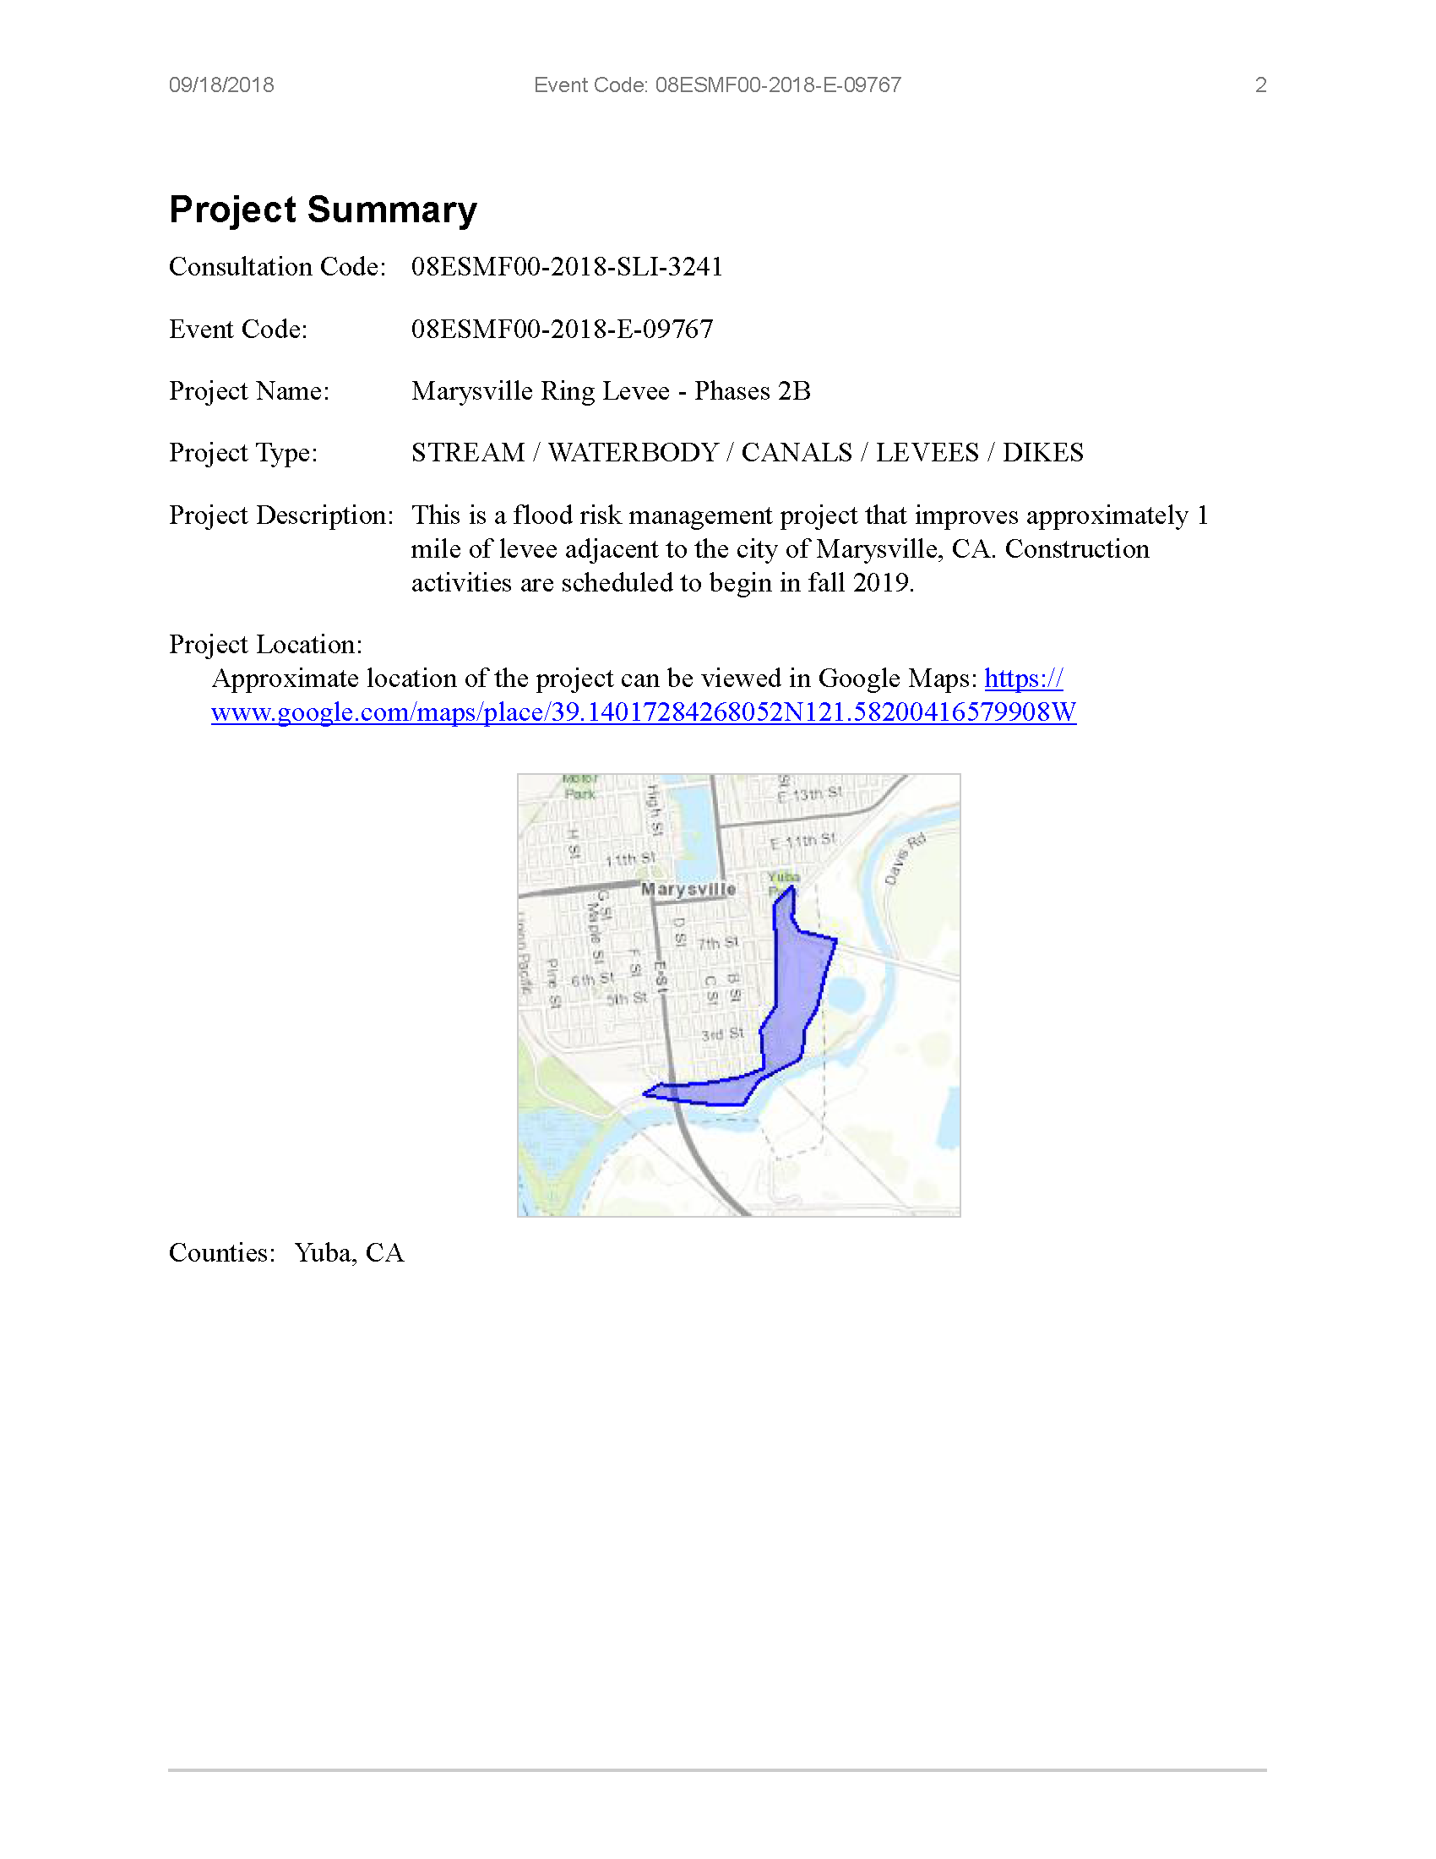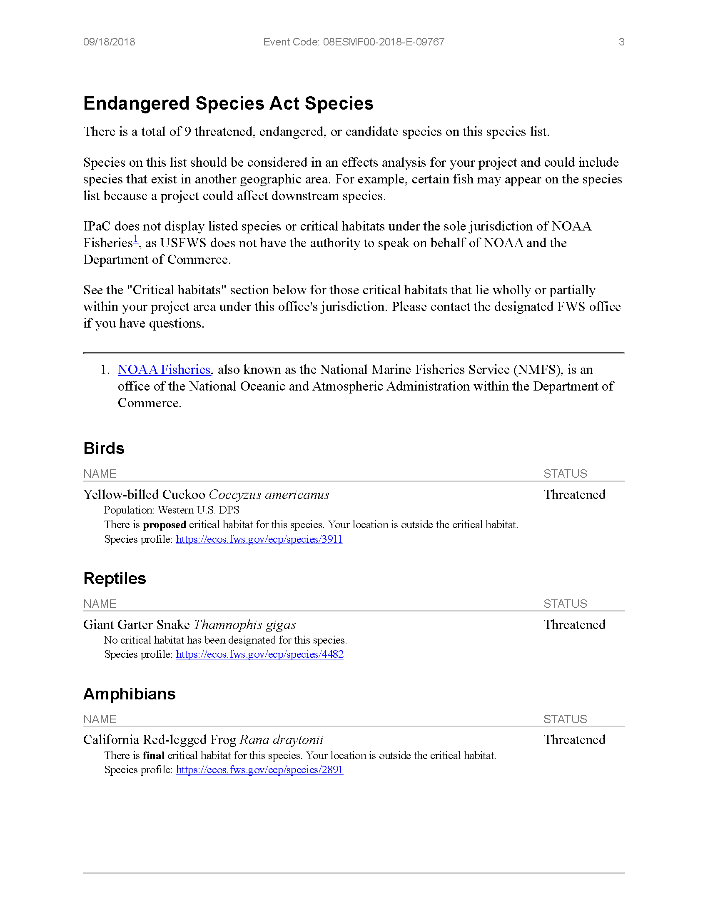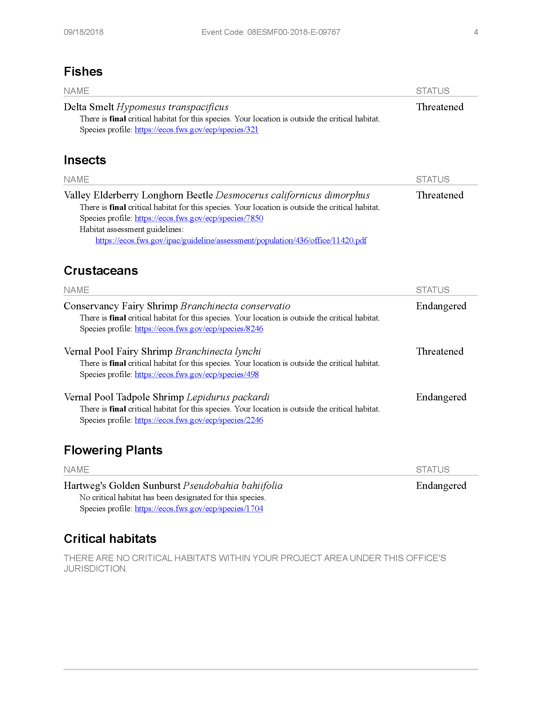
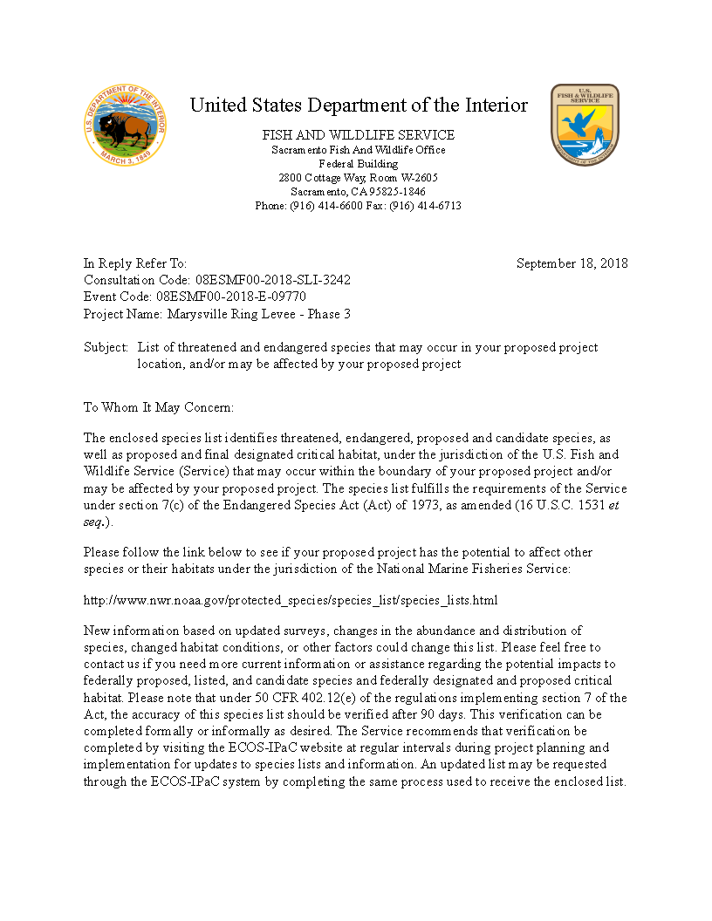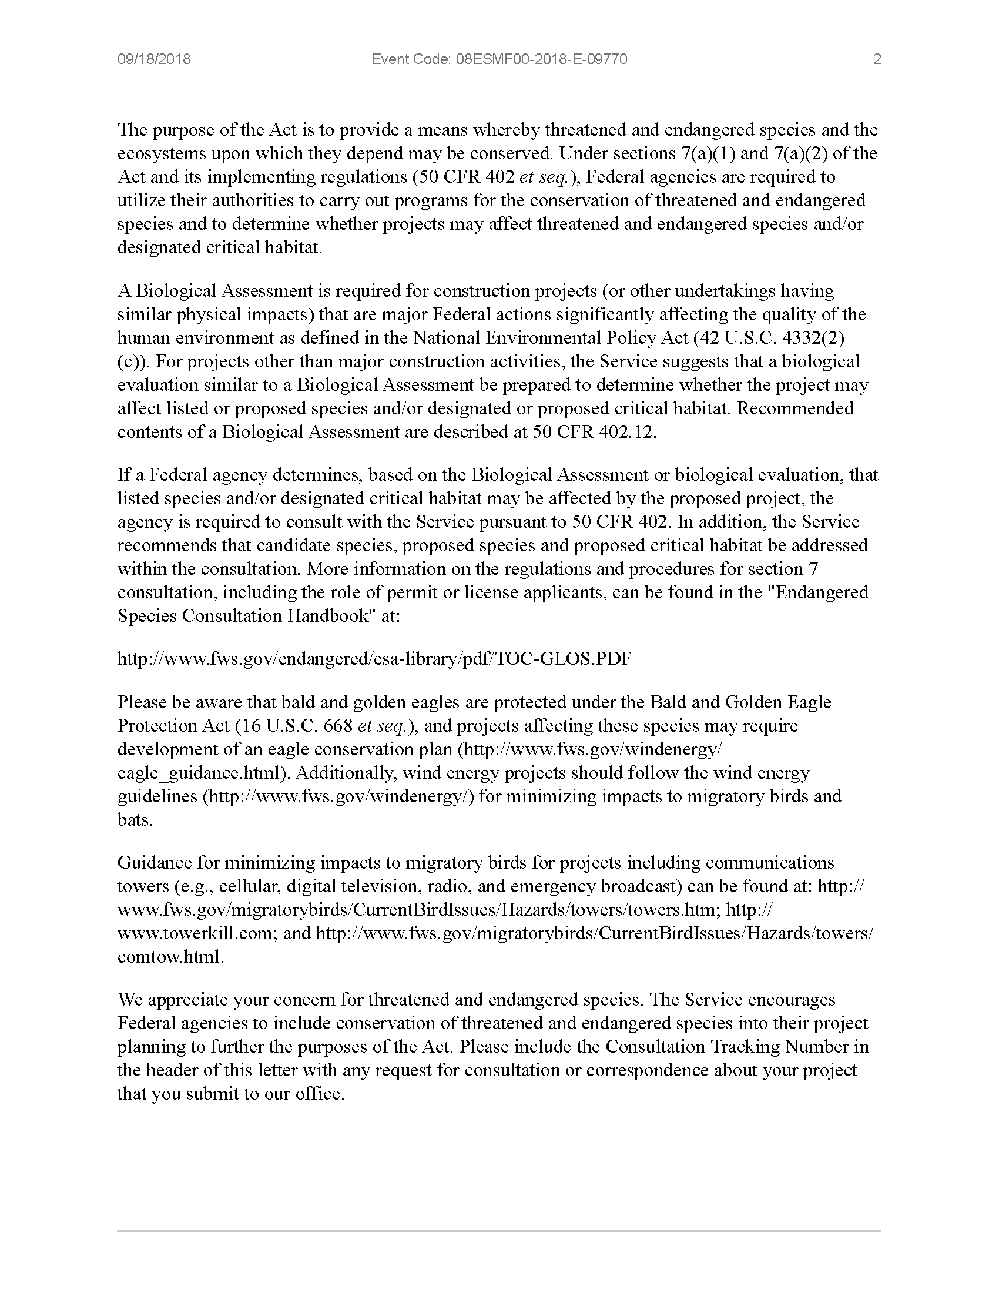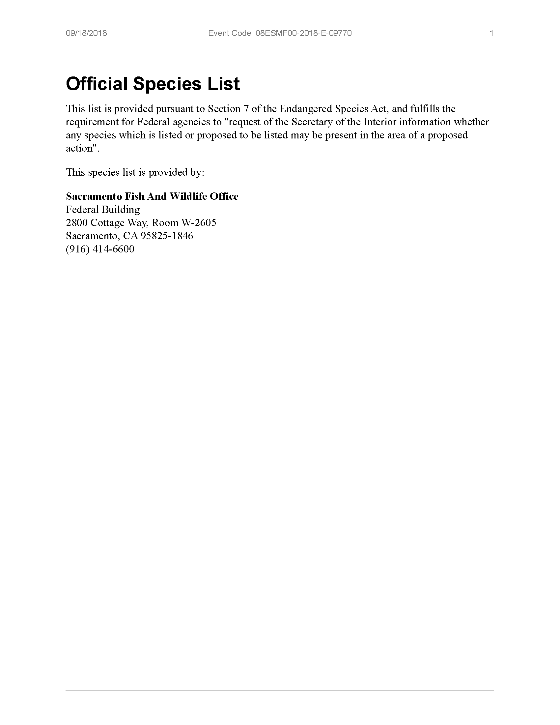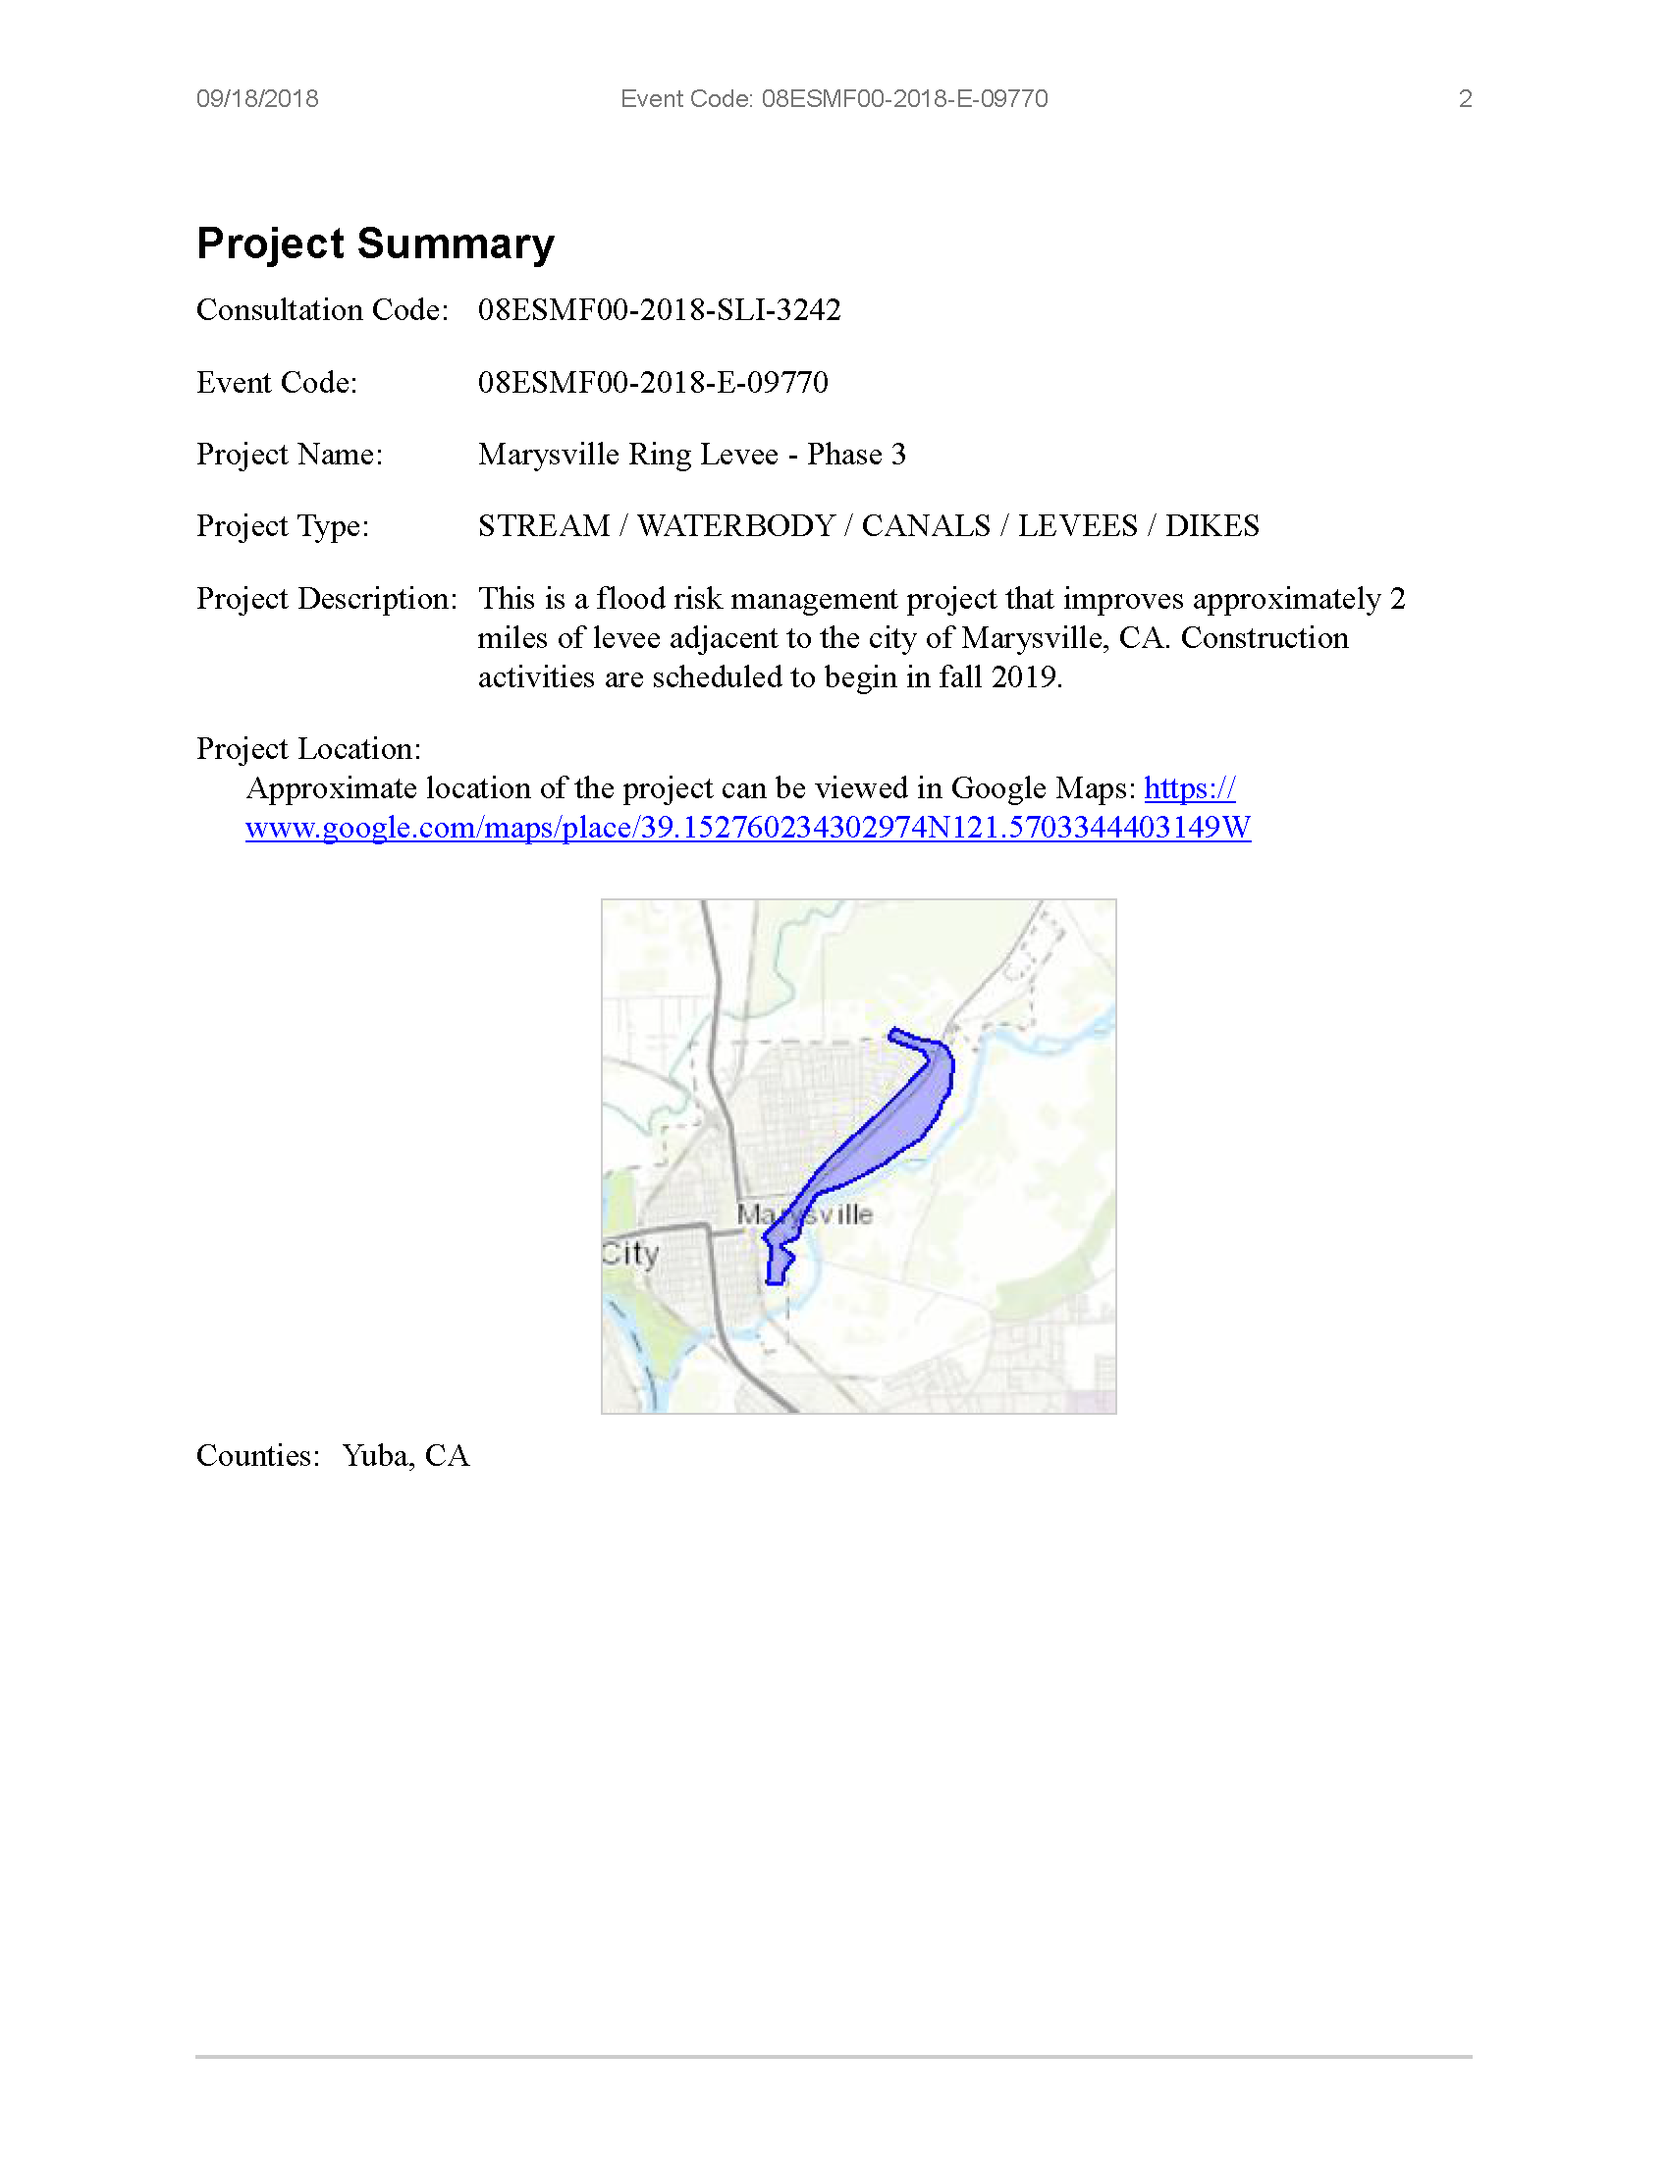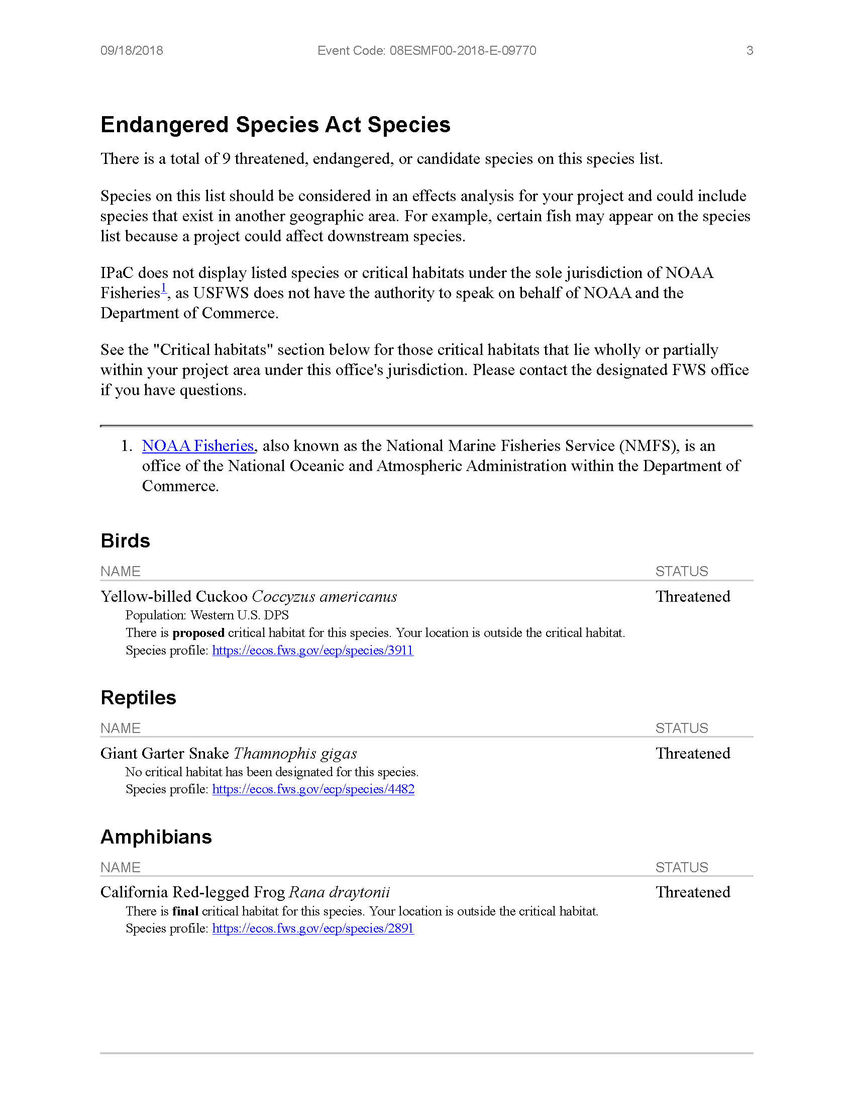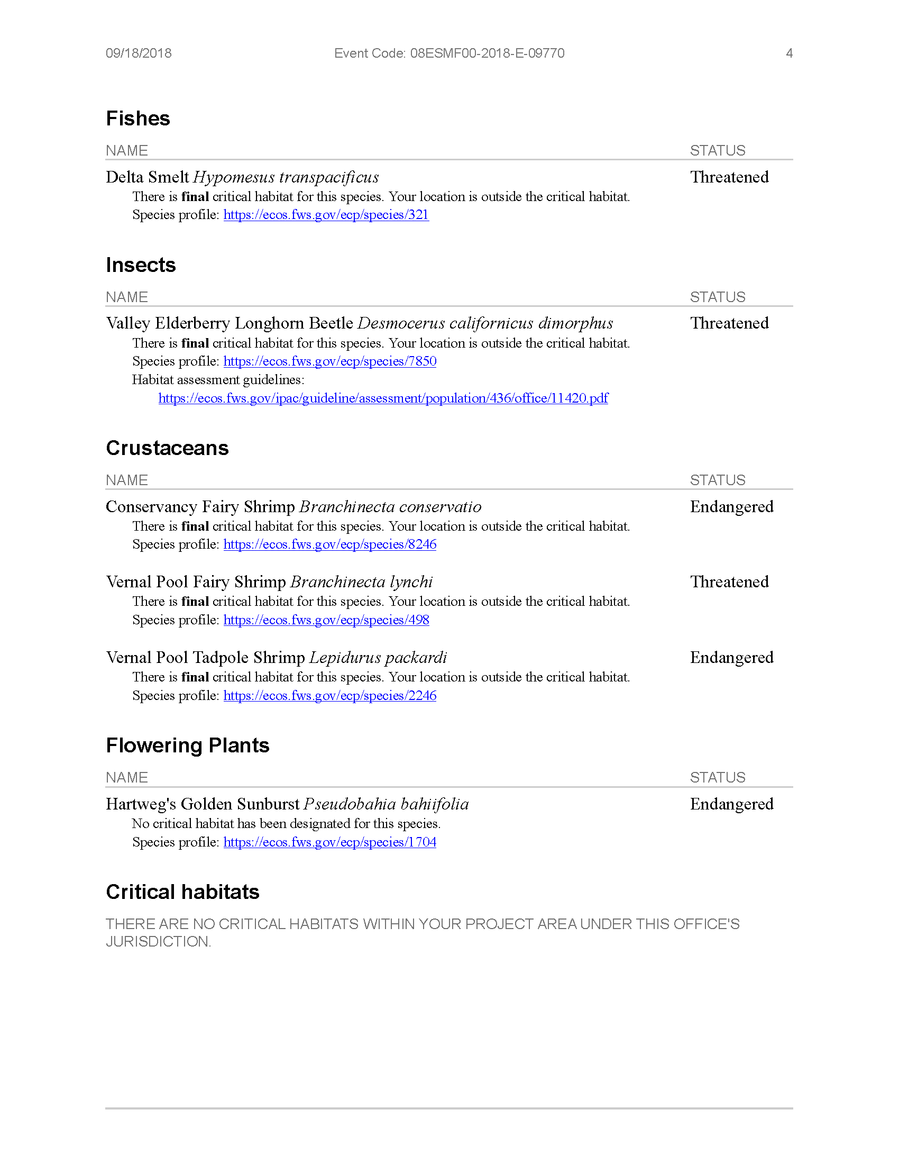
Query Summary:
County IS (Yuba)
CALIFORNIA DEPARTMENT OF FISH AND WILDLIFE (CDFW)
Scientific  Name |  | Common Name | Taxonomic Group | Element Code | Total Occs | Returned Occs | Federal Status | State Status |  | Global Rank | State Rank | CA  Rare  Plant  Rank | Other Status |  | Habitats
Agelaius tricolor |  | tricolored blackbird | Birds | ABPBXB0020 | 951 | 6 | None | Candidate Endangered |  | G2G3 | S1S2 | null | BLM_S-Sensitive, CDFW_SSC-Species of Special Concern, IUCN_EN-Endangered, NABCI_RWL-Red Watch List, USFWS_BCC-Birds of Conservation Concern |  | Freshwater marsh, Marsh & swamp, Swamp, Wetland
Astragalus tener var. ferrisiae |  | Ferris' milk-vetch | Dicots | PDFAB0F8R3 | 18 | 1 | None | None |  | G2T1 | S1 | 1B.1 | BLM_S-Sensitive |  | Meadow & seep, Valley & foothill grassland, Wetland
Buteo swainsoni |  | Swainson's hawk | Birds | ABNKC19070 | 2465 | 2 | None | Threatened |  | G5 | S3 | null | BLM_S-Sensitive, IUCN_LC-Least Concern, USFWS_BCC-Birds of Conservation Concern |  | Great Basin grassland, Riparian forest, Riparian woodland, Valley & foothill grassland
Coccyzus americanus occidentalis |  | western yellow-billed cuckoo | Birds | ABNRB02022 | 155 | 2 | Threatened | Endangered |  | G5T2T3 | S1 | null | BLM_S-Sensitive, NABCI_RWL-Red Watch List, USFS_S-Sensitive, USFWS_BCC-Birds of Conservation Concern |  | Riparian forest
Delphinium recurvatum |  | recurved larkspur | Dicots | PDRAN0B1J0 | 100 | 1 | None | None |  | G2? | S2? | 1B.2 | BLM_S-Sensitive |  | Chenopod scrub, Cismontane woodland, Valley & foothill grassland
Desmocerus californicus dimorphus |  | valley elderberry longhorn beetle | Insects | IICOL48011 | 271 | 1 | Threatened | None |  | G3T2 | S2 | null | null |  | Riparian scrub
Great Valley Cottonwood Riparian Forest |  | Great Valley Cottonwood Riparian Forest | Riparian | CTT61410CA | 56 | 2 | None | None |  | G2 | S2.1 | null | null |  | Riparian forest
Great Valley Mixed Riparian Forest |  | Great Valley Mixed Riparian Forest | Riparian | CTT61420CA | 68 | 1 | None | None |  | G2 | S2.2 | null | null |  | Riparian forest
Lepidurus packardi |  | vernal pool tadpole shrimp | Crustaceans | ICBRA10010 | 324 | 1 | Endangered | None |  | G4 | S3S4 | null | IUCN_EN-Endangered |  | Valley & foothill grassland, Vernal pool, Wetland
Melospiza melodia |  | song sparrow ("Modesto" population) | Birds | ABPBXA3010 | 92 | 1 | None | None |  | G5 | S3? | null | CDFW_SSC-Species of Special Concern |  | null
Monardella venosa |  | veiny monardella | Dicots | PDLAM18082 | 4 | 1 | None | None |  | G1 | S1 | 1B.1 | BLM_S-Sensitive, SB_RSABG-Rancho Santa Ana Botanic Garden |  | Cismontane woodland, Valley & foothill grassland
 | Oncorhynchus mykiss irideus pop. 11 | steelhead - Central Valley DPS | Fish | AFCHA0209K | 31 | 2 | Threatened |  | None | G5T2Q | S2 | null |  | AFS_TH-Threatened | Aquatic, Sacramento/San Joaquin flowing waters
 | Oncorhynchus tshawytscha pop. 6 | chinook salmon - Central Valley spring-run ESU | Fish | AFCHA0205A | 13 | 1 | Threatened |  | Threatened | G5 | S1 | null |  | AFS_TH-Threatened | Aquatic, Sacramento/San Joaquin flowing waters
 | Pseudobahia bahiifolia | Hartweg's golden sunburst | Dicots | PDAST7P010 | 27 | 1 | Endangered |  | Endangered | G2 | S2 | 1B.1 |  | SB_RSABG-Rancho Santa Ana Botanic Garden | Cismontane woodland, Valley & foothill grassland
 | Riparia riparia | bank swallow | Birds | ABPAU08010 | 297 | 8 | None |  | Threatened | G5 | S2 | null |  | BLM_S-Sensitive, IUCN_LC-Least Concern | Riparian scrub, Riparian woodland
 | Vireo bellii pusillus | least Bell's vireo | Birds | ABPBW01114 | 483 | 1 | Endangered |  | Endangered | G5T2 | S2 | null |  | IUCN_NT-Near Threatened, NABCI_YWL-Yellow Watch List | Riparian forest, Riparian scrub, Riparian woodland

APPENDIX D

AIR QUALITY EMISSIONS SPREADSHEETS

This page intentionally left blank.

APPENDIX E

HTRW ENVIRONMENTAL SITE ASSESSMENTS (PHASES 2B AND 3)

This page intentionally left blank.

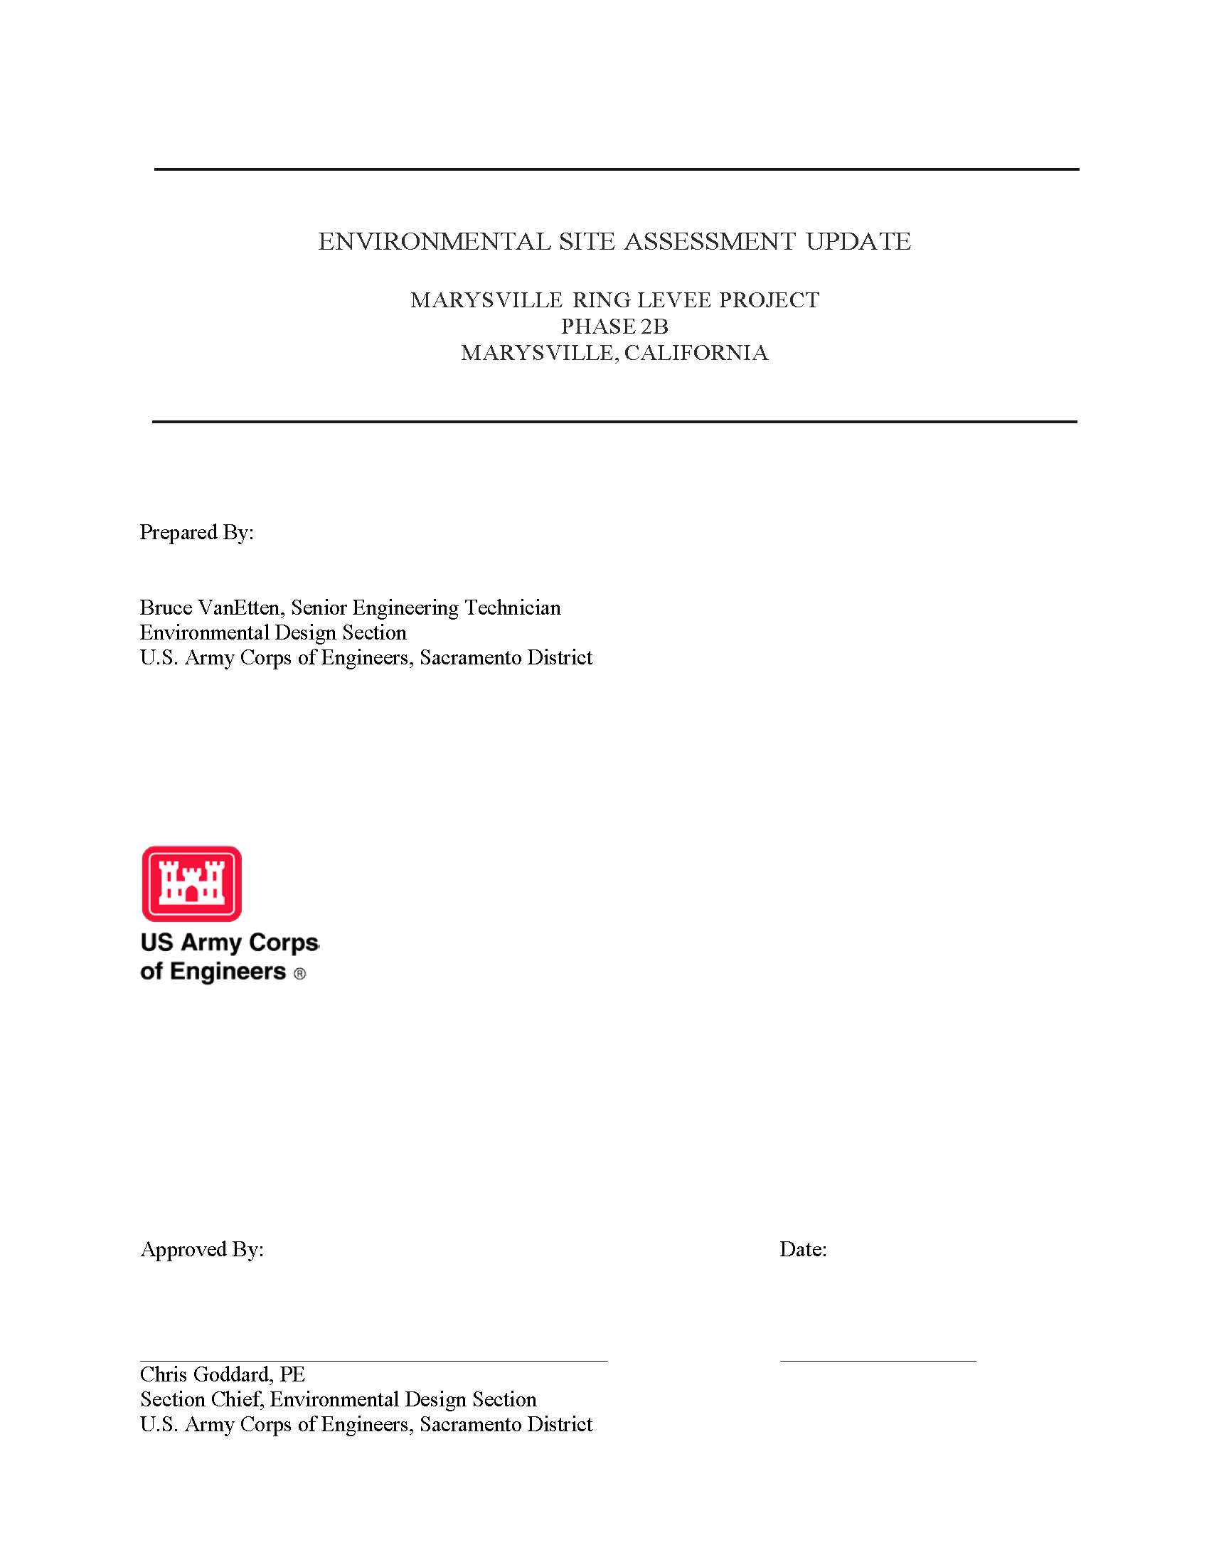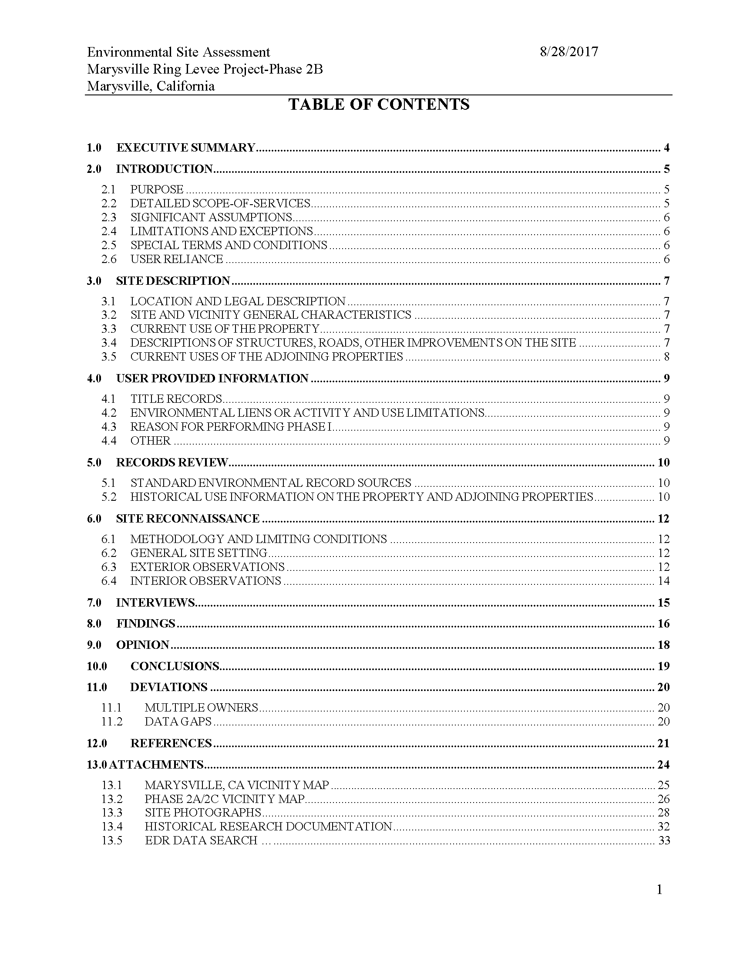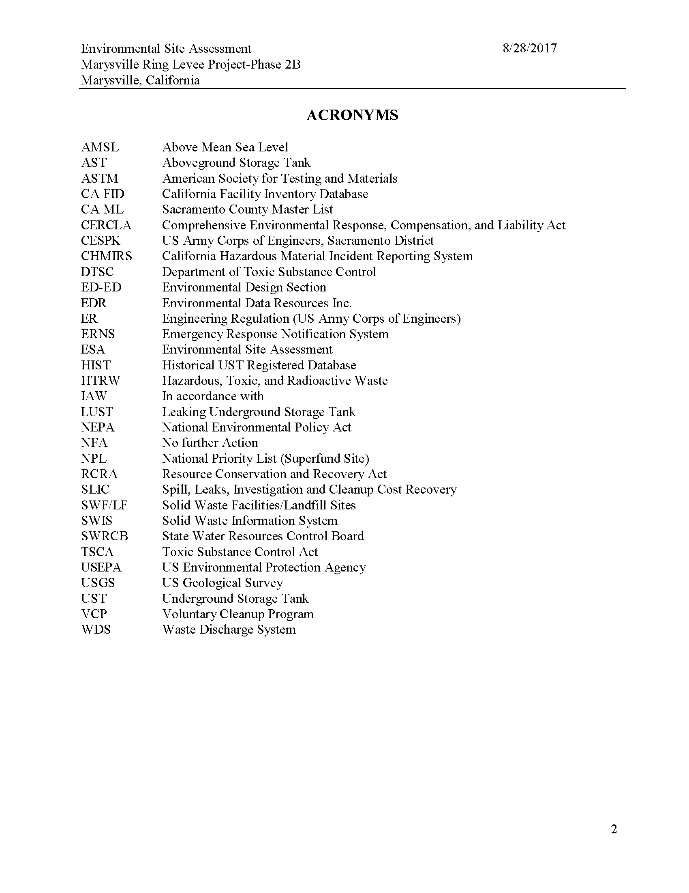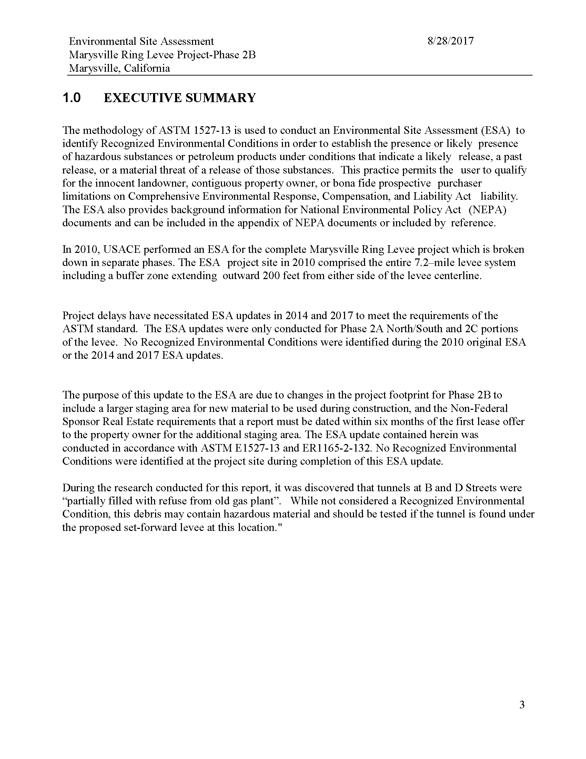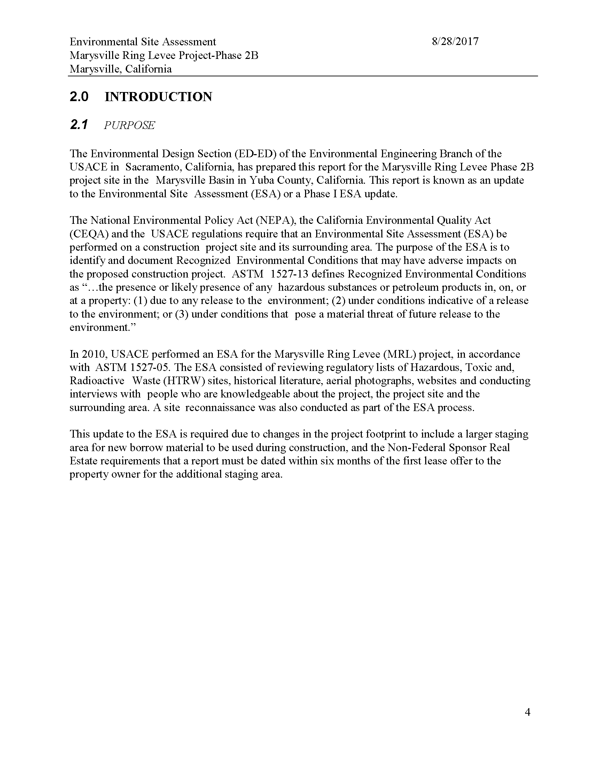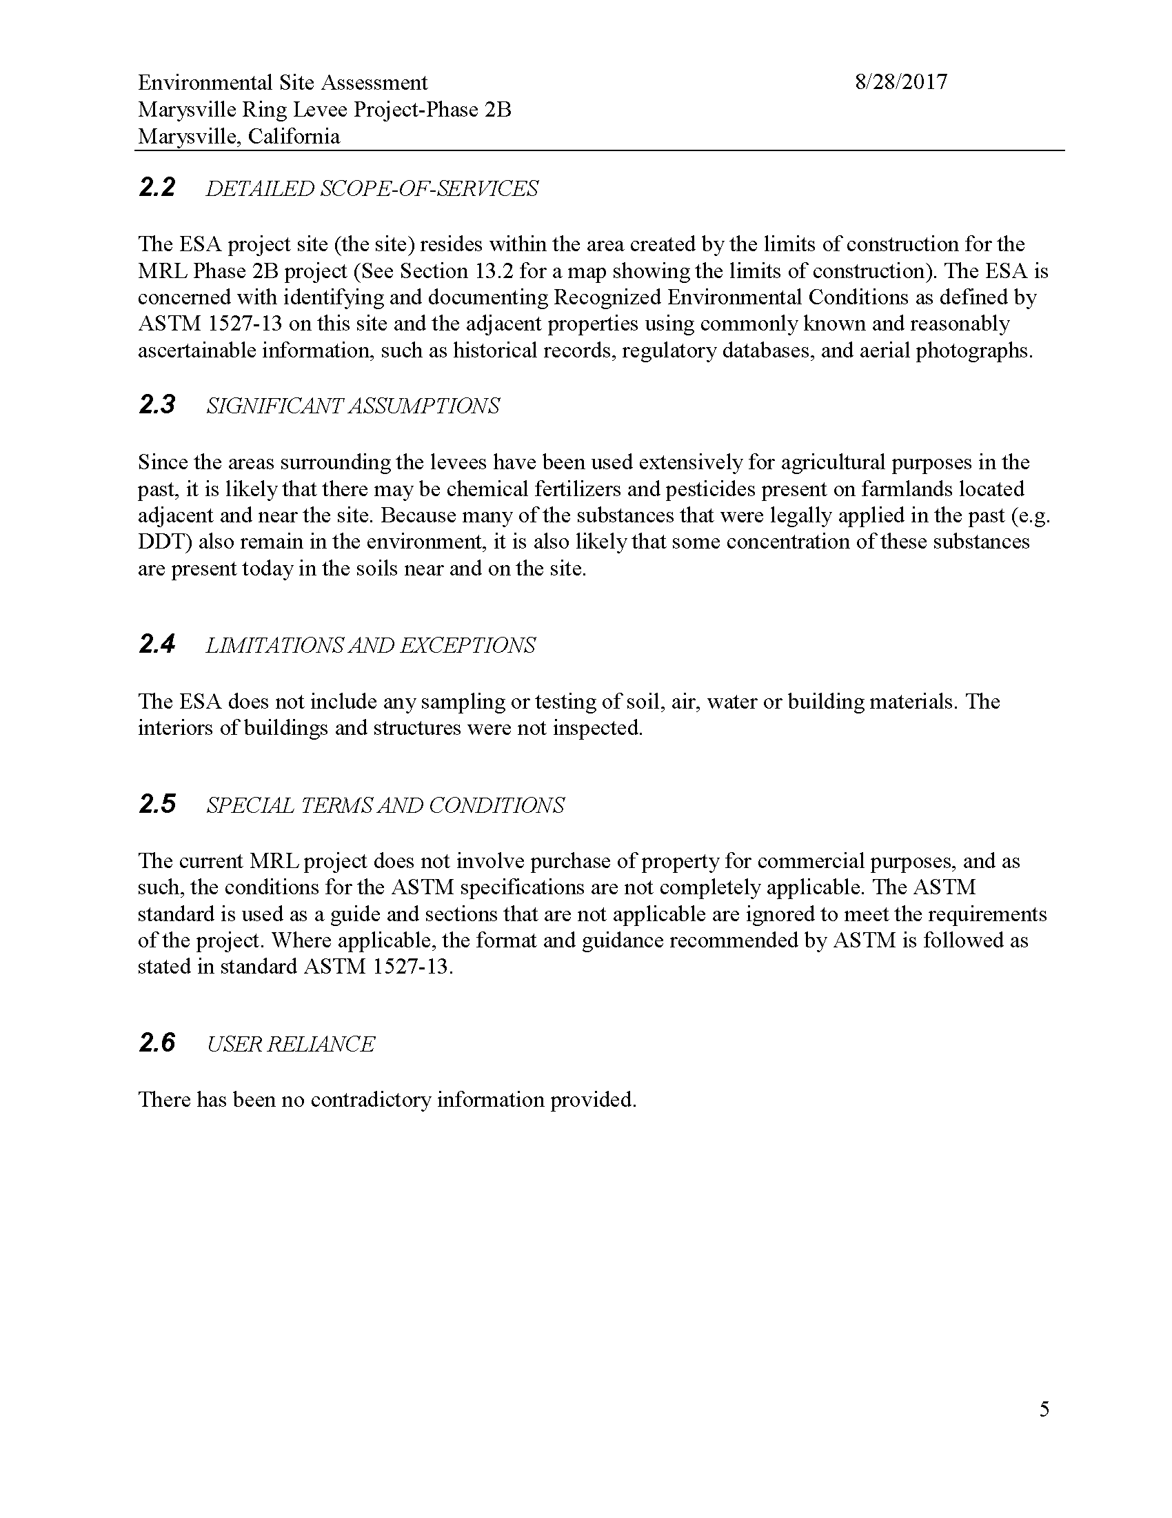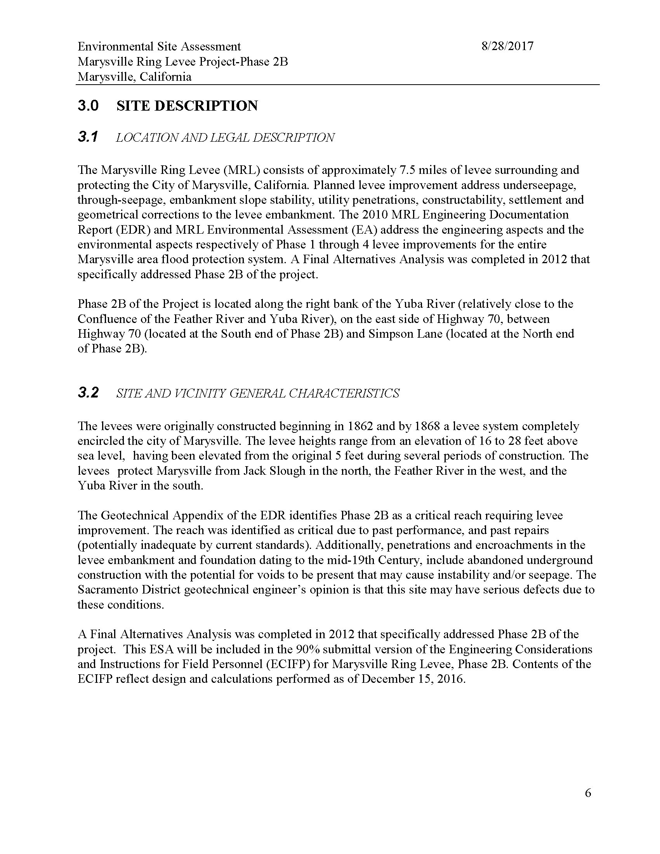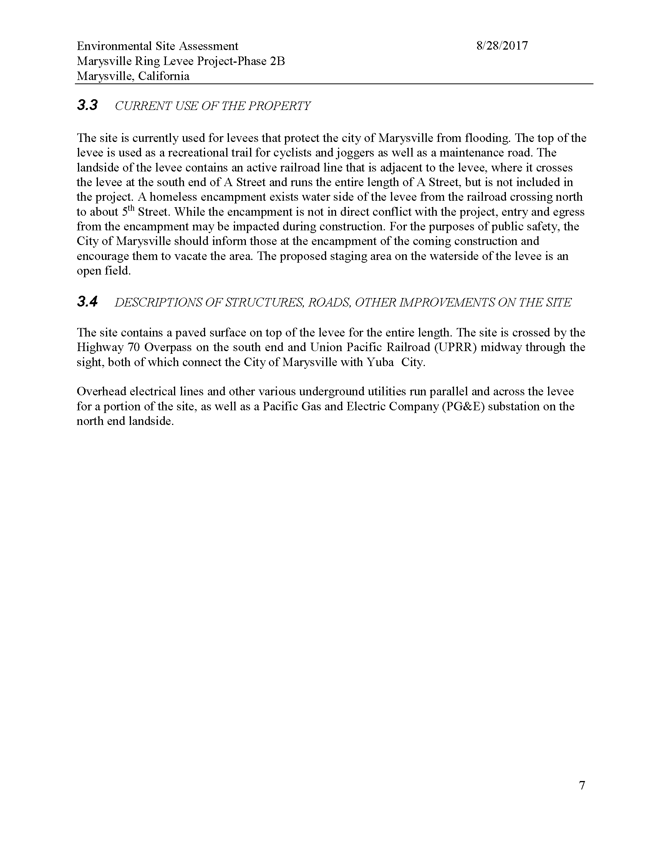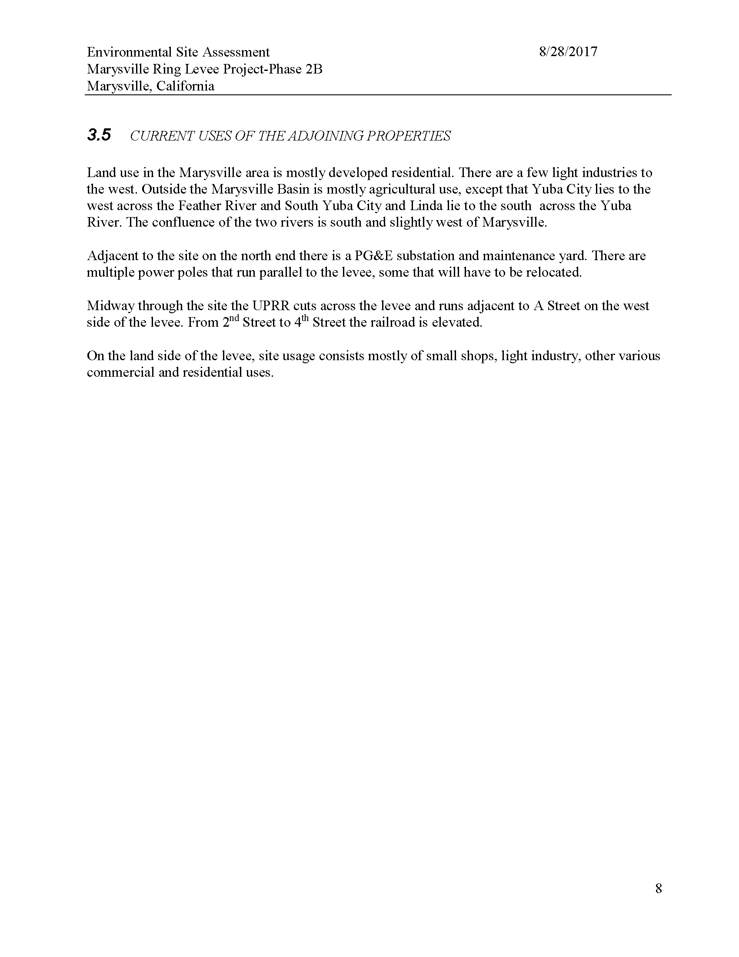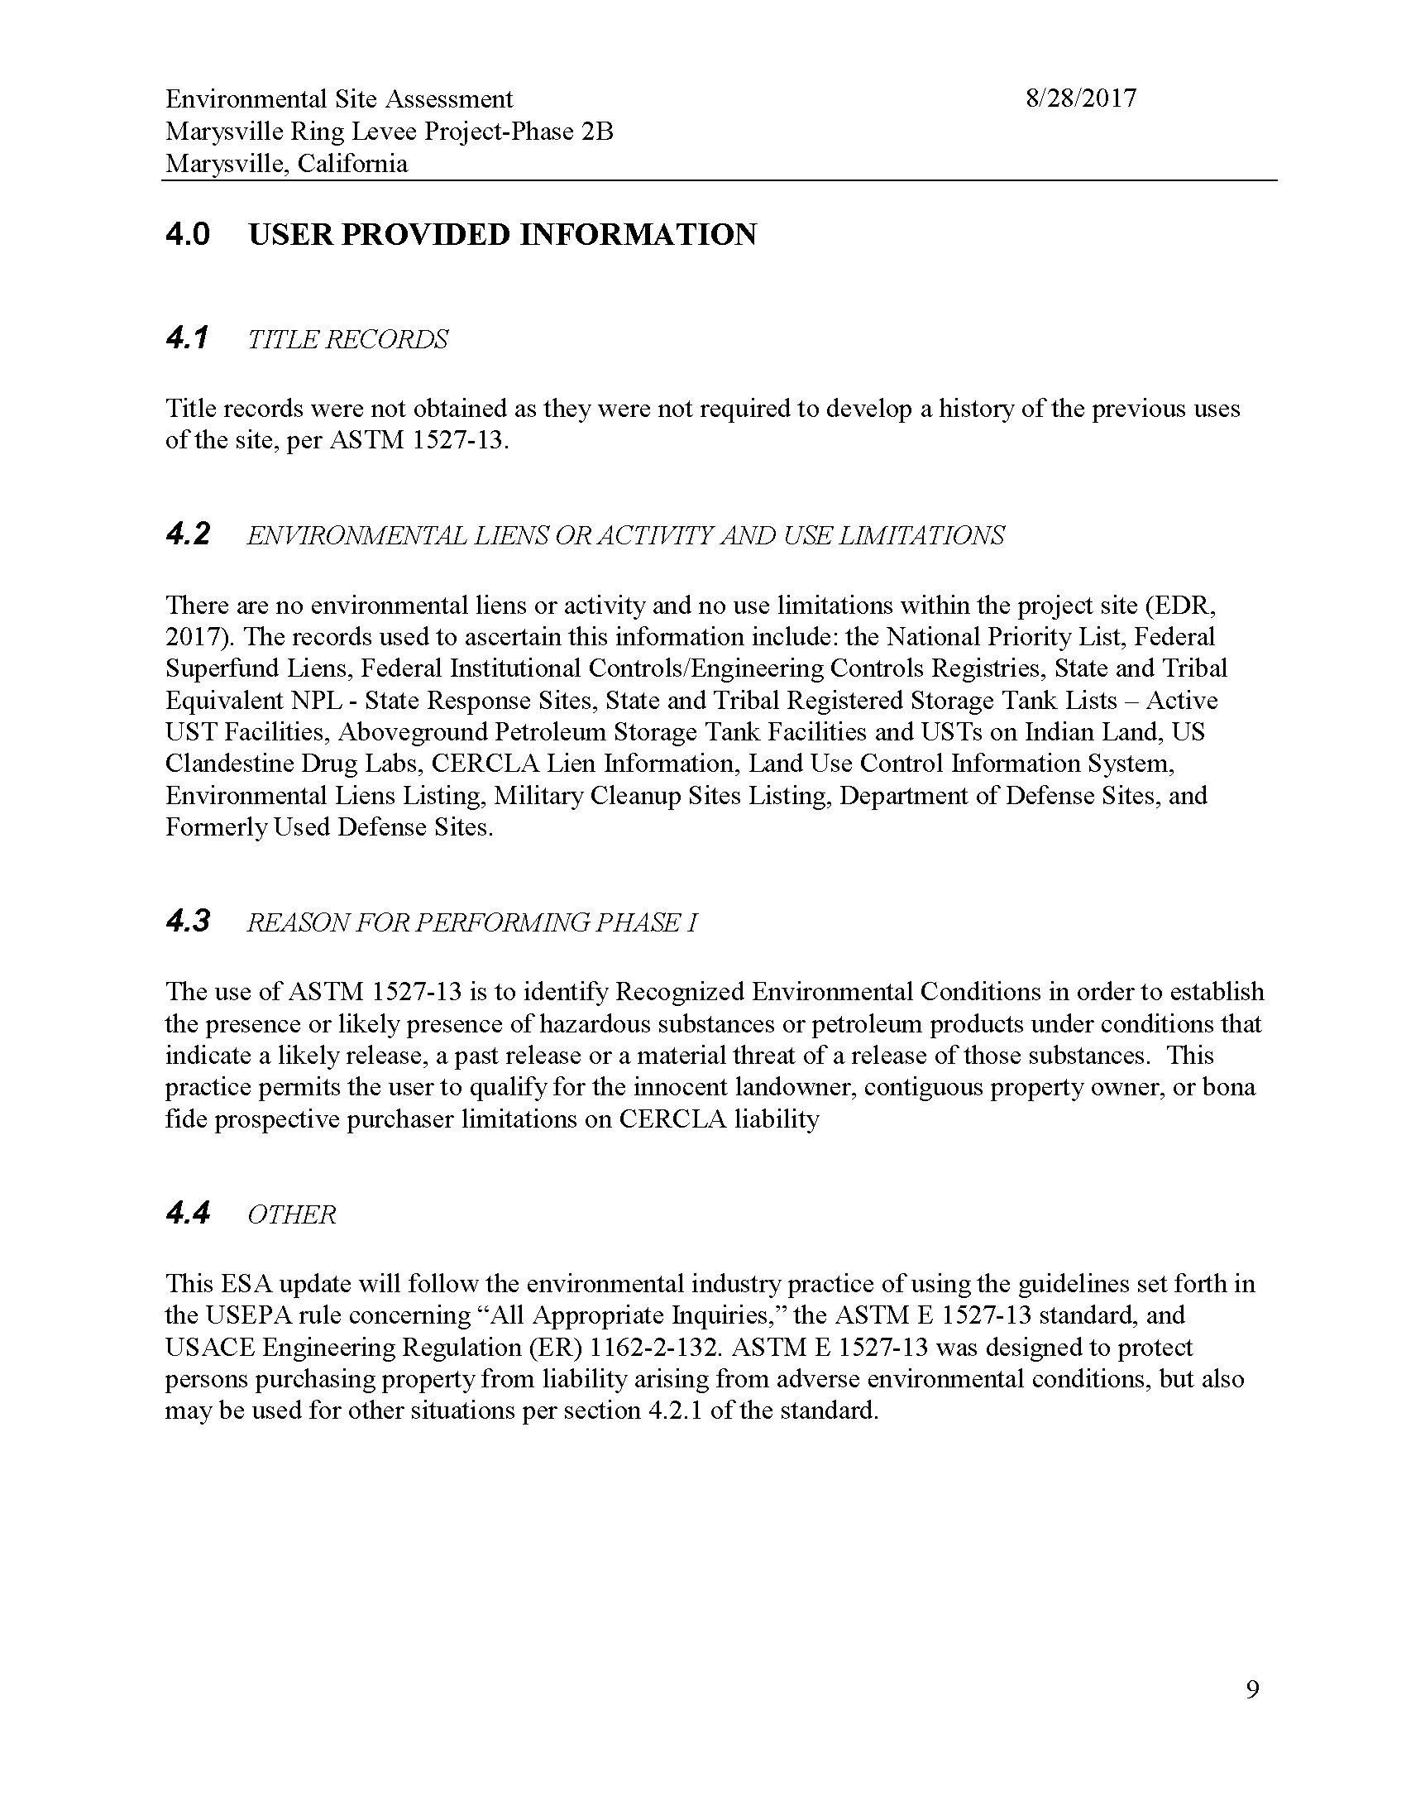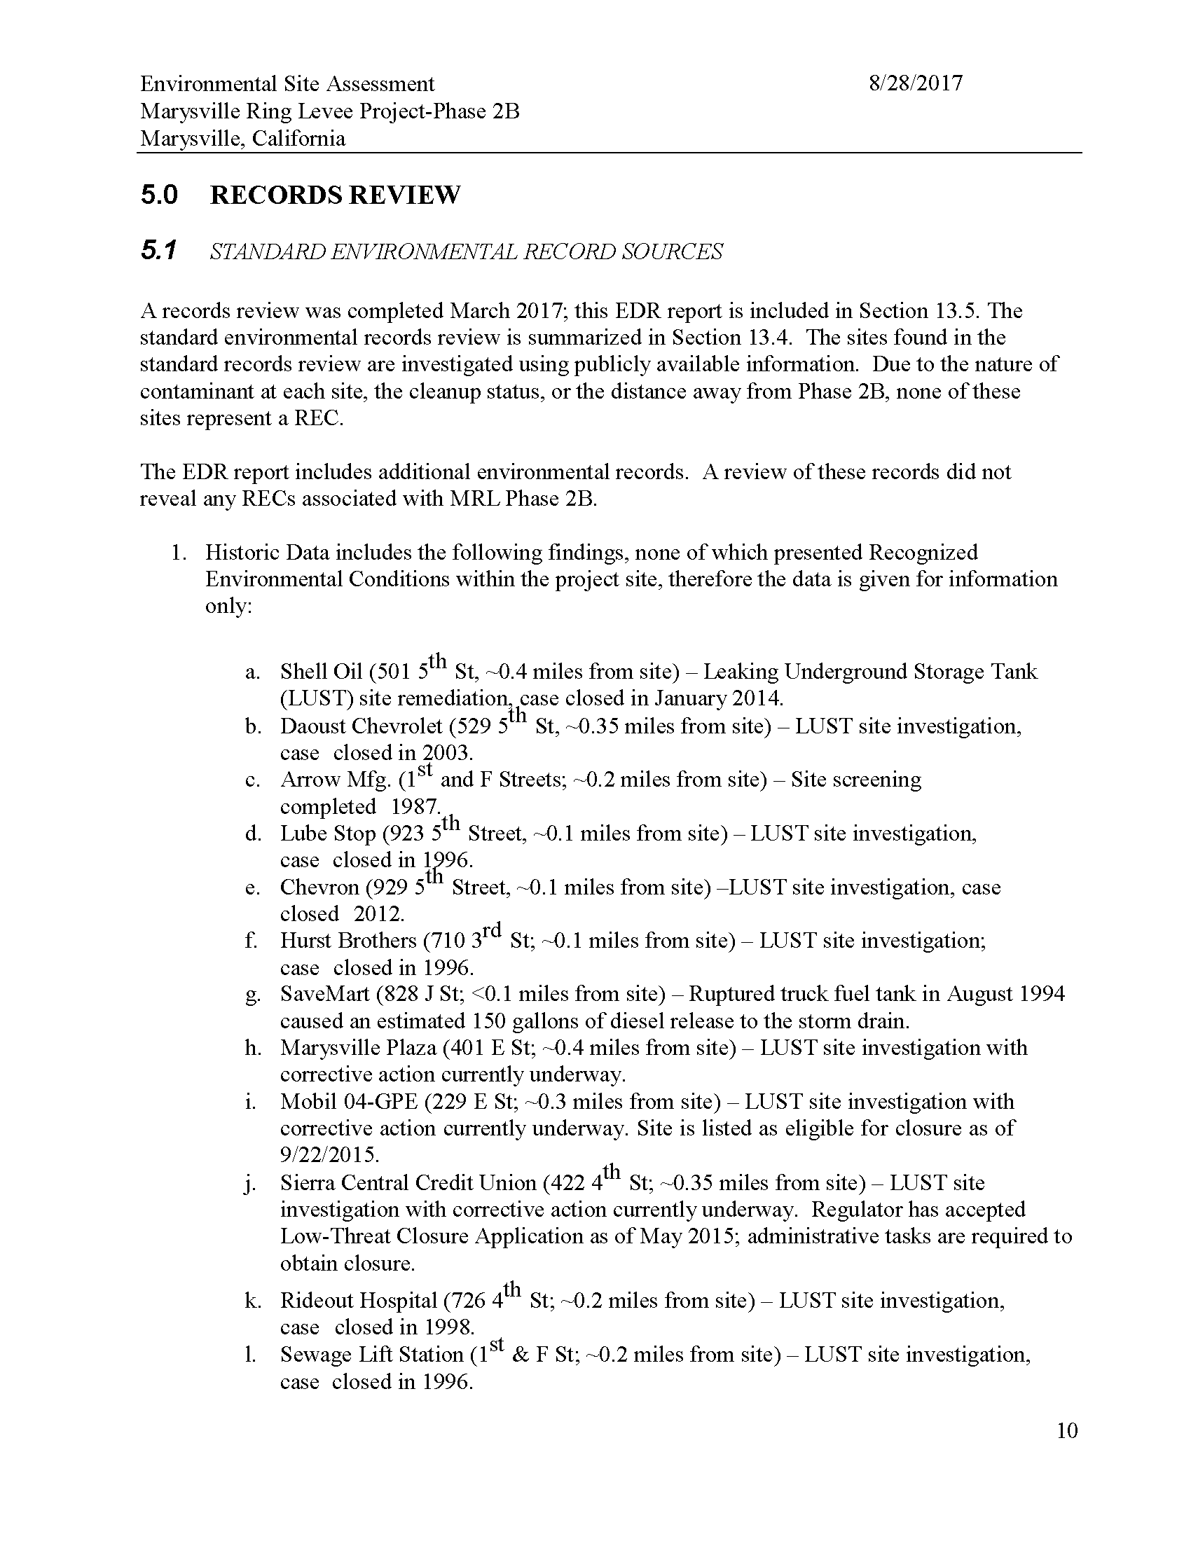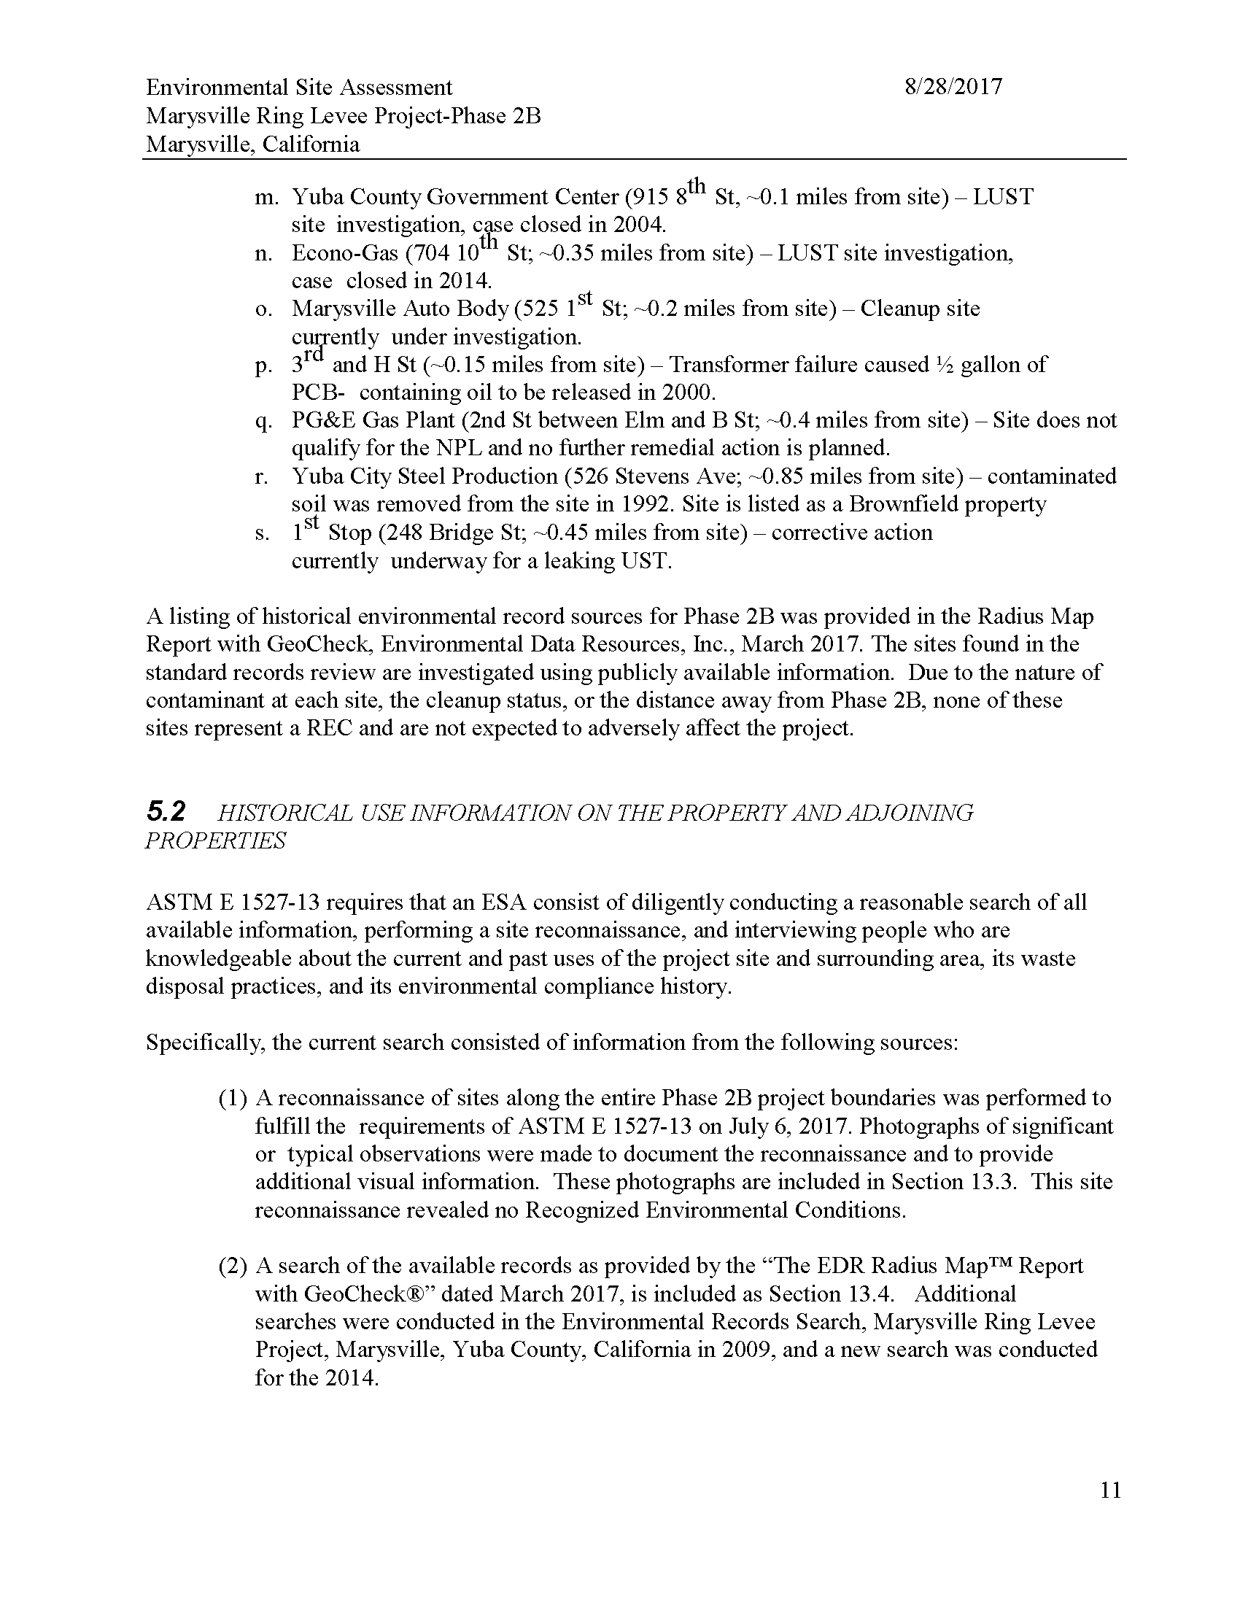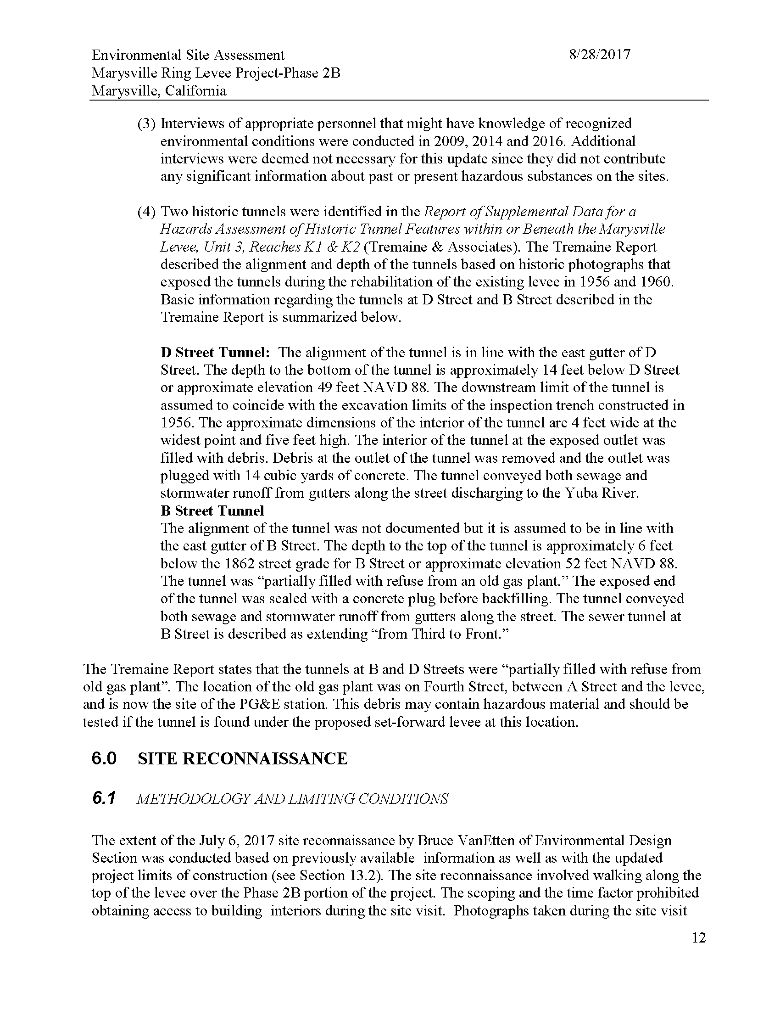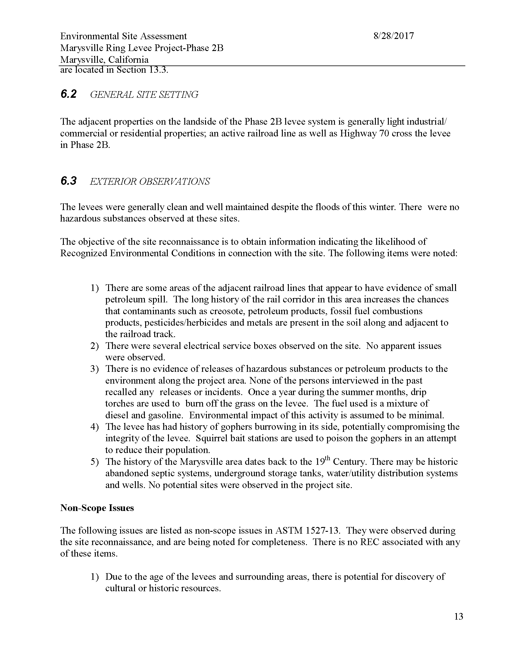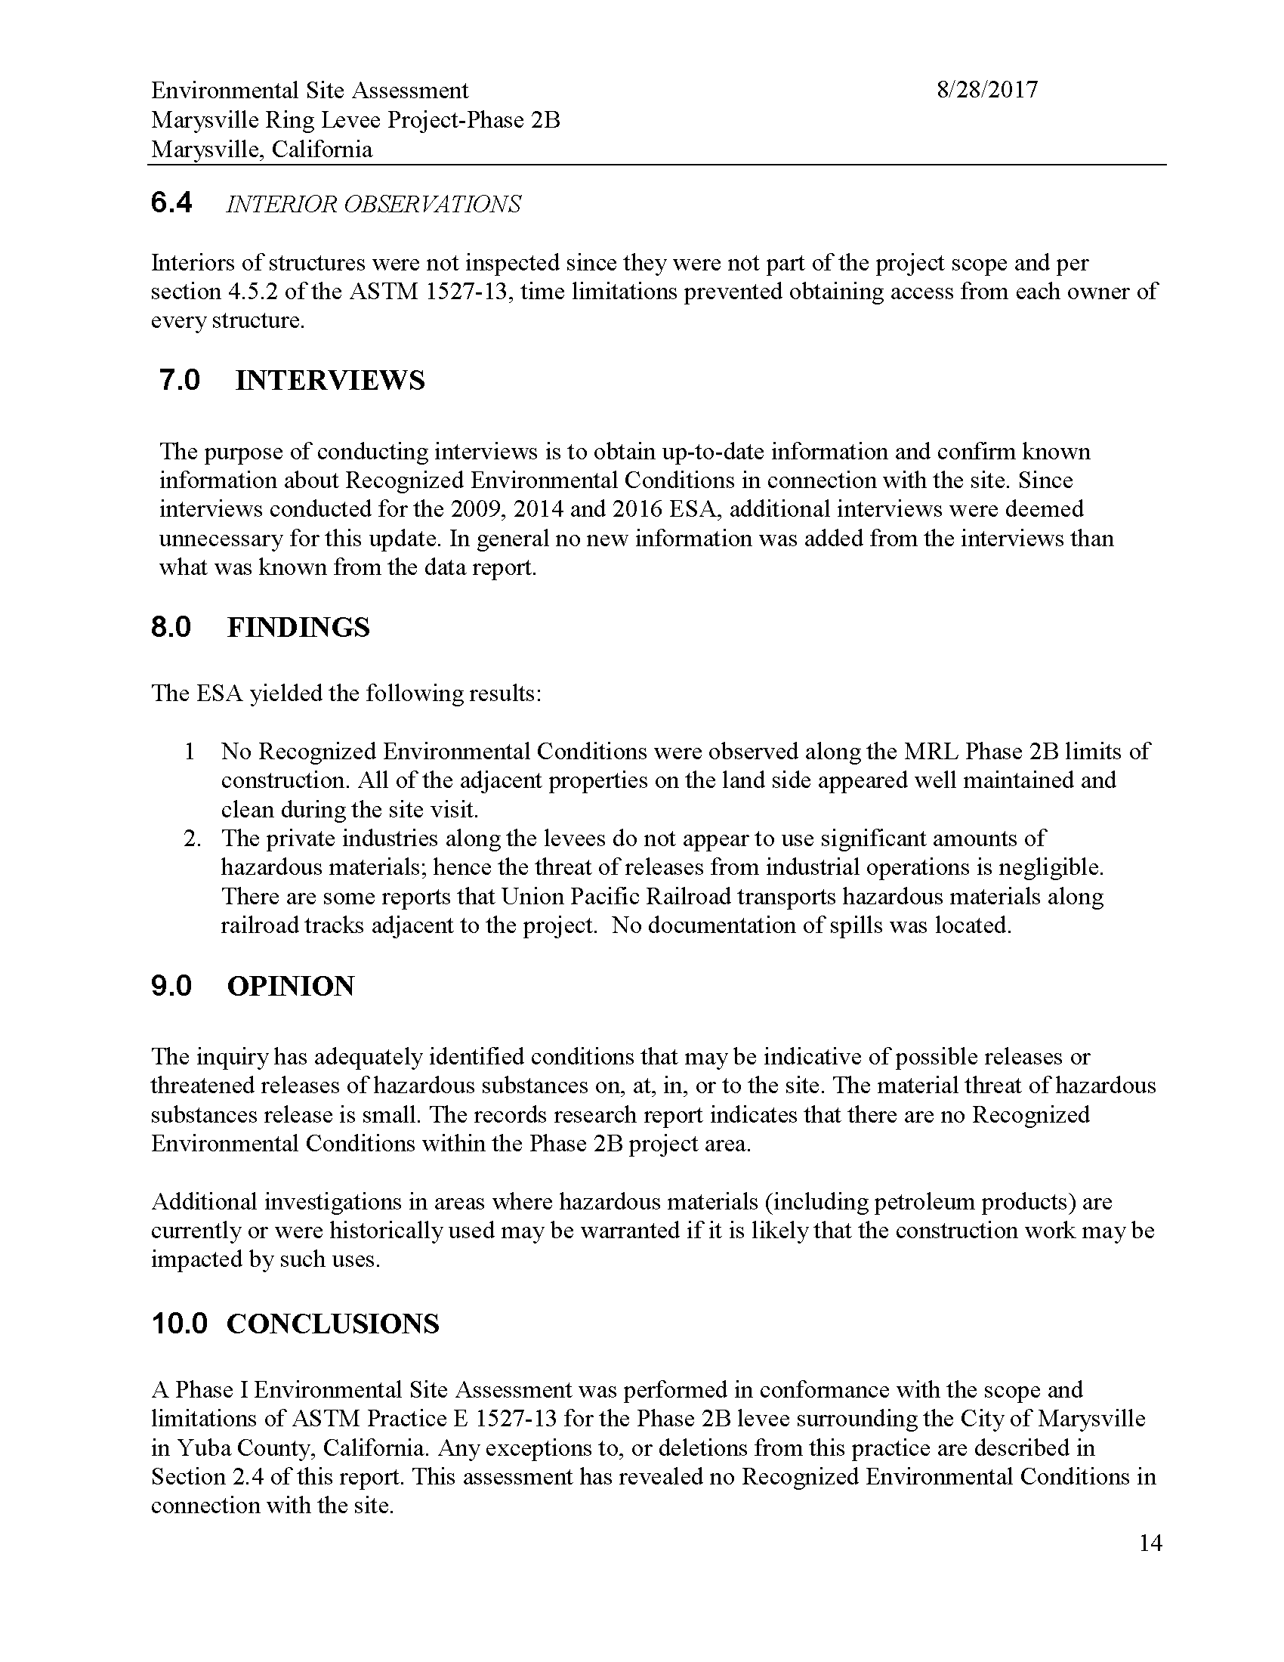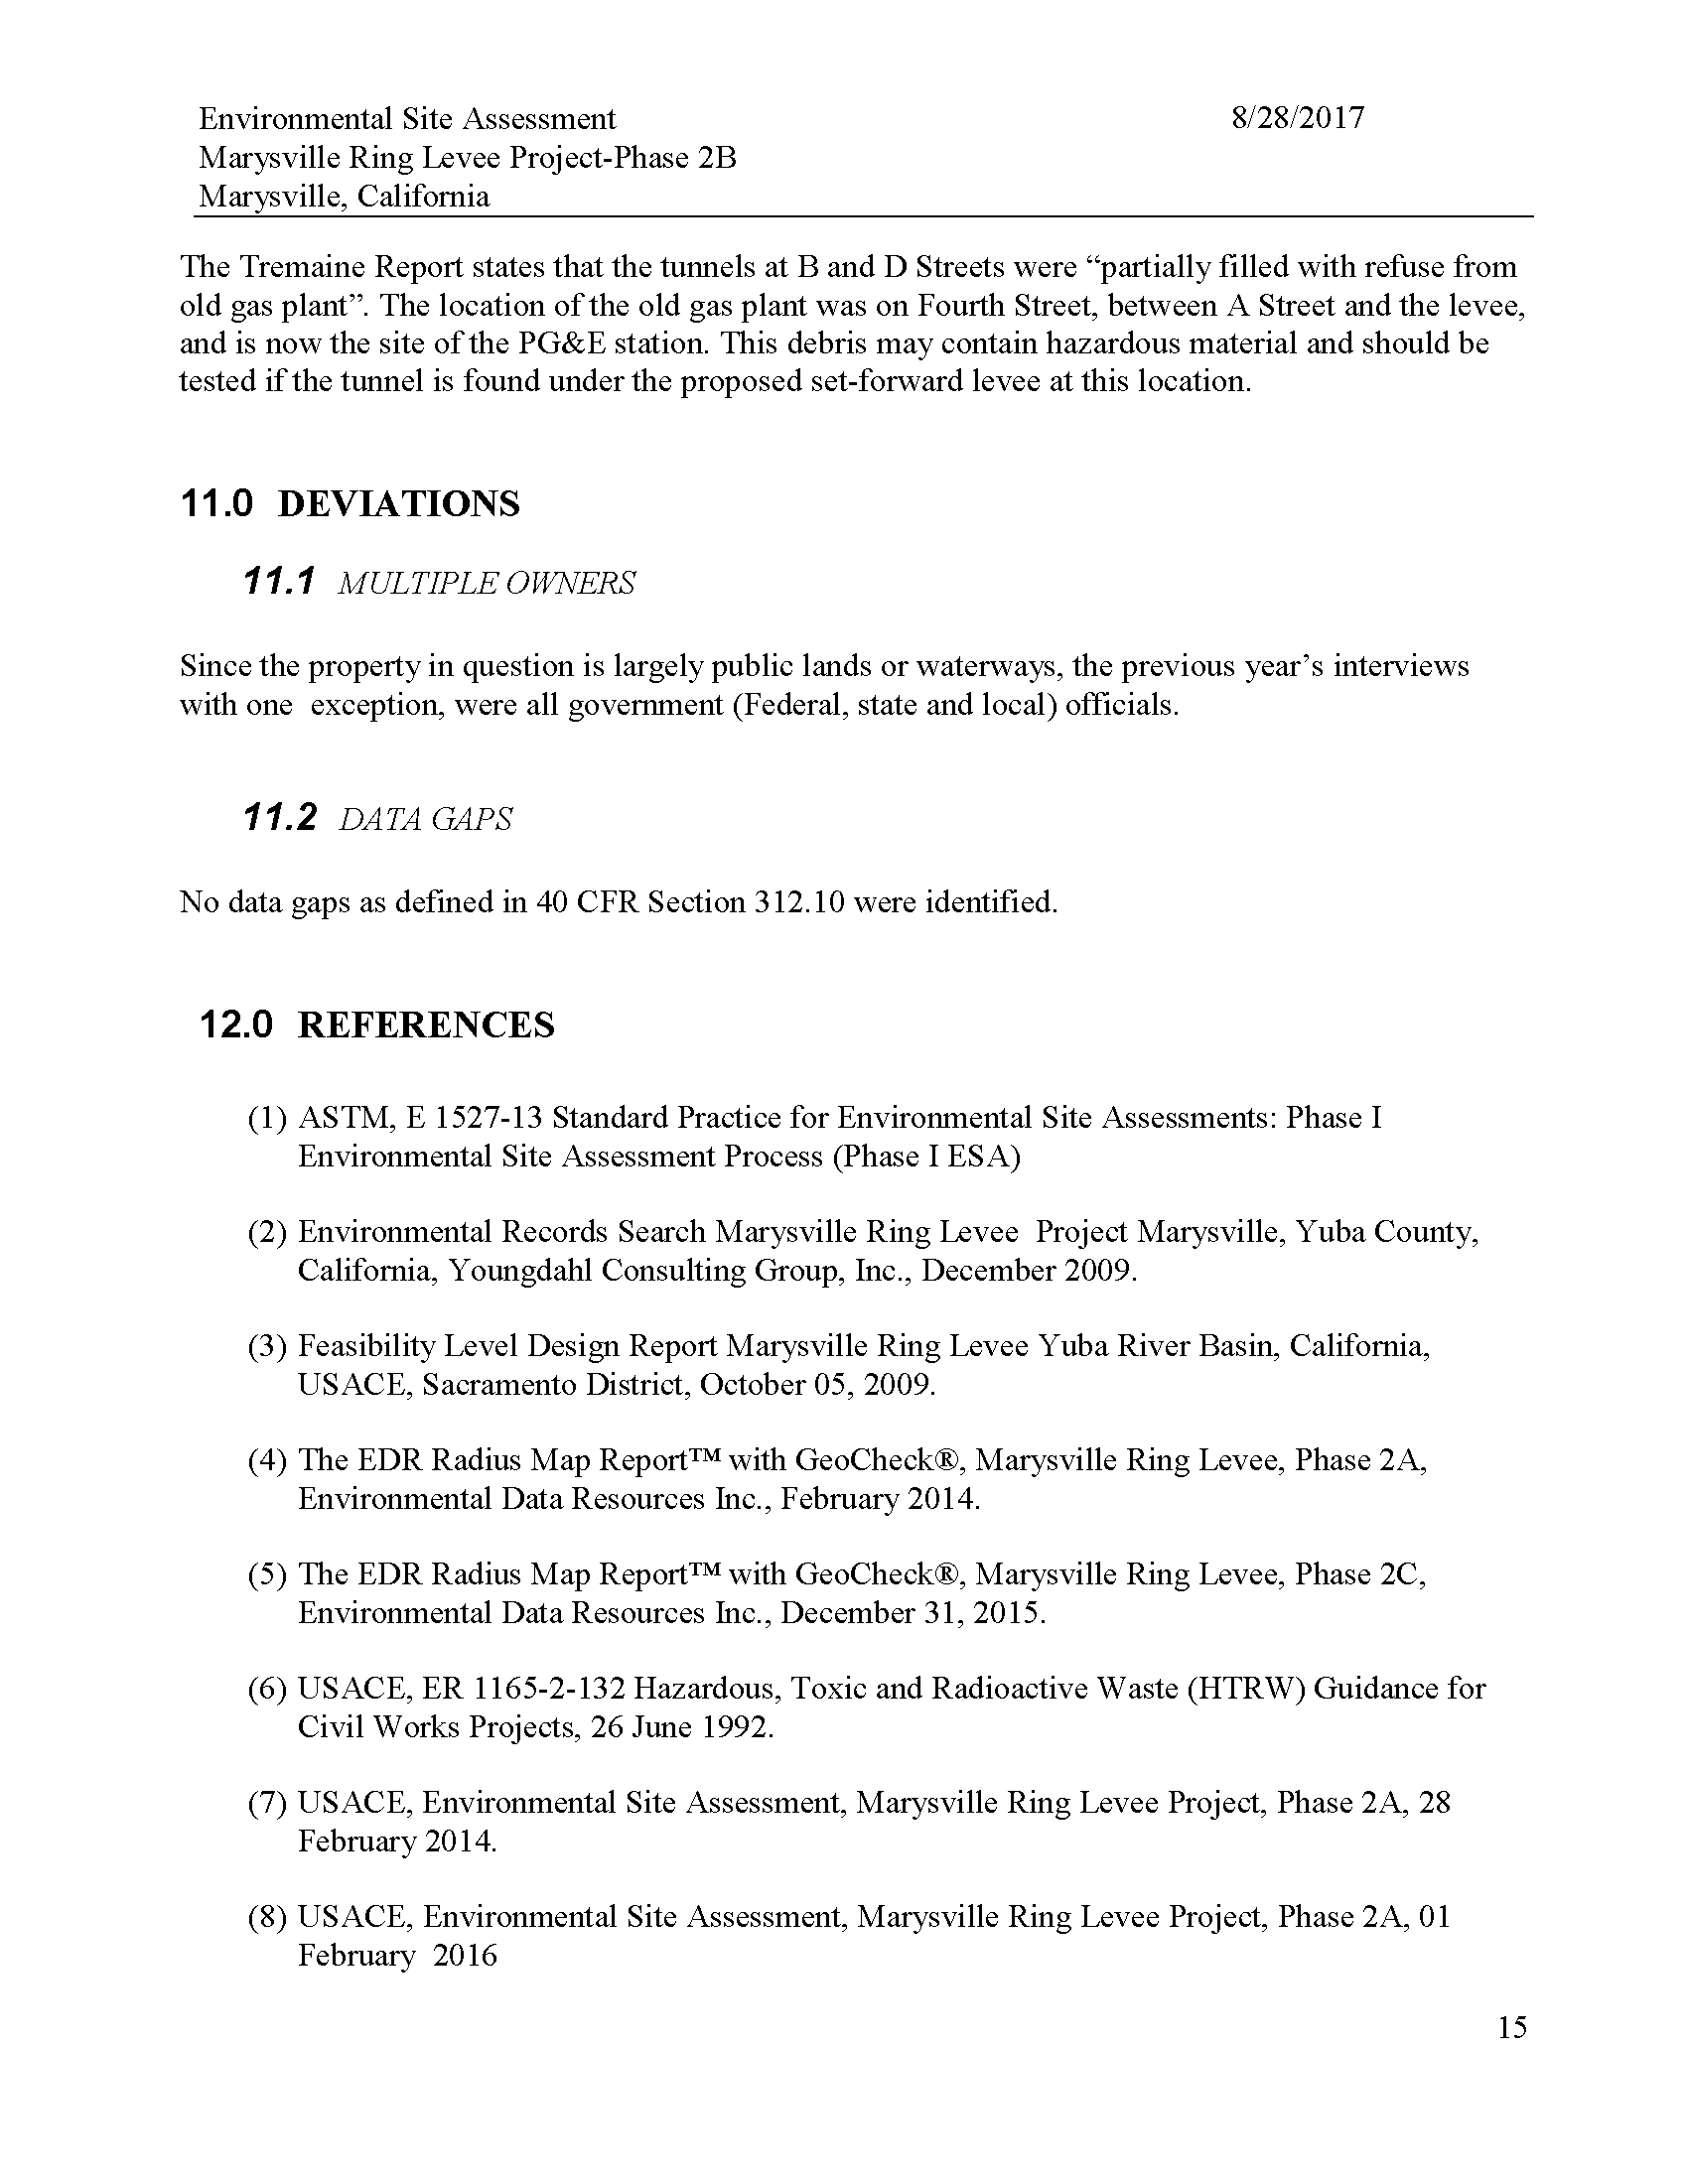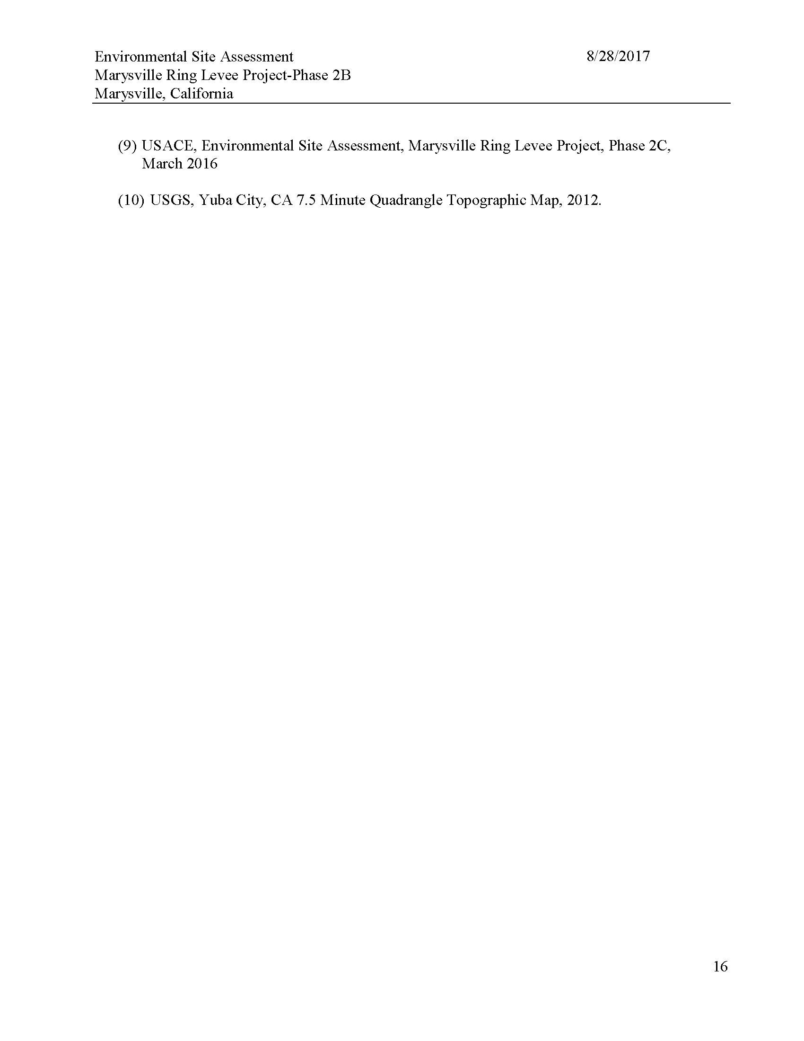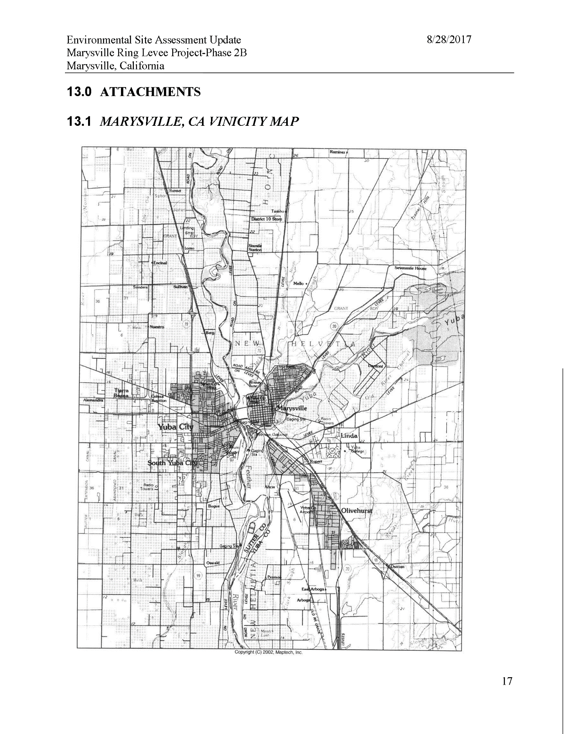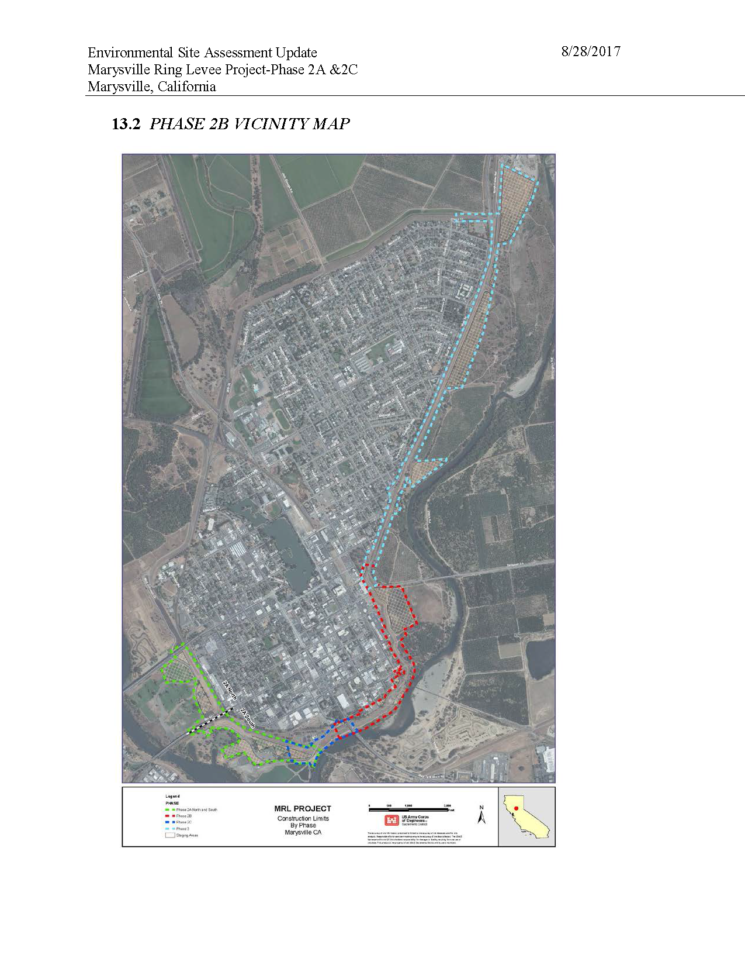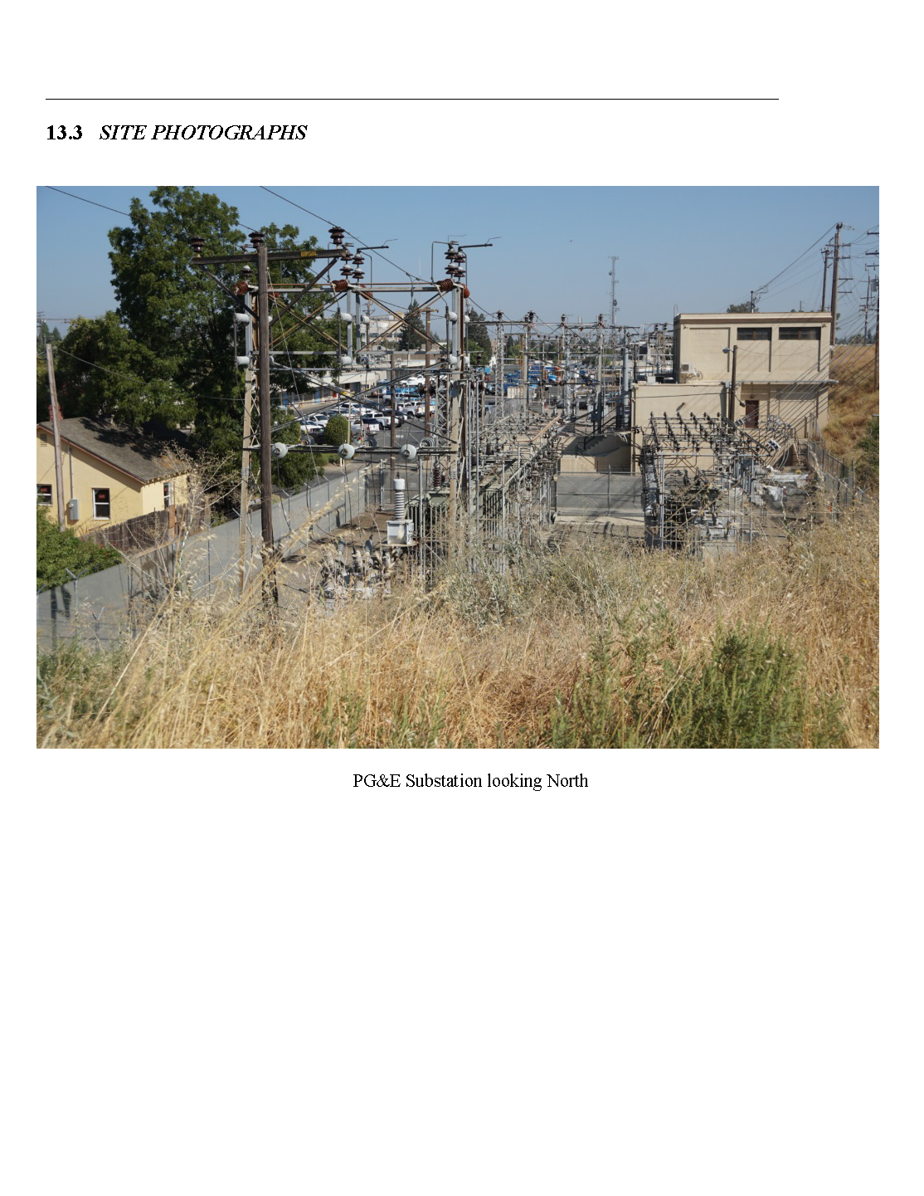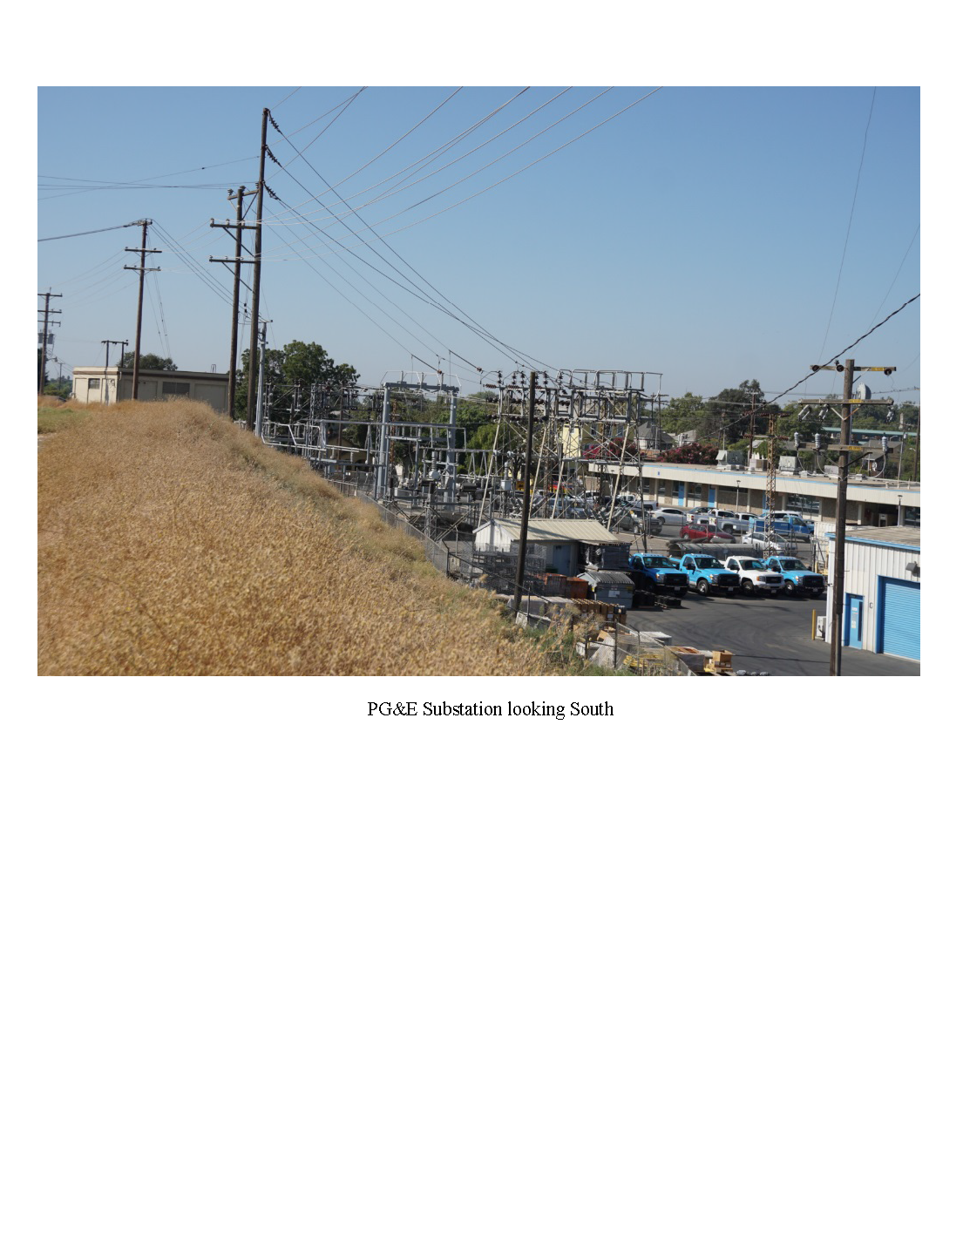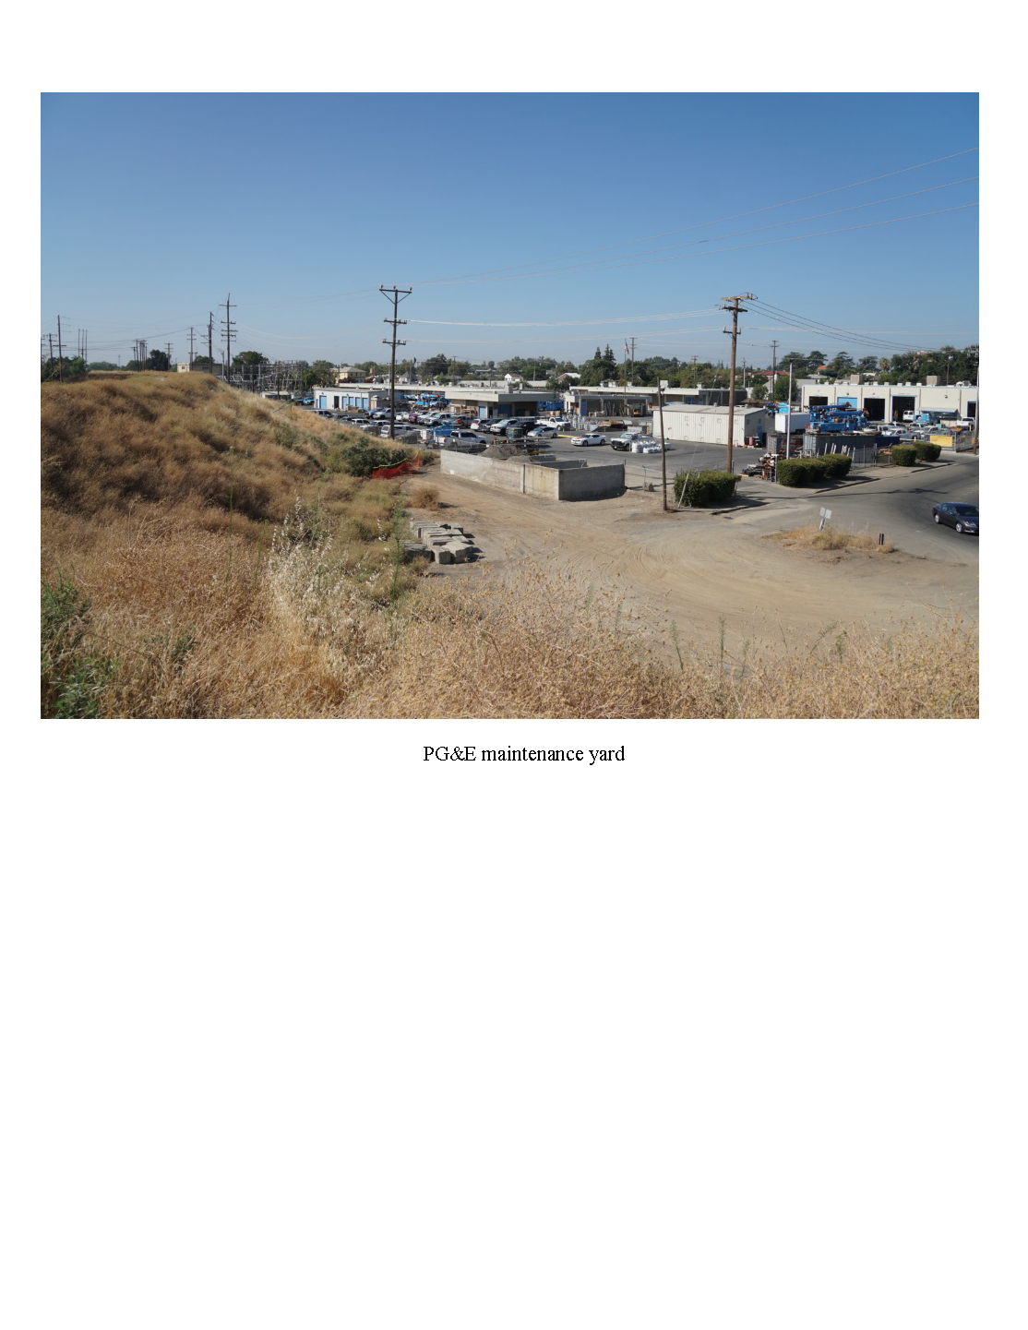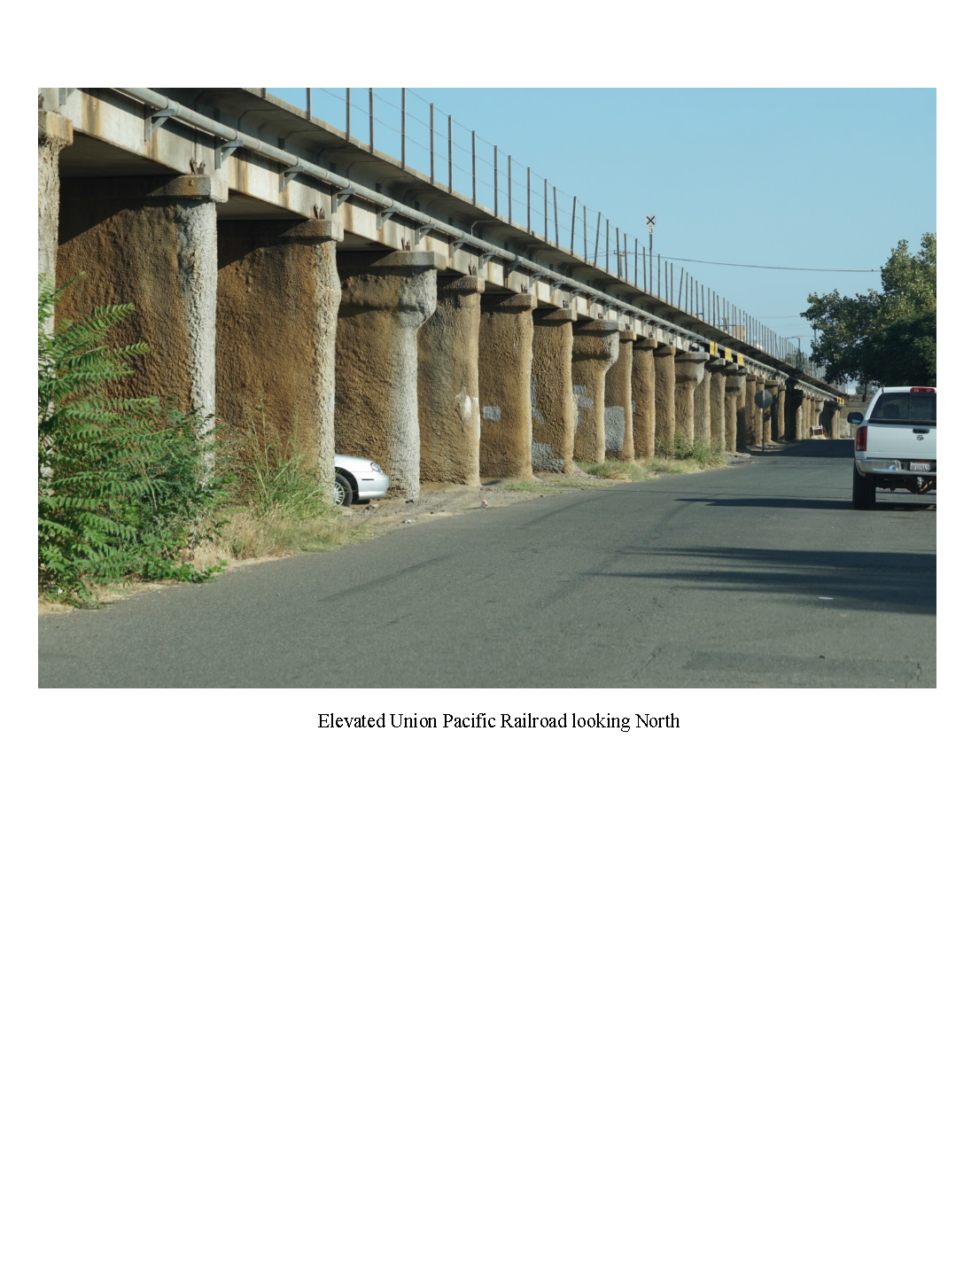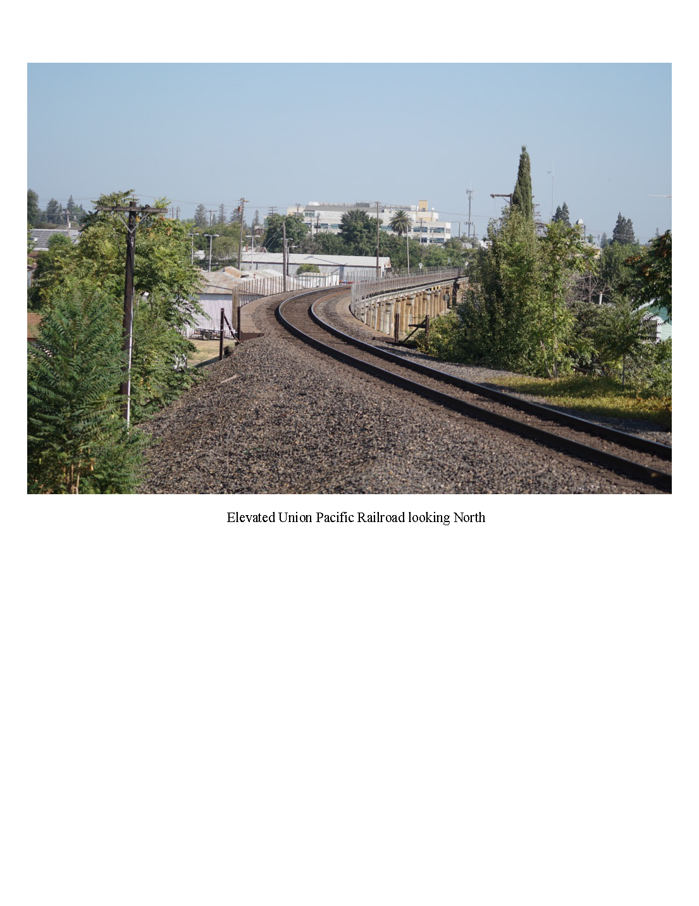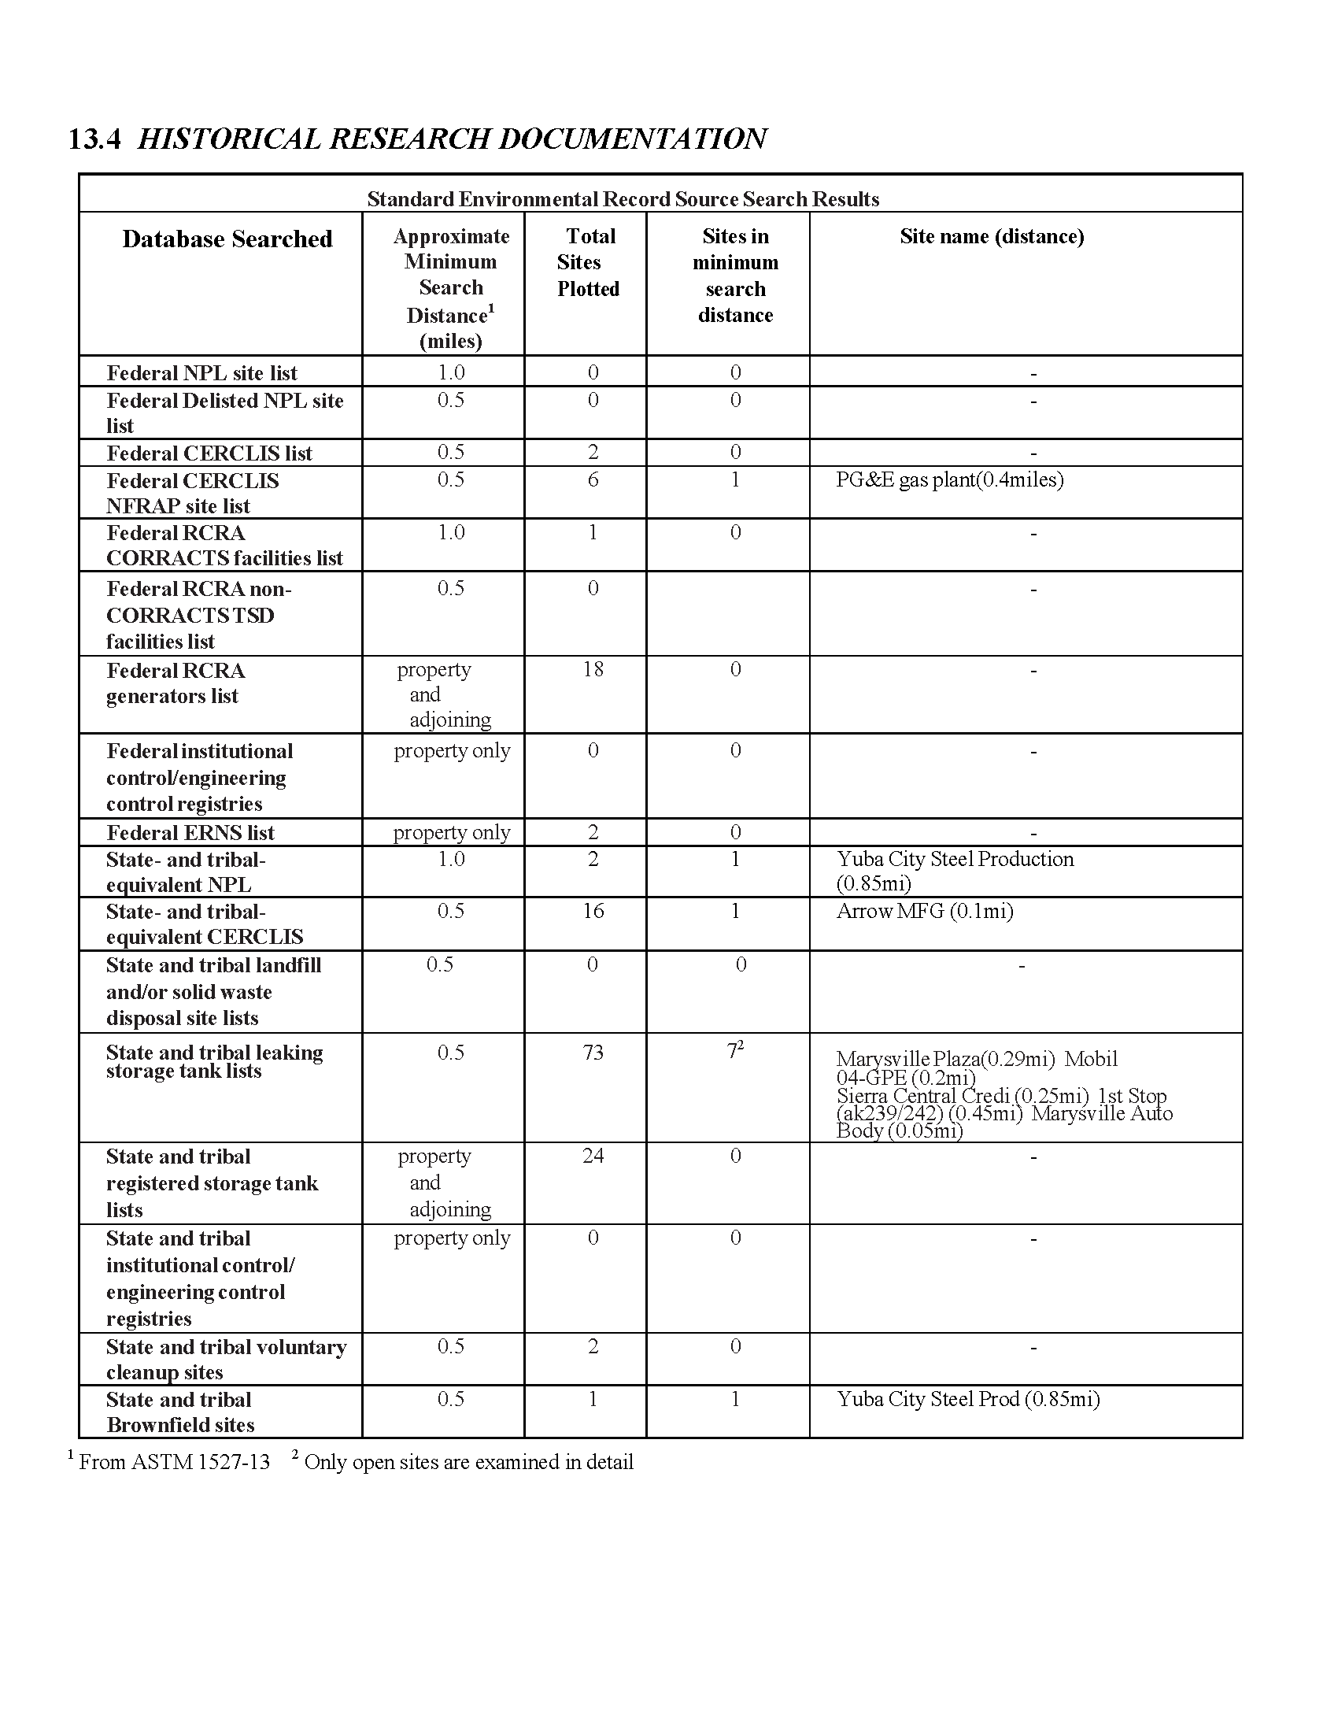
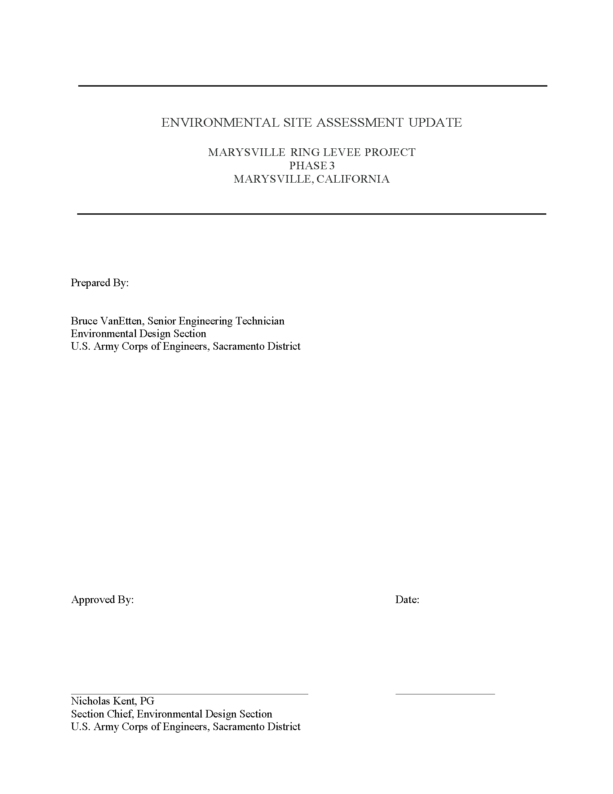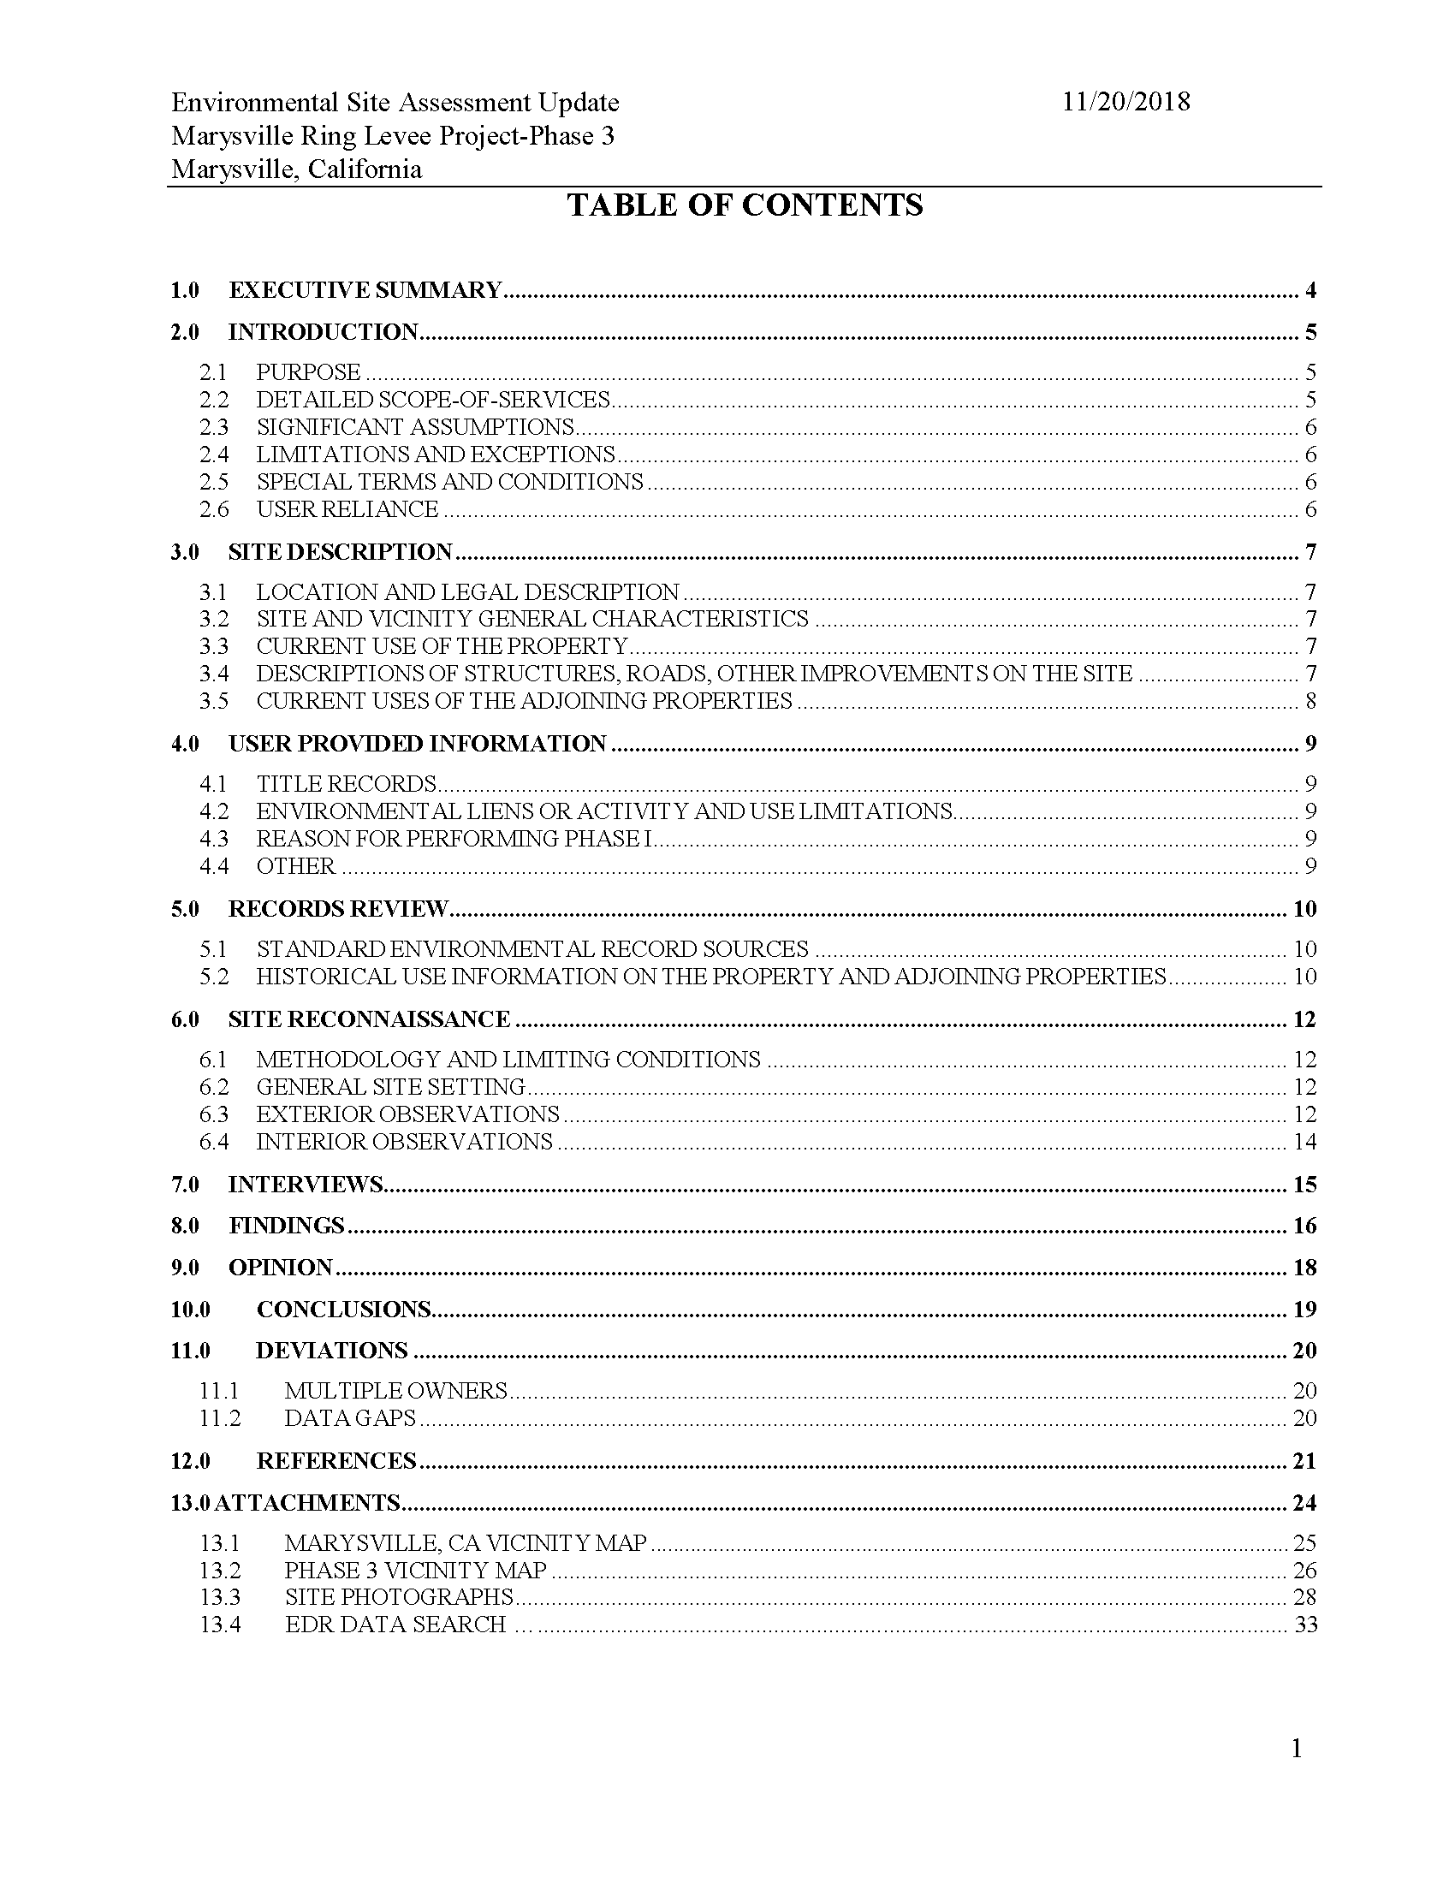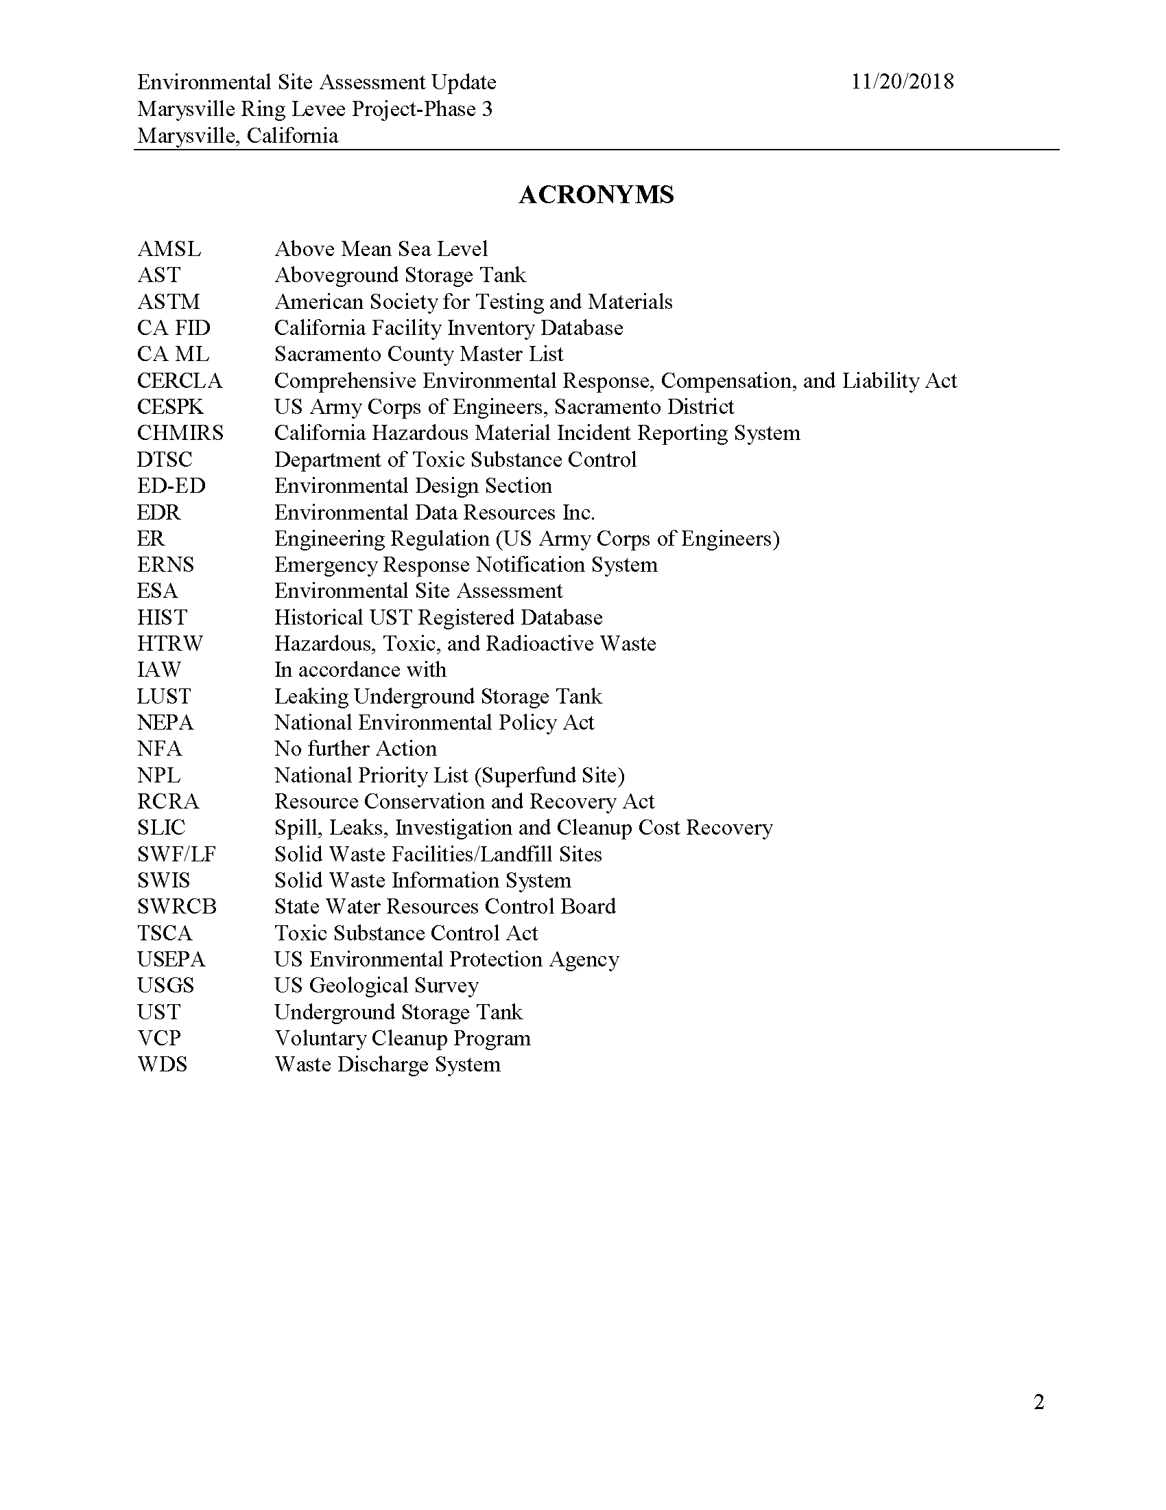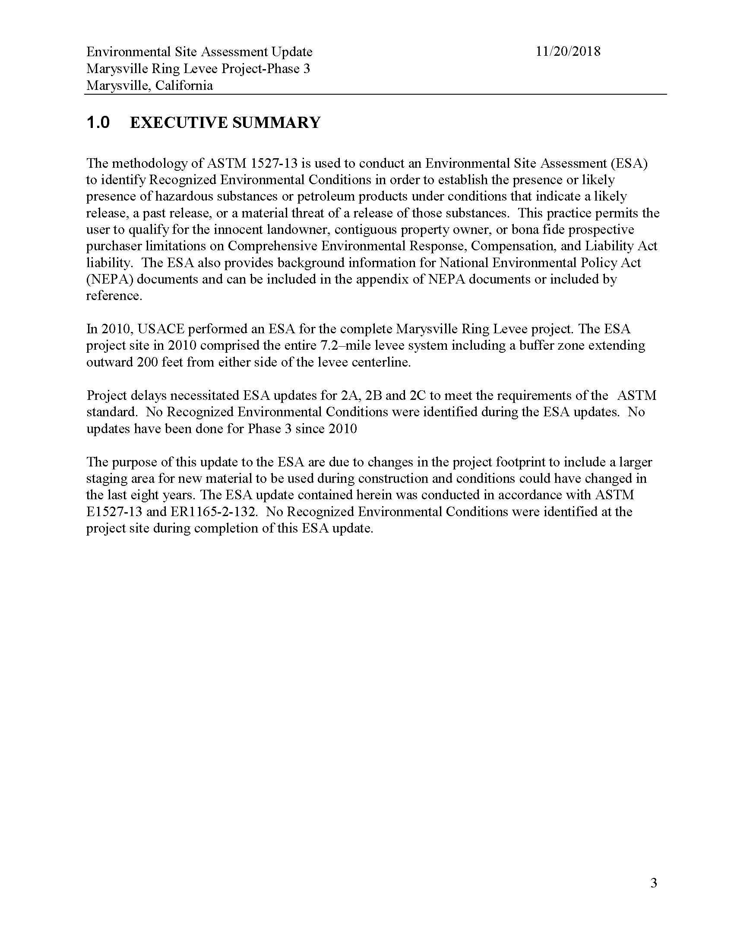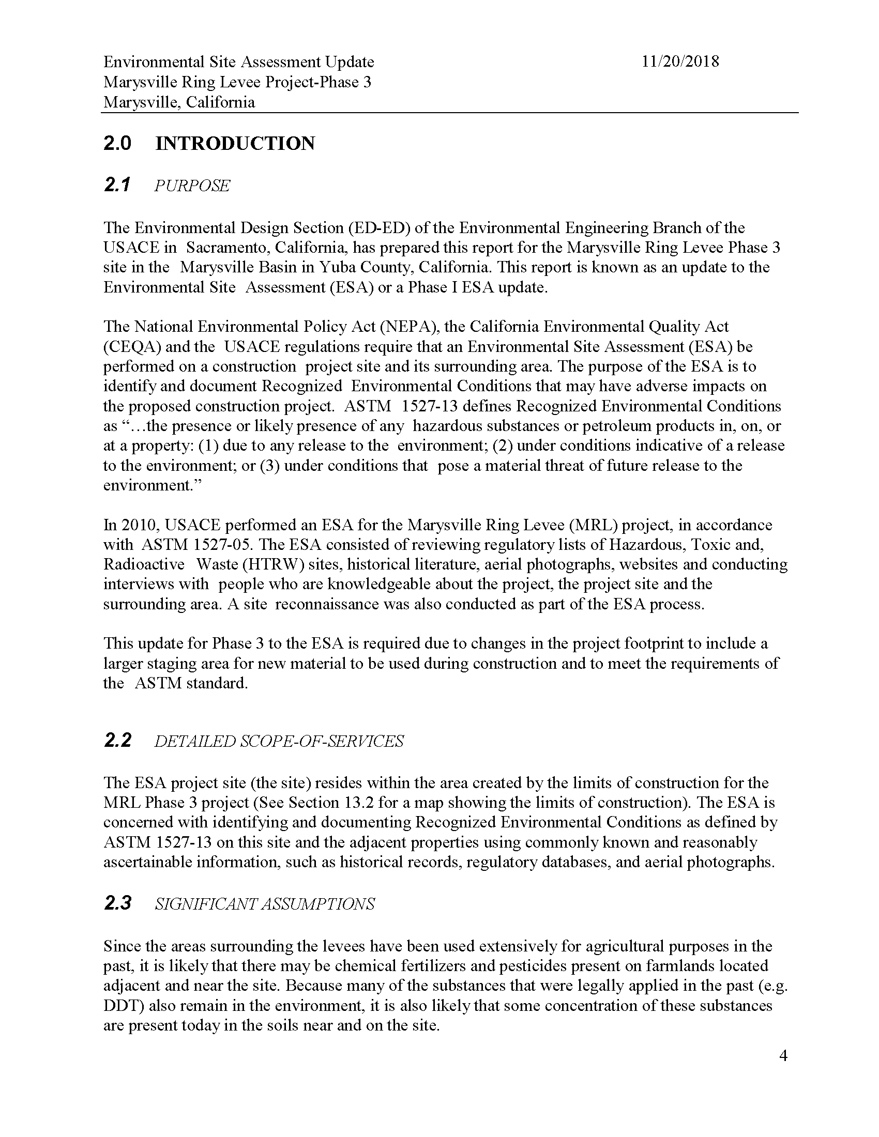
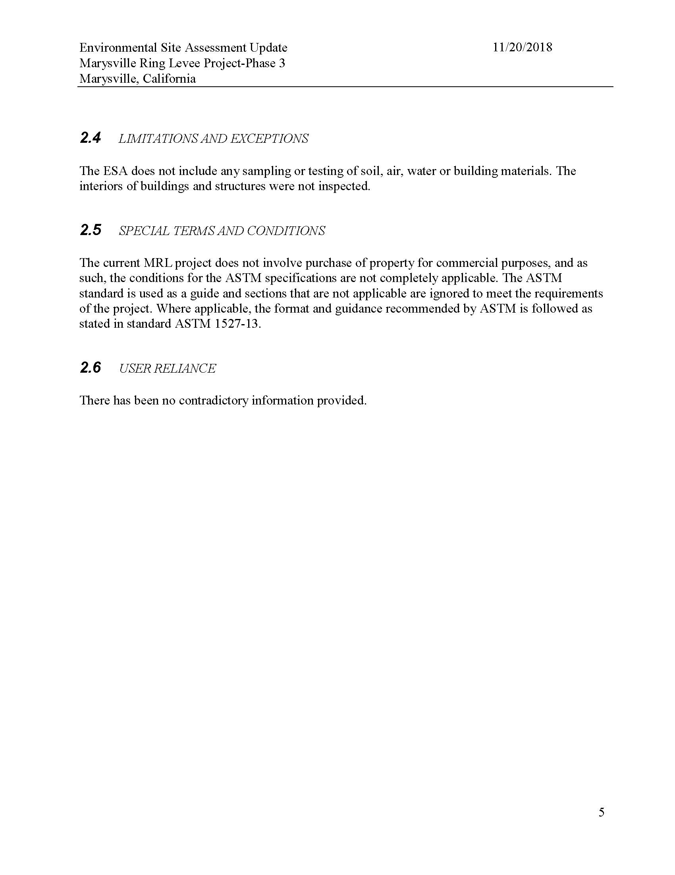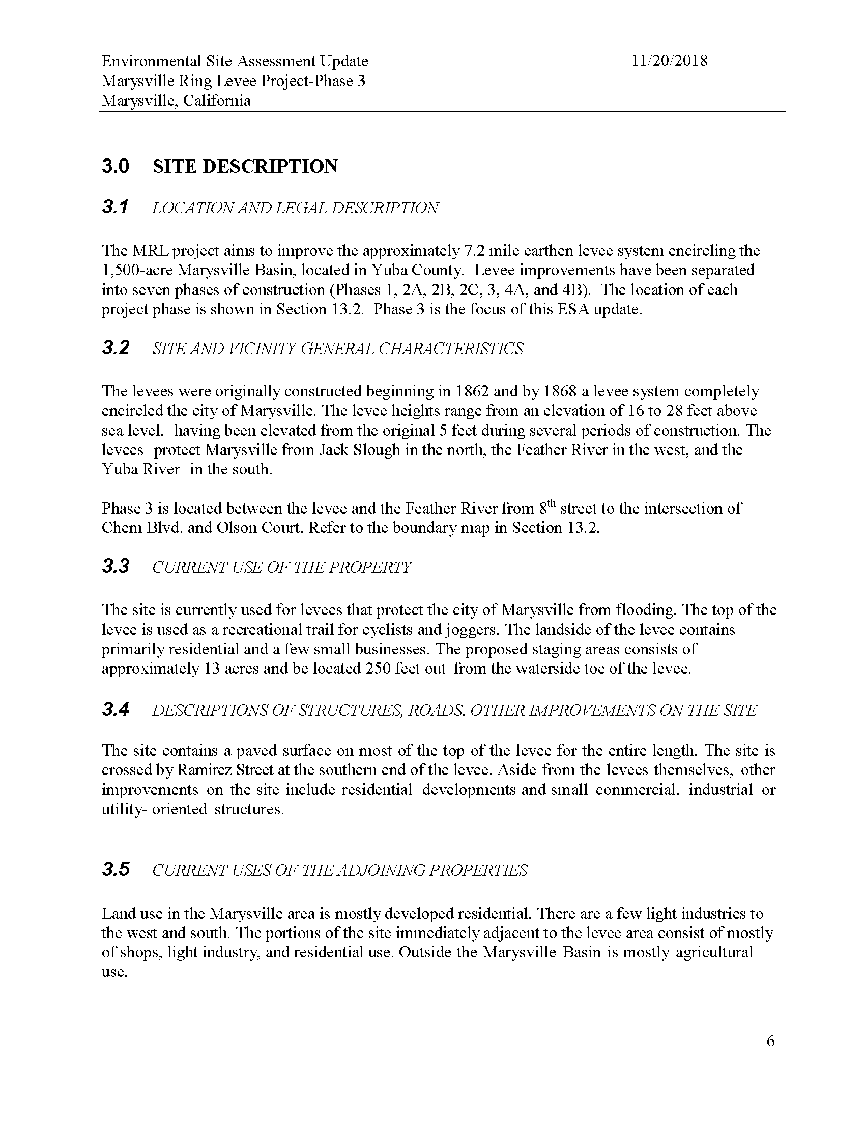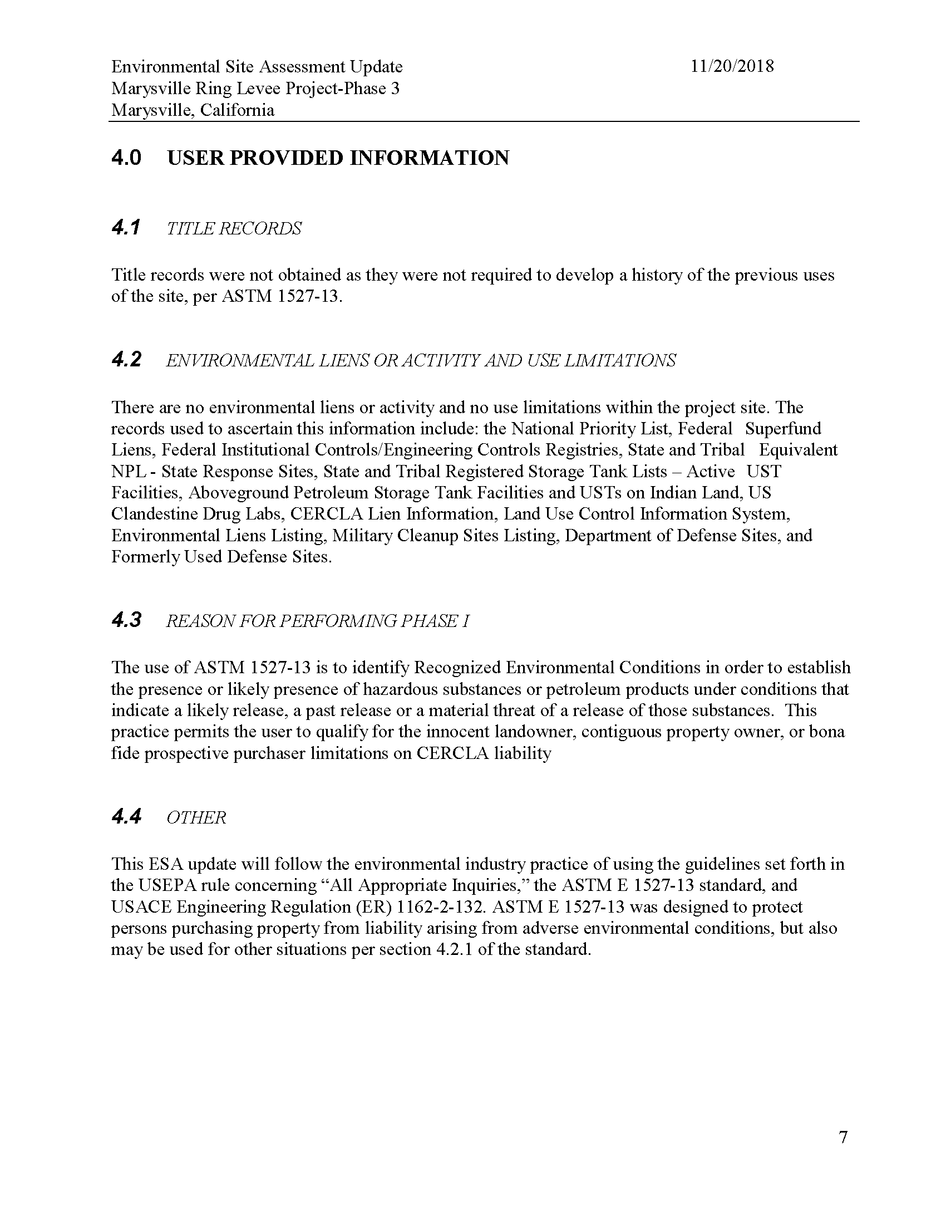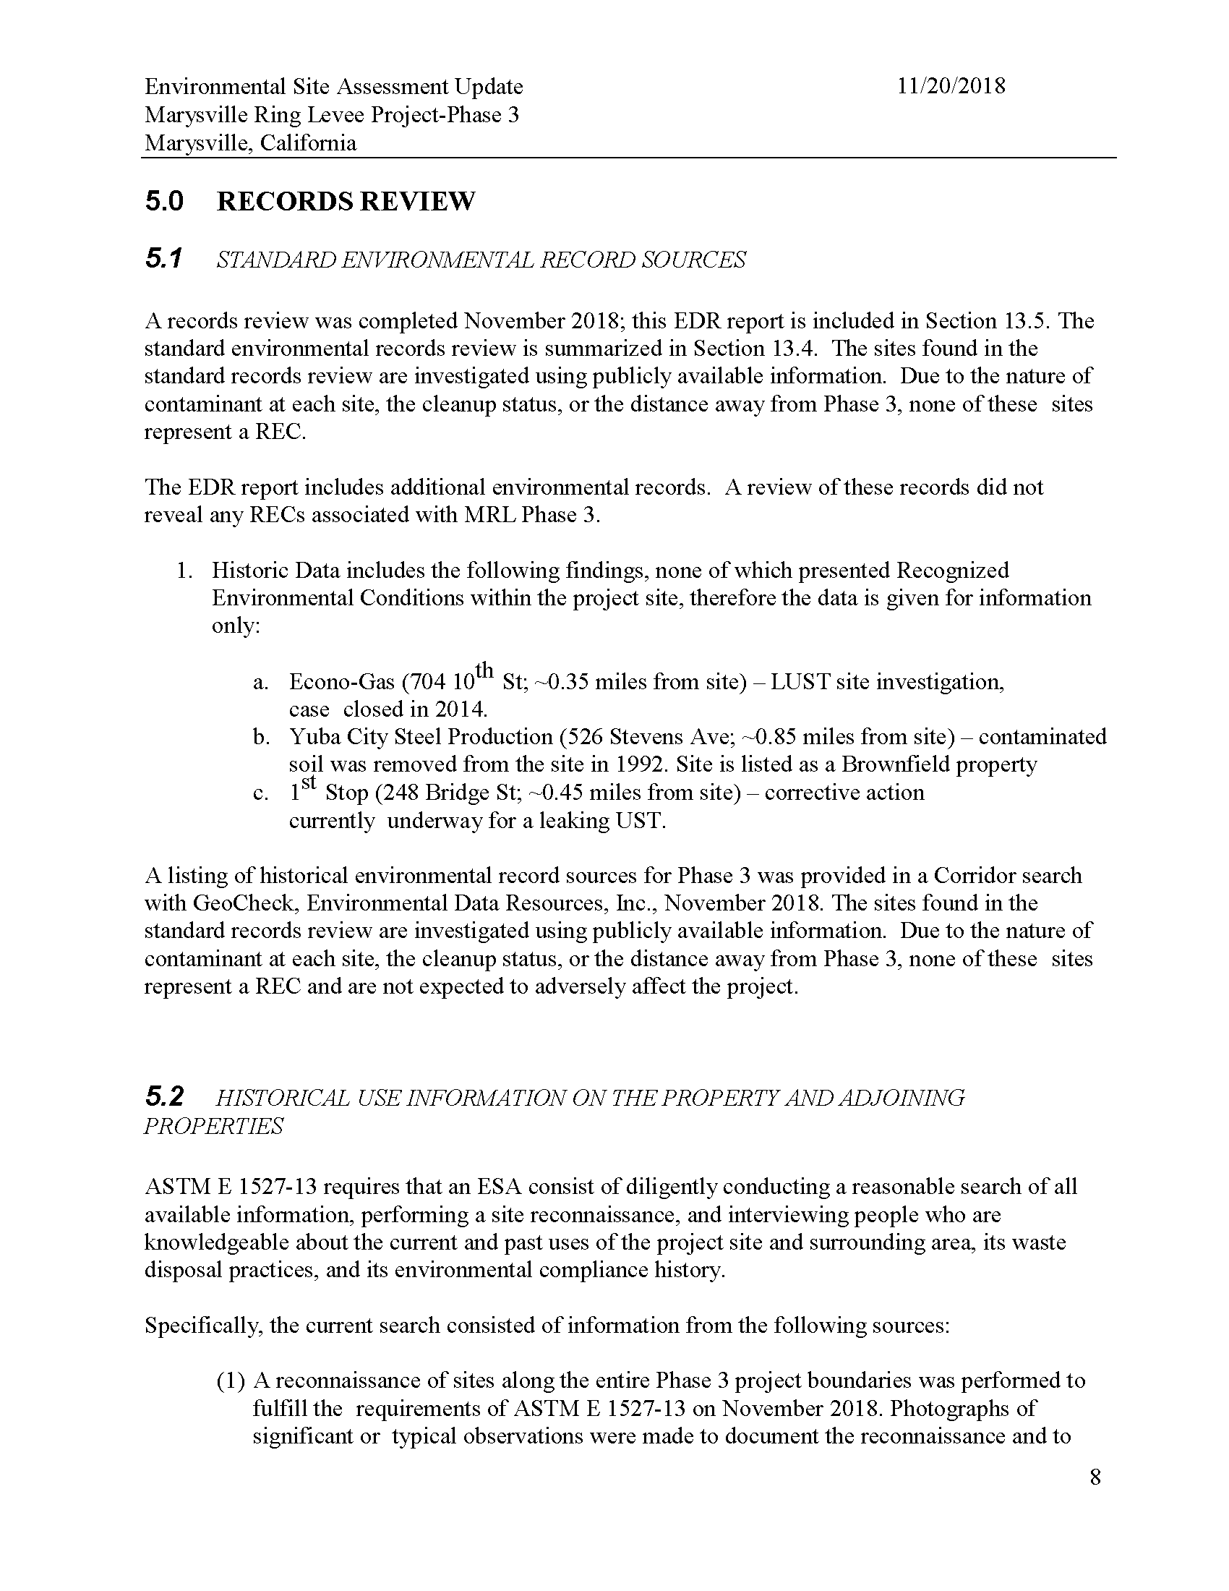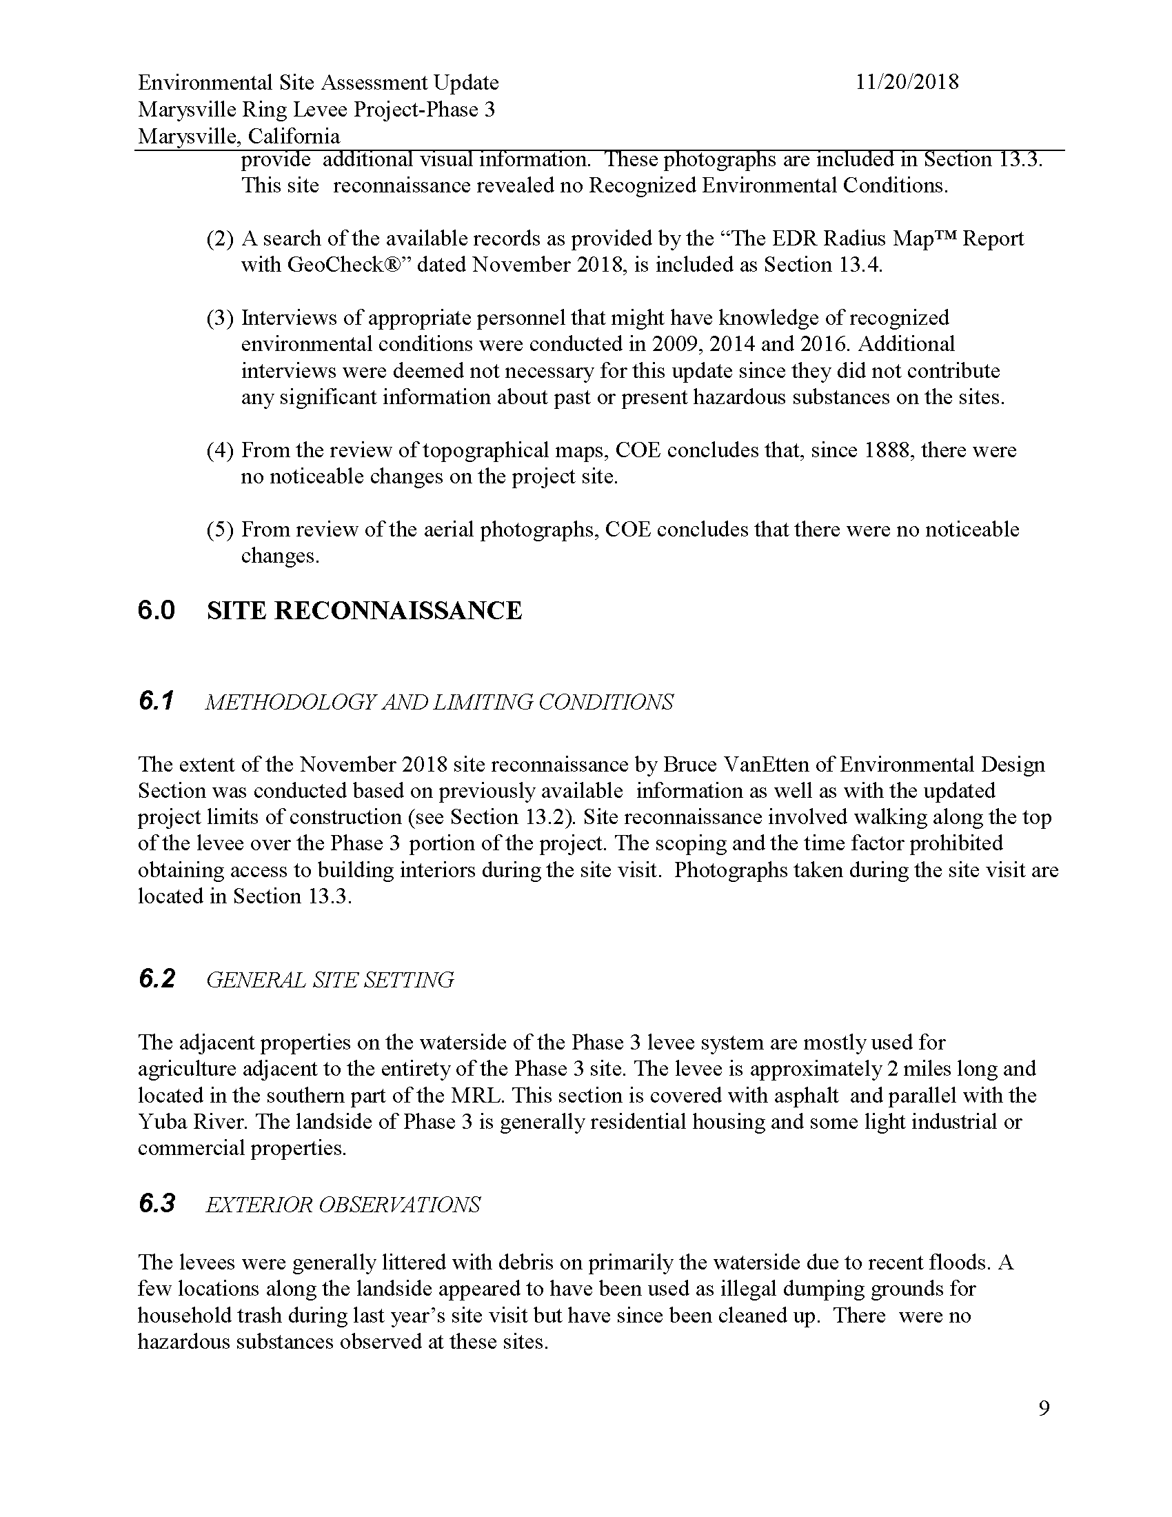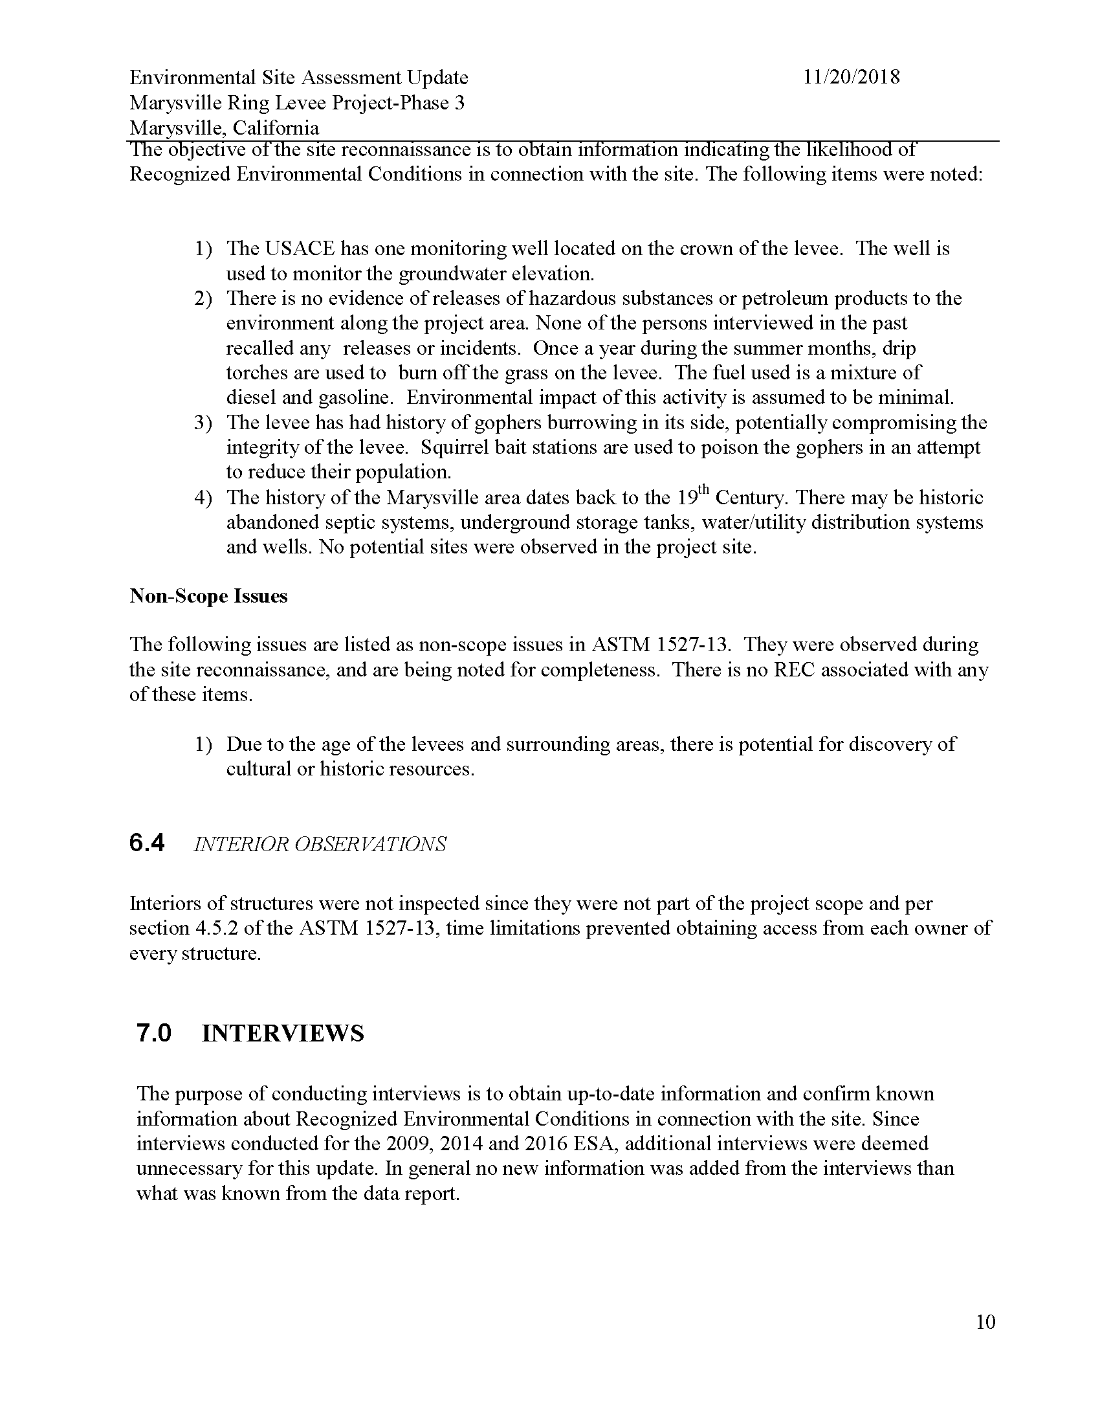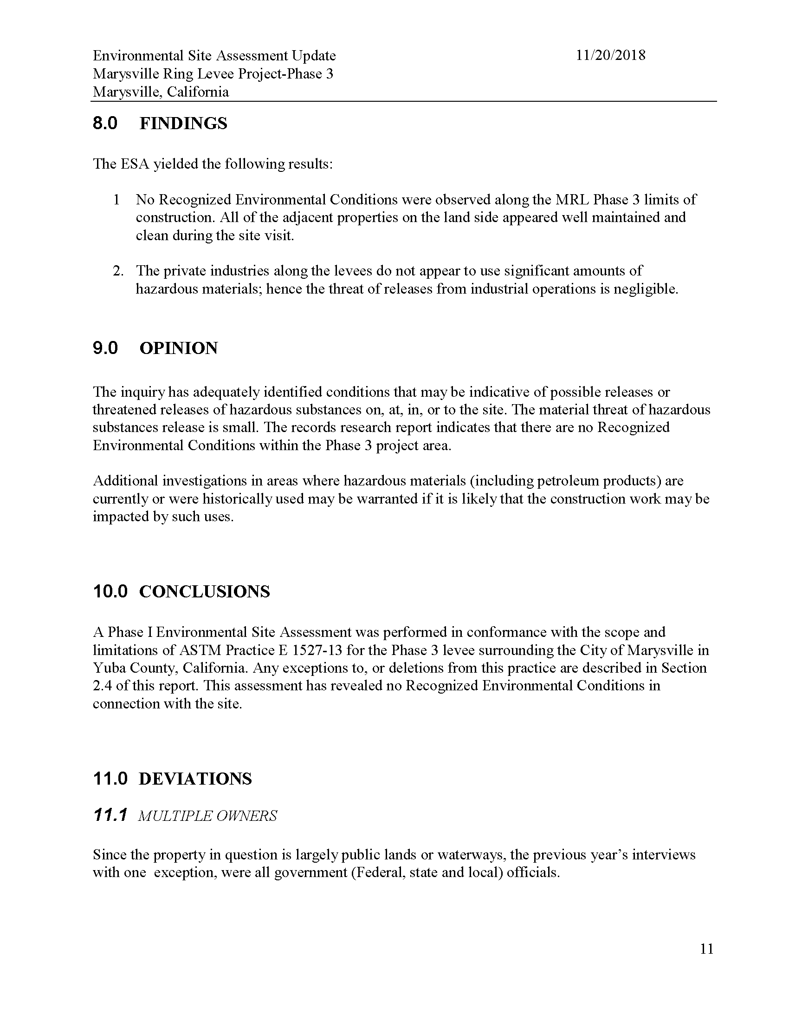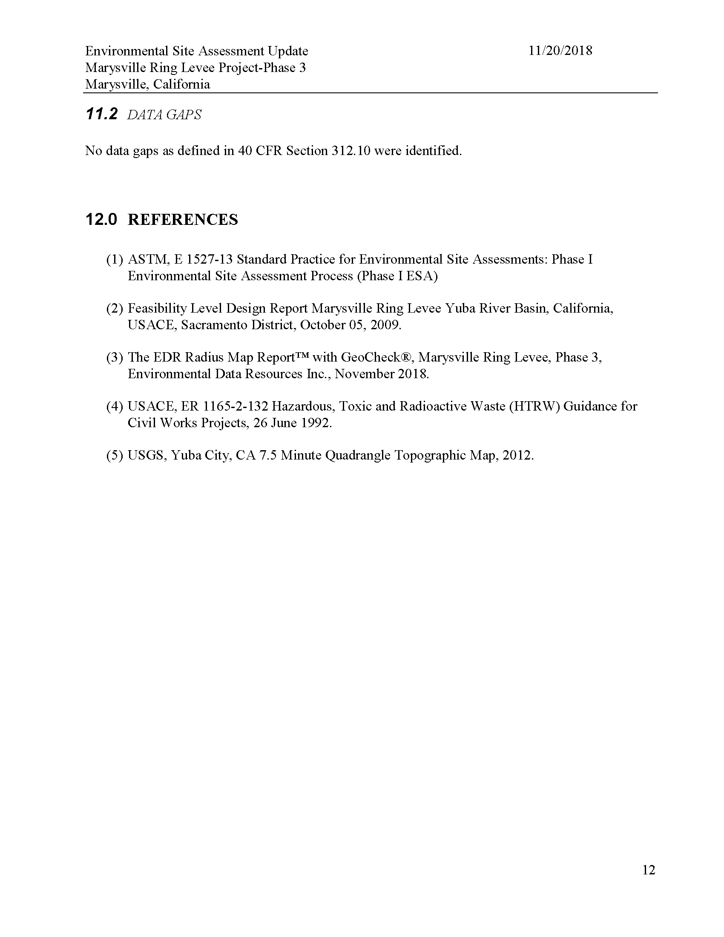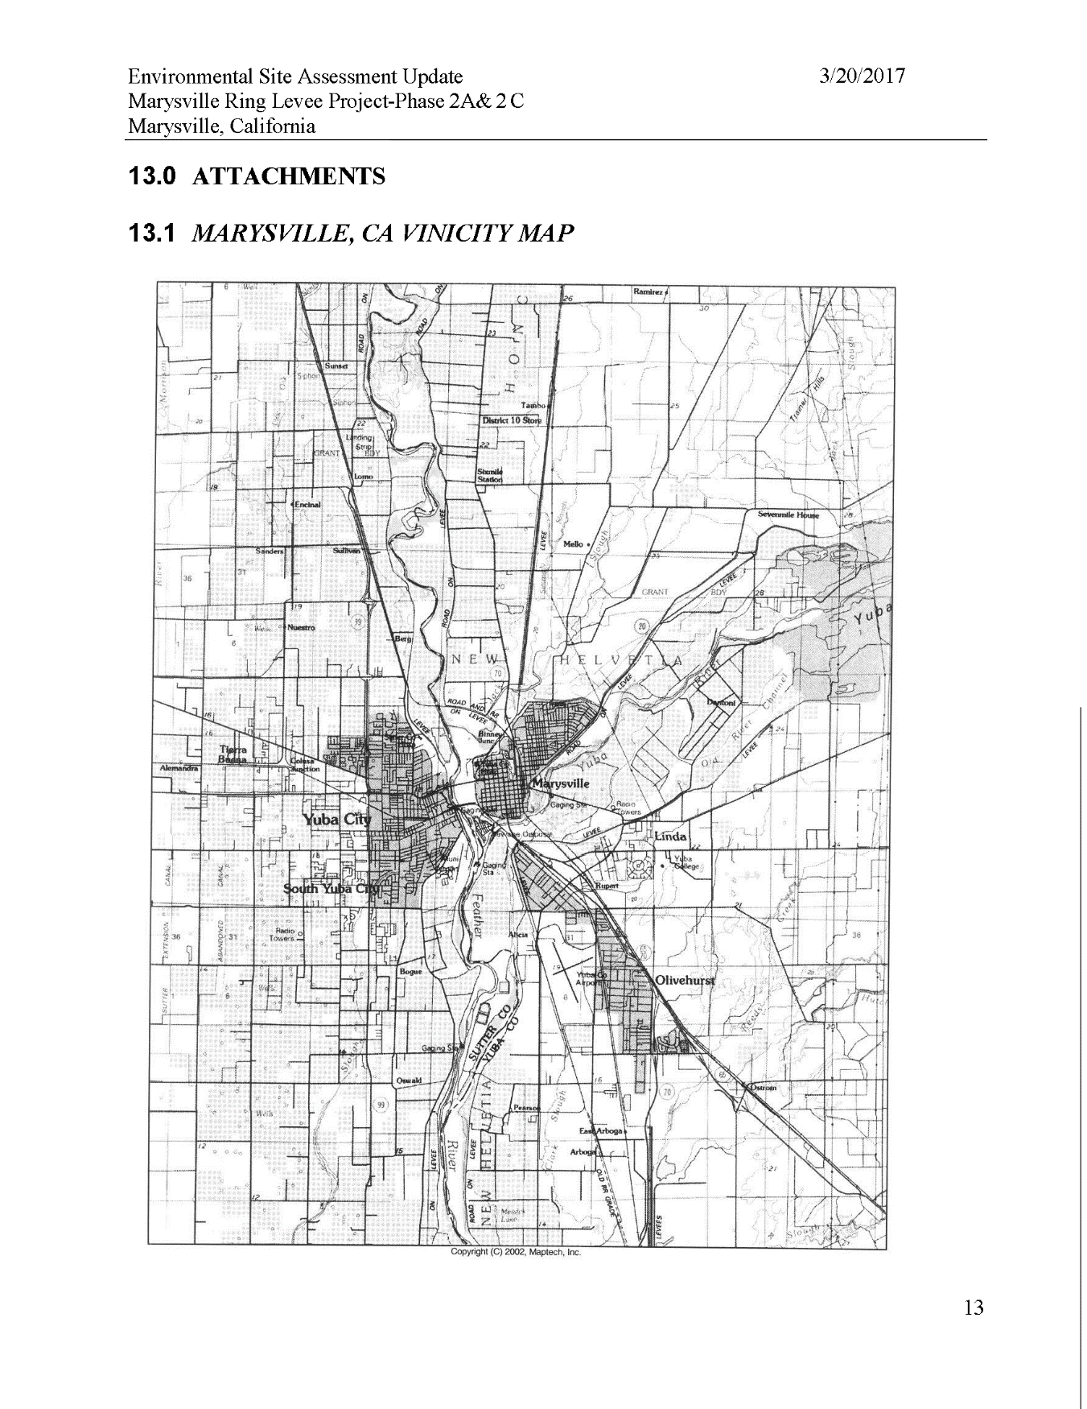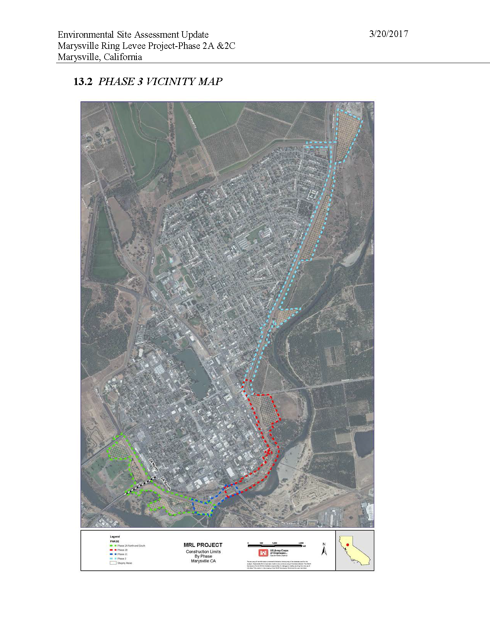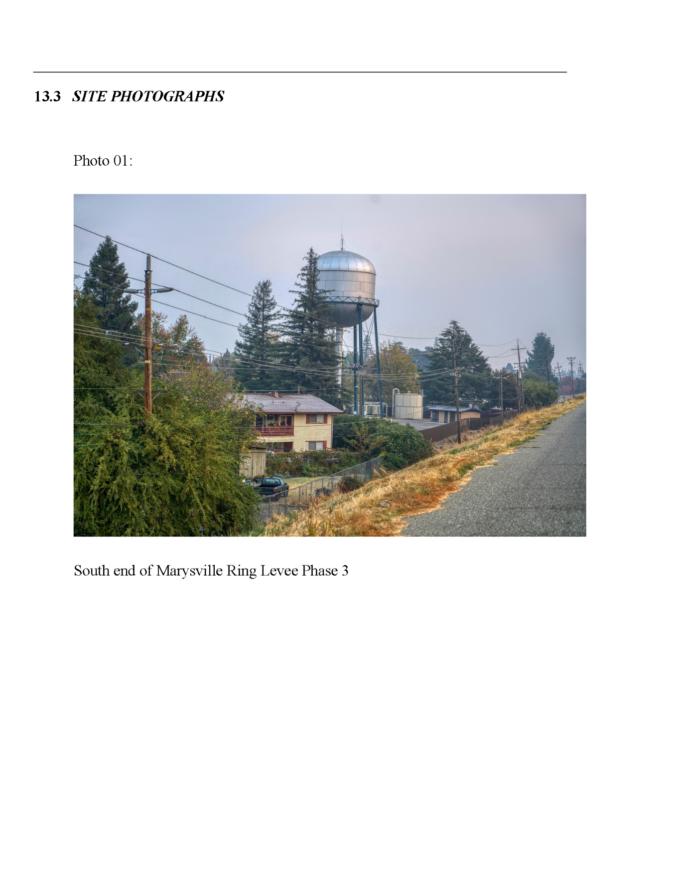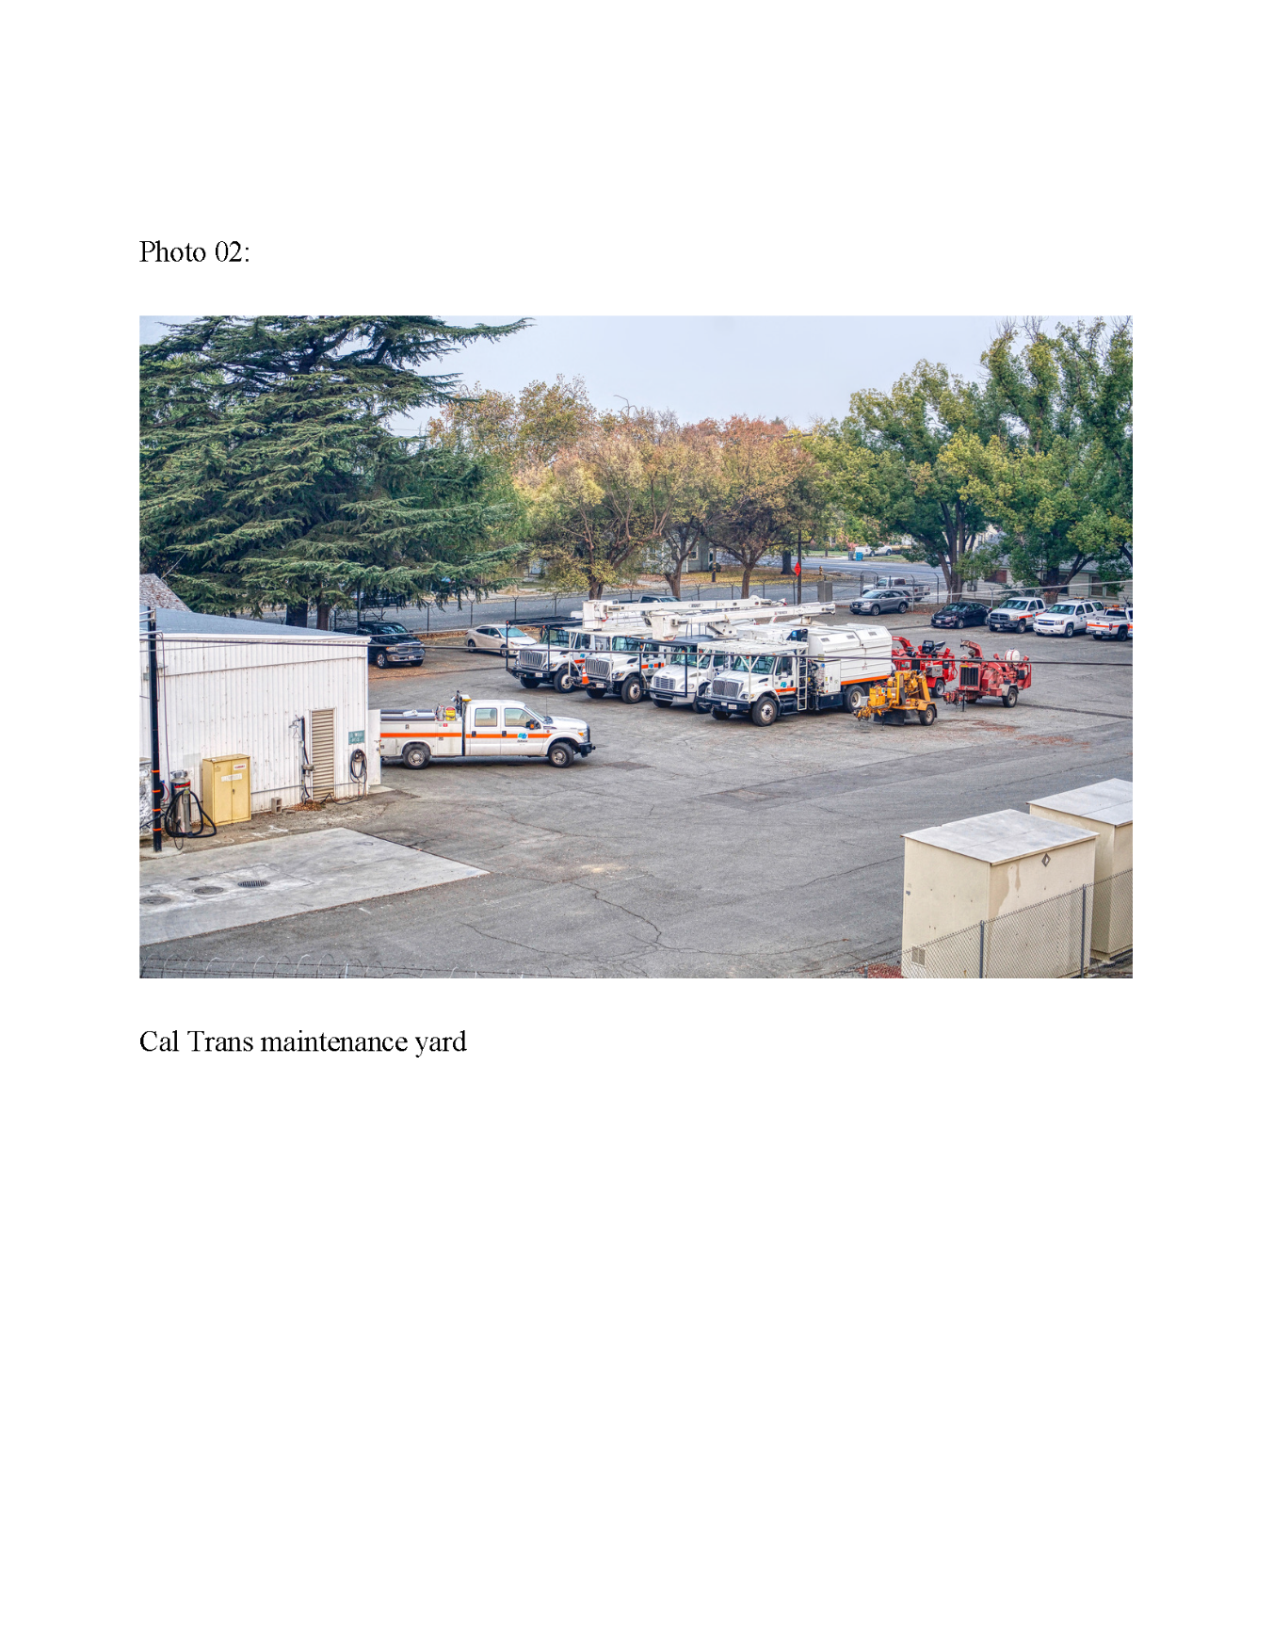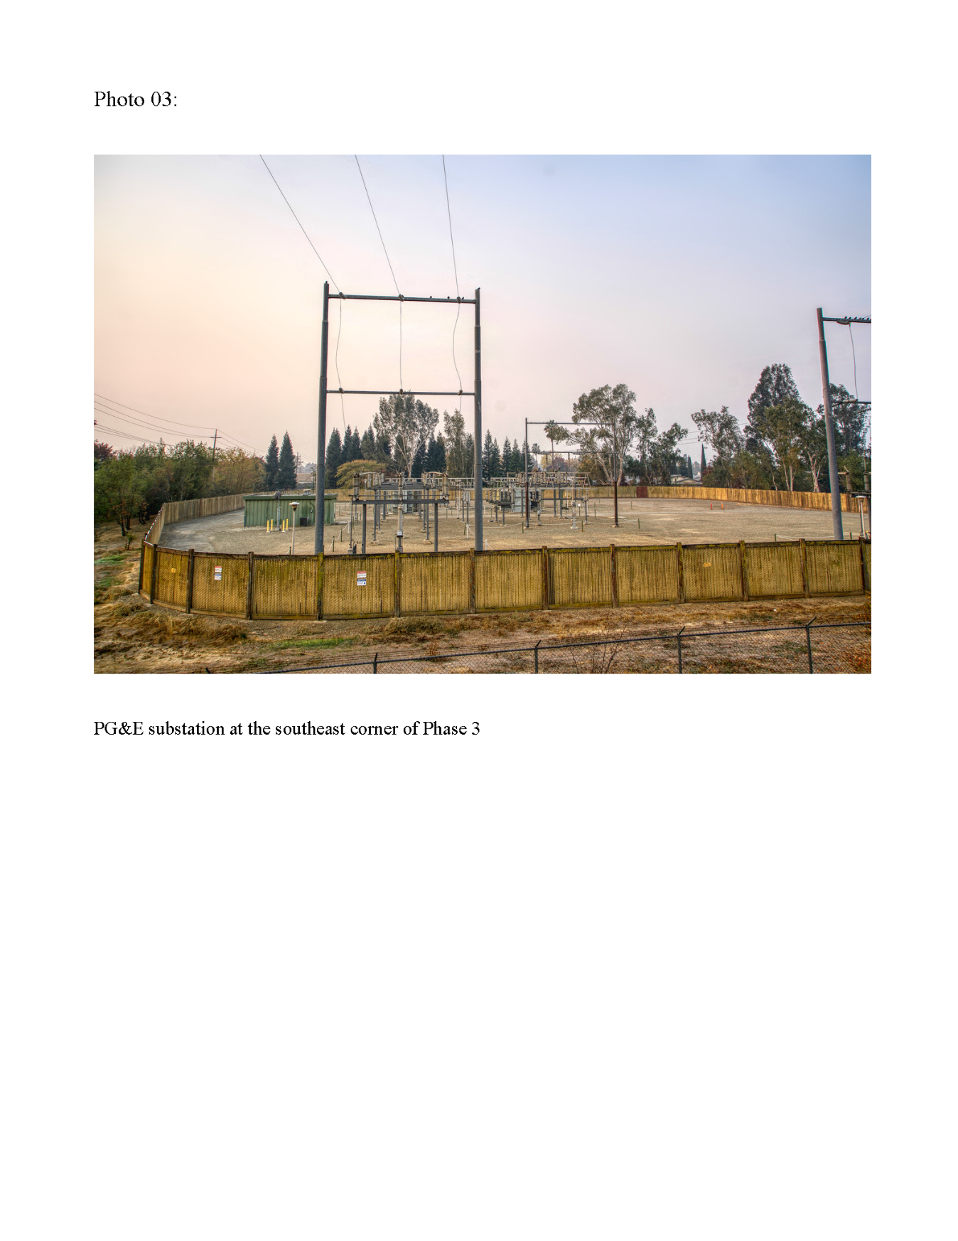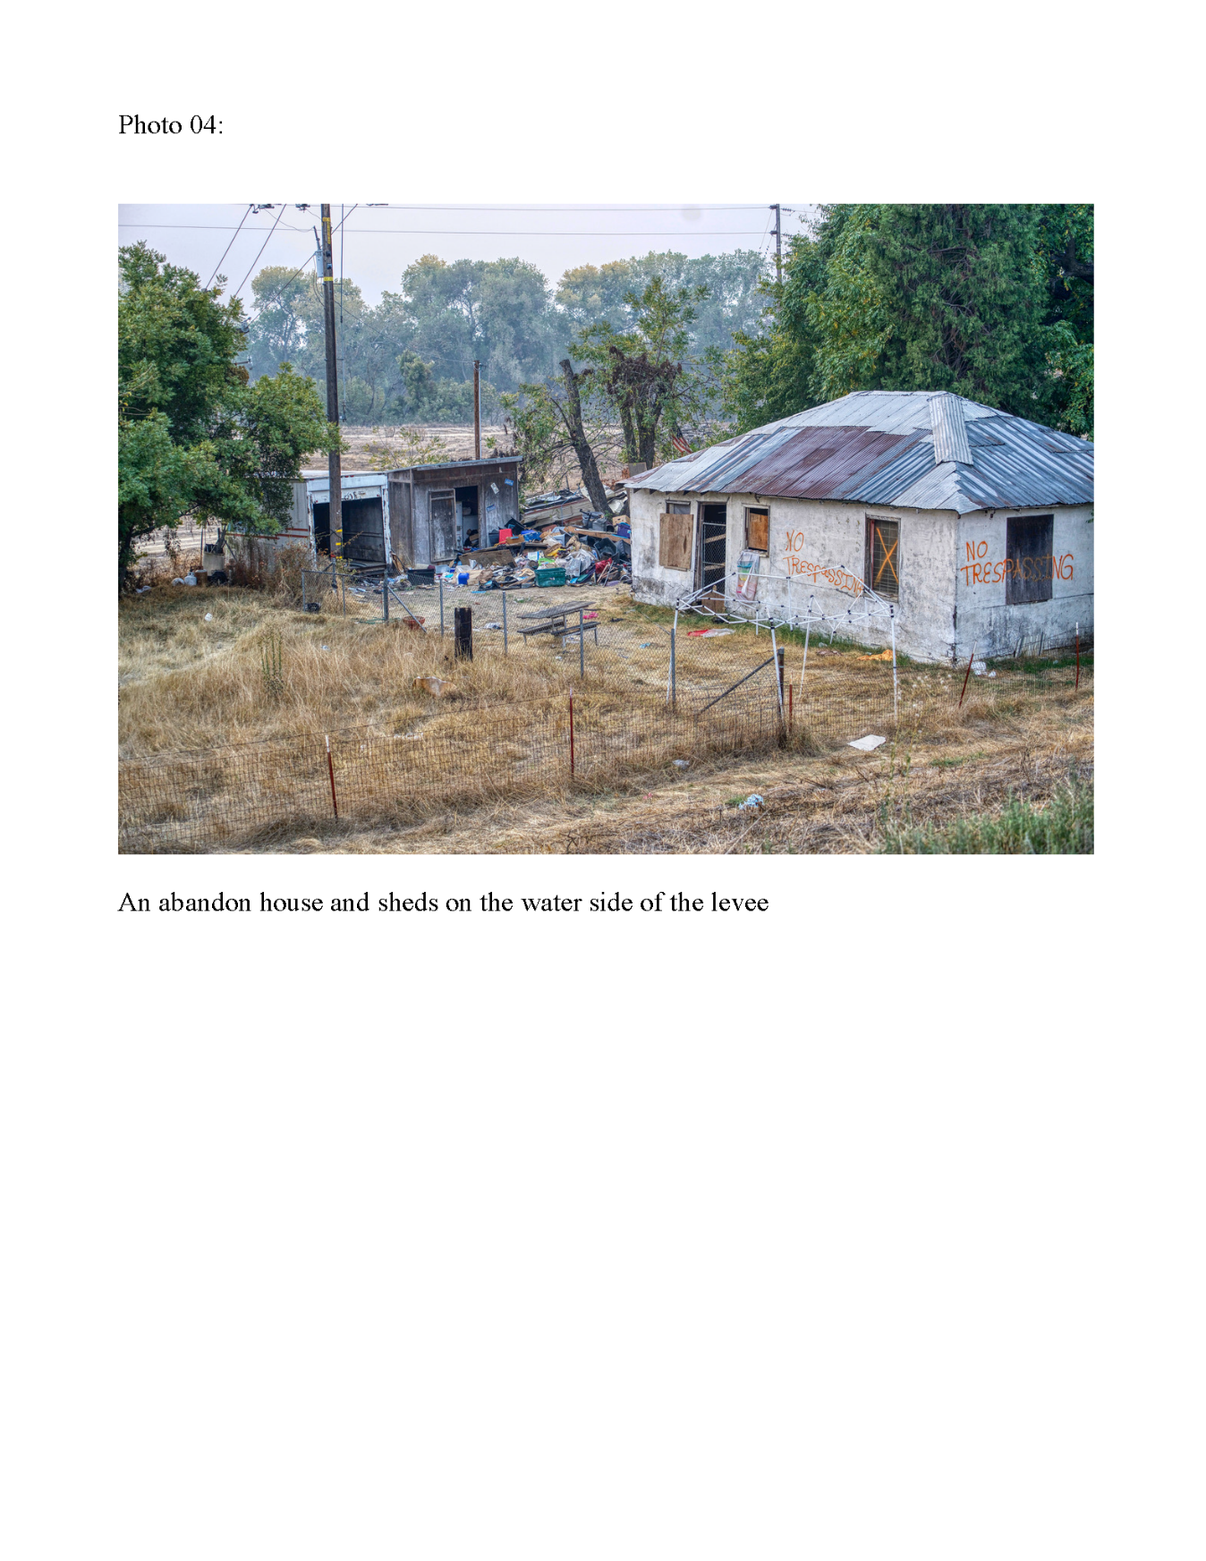

APPENDIX F

PUBLIC INVOLVEMENT

This page intentionally left blank.

INTRODUCTION
This appendix provides responses to public and agency comments on the Marysville Ring Levee (MRL) Draft Supplemental Environmental Assessment (SEA)/Initial Study (IS) received during the public comment period. The draft SEA/IS would be circulated at least 30-days for review by Federal, State, and local agencies; organizations; and members of the public. A public involvement workshop is currently scheduled for February 2019 to provide additional opportunities for comments on the draft SEA/IS.

