CALIFORNIA ENVIRONMENTAL QUALITY ACT NOTICE OF DETERMINATION

To: Office of Planning and Research State Clearinghouse
P.O. Box 3044, 1400 Tenth Street, Room 212 Sacramento, CA 95812-3044
From: Department of Toxic Substances Control Permitting Division
8800 Cal Center Drive Sacramento, CA 95826

Subject: Filing of Notice of Determination in Compliance with Section 21108 of the Public Resources Code
Project Title: Chevron USA Inc. Richmond Refinery Hazardous Waste Facility Permit Renewal
State Clearinghouse Number: 2006042054
Project Location: 841 Chevron Way in the City of Richmond, California
County: Contra Costa County
Project Applicant: Chevron USA Inc. Richmond Refinery
Project Description: The California Department of Toxic Substances Control (DTSC) adopted an Addendum to the previous Negative Declaration and approved the Hazardous Waste Facility Standardized Permit to continue operating a Hazardous Waste Storage and Treatment Facility (HWSTF) for the storage and treatment hazardous wastes which are generated onsite, pursuant to authority granted under California Health and Safety Code Chapter 6.5 and California Code of Regulations, Title 22, Division 4.5, Chapter 20.

The Chevron USA Inc. Richmond Refinery Hazardous Waste Facility (Facility) stores and treats hazardous wastes including acids, bases, and reactive chemicals. These wastes can be stored at the facility for up to one year. The Facility has five areas consisting of Storage for Drummed Waste, Neutralization, Bulk Liquid Storage and Treatment, Solid Waste Bin Storage and Liquids/Sludge Storage and Treatment. The Refinery is an integrated petroleum refinery which produces a broad range of petroleum products including transportation fuels and lubricants. The HWTSF is utilized for storage and treatment of many of the hazardous wastes generated at the Refinery. The HWTSF is arranged into five major storage/treatment areas to avoid the potential for physical contact of different waste types. The HWTSF has a small laboratory for performing on-site evaluations of waste and a personnel office and shower/change trailer. There are two sheds for storing safety related items and spill containment, control, and cleanup materials, located along the east boundary of the HWTSF. The administrative offices for the HWTSF are just outside the main entrance gate on the northern boundary of the HWTSF.

The Facility has been in existence since the 1980’s and proposes no construction activities. All previously approved operational activities will continue to be consistent with the Hazardous Waste Facility Permit. The Facility’s permit renewal would not result in a significant impact on the environment.

As Lead Agency under the California Environmental Quality Act (CEQA), DTSC approved the above-described project on September 23, 2020, and has made the following determinations:

- The project will not have a significant effect on the environment.
- A Negative Declaration was prepared for this project pursuant to the provisions of CEQA.
- Mitigation measures were not made a condition of project approval by DTSC.
- A Statement of Overriding Considerations was not adopted for this project by DTSC.
- Findings were not made pursuant to the provisions of CEQA by DTSC.

The administrative record for this project is available to the public by appointment at the following location:

Department of Toxic Substances Control Permitting Division
8800 Cal Center Drive Sacramento, CA 95826

Contact Person Hai-Yong Kang
Contact Title
Hazardous Substances Engineer
Phone Number 916) 255-6522

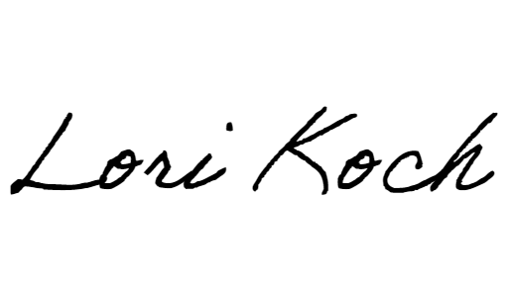Approver’s Signature: Date:

October 28, 2020

Approver’s Name Lori Koch
Approver’s Title
Supervising Hazardous Substances Engineer II
Approver’s Phone Number 510) 540-3951

TO BE COMPLETED BY OPR ONLY
Date Received for Filing and Posting at OPR:

